|  |  |
| --- | --- |
|  | **MINISTRY OF EDUCATION AND TRAINING** |

**FPT UNIVERSITY**

|  |  |
| --- | --- |
| Capstone Project Document | |
| **Mindef(Ministry of defence) Inventory System** | |
| **Group 02 – Colaboration** | |
| **Group members** | Tôn thất bảo(Vietnam) – SE62569 (Leader)  Masdey (Brunei)  Nguyễn Trung Tín (Vietnam)  Anas (Brunei)  Aidee Suherman (Brunei) |
| **Supervisor** | Ngô Đăng Hà An |
| **Ext. Supervisor** | N/A |
| **Project Code** | MIS |

**Table of Content**



List of Figure 31

List of Table 33

1. Introduction 37

1.1. Project Information 37

1.2. Introduction 37

1.3. Current Situation 37

1.4. Problem Definition 38

1.5. Proposed Solution 38

1.5.1. Feature Functions 39

1.5.2. Advantages 39

1.5.3. Disadvantages 39

1.6. Functional Requirements 40

1.6.1. User Story 40

1.7. Roles and Responsibilities 41

2. Software Project Management Plan 42

2.1. Problem Definition 42

2.1.1. Name of this Capstone Project 42

2.2. Problem Abstract 42

2.3. Project Overview 42

2.3.1. Current Situation 42

2.4. The Proposed System 42

2.5. Boundaries of the System 43

2.6. Future Plan 43

2.7. Development Environment 43

2.7.1. Hardware Requirements 43

2.7.2. Software Requirements 44

2.8. Project Organization 45

2.8.1. Software Process Model 45

2.9. Roles and Responsibilities 45

2.10. Tools and Techniques 46

2.11. Project Management Plan 47

2.11.1. Product Backlog 47

2.11.2. Deliverables 50

2.12. Coding Convention 50

3. Software Requirement Specification 51

3.1. User Requirement Specification 51

3.1.1. Admin Requirement 51

3.1.2. Inventory Department Requirement 51

3.1.3. System Requirement 51

3.2. System Requirement Specification 51

3.2.1. External Interface Requirement 51

3.2.1.1. User Interface 51

3.2.1.2. Hardware Interface: 52

3.2.1.3. Software Interface 52

3.2.1.4. Communication Protocol 52

3.3. List of Mobile App Use Cases 52

3.3.1. <Inventroy User> Mobile Overview Use Cases 52

3.3.2. <Inventory User> Login Use Case 53

3.3.3. <Inventory User> Search Overview 54

3.3.4. <Inventory User> Search by Personnel 55

3.3.5. <Inventroy User> Search by Location 58

3.3.6. <Inventory User>QR Search 60

3.3.7. <Inventory User>Add Asset Use Cases 62

3.3.8. <Inventory User>Log out 65

3.4. List of Web App Overview Use Case 66

3.4.1. <Authorized User> Web Application Overview 66

3.4.2. <Admin> Login Overview 68

3.4.3. <Admin> User Account Overview 70

3.4.4. <Admin> View User Account list 71

3.4.5. <Admin> Confirm User Account 73

3.4.6. <Admin> Activate/Deactivate User Account 74

3.4.7. <Inventory User> User Registration Overview 75

3.4.8. <Inventory User> Register User 76

3.4.9. <Inventory User> Change Password 77

3.4.10. <Inventory User >Equipment Type Overview Use Cases 79

3.4.11. <Admin> View Equipment Type 79

3.4.12. <Admin> Add Equipment Type 80

3.4.13. <Admin> Edit Equipment Type 83

3.4.14. <Admin> Delete Equipment Type 84

3.4.15. <Admin> Serach Equipment Type 85

3.4.16. <Admin> Supplier Overview 87

3.4.17. <Admin> View Supplier 88

3.4.18. <Admin> Add Supplier 89

3.4.19. <Admin> Edit Supplier 91

3.4.20. <Admin> Delete Supplier 93

3.4.21. <Admin> Search Supplier 94

3.4.22. <Admin> Equipment Overview 95

3.4.23. <Admin> View Equipment 96

3.4.24. <Admin> Add Equipment 97

3.4.25. <Admin> Edit Equipment 100

3.4.26. <Admin> Delete Equipment 102

3.4.27. <Admin> Search Equipment 103

3.4.28. <Admin> Delivery Package Overview 104

3.4.29. <Admin> View Delivery Package 105

3.4.30. <Admin> Add Delivery Package 106

3.4.31. <Admin> Edit Delivery Package 109

3.4.32. <Admin> Delete Delivery Package 110

3.4.33. <Admin> Search Delivery Package 111

3.4.34. <Admin> Brand Overview 114

3.4.35. <Admin> View Brand 114

3.4.36. <Admin> Add Brand 115

3.4.37. <Admin> Edit Brand 118

3.4.38. <Admin> Delete Brand 119

3.4.39. <Admin> Search Brand 120

3.4.40. <Admin> Location Overview 122

3.4.41. <Admin> View Location 122

3.4.42. <Admin> Add Location 124

3.4.43. <Admin> Edit Location 127

3.4.44. <Admin> Delete Location 129

3.4.45. <Admin> Search Location 130

3.4.46. <Admin> Category Overview 133

3.4.47. <Admin> View Category 133

3.4.48. <Admin> Add Category 134

3.4.49. <Admin> Edit Category 137

3.4.50. <Admin> Delete Category 138

3.4.51. <Admin> Search Category 139

3.4.52. <Admin> Staff Overview 142

3.4.53. <Admin> View Staff 142

3.4.54. <Admin> Add Staff 143

3.4.55. <Admin> Edit Staff 146

3.4.56. <Admin> Delete Staff 147

3.4.57. <Admin> Search Staff 148

3.4.58. <Admin> Issue Item Overview 149

3.4.59. <Admin> View Issue Item 150

3.4.60. <Admin> Add Issue Item 151

3.4.61. <Admin> Edit Issue Item 154

3.4.62. <Admin> Delete Issue Item 155

3.4.63. <Admin> Search Issue Item 156

3.4.64. <Admin> Generate QR 158

3.5. Software System Attributes 160

3.5.1. Usability 160

- All textboxes, labels, alerts and messages are written in English. 160

- GUI for web application is designed based on material design with navigation bar on the left and main content box on the right. 160

- The application is assumed to have basic information of Asset, Supplier, Personnel, User Account, which allows user to view and perform actions. 160

- The application has friendly and clear interfaces and features to use easily. 160

- Data will be automaticly backed up at the end of Office Hours to eliminate congestion. 160

- System will be available 24/7. 160

- System can handle a large number of requests. 160

3.6. Conceptual Diagram 161

161

4. Software Design Description 162

4.1. Design Overview 162

**3.2.** **System Architectural Design** 162

**3.3.** **Component Diagram** 163

3.4. Detail Description 165

3.4.1. Class Diagram 165

3.5. Class Diagram Explanation 166

3.5.1. User 166

3.5.2. Equipment 166

3.5.3. Equipment Type 167

3.5.4. Supplier 167

3.5.5. Issue to Personnel 167

3.5.6. Staff 168

3.5.7. Category 168

3.5.8. Location 168

3.5.9. Register 168

3.5.10. Delivery Package 168

3.6. Interaction Diagram 171

3.7. Web Sequence Diagram 175

2.8. Mobile User Interface Design 199

3.8.1. Login 199

3.8.2. Main Menu 201

3.8.2. Add New Item 203

3.8.3. Add Supplier 205

3.8.4. Add Brand 207

3.8.5. Scan QR Code 209

3.8.6. Search by Location Criteria 210

3.8.7. Item List pop up 212

3.8.8. Search by User Criteria 213

3.8.9. View Equipment Detail page 215

3.9. User Interface Design 217

3.9.1. Home Page 217

3.9.2. Login Page 220

3.9.3. Personal Interface Design 221

7.2 Mobile Apps Design 224

5.4.1. Manager’s menu 224

7.3 224

5.4.2. Staff management 225

5.4.2.1. View staff list 225

7.4 226

5.4.2.2. Create staff 229

7.5 230

5.4.3. Customer management 232

5.4.3.1. View customer list 232

7.6 233

5.4.3.2. Create customer 236

7.7 237

5.4.4. Product management 239

5.4.4.1. View product list 239

7.8 239

5.4.4.2. Create product 240

7.9 240

5.4.5. Template Management 241

5.4.5.1. View Template List 241

7.10 241

5.4.5.2. View template detail 242

7.11 242

5.4.5.3. Create template 244

7.12 244

7.13 Accountant Interface Design 246

7.13.1 Accountant’s menu 246

7.14 246

7.14.1 Invoice management 247

7.14.1.1 View invoice list 247

7.15 247

7.15.1.1 Create invoice 249

7.15.1.1.1 Customer information 249

7.16 249

7.16.1.1.1 Product information 250

7.17 250

7.17.1.1.1 Create invoice’s product popup 252

7.18 252

7.18.1 Proforma invoice management 253

7.18.1.1 View proforma invoice list 253

7.19 253

7.19.1.1 Create proforma invoice 256

7.19.1.1.1 Proforma invoice information 256

7.20 256

7.20.1.1.1 Create proforma invoice’s product popup 258

7.21 258

7.21.1 Liabilities management 259

7.21.1.1 View liabilities list 259

7.22 259

7.22.1.1 Liabilities detail 261

7.23 261

7.23.1.1 Payment popup 262

7.24 262

7.25 Customer Interface Design 263

7.25.1 Customer’s menu 263

7.26 263

7.26.1 Invoice list 264

7.27 264

7.27.1 Proforma invoice list 265

7.28 265

7.28.1 Liabilities 266

7.29 266

7.29.1 Liabilities detail 268

7.30 268

7.31 Admin Interface Design 270

7.31.1 Admin’s menu 270

7.32 270

7.32.1 Company management 271

7.32.1.1 View company list 271

7.33 271

7.33.1.1 Create company 273

7.34 273

7.34.1 Account management 274

7.34.1.1 View admin list 274

7.35 274

7.35.1.1 Create Admin 276

7.36 276

**5.8. Windows Application** 278

4.1. Introduction 283

4.1.1. Overview 283

4.1.2. Test Approach 283

4.2. Database Relationship Diagram 284

4.2.1. Physical Diagram 284

4.2.2. Data Dictionary 285

2.9. Test Plan 285

1.1. Features To Be Tested Web Application 286

All the test must pass Adding , Editing, Deleteing , Viewing and Searching to each class listed below 286

Features To Be Tested Mobile Application 286

All the test must pass Adding, Viewing, Searching and Scanning to each class listed below 286

1.2. Features Not To Be Tested 286

- Log in, log out, update profile,… 286

- Admin: create company, create account,… 286

2.10. System Testing Test Case 286

1.3. Test Case 286

# List of Figure

Figure 1. Scrum framework 45

Figure 7. <Inventory User> QR Search Use Case 60

Figure 18. <Inventory User>Change Password 77

Figure 54. <Admin> Search Location 131

Figure 63. Conceptual diagram 161

Figure 64. System architectural design 162

Figure 65. Component diagram 163

*Figure 66. Class diagram* 165

Figure 67. <Sequence Diagram><Inventory User> Mobile Login 171

Figure 68. <Sequence Diagram><Inventory User> Mobile LogOut 172

Figure 69. <Sequence Diagram><Inventory User> Mobile Search by User 173

Figure 70. <Sequence Diagram>><Inventory User> Mobile Search by Location 173

Figure 71. <Sequence Diagram><Inventory User> Mobile Search by QR 174

Figure 72. <Sequence Diagram><Inventory User>Mobile Add Item 174

Figure 74. Login 199

Figure 74. MainMenu 202

Figure 74. Add New Item 203

Figure 74. Add Supplier 205

Figure 74. Add Brand 208

Figure 74. Scan QR Code 209

Figure 74. Search by Location Criteria 210

Figure 74. Location Search Item List pop up 212

Figure 74. Search by User Criteria 213

Figure 74. View Equipment 215

Figure 74. Home page 217

Figure 75. Login page 220

Figure 76. Personal menu 221

Figure 77. Personal information page 222

Figure 78. Change password page 223

Figure 79. Manager’s menu 224

Figure 80. View staff list 227

Figure 81. Create staff 231

Figure 82. View customer list 234

Figure 83. Create customer 238

Figure 84. View product list 239

Figure 85. Create product 240

Figure 86. View template list 241

Figure 87. View template detail 242

Figure 88. Create template 244

Figure 89. Accountant’s menu 246

Figure 90. View invoice list 247

Figure 91. Customer information 249

Figure 92. Product information 250

Figure 93. Create invoice’s product popup 252

Figure 94. View proforma invoice list 253

Figure 95. Proforma invoice information 256

Figure 96. Create proforma invoice’s product popup 258

Figure 97. View liabilities list 259

Figure 98. Liabilities detail 261

Figure 99. Payment popup 262

Figure 100. Customer’s menu 263

Figure 101. Invoice list 264

Figure 102. Proforma invoice list 265

Figure 103. Liabilities 266

Figure 104. Liabilities detail 268

Figure 105. Liabilities detail 269

Figure 106. Admin’s menu 270

Figure 107. View company list 271

Figure 108. Create company 273

Figure 109. View admin list 274

Figure 110. Create admin account 276

Figure 111. Login form 278

Figure 112. Sign form 279

Figure 113. Entity relationship diagram 280

Figure 114. Physical database 284

# List of Table

Table 1. Roles and responsibilities 19

Table 2. Hardware requirements for server 21

Table 3. Hardware requirements for PC 22

Table 4. Software requirements 22

Table 5. Roles and responsibilities details 24

Table 7. Product backlog 28

Table 8. Deliverables 29

Table 9. <Inventory User> Login 35

Table 10. <Inventory User> Search Overview 36

Table 11. Search by Personnel 37

Table 11. Search by Location 39

Table 11. Scan QR 40

Table 11. Add Asset 41

Table 12. <Inventory User> Logout 43

Table 20. <Admin> View account list 46

Table 21. <Admin> Add account 47

Table 22. <Admin> Update account 49

Table 23. <Admin> Activate.Deactivate account 50

Table 24. <Admin> Change account password 52

Table 25. <Admin> Delete account 53

Table 20. <Admin> View account list 56

Table 21. <Admin> Create account 57

Table 22. <Admin> Update account 59

Table 19. <Inventory User> Delete Personnel 60

Table 10. <Inventory User> Search Personnel 62

Table 20. <Inventory User> View Supplier list 63

Table 21. <Inventory User> Add Supplier 65

Table 22. <Inventory User> Edit Supplier 67

Table 19. <Inventory User> Delete Personnel 68

Table 10. <Inventory User> Search Supplier 70

Table 20. <Inventory User> View Asset list 72

Table 21. <Inventory User> Add Asset 74

Table 22. <Inventory User> Edit Asset 76

Table 19. <Inventory User> Delete Asset 77

Table 10. <Inventory User> Search Asset 79

Table 61. Component diagram dictionary 84

Table 62. Class Diagram Dictionary 88

Table 63. <Class Diagram Attributes> User 88

Table 64. <Class Diagram Methods> User 88

Table 65. <Class Diagram Attributes> Role 89

Table 66. <Class Diagram Methods> Role 89

Table 67. < Class Diagram Attributes> UserRole 89

Table 68. <Class Diagram Attributes> Company 89

Table 69. <Class Diagram Methods> Company 89

Table 70. <Class Diagram Attributes> Staff 90

Table 71. <Class Diagram Methods> Staff 90

Table 72. <Class Diagram Attributes> Customer 90

Table 73. <Class Diagram Methods> Customer 90

Table 74. <Class Diagram Attributes> Company Customer 90

Table 75. <Class Diagram Methods> Company Customer 90

Table 76. <Class Diagram Attributes> Product 91

Table 77. <Class Diagram Methods> Product 91

Table 78. <Class Diagram Attributes> CustomerProduct 91

Table 79. <Class Diagram Methods> CustomerProduct 91

Table 80. <Class Diagram Attributes> Transaction 91

Table 81. <Class Diagram Methods> Transaction 91

Table 82. <Class Diagram Attributes> Template 91

Table 83. <Class Diagram Methods> Template 92

Table 84. <Class Diagram Attributes> Invoice 92

Table 85. <Class Diagram Methods> Invoice 92

Table 86. <Class Diagram Attributes> InvoiceItem 92

Table 87. <Class Diagram Methods> Invoice Item 93

Table 88. <Class Diagram Attributes> ProformaInvoice 93

Table 89. <Class Diagram Methods> ProformaInvoice 93

Table 90. <Class Diagram Attributes> ProformaInvoiceItem 93

Table 91. <Class Diagram Methods> ProformaInvoiceItem 93

Table 92. <Fields> Home page 97

Table 93. <Buttons/Hyperlinks> Home page 97

Table 92. <Fields> Home page 98

Table 93. <Buttons/Hyperlinks> Home page 98

Table 92. <Fields> Home page 99

Table 93. <Buttons/Hyperlinks> Home page 99

Table 92. <Fields> Home page 100

Table 93. <Buttons/Hyperlinks> Home page 100

Table 92. <Fields> Home page 101

Table 93. <Buttons/Hyperlinks> Home page 101

Table 92. <Fields> Home page 102

Table 93. <Buttons/Hyperlinks> Home page 102

Table 92. <Fields> Home page 103

Table 93. <Buttons/Hyperlinks> Home page 103

Table 92. <Fields> Home page 104

Table 93. <Buttons/Hyperlinks> Home page 104

Table 92. <Fields> Home page 105

Table 93. <Buttons/Hyperlinks> Home page 105

Table 92. <Fields> Home page 106

Table 93. <Buttons/Hyperlinks> Home page 106

Table 92. <Fields> Home page 107

Table 93. <Buttons/Hyperlinks> Home page 107

Table 92. <Fields> Home page 108

Table 93. <Buttons/Hyperlinks> Home page 108

Table 94. <Fields> Login page 111

Table 95. <Buttons/Hyperlinks> Login page 111

Table 96. <Fields>Personal menu 112

Table 97. <Buttons/Hyperlinks> Personal menu 112

Table 98. <Fields> Personal information page 113

Table 99. <Buttons/Hyperlinks> Personal information page 113

Table 100. <Fields> Change password page 114

Table 101. <Buttons/Hyperlinks> Change password page 114

Table 102. <Fields> Manager’s menu 115

Table 103. <Buttons/Hyperlinks> Manager’s menu 115

Table 104. <Fields> View staff list 119

Table 105. <Buttons/Hyperlinks> View staff list 120

Table 106. <Fields> Create staff 123

Table 107. <Buttons/Hyperlinks> Create staff 123

Table 108. <Fields>View customer list 126

Table 109. <Buttons/Hyperlinks>View customer list 127

Table 110. <Fields> Create customer 130

Table 111. <Buttons/Hyperlinks> Create customer 130

Table 112. View product list 132

Table 113. <Buttons/Hyperlinks> View product list 132

Table 114. <Fields> Create product 133

Table 115. <Buttons/Hyperlinks> Create product 133

Table 116. <Fields> View template list 134

Table 117. <Buttons/Hyperlinks> View template list 134

Table 118. <Fields> View template detail 136

Table 119. <Buttons/Hyperlinks> View template detail 136

Table 120. <Fields> Create template 138

Table 121. <Buttons/Hyperlinks> Create template 138

Table 122. <Fields> Accountant’s menu 140

Table 123. <Buttons/Hyperlinks> Accountant’s menu 140

Table 124. <Fields> View invoice list 141

Table 125. <Buttons/Hyperlinks> View invoice list 141

Table 126. <Fields> Customer information 143

Table 127. <Buttons/Hyperlinks> Customer information 143

Table 128. <Fields> Product information 144

Table 129. <Buttons/Hyperlinks> Product information 145

Table 130. <Fields> Create invoice’s product popup 145

Table 131. <Buttons/Hyperlinks> Create invoice’s product popup 146

Table 132. <Fields> View proforma invoice list 147

Table 133. <Buttons/Hyperlinks> View proforma invoice list 148

Table 134. <Fields> Proforma invoice information 150

Table 135. <Buttons/Hyperlinks> Proforma invoice information 150

Table 136. <Fields> Create proforma invoice’s product popup 152

Table 137. <Buttons/Hyperlinks> Create proforma invoice’s product popup 152

Table 138. <Fields> View liabilities list 153

Table 139. <Buttons/Hyperlinks> View liabilities list 153

Table 140. <Fields> Liabilities detail 155

Table 141. <Buttons/Hyperlinks> Liabilities detail 155

Table 142. <Fields> Payment popup 156

Table 143. <Buttons/Hyperlinks> Payment popup 156

Table 144. <Fields> Customer’s menu 156

Table 145. <Buttons/Hyperlinks> Customer’s menu 157

Table 146. <Fields> Invoice list 158

Table 147. <Buttons/Hyperlinks> Invoice list 158

Table 148. <Fields> Proforma invoice list 159

Table 149. <Buttons/Hyperlinks> Proforma invoice list 160

Table 150. <Fields> Liabilities 160

Table 151. <Buttons/Hyperlinks> Liabilities 161

Table 152. <Fields> Liabilities detail 162

Table 153. <Fields> Liabilities detail 163

Table 154. <Buttons/Hyperlinks> Liabilities detail 163

Table 155. <Fields> Admin’s menu 164

Table 156. <Buttons/Hyperlinks> Admin’s menu 164

Table 157. <Fields> View company list 165

Table 158. <Buttons/Hyperlinks> View Company List 165

Table 159. <Fields> Create company 167

Table 160. <Buttons/Hyperlinks> Create company 167

Table 161. <Fields> View admin list 168

Table 162. <Buttons/Hyperlinks> View admin list 168

Table 163. <Fields> Create admin account 169

Table 164. <Buttons/Hyperlinks> Create admin account 170

Table 165. <Fields> Login form 171

Table 166. <Buttons/Hyperlinks> Login form 171

Table 167. <Fields> Sign form 172

Table 168. <Buttons/Hyperlinks> Sign form 172

Table 169. Entity dictionary 175

Table 170. Database dictionary 180

Table 171. <Test case> Create proforma invoice 183

Table 172. <Test case> Create invoice 185

Table 173. <Test case> Add payment 186

Table 174. <Test case> Confirm payment 187

Table 175. <Test case> Approve proforma invoice 188

Table 176. <Test case> Convert proforma invoice into invoice 188

Table 177. <Test case> Approve invoice 189

Table 178. <Test case> Create template release 190

Table 179. Hardware requirement 191

Table 180. Software requirement 191

Table 181. <User Manual> Login 192

Table 182. <User Manual> Create invoice 195

Table 183. <User Manual> Confirm payment 199

Table 184. <User Manual> Create proforma invoice 203

Table 185. <User Manual> Approve proforma invoice 205

Table 186. <User Manual> Convert proforma invoice 208

Table 187. <User Manual> Add payment 209

Table 188. <User Manual> Window application - Login 210

Table 189. <User Manual> Window application - Sign 211

# Introduction

## Project Information

* Project name: **Mindef Inventory System**
* Project Code: **MIS**
* Product Type: **Mobile and Web Apps**
* Start Date: **October 1th, 2018**
* End Date: **November 27th, 2018**

## Introduction

Defense Information Technology Unit deals with anything related to technology and computer needs in Ministry of Defense. Obviously there will be a huge amount of employee be as an army men or the civilian employee. Huge amount of computer hardware and peripharals such as printer, monitor, scanner and others are needed to cater each employee.

In order to keep on par with the rapid development of technological growth, issued personal computer system too are in rapidly approaching their phase out stage. This is due to compatibility issues in hardware and software and ultimately due to wear and tear of daily use. As part of the government asset, each issued computer require proper paper work to track the status of issued computer not forgetting disposal of each asset. Managing and tracking all the above fell into the responsibility of the inventory section in the support unit in DITU.

Realizing duplication issues found in Microsoft Excel this section opted to adapt Microsoft Access to solve the issues. As years past by the requirement to have a much more robust and scalable solution are in demand. Preferebly, the new system should be easy to integrate and adapting the use of new available hardware such as QR system.

In the past few years disposal of hardware that is verified and considered Beyond Economical Repair by the technician are not properly organized and manage effectively. This resulted in difficulty to track each item and sometime to track an item could take up to a week to track and verify.

## Current Situation

Current system to stored details of various devices (computers, projectors, keyboards, storage devices, etc), office equipments (chairs, tables, etc) and components (network cables, power adapters, dongles, etc). The stored details is divided into two types 1) Computer 2) Acessories. Currently, the asset details are stored in Microsoft Access file, indicated by a serial number.

This system is used to check the status of availability, issue to, replacements if required, auditing, and others. Any enquiry that require tracking an item, the section will give a printout of any related details and given to the requester.

In order to have a more scalable and reliable system the management had requested a proposal from Group 2, to come up with a new system development. This development should be able to provide a better solution that enable sustainability and scalability from the current management system. Group 2 had come up with a Mobile Application and the use of QR tagging system for the development.

## Problem Definition

1. **Unsustainable:** Using the current Microsoft Access is obviously unscalabe to sustain the increase storage and process demand
2. **Integration Issue:** Microsoft Access are difficult to integrate with other system used in the company
3. **Tracking:** Tracking inventory item are not organized resulting to improper storage system.

## Proposed Solution

The proposed solution is to develop two different application that consist of web application as the main system and a mobile web portal that will be integrated with QR code functionality to optimize tracking all the Hardware item (Equipment) effectively.

Due to the time constraint the client had agree to have basic functional system for the first phase of the development stage. There will be two team that will concentrate on the web application development, while the other team will concentrate on the mobile application development.

The web application will act as the main data collection to effectively store and manage the whole system. Inventory User will be able to self register to the system easily. Management of the Inventory User will be the responsibility of User that are have the role of Administration in order make any update regarding System User Needs. The current registered user can also be assigned different role to limit access to any confidential details available in the system.

The application should also be able to generate QR code to be print out and stick to its respective hardware for tagging.

The mobile application will use the QR Scanner functionality available in mostly any device to retrieve information of the asset, the personnel issued to, its location, status and others. User can also type in any related criteria through Manual Search to obtain the desired result.

The mobile application will able to shorten the amount of time wasted during auditing also will provide reliability and automation compare to the current system.

User can scan the QR code to edit the asset information such as issued to which user, location, status of the asset (need to be replace or not).  
End-User - Able to access the asset information and update certain information such as the status or if there is an issue with the asset that requires maintenance (slow performance, virus, no network connection, etc)

## Feature Functions

* Item will be tracked using QR Tag or sticker
* The system will use mobile phone to scan the QR code or using webcam
* Managers can view inventory item eiter through web browser or mobile apps
* Easy to manage user
* The system will enable to list out search result base on selected criteria

## Advantages

* Efficient management: easy to lookup and manage inventory information, future ready, scalability and storage.
* Cost saving: reduce the costs of printing, and paper usage.
* Time saving: minimize administrative procedures.
* Security: ensure record safety and validity.

## Disadvantages

* System have only basic function in the first deployment.

## Functional Requirements

## User Story

Functional requirements are listed as below:

* **Admin:**
  + Manage staff
  + Manage user account
  + Manage Package Delivery
  + Manage Issued items
  + Manage Supplier Detail
  + Manage Inventory Status
  + Manage Equipment
  + Manage Issued Personnel
  + Manage Location
  + Manage Equipment related info(Category, Type, Brand,…)
* **Inventory Department:**
* Scan Qr
* Add delivery package
* Search issued item
* Login using approved account
* **System:**
  + Management and Tracking the Location of Inventory Asset Issued

## Roles and Responsibilities

|  |  |  |  |  |
| --- | --- | --- | --- | --- |
| **No** | **Full name** | **Role** | **Position** | **Contact** |
| 1 | Ngô Đăng Hà An | Mentor | Supervisor | AnNDH@fpt.edu.vn |
| 2 | Tôn thất bảo | Team Leader  Developer  Project Manager | Leader | Baottse62569@fpt.edu.vn |
| 3 | Masdey | Business analyst  Developer  Designer | Member |  |
| 4 | Nguyễn Trung Tín | Team member  Developer  Documenter | Member |  |
| 5 | Anas | Team member  Designer  Developer  Tester | Member |  |
| 6 | Aidee Suherman | Team member  Documenter  Tester | Member |  |
|  |  |  |  |  |

Table 1. Roles and responsibilities

# Software Project Management Plan



## Problem Definition

## Name of this Capstone Project

* Official name: **Mindef Inventory System**
* Abbreviation: MIS



## Problem Abstract

Increasing amount of computer items in DITU Mindef need an upgrade by adapting latest technology and hardware use. Due to the lack of Storage space to store phase out and damage computer half of the item need to be relocated to a temporary storage. Several problem in the current system had been identified, which prompted a new development solution that can provide integration and integrity to sustain increasing demand for a robust system. As agreed the proposed solution will use Mobile Application and QR Code namely Mindef Inventory System

## Project Overview

## Current Situation

Due to the relocation of the storage area to a new temporary place, also the lack of proper management in organizing the returned item, resulted in a huge pile of jumble up stacked computer hardware that grows beyond proportion. Add up to the current problem there will also be random auditing conducted by the audit department that usually took place twice every year. Tracking each item for audit requirement is a nightmare involving very tedious work that also require huge amount of manpower, and usually takes minimum of a week to find and locate the serial number of each hardware for final verification before disposal or auction.



## The Proposed System

To create an app that scans a QR code to retrieve information of the asset. A website where the admin can edit or add the asset information. System will automatically generate a QR code that will be printed to a sticker or a special tag and attached to the item before storing it. Having the QR tag will ease the store keeper or whoever is assign to locate the item only required to Scan the QR code in order to verify the returned item.

A web application can be use to provide the same function accessible using a computer browser. Functions such as adding users (admin or end-user), generating reports and statistics can also be implemented.  
  
End-User - Able to access the asset information and update certain information such as the status or if there is an issue with the asset that requires maintenance such as slow performance, virus, upgrading, servicing and others

**The development will be divided into 2 development in parallel:**

1. Mobile:

* Allow scanning the QR code to locate any computer item
* Allow to add new asset when new item arrive
* Allow to add new brand and supplier
* Allow to search issued item base on critical info (Such as location or user info)
* Only allow user with account to login to the system

1. Web:
   * + Allow generating a printable QR code for tagging.
     + Allow inventory unit to produce detail report.
     + Allow management of item, supplier and user easier.
     + User for this system need to be registered by this section for access.

## Boundaries of the System

This section provide the perquisites that this system will need mindef closed network to run



## Future Plan

Further development can be added for future plan to provide more value to Mindef as a whole.

* Support multiple languages.
* Able to cater and provide access to other department such as Finance and Acquisition department for better budgeting projection and plan
* Ability to integrate with other system with ease

## Development Environment



### Hardware Requirements

|  |  |  |
| --- | --- | --- |
| **Server** | **Minimum Requirements** | **Recommended** |
| **Internet Connection** | Cable, Wifi | Cable, Wifi |
| **Operating System** | Window Server 2008 | Window Server 2008 |
| **Computer Processor** | Intel® Xeon ® 1.4GHz | Intel® Xeon ® Quad Core (12M Cache, 2.50 GHz) |
| **Computer Memory** | 1GB RAM | 2GB or more |

Table 2. Hardware requirements for server

|  |  |  |
| --- | --- | --- |
| **PC** | **Minimum Requirements** | **Recommended** |
| **Internet Connection** | Cable, Wi-Fi (4 Mbps) | Cable, Wi-Fi (8 Mbps) |
| **Operating System** | Window 8 | Window 8 or more. |
| **Computer Processor** | Intel® Core i3 1.4GHz | Intel® Core i5 2.50GHz |
| **Computer Memory** | 1GB RAM | 2GB RAM or more |
| **Web Browser** | Firefox (v52 or higher), Chromes (v28 or higher) | Chrome latest stable version |

Table 3. Hardware requirements for PC



### Software Requirements

|  |  |  |
| --- | --- | --- |
| **Software** | **Name/ Version** | **Description** |
| **Operating System** | Windows 8 or above | Operating system and platform for development |
| **IDE** | Visual Studio 2018 | Used for implementing website and mobile apps xamarin |
| **Design Model Tool** | Microsoft Visio 2013 | Used for creating model and diagram |
| **DBMS** | SQL Server 2017 | Used for creating & managing database |
| **Document storage** | GitHub | Used for storing documents |
| **Store and manage source code** | GitHub | Used for storing source code |
| **Communication** | Email, whatsapp | Used for exchanging information, online meeting, communication |
| **Web browser** | Chrome 28 or higher | Testing browser |
| **Mobile App** | Cross platform using xamarin | Use for mobile application |

Table 4. Software requirements

|  |  |  |
| --- | --- | --- |
| **Mobile** | **Minimum Requirements** | **Recommended** |
| **Internet Connection** | Wi-Fi (4 Mbps) | Wi-Fi (8 Mbps) |
| **Operating System** |  | Android OS 8.0 Oero |
| **Camera** |  |  |
| **Mobile Memory** | 1GB RAM | 2GB RAM or more |

## Project Organization

### Software Process Model

Software development process for this project will be using agile framework which we agreed are the best development approach. System development will have several sprint iterated until both party agree which will resulted in its release number or version. Selection of this model are due to the following reasons:

* User Friendly: number of meeting during sprint will ensure accurate and more user oriented development.
* Time Constraint: Short amount of time to complete the project.
* Fast response to changes: product owner may change requirements or extend / reduce scope and we can adapt better.
* Encourage teamwork: roles and tasks are divided and assigned efficiently.
* Functional tests are frequent in the entire process.

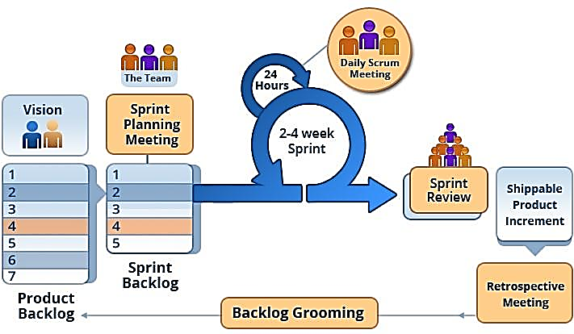

Figure 1. Scrum framework



## Roles and Responsibilities

|  |  |  |  |
| --- | --- | --- | --- |
| **No.** | **Full name** | **Role in Group** | **Responsibilities** |
| 1. | Tôn thất bảo | Team Leader  Developer,  Project Manager | * Manage process * Plan Scrum implementations * Code * Task Delegation * Clarify requirements * Create Ui Function * Write document and report |
| 2. | Masdey | BA ,  Developer ,  Project Manager | * Specify user requirements * Control the development process * Support in technique and business logic. * Arrange Meeting with Client * Code |
| 3. | Nguyễn Trung Tín | Team member,  Designer  Developer | * Design database * Code * Clarify requirements |
| 4. | Anas | Team member,  Designer  Developer  Tester | * Design GUI * Code * Create test plan |
| 5. | Aidee Suherman | Team member,  Documenter  Tester | * Support Design database * Write document and report * Test |

Table 5. Roles and responsibilities details



## Tools and Techniques

|  |  |
| --- | --- |
| **Tool/Technique** | **Name/Version** |
| Front-end(Web) | HTML5, CSS3, Bootstrap, Javascript/jQuery |
| Front-end(Mobile) | eXtensible Application Markup Language (XAML) |
| Back-end(Web+Mobile) | C#, .NET Framework |
| Managing Database | Microsoft® SQL Server® 2017 Management Studio |
| Source Control | Github Desktop |
| Modeling Tool | Microsoft Visio 2013 |
| Web Browser | Google Chrome |

Table 6. Tools and technique



## Project Management Plan

### Product Backlog

|  |  |  |  |  |
| --- | --- | --- | --- | --- |
| **Story** **ID** | **Features** | **Task** **ID** | **Task description** | **Sprint** |
| 1 | Create Product Backlog | 1.1 | Create product backlog | 1 |
| 2 | Create Introduction document | 2.1 | Create introduction document | 1 |
| 2.2 | Review introduction document | 1 |
| 3 | Learning MVC, Entity Framework | 3.1 | Learning MVC, Entity Framework | 1 |
| 4 | Create Mobile UI mockups | 4.1 | Brainstorming about UI | 2 |
| 4.2 | Login UI | 2 |
| 4.3 | MainMenu UI | 2 |
| 4.4 | Add UI | 2 |
| 4.5 | Search UI (Main) | 2 |
| 4.6 | Search By Location UI | 2 |
| 4.7 | Search By User UI | 2 |
|  |  | 4.8 | Qr Scanner UI | 2 |
|  |  | 4.9 | ItemDetail UI | 2 |
| 5 | Create Web UI mockups | 5.1 | Brainstorming about UI | 2 |
| 5.2 | Login and register UI | 2 |
| 5.3 | Package Delivery UI | 2 |
| 5.4 | Equipment UI | 2 |
| 5.5 | Staff UI | 2 |
| 5.6 | User UI | 2 |
| 5.7 | Advanced UI | 2 |
| 5.8 | Location UI | 2 |
| 5.9 | Equipment Type UI | 2 |
| 5.10 | Category UI | 2 |
| 5.11 | Supplier UI | 2 |
| 5.12 | Brand UI | 2 |
| 5.13 | Status UI | 2 |
| 6 | Create Software Project Management Plan | 6.1 | Problem definition | 2 |
| 6.2 | Project organization | 2 |
| 6.3 | Project management plan | 2 |
| 6.4 | Coding convention | 2 |
| 7 | Create Software Requirement Specifications | 7.1 | User requirement specification | 3 |
| 7.2 | External interface requirement | 3 |
| 7.3 | Use case diagram | 2 |
| 7.4 | Software system attributes | 3 |
| 7.5 | Database diagram | 3 |
| 8 | Create Software Design Description | 8.1 | Design overview | 4, 5 |
| 8.2 | System architectural design | 4, 5 |
| 8.3 | Component diagram | 4, 5 |
| 8.4 | Detailed description of components | 4, 5 |
| 8.5 | Sequence diagram | 4, 5 |
| 8.6 | User interface design | 4, 5 |
| 8.7 | Database design | 4, 5 |
| 8.8 | Coding | 4, 5 |
| 9 | Create Software Test Documentation | 9.1 | Test Plan | 6 |
| 9.2 | Test Cases | 6 |
| 9.3 | Checklists | 6 |
| 10 | Software User’s Manual | 10.1 | Installation Guide | 6 |
| 10.2 | User’s Guide | 6 |

Table 7. Product backlog



### Deliverables

|  |  |  |  |  |
| --- | --- | --- | --- | --- |
| **No** | **Deliverable** | **Delivery date** | **Delivery location** | **Note** |
| 1 | Introduction Document, Task list | 13/10/2018 | Email | Report No.1 |
| 2 | Software Project Management Plan | 20/10/2018 | Git Hub | Report No.2 |
| 3 | Software Requirements Specification | 27/10/2018 | Lab | Report No.3 |
| 4 | Software Design Description | 3/11/2018 | Lab | Report No.4 |
| 5 | Software Test Documentation Guide Implementation (Coding) | 10/11/2018 | Lab | Report No.5 |
| 6 | Software User’s Manual | 17/11/2018 | Lab | Report No.6 |

Table 8. Deliverables

* For each sprint, deliverables are potentially shippable products, which can be a part of documents or runnable software application which is implementation of some program features.

* Each sprint is completed in 1 week.



## Coding Convention

* **Naming conventions:**
  + Standard naming conventions adhering to the standards set by Microsoft C# development.
* **Layout conventions:**
  + Tabs must be set exactly 4 spaces.
  + Avoid lines longer than 80 characters.
  + Vertically align curly brackets.
  + Write only one statement per line.
  + Write only one declaration per line.
  + Add one blank line between method definitions and property definitions.
* **Declaration:**
  + Use implicit type ‘var’ for local variable declarations. Except: primitive types (int, string, double, etc.) use predefined names.
  + Organize namespaces with a clearly defined structure.
* **Commenting conventions:**
  + Place comment on a separate line.
  + Begin comment text with an uppercase letter and end with a period.
  + Add one space between comment delimiter (//) and comment text.

# Software Requirement Specification

## User Requirement Specification

## Admin Requirement

Admin is any inventory employee team which can perform the following functions:

* Manage user
* Manage supplier
* Manage staff
* Manage items info (Brand, type, …)
* Manage Issued items
* Manage Location (Main unit, Unit, subunit,…)

## Inventory Department Requirement

Inventory User can perform all the usual CRUDS (Create, Read, Update, Delete, & Search) function if accessing the system through web browser. The main function as the system user are as below.

* Add new item when delivery received
* Search for item base on location or user info
* Scan Qr code to get item info
* Login to approve account

## System Requirement

* Track Location of Inventory Issued

## System Requirement Specification

## External Interface Requirement

### User Interface

* Mobile application able to scan QR to locate item and issued to

### Hardware Interface:

* The system should be able to use QR or barcode scanner as additional plugin interface to scan
* Mobile must have hardware for camera

### Software Interface

* The Web application: work with browsers Firefox (v52 or higher), Chromes (v28 or higher), Internet Explorer (v10 or above) or with any web browser that supports HTML5 & CSS3

### Communication Protocol

* It uses HTTP protocol for communication between web browser and web server.
* It uses HTTP protocol for communication between window application and web server.

## List of Mobile App Use Cases

### <Inventroy User> Mobile Overview Use Cases



Figure 2. <Inventory User>Mobile Overview

### <Inventory User> Login Use Case



Figure 3. <Inventory User> Login

**Use Case Specification**

|  |  |  |  |
| --- | --- | --- | --- |
| **USE CASE – UC_MIS_01** | | | |
| **Use Case No.** | **01** | **Use Case Version** | 1.0 |
| **Use Case Name** | Login | | |
| **Author** | BaoTT | | |
| **Date** | 17/10/2018 | **Priority** | Normal |
| **Actor:** Inventory User  **Summary:** This use case allows Inventory User to login.  **Goal:** Inventory User can access their account.  **Triggers:**  Inventory User fills in their account information in login page and click on “Login” button.  **Preconditions:** Inventory User has an active account.  **Post Conditions:** N/A  **Success:** Access to the system with specified roles.  **Fail:** Show error message.  **Main Success Scenario:**   |  |  |  | | --- | --- | --- | | Step | Actor Action | System Response | | 1 | Open application | - Check for Token Storage  - Navigate to login page with two input fields if don’t have token:  - “Username” : free text input  - “Password” : free text input  [Alternative1] | | 2 | Fill in login information and click on “Login” button. | - Connect and Get Token from server  - Navigate to MainMenu page or  [Excaption1]  [Excaption2]  [Excaption3] |   **Alternative:**   |  |  |  | | --- | --- | --- | | No | Actor Action | System Response | | 1 | Open application | - Navigate to MainMenu if Token already exited |   **Exceptions:**   |  |  |  | | --- | --- | --- | | No | Cause | System Response | | 1 | Guest enter wrong identity information. | Wrong identity information, System shows error message. | | 2 | Missing required fields. | Show instruction message bellow missing fields. | | 3 | Database occurs exception. | Show error message. |   **Relationships:**  N/A  **Business Rules:**   * Validation: * Require username and password. * Must have connection to server * Only Confirm and active account can login to mobile * After login, user will receive a session token and from there on will have to use that Token to access any api | | | |

Table 9. <Inventory User> Login

### <Inventory User> Search Overview

**Use Case Diagram**



Figure 4. <Inventory User> Search Overview

**Use Case Specification**

|  |  |  |  |
| --- | --- | --- | --- |
| **USE CASE – UC_MIS_02** | | | |
| **Use Case No.** | **02** | **Use Case Version** | 2.0 |
| **Use Case Name** | Search Overview | | |
| **Author** | Anas, BaoTT | | |
| **Date** | 17/10/2018 | **Priority** | High |
| **Actor:**  Inventory User  **Summary:**  This use case allows Inventory User to search item by two criteria.  **Goal:**  Inventory User can view different type of search.  **Triggers:**  Tap on Search Option on MainMenu.  **Preconditions:** Inventory user is log in.  **Post Conditions:** N/A  **Success:** Display Search Option page.  **Fail:** Show error message.  **Main Success Scenario:**   |  |  |  | | --- | --- | --- | | Step | Actor Action | System Response | | 1 | Access to MainMenu page and choose “Search” tab. | Display “Search Option Page”.  [Exception 1] |   **Alternative: N/A**  **Exceptions:**   |  |  |  | | --- | --- | --- | | Step | Actor Action | System Response | | 1 | User doesn’t have connection to server | Display No connection error and redict back to main menu |   **Relationships:**  SearchbyLocation, SearcByPersonal  **Business Rules:**   * User can choose what kind of criteria info they want to search by (Location or Staff) * Each kind of search will return different result | | | |

Table 10. <Inventory User> Search Overview

### <Inventory User> Search by Personnel

**Use Case Diagram**

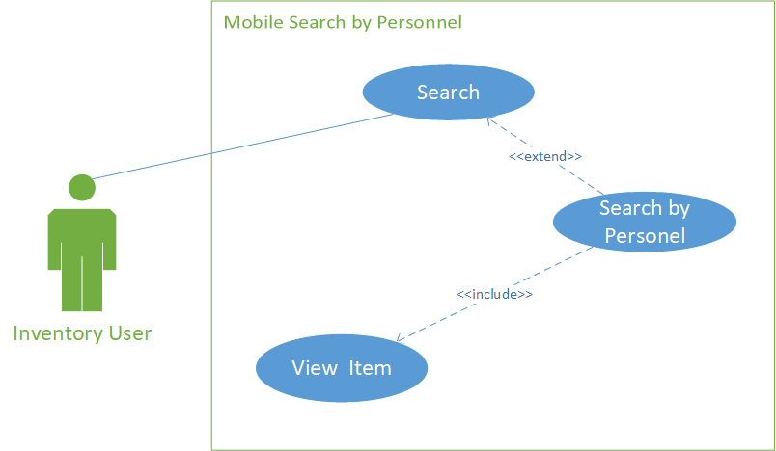

Figure 5. <Inventory User> Search by Personnel

**Use Case Specification**

|  |  |  |  |
| --- | --- | --- | --- |
| **USE CASE – UC_MIS_03** | | | |
| **Use Case No.** | **03** | **Use Case Version** | 2.0 |
| **Use Case Name** | Search by Personnel | | |
| **Author** | Bao, Anas | | |
| **Date** | 17/10/2018 | **Priority** | High |
| **Actor:**  Inventory User  **Summary:**  This use case allows Inventory User to search item group by personnel criteria.  **Goal:**  Inventory User can view search result that should contain Issued Personel containing Fullname, Identity Card No, Unit, Issued items: brand and model.  **Triggers:**  Input criteria in the search by personnel textboxt and click on “Search” button.  **Preconditions:** Inventory user is log in.  **Post Conditions:** N/A  **Success:** Displayresult popup containing list according to the sequence in Goal group by Personnel  **Fail:** Show error message.  **Main Success Scenario:**   |  |  |  | | --- | --- | --- | | Step | Actor Action | System Response | | 1 | Access to Search Option Page and choose “Search by User” tab. | Display input field:   * Staff Name : Free text input * Staff Id : Free text input * Unit : Drop down list | | 2 | Input info and click on “Search” button.  [Alternative 1]  [Alternative 2]  [Alternative 3] | Display results of personnels and details according to input.  [Exception 1]  [Exception 2]  [Exception 3] | | 3 | User select personnel | Display list of issued items | | 4 | User select issued item | Show chosen issued item info |   **Alternative:**   |  |  |  | | --- | --- | --- | | No | Cause | System Response | | 1 | User only input Staff Name | Display result of personnel and details according to input. | | 2 | User only input Staff Id | Display result of personnel and details according to input. | | 3 | User input Staff Name and Staff id | Display result of personnel and details according to both inputs. |   **Exceptions:**   |  |  |  | | --- | --- | --- | | No | Cause | System Response | | 1 | Search textbox is blank. | Show warning message. | | 2 | Search result doesn’t exist. | Show not found message. | | 3 | Database occurs exception. | Show error message and ask user to try again later. |   **Relationships:**  Search, ViewItem  **Business Rules:**   * Valid Search Criteria Result will be shown. * Result will be sort according to input info. * Show notice if no item found. * Only show issued item. * Show notice if there is no connection. * First after search, the application will show a list of found staff and number of issued item that belong to the staff * After select on certain staff, application will show a pop up contain all issued items belong to that staff. * User can choose which item they want to see detail of, after choose the detail page will show, contain info about: * Picture * Item Details:   + - Equipment Id     - Serial No     - Item Type     - Item Category     - Brand     - Model     - Processor     - Ram     - Hdd     - Vga * Item Status: * Currently Issued to * Unit * ContactNo * Location * List of all staf that item have been issued to. | | | |

Table 11. Search by Personnel

### <Inventroy User> Search by Location

**Use Case Diagram**

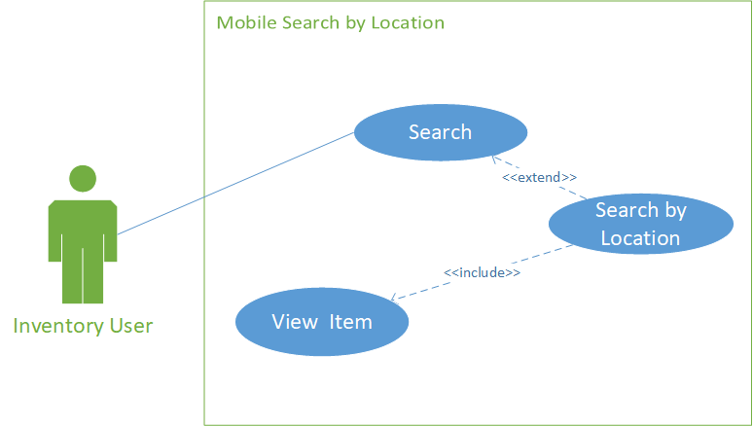

Figure 6. <Inventory User> Search by Location

Use Case Specification

|  |  |  |  |
| --- | --- | --- | --- |
| **USE CASE – UC_MIS_05** | | | |
| **Use Case No.** | **05** | **Use Case Version** | 2.0 |
| **Use Case Name** | Search by Location | | |
| **Author** | Bao, Anas | | |
| **Date** | 17/10/2018 | **Priority** | High |
| ***Actor:***  *Inventory User*  ***Summary:***  *This use case allows Inventory User to search item group by location criteria.*  ***Goal:***  *Inventory User can view search result of list item issued to group by location*  ***Triggers:***  *Input criteria in the search by location textboxt and click on “Search” button.*  ***Preconditions:*** Inventory user is log in.  ***Post Conditions:*** N/A  ***Success:*** *Display**result popup containing list according to the sequence in Goal group by location*  ***Fail:*** *Show error message.*  ***Main Success Scenario:***   |  |  |  | | --- | --- | --- | | *Step* | *Actor Action* | *System Response* | | *1* | *Access to Search Option Page and choose “Search by Location” tab.* | *Display input field:*   * *Mai Unit : Drop down list* * *Unit : Drop down list* * *Sub Unit : Drop down list* * *Department : Drop down list* | | *2* | *Choose location and click on “Search” button.* | *Display results of Types and Quantities according to input.*  *[Exception 1]*  *[Exception 2]* | | *3* | *User select item type* | *Display list of issued items accouding to item type* | | *4* | *User select issued item* | *Show chosen issued item info* |   ***Alternative:*** *N/A*  ***Exceptions:***   |  |  |  | | --- | --- | --- | | *No* | *Cause* | *System Response* | | *1* | *Search result doesn’t exist.* | *Show not found message.* | | *2* | *Database occurs exception.* | *Show error message and ask user to try again later.* |   ***Relationships:***  *Search, Viewitem*  ***Business Rules:***   * Valid Search Criteria Result will be shown. * Show result base on user selection. * Show notice if no item found. * Only show issued item. * Show notice if there is no connection. * After search, application will return a list of item base on type that belong to that location * After user choose a category item in a type list, application will show a pop up contain all issued items belong to that Category. * User can choose which item they want to see detail of, after choose the detail page will show, contain info about: * Picture * Item Details: * Equipment Id * Serial No * Item Type * Item Category * Brand * Model * Processor * Ram * Hdd * Vga * Item Status: * Currently Issued to * Unit * ContactNo * Location * List of all staf that item have been issued to. | | | |

*Table* 12*. Search by Location*

### <Inventory User>QR Search

**Use Case Diagram**



Figure 7. <Inventory User> QR Search Use Case

**Use Case Specification**

|  |  |  |  |
| --- | --- | --- | --- |
| **USE CASE – UC_MIS_06** | | | |
| **Use Case No.** | **06** | **Use Case Version** | 1.0 |
| **Use Case Name** | QR Search | | |
| **Author** | Bao, Anas | | |
| **Date** | 17/10/2018 | **Priority** | Normal |
| **Actor:**  Inventory User  **Summary:**  This use case allows Inventory User to scan QR to search and View item info.  **Goal:**  Inventory User can view item detail by scaning QR code  **Triggers:**  Search input require QR image to get item detail  ***Preconditions:*** Inventory user is log in.  ***Post Conditions:*** N/A  **Success:** Able to view the requested data  **Fail:** Show error message.  **Main Success Scenario:**   |  |  |  | | --- | --- | --- | | Step | Actor Action | System Response | | 1 | Access to home page and choose “Scan QR” button  [Alternative 1 ] | Open Camera to scan QR image | | 2 | Direct camera to QR image | After QR image identify, show item detail page  [Exception 1]  [Exception 2] |   **Alternative:**   |  |  |  | | --- | --- | --- | | No | Actor Action | System Response | | 1 | User press back arrow | Go back to main menu. |   **Exceptions:**   |  |  |  | | --- | --- | --- | | No | Cause | System Response | | 1 | The Item’s Qr doesn’t exist | Show no item found and go back to main menu. | | 2 | Database occurs exception. | Show error message and go back to main menu. |   **Relationships:**  View Item  **Business Rules:**   * Valid Search Criteria Result will be shown. * Show result base on Qr code. * Show notice if no item found. * Show notice if there is no connection. * After scan the detail page will show, contain info about: * Picture * Item Details:   + - Equipment Id     - Serial No     - Item Type     - Item Category     - Brand     - Model     - Processor     - Ram     - Hdd     - Vga * Item Status: * Currently Issued to * Unit * ContactNo * Location * List of all staf that item have been issued to. | | | |

Table 13. Scan QR

### <Inventory User>Add Asset Use Cases



Figure 8. <Inventory User> Add Asset use cases

**Use Case Specification**

|  |  |  |  |
| --- | --- | --- | --- |
| **USE CASE – UC_MIS_07** | | | |
| **Use Case No.** | **07** | **Use Case Version** | 1.0 |
| **Use Case Name** | Add Asset | | |
| **Author** | Bao, Anas | | |
| **Date** | 17/10/2018 | **Priority** | Normal |
| **Actor:**  Inventory User  **Summary:**  This use case allows Inventory User Add new Asset (item).  **Goal:**  Inventory User can add new Asset detail in the system.  **Triggers:**  Input required data in the text box and click on “Save” button to store data  ***Preconditions:*** Inventory user is log in.  ***Post Conditions:*** N/A  **Success:** Able to add new data then view the save data  **Fail:** Show error message.  **Main Success Scenario:**   |  |  |  | | --- | --- | --- | | Step | Actor Action | System Response | | 1 | Access to home page and choose “Add Asset” tab. | Redirect to Add new asset page and sow input fields.  Fields:   * Item Picture: Image picture * Delivery Details:   + Delivery Order Number: Free Text input   + Delivery Date: Calendar   + Supplier Name: Drop down list * Item Details:   + Equipment Type: Drop down list   + Category: Drop down list   + Brand: Drop down list   + Model: Free text input   + Quantity: Number input | | 2 | User input info or  [Alternative 1]  [Alternative 2] |  | | 3 | Input new data and click on “Save” button. | Entered Asset stored and show list view of the Asset  [Exception 1]  [Exception 2] |   **Alternative:**   |  |  |  | | --- | --- | --- | | No | Cause | System Response | | 1 | User add new brand | Show popup add brand. | | 2 | User add new supplier | Show popup add supplier. |   **Exceptions:**   |  |  |  | | --- | --- | --- | | No | Cause | System Response | | 1 | Input info is missing. | Show warning message. | | 2 | Database occurs exception. | Show error message and ask user to try again later. |   **Relationships:**  Add brand, add supplier.  **Business Rules:**   * All fields must be fill in order for assest to be added (Including Picture) * Valid data will be stored in the system. * Added assest will needed to be check by admin in the web * Added assest it not issued and will have to wait for admin to issue it to certain staff | | | |

Table 14. Add Asset

|  |  |  |  |
| --- | --- | --- | --- |
| **USE CASE – UC_MIS_08** | | | |
| **Use Case No.** | **08** | **Use Case Version** | 1.0 |
| **Use Case Name** | Add supplier | | |
| **Author** | Bao | | |
| **Date** | 17/10/2018 | **Priority** | Normal |
| **Actor:**  Inventory user (Autorized)  **Summary:**  This use case allows Inventory user to Add new supplier.  **Goal:**  Inventory user can add new supplier if needed.  **Triggers:**  Click on “+” button on supplier section of Add Asset Page.  **Preconditions:** User is logged in.  **Post Conditions:**  **Success:** New supplier is added to database.  **Fail:** Show error message.  **Main Success Scenario:**   |  |  |  | | --- | --- | --- | | Step | Actor Action | System Response | | 1 | Click on “+” button on supplier section of Add Asset Page. | Show pop up page of add supplier.  Field:   * Supplier Name : free text input | | 2 | Input new supplier name and click “add” | Add new supplier and close pop up page.  [Exception 1] |   **Alternative:** N/A  **Exceptions:**   |  |  |  | | --- | --- | --- | | No | Cause | System Response | | 1 | User doesn’t input supplier name | Show error message and ask user to input. |   **Relationships:**  Add Assest  **Business Rules:**   * Valid data will be stored in the system. * Any added supplier can be use immediately after added | | | |

Table 15. Add Supplier

|  |  |  |  |
| --- | --- | --- | --- |
| **USE CASE – UC_MIS_09** | | | |
| **Use Case No.** | **09** | **Use Case Version** | 1.0 |
| **Use Case Name** | Add Brand | | |
| **Author** | Bao | | |
| **Date** | 17/10/2018 | **Priority** | Normal |
| **Actor:**  Inventory user (Autorized)  **Summary:**  This use case allows Inventory user to Add new Brand.  **Goal:**  Inventory user can add new Brand if needed.  **Triggers:**  Click on “+” button on Brand section of Add Asset Page.  **Preconditions:** User is logged in.  **Post Conditions:**  **Success:** New Brand is added to database.  **Fail:** Show error message.  **Main Success Scenario:**   |  |  |  | | --- | --- | --- | | Step | Actor Action | System Response | | 1 | Click on “+” button on supplier section of Add Asset Page. | Show pop up page of add Brand.  Field:   * Brand Name : free text input | | 2 | Input new Brand name and click “add” | Add new Brand and close pop up page.  [Exception 1] |   **Alternative:** N/A  **Exceptions:**   |  |  |  | | --- | --- | --- | | No | Cause | System Response | | 1 | User doesn’t input Brand name | Show error message and ask user to input. |   **Relationships:**  Add Assest  **Business Rules:**   * Valid data will be stored in the system. * Any added brand can be use immediately after added. | | | |

Table 16. Add Brand

### <Inventory User>Log out

**Use Case Diagram**



Figure 9. <Inventory User> Logout

**Use Case Specification**

|  |  |  |  |
| --- | --- | --- | --- |
| **USE CASE – UC_MIS_10** | | | |
| **Use Case No.** | **10** | **Use Case Version** | 1.0 |
| **Use Case Name** | Logout | | |
| **Author** | Bao | | |
| **Date** | 17/10/2018 | **Priority** | Normal |
| **Actor:**  Inventory user (Authorized)  **Summary:**  This use case allows Inventory user to log out from the system.  **Goal:**  Inventory user can exit their current account.  **Triggers:**  Click on “Log Out” link.  ***Preconditions:*** Inventory user is log in.  ***Post Conditions:*** N/A  **Success:** User exits the system and is returned to main page.  **Fail:** Show error message.  **Main Success Scenario:**   |  |  |  | | --- | --- | --- | | Step | Actor Action | System Response | | 1 | Click on “Log Out” Button. | Remove user’s Token and return to Login page.  [Exception] |   **Alternative:** N/A  **Exceptions:**   |  |  |  | | --- | --- | --- | | No | Cause | System Response | | 1 | Database occurs exception. | Show error message and ask user to try again later. |   **Relationships:**  N/A  **Business Rules:**   * Log user out of app and remove session token | | | |

Table 17. <Inventory User> Logout

## List of Web App Overview Use Case

### <Authorized User> Web Application Overview

**Use Case Diagram**



Figure 10. <Authorized User> Web Application Overview

### <Admin> Login Overview

**Use Case Diagram**



Figure 11. <Admin> Login

**Use Case Specification**

|  |  |  |  |
| --- | --- | --- | --- |
| **USE CASE – UC_MIS_11** | | | |
| **Use Case No.** | 11 | **Use Case Version** | 2.0 |
| **Use Case Name** | Login | | |
| **Author** | Masdey, Tin, Aidee | | |
| **Date** | 17/10/2018 | **Priority** | Normal |
| **Actor:** Admin  **Summary:** This use case allows Admin to login.  **Goal:** Admin can access their account.  **Triggers:**  Admin fills in their account information in login page and click on “Login” button.  ***Preconditions:*** Inventory user is log in.  ***Post Conditions:*** N/A  **Success:** Access to the system as admin.  **Fail:** Show error message.  **Main Success Scenario:**   |  |  |  | | --- | --- | --- | | Step | Actor Action | System Response | | 1 | Open application | - Check for Token Storage  [Alternative1]  - Navigate to login page with two input fields if don’t have token:  - “Username” : free text input  - “Password” : free text input | | 2 | Fill in login information and click on “Login” button. | - Connect and Get Token from server  - Navigate to MainMenu page or  [Excaption1]  [Excaption2]  [Excaption3] |   **Alternative:**   |  |  |  | | --- | --- | --- | | No | Actor Action | System Response | | 1 | Open application | - Navigate to MainMenu if Token already exited |   **Exceptions:**   |  |  |  | | --- | --- | --- | | No | Cause | System Response | | 1 | Guest enter wrong identity information. | Wrong identity information, System shows error message. | | 2 | Missing required fields. | Show instruction message bellow missing fields. | | 3 | Database occurs exception. | Show error message. |   **Relationships:**  N/A  **Business Rules:**  Validation:   * Require username and password. * Must have connection to server. * Only admin account can access. | | | |

Table 18. <Admin> Login

**Use Case Specification**

|  |  |  |  |
| --- | --- | --- | --- |
| **USE CASE – UC_MIS_12** | | | |
| **Use Case No.** | **12** | **Use Case Version** | 1.0 |
| **Use Case Name** | Logout | | |
| **Author** | Masdey, Tin, Aidee | | |
| **Date** | 17/10/2018 | **Priority** | Normal |
| **Actor:**  Admin  **Summary:**  This use case allows Admin to log out from the system.  **Goal:**  Admin can exit their current account.  **Triggers:**  Click on “Log Out”.  ***Preconditions:*** Inventory user is log in.  ***Post Conditions:*** N/A  **Success:** Admin exits the system and is returned to main page.  **Fail:** Show error message.  **Main Success Scenario:**   |  |  |  | | --- | --- | --- | | Step | Actor Action | System Response | | 1 | Click on “Log Out” link on the top right of the screen. | Remove user’s session and return to Login page.  [Exception] |   **Alternative:** N/A  **Exceptions:**   |  |  |  | | --- | --- | --- | | No | Cause | System Response | | 1 | Database occurs exception. | Show error message and ask user to try again later. |   **Relationships:**  N/A  **Business Rules:**   * Log user out of app and remove session token | | | |

Table 19. <Inventory User> Logout

### <Admin> User Account Overview

**Use Case Diagram**



Figure 12. <Authorized User> Account Overview

### <Admin> View User Account list

**Use Case Diagram**



Figure 13. <Admin> View User Account list

**Use Case Specification**

|  |  |  |  |
| --- | --- | --- | --- |
| **USE CASE – UC_MIS_13** | | | |
| **Use Case No.** | 13 | **Use Case Version** | 1.0 |
| **Use Case Name** | View User Account list | | |
| **Author** | Masdey, Tin, Aidee | | |
| **Date** | 17/10/2018 | **Priority** | Normal |
| **Actor:**  Admin  **Summary:**  This use case allows admin to view account list.  **Goal:**  User can view list of accounts.  **Triggers:**  Click on view in user sub menu from menu bar.  **Preconditions:**  User is logged in as admin.  **Post Conditions:** N/A  **Success:**  Navigate to account list page.  **Fail:**  Show error message.  **Main Success Scenario:**   |  |  |  | | --- | --- | --- | | Step | Actor Action | System Response | | 1 | Click on view from Users section in menu bar. | Navigate to view account list page.  [Exception] |   **Alternative:** N/A  **Exceptions:**   |  |  |  | | --- | --- | --- | | No | Cause | System Response | | 1 | Database occurs exception. | Show error message and ask user to try again later. |   **Relationships:**  N/A  **Business Rules:**   * Allow user to view all accounts and it’s information: * Staff * IndentityNo * Designation * MobileNumber * Email * Username * DateCreated * IsConfirmed * Show option for admin: Detail | | | |

Table 20. <Admin> View account list

### <Admin> Confirm User Account

**Use Case Diagram**



Figure 14. <Admin>.Confirm User Aaccount

**Use Case Specification**

|  |  |  |  |
| --- | --- | --- | --- |
| **USE CASE – UC_MIS_14** | | | |
| **Use Case No.** | **14** | **Use Case Version** | 1.0 |
| **Use Case Name** | Confirm User Account | | |
| **Author** | Masdey, Tin, Aidee | | |
| **Date** | 17/10/2018 | **Priority** | Normal |
| **Actor:**  Admin  **Summary:**  This use case allows admin to confirm an account.  **Goal:**  Account is confirm.  **Triggers:**  Click on Confirm in detail page.  **Preconditions:**  User is logged in as admin.  The chosen account already exists in the system.  **Post Conditions:** N/A  **Success:** Account status changes to toggle-on icon or toggle-off icon.  **Fail:** Show error message.  **Main Success Scenario:**   |  |  |  | | --- | --- | --- | | Step | Actor Action | System Response | | 1 | Access account detail page through “Detail” and click on “Confirm” in the end of detail page. | Confirm the chosen account.  [Exception] |   **Alternative:** N/A  **Exceptions:**   |  |  |  | | --- | --- | --- | | No | Cause | System Response | | 1 | Database occurs exception. | Show error message and ask user to try again later. |   **Relationships:**  Extended from View Account List use case.  **Business Rules:**   * If an employee account is not confirm, that account cant login to mobile version. | | | |

Table 21. <Admin> Confirm User Account

### <Admin> Activate/Deactivate User Account

**Use Case Diagram**



Figure 15. <Admin> Active/Deactive account

**Use Case Specification**

|  |  |  |  |
| --- | --- | --- | --- |
| **USE CASE – UC_MIS_15** | | | |
| **Use Case No.** | **15** | **Use Case Version** | 1.0 |
| **Use Case Name** | Active/Deactive Account | | |
| **Author** | Masdey, Tin, Aidee | | |
| **Date** | 17/10/2018 | **Priority** | Normal |
| **Actor:**  Admin  **Summary:**  This use case allows admin to activate/deactivate an account.  **Goal:**  Account is activated/deactivated.  **Triggers:**  Click on “Deactive”/”Active” button.  **Preconditions:**  User is logged in as admin.  The chosen account already exists in the system.  **Post Conditions:** N/A  **Success:** Account status changes to toggle-on icon or toggle-off icon.  **Fail:** Show error message.  **Main Success Scenario:**   |  |  |  | | --- | --- | --- | | Step | Actor Action | System Response | | 1 | Access account detail page and click on “Deactive”/”Active” button in the end of detail page. | Activate/deactivate the chosen account.  [Exception] |   **Alternative:** N/A  **Exceptions:**   |  |  |  | | --- | --- | --- | | No | Cause | System Response | | 1 | Database occurs exception. | Show error message and ask user to try again later. |   **Relationships:**  Extended from View Account List use case.  **Business Rules:**   * If an employee account is deactivated, his/her company will decide by themselves how to hand over the remaining work to another employee (account). * If an employee account is not active, that account cant login to mobile version. | | | |

Table 22. <Admin>De/Activate User Account

### <Inventory User> User Registration Overview

**Use Case Diagram**



Figure 16. <Inventory User> User Registration Overview

### <Inventory User> Register User

**Use Case Diagram**



Figure 17. <Inventory User>Register User

**Use Case Specification**

|  |  |  |  |
| --- | --- | --- | --- |
| **USE CASE – UC_MIS_16** | | | |
| **Use Case No.** | 16 | **Use Case Version** | 1.0 |
| **Use Case Name** | Register User | | |
| **Author** | Masdey, Tin, Aidee | | |
| **Date** | 17/10/2018 | **Priority** | Normal |
| **Actor:**  Inventory user  **Summary:**  This use case allows staff to create new account.  **Goal:**  Inventory staff can register account for using the mobile version.  **Triggers:**  Click on "Register as new user" button in login page.  **Preconditions:**  User connected to the server.  **Post Conditions:** N/A  **Success:** Email will be sent to your email and wait for confirm from the admin.  **Fail:** Show error message.  **Main Success Scenario:**   |  |  |  | | --- | --- | --- | | Step | Actor Action | System Response | | 1 | Click on "Register as new user" button in login page. | Navigate to create account page.  Fields:   * Email: Free Text Input * Identity Number: Free Text Input * Password : Free Text Input * Confirm Password: Free Text Input | | 2 | Fill in required information and click on “Register” button. | Create new account with inputted information and wait for admin confirmation.  [Exception 1] |   **Alternative:** N/A  **Exceptions:**   |  |  |  | | --- | --- | --- | | No | Cause | System Response | | 1 | Required fields are missing. | Show instruction message above input fields. | | 2 | Account already exists. | Show duplicate error message below account name input field. | | 3 | Database occurs exception. | Show error message and ask user to try again later. |   **Relationships:**  N/A  **Business Rules:** General validation:   * Require email, username, password, confirm password fields. * Username may contain special characters. * Password and Confirm password must be the same. | | | |

Table 23. <Inventory User> Register User

### <Inventory User> Change Password

**Use Case Diagram**



Figure 18. <Inventory User>Change Password

**Use Case Specification**

|  |  |  |  |
| --- | --- | --- | --- |
| **USE CASE – UC_MIS_17** | | | |
| **Use Case No.** | **17** | **Use Case Version** | 1.0 |
| **Use Case Name** | Change password | | |
| **Author** | Masdey, Tin, Aidee | | |
| **Date** | 24/05/2018 | **Priority** | Normal |
| **Actor:**  Inventory User  **Summary:**  This use case allows user to change password of an account.  **Goal:**  New password of the chosen account is updated.  **Triggers:**  Click on "Forgot your password" in Login page.  **Preconditions:**  User have connection to server.  **Post Conditions:** N/A  **Success:** Account password is updated.  **Fail:** Show error message.  **Main Success Scenario:**   |  |  |  | | --- | --- | --- | | Step | Actor Action | System Response | | 1 | Click on “Forgot your password” button in the login page. | Navigate to change password page.  Field:   * Email : Free text input | | 2 | Fill in Email.  Click on “Email Link” button. | Send Email to user’s Email with link tochange password.  [Exception] |   **Alternative:** N/A  **Exceptions:**   |  |  |  | | --- | --- | --- | | No | Cause | System Response | | 1 | Required fields are missing. | Show instruction message above input fields. | | 2 | Database occurs exception. | Show error message and ask user to try again later. |   **Relationships:** N/A  **Business Rules:**   * Require connection to internet. * To receive reset password email, the input email must be valid and belong to user | | | |

Table 24. <Inventory user> Change password

### <Inventory User >Equipment Type Overview Use Cases



Figure 19. Inventory User Equipment overview use cases

### <Admin> View Equipment Type

**Use Case Diagram**



Figure 20. <Admin> View Equipment Type

**Use Case Specification**

|  |  |  |  |
| --- | --- | --- | --- |
| **USE CASE – UC_MIS_18** | | | |
| **Use Case No.** | 18 | **Use Case Version** | 1.0 |
| **Use Case Name** | View Equipment Type | | |
| **Author** | Masdey, Tin, Aidee | | |
| **Date** | 17/10/2018 | **Priority** | Normal |
| **Actor:**  Admin  **Summary:**  This use case allows admin to view all Equipment types.  **Goal:**  User can view list of Equipment types.  **Triggers:**  Click on View in Equipment type from “Advance” menu.  **Preconditions:**  User is logged in as admin.  **Post Conditions:** N/A  **Success:**  Navigate to Equipment type page.  **Fail:**  Show error message.  **Main Success Scenario:**   |  |  |  | | --- | --- | --- | | Step | Actor Action | System Response | | 1 | Click on View in Equipment type from “Advance” menu. | Navigate to Equipment type page. [Exception] |   **Alternative:** N/A  **Exceptions:**   |  |  |  | | --- | --- | --- | | No | Cause | System Response | | 1 | Database occurs exception. | Show error message and ask user to try again later. |   **Relationships:**  N/A  **Business Rules:**   * Equipment type page: display Type, createdDate, Note, Description, IsActive. * Each item have sub menu contain (Edit, Detail, Delete) | | | |

Table 25. <Admin> View account list

### <Admin> Add Equipment Type

**Use Case Diagram**



Figure 21. <Admin> Add Equipment Type

**Use Case Specification**

|  |  |  |  |
| --- | --- | --- | --- |
| **USE CASE – UC_MIS_19** | | | |
| **Use Case No.** | 19 | **Use Case Version** | 1.0 |
| **Use Case Name** | Add Equipment type | | |
| **Author** | Masdey, Tin, Aidee | | |
| **Date** | 17/10/2018 | **Priority** | Normal |
| **Actor:**  Admin  **Summary:**  This use case allows admin to create new equipment type.  **Goal:**  Admin can create new equipment type.  **Triggers:**  Click on "Create New" in view page or Add from Equipment sub menu.  **Preconditions:**  User is logged in as admin.  **Post Conditions:** N/A  **Success:** Equipment type is added to database .  **Fail:** Show error message.  **Main Success Scenario:**   |  |  |  | | --- | --- | --- | | Step | Actor Action | System Response | | 1 | Click on "Create New" in view page.  [Alternative 1] | Navigate to create new equipment type page.  Fields:   * Equipment Type * Description * Note * IsActive | | 2 | Fill in required information and click on “Save” button. | Create new Equipment with inputted information.  Redirect to view equipment type list page.  [Exception] |   **Alternative:**   |  |  |  | | --- | --- | --- | | No | Actor Action | System Response | | 1 | Click on “Add” from Equipment Type sub menu. | Navigate to create new equipment type page.  Fields:   * Equipment Type * Description * Note * IsActive |   **Exceptions:**   |  |  |  | | --- | --- | --- | | No | Cause | System Response | | 1 | Required fields are missing or fields are invalid. | Show instruction message below those input fields. | | 2 | Database occurs exception. | Show error message and ask user to try again later. |   **Relationships:**  Extended from View Account List use case.  **Business Rules:**   * Equipment type need to be actived in order to be used . | | | |

Table 26. <Admin> Create Equipment type

### <Admin> Edit Equipment Type

**Use Case Diagram**



Figure 22. <Admin> Edit Equipment Type

**Use Case Specification**

|  |  |  |  |
| --- | --- | --- | --- |
| **USE CASE – UC_MIS_20** | | | |
| **Use Case No.** | **20** | **Use Case Version** | 1.0 |
| **Use Case Name** | Edit equipment type | | |
| **Author** | Masdey, Tin, Aidee | | |
| **Date** | 17/10/2018 | **Priority** | Normal |
| **Actor:**  Admin  **Summary:**  This use case allows admin to edit equipment type.  **Goal:**  Equipment type info is updated.  **Triggers:**  Click on "Edit" in the last column of an Equipment row.  **Preconditions:**  User is logged in as admin.  The chosen type already exists in the system.  **Post Conditions:** N/A  **Success:** New information of equipment type is updated.  **Fail:** Show error message.  **Main Success Scenario:**   |  |  |  | | --- | --- | --- | | Step | Actor Action | System Response | | 1 | Access view equipment type list page and click on “Edit” button in the last column of an Equipment row. | Redirect to edit page with equipment type information automatically filled in. | | 2 | Change information and click on “Save” button. | Update equipment type.  Redirect to view equipment type list page. |   **Alternative:** N/A  **Exceptions:**   |  |  |  | | --- | --- | --- | | No | Cause | System Response | | 1 | Required fields are missing or fields are invalid. | Show instruction message below those input fields. | | 2 | Database occurs exception. | Show error message and ask user to try again later. |   **Relationships:**  Extended from View equipment type use case.  **Business Rules:**  There are 4 critical in edit equipment type: update equipment type, Description, Note and IsActive. Each has different input fields. | | | |

Table 27. <Admin> Update Equipment type

### <Admin> Delete Equipment Type

**Use Case Diagram**



Figure 23. <Admin> Delete Equipment Type

**Use Case Specification**

|  |  |  |  |
| --- | --- | --- | --- |
| **USE CASE – UC_MIS_21** | | | |
| **Use Case No.** | 21 | **Use Case Version** | 1.0 |
| **Use Case Name** | Delete equipment type | | |
| **Author** | Masdey, Tin, Aidee | | |
| **Date** | 17/10/2018 | **Priority** | Normal |
| **Actor:**  Admin  **Summary:**  This use case allows admin to delete an equipment type.  **Goal:**  The chosen equipment type is removed.  **Triggers:**  Click on "Delete" in the last column of an equipment type row.  **Preconditions:**  User is logged in as admin.  **Post Conditions:** N/A  **Success:**  The chosen equipment type is deleted and equipment type list is reloaded.  **Fail:**  Show error message.  **Main Success Scenario:**   |  |  |  | | --- | --- | --- | | Step | Actor Action | System Response | | 1 | Click on “Delete” the last colum of a equipment type row. | Show a popup for comfirmation. | | 2 | Choose “Delete” to confirm.  [Alternative] | Delete the chosen equipment type. equipment type list is reloaded.  [Exception] |   **Alternative:**   |  |  |  | | --- | --- | --- | | No | Actor Action | System Response | | 1 | Click on “Back to list”. | Go back to view equipment type page. |   **Exceptions:**   |  |  |  | | --- | --- | --- | | No | Cause | System Response | | 1 | Database occurs exception. | Show error message and ask user to try again later. |   **Relationships:**  Extended from View equipment type use case.  **Business Rules:** N/A | | | |

Table 28. <Admin> Delete equipment type

### <Admin> Serach Equipment Type

**Use Case Diagram**



Figure 24. <Admin> Search Equipment Type

**Use Case Specification**

|  |  |  |  |
| --- | --- | --- | --- |
| **USE CASE – UC_MIS_22** | | | |
| **Use Case No.** | 22 | **Use Case Version** | 1.0 |
| **Use Case Name** | Search Equipment Type | | |
| **Author** | Masdey, Tin, Aidee | | |
| **Date** | 17/10/2018 | **Priority** | Normal |
| **Actor:**  Admin  **Summary:**  This use case allows Admin to search Equipment Type.  **Goal:**  Admin can search for Equipment Type base on specific info.  **Triggers:**  Input search info into search bar on the right.  **Preconditions:**  User is logged in as admin.  **Post Conditions:** N/A  **Success:** DisplayEquipment Type list base on search info.  **Fail:** Show error message.  **Main Success Scenario:**   |  |  |  | | --- | --- | --- | | Step | Actor Action | System Response | | 2 | Input Equipment Type info into search box. | Display Equipment Type base on input.  [Exception] |   **Alternative:** N/A  **Exceptions:**   |  |  |  | | --- | --- | --- | | No | Cause | System Response | | 2 | Equipment Type doesn’t exist. | Show not found message. | | 3 | Database occurs exception. | Show error message and ask user to try again later. |   **Relationships:**  Generalized from View Equipment Type use case.  **Business Rules:**   * Show Equipment Type that have info suit with input from admin | | | |

Table 29. <Admin> Search Equipment type

### <Admin> Supplier Overview

**Use Case Diagram**



Figure 25. <Admin> View Supplier list

### <Admin> View Supplier

**Use Case Diagram**



Figure 26. <Admin> View Supplier list

**Use Case Specification**

|  |  |  |  |
| --- | --- | --- | --- |
| **USE CASE – UC_MIS_23** | | | |
| **Use Case No.** | 23 | **Use Case Version** | 1.0 |
| **Use Case Name** | View Supplier list | | |
| **Author** | Masdey,Tin, Aidee | | |
| **Date** | 17/10/2018 | **Priority** | Normal |
| **Actor:**  Admin  **Summary:**  This use case allows admin to view all supplier.  **Goal:**  User can view list of supplier.  **Triggers:**  Click on View in Supplier from “Advance” menu.  **Preconditions:**  User is logged in as admin.  **Post Conditions:** N/A  **Success:**  Navigate to Supplier page.  **Fail:**  Show error message.  **Main Success Scenario:**   |  |  |  | | --- | --- | --- | | Step | Actor Action | System Response | | 1 | Click on View in Supplier from “Advance” menu. | Navigate to Supplier page. [Exception] |   **Alternative:** N/A  **Exceptions:**   |  |  |  | | --- | --- | --- | | No | Cause | System Response | | 1 | Database occurs exception. | Show error message and ask user to try again later. |   **Relationships:**  N/A  **Business Rules:**   * Show info about Supplier : Supplier, ContactPerson, MobileNumber, Telephone number, Fax, Email, Address, IsActive * Show option for admin : Edit, Details, Delete | | | |

Table 30. <Admin> View Supplier list

### <Admin> Add Supplier

**Use Case Diagram**



Figure 27. <Admin> Add Supplier

**Use Case Specification**

|  |  |  |  |
| --- | --- | --- | --- |
| **USE CASE – UC_MIS_24** | | | |
| **Use Case No.** | 24 | **Use Case Version** | 1.0 |
| **Use Case Name** | Add Supplier | | |
| **Author** | Masdey, Tin, Aidee | | |
| **Date** | 17/10/2018 | **Priority** | Normal |
| **Actor:**  Admin  **Summary:**  This use case allows admin to create new supplier.  **Goal:**  Admin can create new supplier.  **Triggers:**  Click on "Create New" in view page or Add from suppliers sub menu.  **Preconditions:**  User is logged in as admin.  **Post Conditions:** N/A  **Success:**  Supplier is added to database .  **Fail:**  Show error message.  **Main Success Scenario:**   |  |  |  | | --- | --- | --- | | Step | Actor Action | System Response | | 1 | Click on “Create New” button in Supplier list page.  [Alternative] | Navigate to Add Supplier page.  Fields:   * Supplier * ContactPerson * MobileNumber * TeleNumber * Fax * Email * Address * Description * Note * IsActive | | 2 | Fill in required information and click on “Save” button. | A new Supplier record is added with inputted information.  Redirect to Supplier list page.  [Exception] |   **Alternative:**   |  |  |  | | --- | --- | --- | | No | Cause | System Response | | 1 | Click on “Add” from Supplier sub menu | Navigate to Add Supplier page.  Fields:   * Supplier * ContactPerson * MobileNumber * TeleNumber * Fax * Email * Address * Description * Note * IsActive |   **Exceptions:**   |  |  |  | | --- | --- | --- | | No | Cause | System Response | | 1 | Required fields are missing or fields are invalid. | Show instruction message below those input fields. | | 2 | Account already exists. | Show warning message below Suppliers Input | | 3 | Database occurs exception. | Show error message and ask user to try again later. |   **Relationships:**  Extended from View supplier use case.  **Business Rules:**   * Allow admin to add new Supplier | | | |

Table 31. <Admin> Add Supplier

### <Admin> Edit Supplier

**Use Case Diagram**



Figure 28. <Admin> Edit Supplier

**Use Case Specification**

|  |  |  |  |
| --- | --- | --- | --- |
| **USE CASE – UC_MIS_25** | | | |
| **Use Case No.** | 25 | **Use Case Version** | 1.0 |
| **Use Case Name** | Edit Supplier | | |
| **Author** | Madey, Tin, Aidee | | |
| **Date** | 17/10/2018 | **Priority** | Normal |
| **Actor:**  Admin  **Summary:**  This use case allows admin to edit supplier.  **Goal:**  Supplier info is updated.  **Triggers:**  Click on "Edit" in the last column of an supplier row.  **Preconditions:**  User is logged in as admin.  The chosen supplier already exists in the system.  **Post Conditions:** N/A  **Success:** New information of supplier is updated.  **Fail:** Show error message.  **Main Success Scenario:**   |  |  |  | | --- | --- | --- | | Step | Actor Action | System Response | | 1 | Access view equipment type list page and click on “Edit” button in the last column of an supplier row. | Redirect to edit page with supplier information automatically filled in. | | 2 | Change information and click on “Save” button. | Update Supplier.  Redirect to view equipment type list page. |   **Alternative:** N/A  **Exceptions:**   |  |  |  | | --- | --- | --- | | No | Cause | System Response | | 1 | Required fields are missing or fields are invalid. | Show instruction message below those input fields. | | 2 | Database occurs exception. | Show error message and ask user to try again later. |   **Relationships:**  Extended from View supplier use case.  **Business Rules:**  -There are 10 critical in edit equipment type: update   * Supplier * ContactPerson * MobileNumber * TeleNumber * Fax * Email * Address * Description * Note * IsActive * Each has different input fields. | | | |

Table 32. <Admin> Edit Supplier

### <Admin> Delete Supplier

**Use Case Diagram**



Figure 29. <Admin> Delete Supplier

**Use Case Specification**

|  |  |  |  |
| --- | --- | --- | --- |
| **USE CASE – UC_MIS_26** | | | |
| **Use Case No.** | 26 | **Use Case Version** | 1.0 |
| **Use Case Name** | Delete Supplier | | |
| **Author** | Masdey, Tin, Aidee | | |
| **Date** | 17/10/2018 | **Priority** | Normal |
| **Actor:**  Admin  **Summary:**  This use case allows admin to delete a supplier.  **Goal:**  The chosen supplier is removed.  **Triggers:**  Click on "Delete" in the last column of a supplier row.  **Preconditions:**  User is logged in as admin.  **Post Conditions:** N/A  **Success:**  The chosen supplier is deleted and supplier list is reloaded.  **Fail:**  Show error message.  **Main Success Scenario:**   |  |  |  | | --- | --- | --- | | Step | Actor Action | System Response | | 1 | Click on “Delete” the last colum of a supplier row. | Show a popup for comfirmation. | | 2 | Choose “Delete” to confirm.  [Alternative] | Delete the chosen supplier. Supplier list is reloaded.  [Exception] |   **Alternative:**   |  |  |  | | --- | --- | --- | | No | Actor Action | System Response | | 1 | Click on “Back to list”. | Go back to view equipment type page. |   **Exceptions:**   |  |  |  | | --- | --- | --- | | No | Cause | System Response | | 1 | Database occurs exception. | Show error message and ask user to try again later. |   **Relationships:**  Extended from View supplier use case.  **Business Rules:**   * Allow admin to delete supplier | | | |

Table 33. <Admin> Delete Supplier

### <Admin> Search Supplier

**Use Case Diagram**



Figure 30. <Admin> Search Supplier

**Use Case Specification**

|  |  |  |  |
| --- | --- | --- | --- |
| **USE CASE – UC_MIS_27** | | | |
| **Use Case No.** | 27 | **Use Case Version** | 1.0 |
| **Use Case Name** | Search Supplier | | |
| **Author** | Masdey, Tin, Aidee | | |
| **Date** | 17/10/2018 | **Priority** | Normal |
| **Actor:**  Admin  **Summary:**  This use case allows Admin to search supplier.  **Goal:**  Admin can search for supplier base on specific info.  **Triggers:**  Input search info into search bar on the right.  **Preconditions:**  User is logged in as admin.  **Post Conditions:** N/A  **Success:** Displaysupplier list base on search info.  **Fail:** Show error message.  **Main Success Scenario:**   |  |  |  | | --- | --- | --- | | Step | Actor Action | System Response | | 2 | Input supplier info into search box. | Display supplier base on input.  [Exception] |   **Alternative:** N/A  **Exceptions:**   |  |  |  | | --- | --- | --- | | No | Cause | System Response | | 2 | Supplier doesn’t exist. | Show not found message. | | 3 | Database occurs exception. | Show error message and ask user to try again later. |   **Relationships:**  Generalized from View supplier use case.  **Business Rules:**   * Show supplier that have info suit with input from admin | | | |

Table 34. <Admin> Search Supplier

### <Admin> Equipment Overview

**Use Case Diagram**



Figure 31. Inventory User Equipment Overview

### <Admin> View Equipment

**Use Case Diagram**



Figure 32. <Admin> View Equipment

**Use Case Specification**

|  |  |  |  |
| --- | --- | --- | --- |
| **USE CASE – UC_MIS_28** | | | |
| **Use Case No.** | 28 | **Use Case Version** | 1.0 |
| **Use Case Name** | View Equipment | | |
| **Author** | Masdey, Tin, Aidee | | |
| **Date** | 17/10/2018 | **Priority** | Normal |
| **Actor:**  Admin  **Summary:**  This use case allows admin to view all Equipment.  **Goal:**  User can view list of Equipment.  **Triggers:**  Click on View in Equipment from menu.  **Preconditions:**  User is logged in as admin.  **Post Conditions:** N/A  **Success:**  Navigate to Equipment page.  **Fail:**  Show error message.  **Main Success Scenario:**   |  |  |  | | --- | --- | --- | | Step | Actor Action | System Response | | 1 | Click on View in Equipment from menu. | Navigate to Equipment page. [Exception] |   **Alternative:** N/A  **Exceptions:**   |  |  |  | | --- | --- | --- | | No | Cause | System Response | | 1 | Database occurs exception. | Show error message and ask user to try again later. |   **Relationships:**  N/A  **Business Rules:**   * Show all Equipment that inventory has and their info: * Brands * Equipment type * Category * DeliveryOrderNo * Equipment Model * CreatedDate * Quantity * Price * IsConfirmed * IsActive | | | |

Table 35. <Admin> View Equipment

### <Admin> Add Equipment

**Use Case Diagram**



Figure 33. <Admin> Add Equipment

**Use Case Specification**

|  |  |  |  |
| --- | --- | --- | --- |
| **USE CASE – UC_MIS_29** | | | |
| **Use Case No.** | 29 | **Use Case Version** | 1.0 |
| **Use Case Name** | Add Equipment | | |
| **Author** | Masdey, Tin, Aidee | | |
| **Date** | 17/10/2018 | **Priority** | Normal |
| **Actor:**  Admin  **Summary:**  This use case allows admin to create new Equipment.  **Goal:**  Admin can create new Equipment.  **Triggers:**  Click on "Create New" in view page or Add from Equipment sub menu.  **Preconditions:**  User is logged in as admin.  **Post Conditions:** N/A  **Success:**  Equipment is added to database.  **Fail:**  Show error message.  **Main Success Scenario:**   |  |  |  | | --- | --- | --- | | Step | Actor Action | System Response | | 1 | Choose Equipment type and click on "Create New" in view Equipment page. | Navigate to create new Equipment page.  [Alternative 1]  [Alternative 2] | | 2 | Fill in required information and click on “Create” button. | Create new Equipment with inputted information.  Redirect to view equipment list page.  [Exception] |   **Alternative:**   |  |  |  | | --- | --- | --- | | No | Actor Action | System Response | | 1 | Choose type “Computer” | Navigate to create new Equipment page with Fields:   * DeliveryPackageID * CategoryID * BrandID * Name * CPUOptionID * RamOptionID * HDDOptionID * VGAOptionID * OsOPtionID * Quantity * Picture * Description * Note * IsConfirmed * IsActive | | 2 | Choose type “Other device” | Navigate to create new Equipment page with Fields:   * DeliveryPackageID * CategoryID * BrandID * Name * Quantity * Picture * Description * Note * IsConfirmed * IsActive |   **Exceptions:**   |  |  |  | | --- | --- | --- | | No | Cause | System Response | | 1 | Required fields are missing or fields are invalid. | Show instruction message below those input fields. | | 2 | Database occurs exception. | Show error message and ask user to try again later. |   **Relationships:**  Extended from View Equipment use case.  **Business Rules:**   * Equipment have to be confirm and active to be in use. | | | |

Table 36. <Admin> Add Asset

### <Admin> Edit Equipment

**Use Case Diagram**



Figure 34. <Admin> Edit Equipment

**Use Case Specification**

|  |  |  |  |
| --- | --- | --- | --- |
| **USE CASE – UC_MIS_30** | | | |
| **Use Case No.** | 28 | **Use Case Version** | 1.0 |
| **Use Case Name** | Edit Equipment | | |
| **Author** | Masdey, Tin, Aidee | | |
| **Date** | 17/10/2018 | **Priority** | Normal |
| **Actor:**  Admin  **Summary:**  This use case allows admin to edit equipment.  **Goal:**  Equipment info is updated.  **Triggers:**  Click on "Edit" in the last column of an Equipment row.  **Preconditions:**  User is logged in as admin.  The chosen equipment already exists in the system.  **Post Conditions:** N/A  **Success:** New information of equipment is updated.  **Fail:** Show error message.  **Main Success Scenario:**   |  |  |  | | --- | --- | --- | | Step | Actor Action | System Response | | 1 | Access view equipment list page and click on “Edit” button in the last column of an equipment row. | Redirect to edit page with equipment information automatically filled in.  [Alternative 1]  [Alternative 2] | | 2 | Change information and click on “Save” button. | Update equipment.  Redirect to view equipment list page. |   **Alternative:**   |  |  |  | | --- | --- | --- | | No | Actor Action | System Response | | 1 | Choose equipment type “Computer” | Navigate to Edit Equipment page with Fields:   * DeliveryPackageID * CategoryID * BrandID * Name * CPUOptionID * RamOptionID * HDDOptionID * VGAOptionID * OsOPtionID * Quantity * Picture * Description * Note * IsConfirmed * IsActive | | 2 | Choose equipment type “Other device” | Navigate to Edit Equipment page with Fields:   * DeliveryPackageID * CategoryID * BrandID * Name * Quantity * Picture * Description * Note * IsConfirmed * IsActive |   **Exceptions:**   |  |  |  | | --- | --- | --- | | No | Cause | System Response | | 1 | Required fields are missing or fields are invalid. | Show instruction message below those input fields. | | 2 | Database occurs exception. | Show error message and ask user to try again later. |   **Relationships:**  Extended from View Equipment List use case.  **Business Rules:**   * Equipment have to be confirm and active to be in use. * If item get Deactive, it can’t longer be issued. | | | |

Table 37. <Admin> Edit Equipment

### <Admin> Delete Equipment

**Use Case Diagram**



Figure 35. <Admin> Delete Equipment

**Use Case Specification**

|  |  |  |  |
| --- | --- | --- | --- |
| **USE CASE – UC_MIS_31** | | | |
| **Use Case No.** | 31 | **Use Case Version** | 1.0 |
| **Use Case Name** | Delete Equipment | | |
| **Author** | Masdey, Tin, Aidee | | |
| **Date** | 17/10/2018 | **Priority** | Normal |
| **Actor:**  Admin  **Summary:**  This use case allows admin to delete an equipment.  **Goal:**  The chosen equipment is removed.  **Triggers:**  Click on "Delete" in the last column of an equipment type row.  **Preconditions:**  User is logged in as admin.  **Post Conditions:** N/A  **Success:**  The chosen equipment is deleted and equipment list is reloaded.  **Fail:**  Show error message.  **Main Success Scenario:**   |  |  |  | | --- | --- | --- | | Step | Actor Action | System Response | | 1 | Click on “Delete” the last colum of an equipment row. | Show a popup for comfirmation. | | 2 | Choose “Delete” to confirm.  [Alternative] | Delete the chosen equipment type. Equipment list is reloaded.  [Exception] |   **Alternative:**   |  |  |  | | --- | --- | --- | | No | Actor Action | System Response | | 1 | Click on “Back to list”. | Go back to view equipment page. |   **Exceptions:**   |  |  |  | | --- | --- | --- | | No | Cause | System Response | | 1 | Database occurs exception. | Show error message and ask user to try again later. |   **Relationships:**  Extended from View Equipment List use case.  **Business Rules:** N/A | | | |

Table 38. <Admin> Delete Equipment

### <Admin> Search Equipment

**Use Case Diagram**



Figure 36. <Admin> Search Equipment

**Use Case Specification**

|  |  |  |  |
| --- | --- | --- | --- |
| **USE CASE – UC_MIS_32** | | | |
| **Use Case No.** | 32 | **Use Case Version** | 1.0 |
| **Use Case Name** | Search Equipment | | |
| **Author** | Masdey, Tin, Aidee | | |
| **Date** | 17/10/2018 | **Priority** | Normal |
| **Actor:**  Admin  **Summary:**  This use case allows Admin to search Equipment.  **Goal:**  Admin can search for Equipment base on specific info.  **Triggers:**  Input search info into search bar on the right.  **Preconditions:**  User is logged in as admin.  **Post Conditions:** N/A  **Success:** DisplayEquipment list base on search info.  **Fail:** Show error message.  **Main Success Scenario:**   |  |  |  | | --- | --- | --- | | Step | Actor Action | System Response | | 2 | Input Equipment info into search box. | Display Equipment base on input.  [Exception] |   **Alternative:** N/A  **Exceptions:**   |  |  |  | | --- | --- | --- | | No | Cause | System Response | | 2 | Equipment doesn’t exist. | Show not found message. | | 3 | Database occurs exception. | Show error message and ask user to try again later. |   **Relationships:**  Generalized from View Equipment use case.  **Business Rules:**   * Show Equipment that have info suit with input from admin | | | |

Table 39. <Admin> Search Equipment

### <Admin> Delivery Package Overview

**Use Case Diagram**



Figure 37. Admin Delivery Package Overview

### <Admin> View Delivery Package

**Use Case Diagram**



Figure 38. <Admin> View Delivery Package

**Use Case Specification**

|  |  |  |  |
| --- | --- | --- | --- |
| **USE CASE – UC_MIS_33** | | | |
| **Use Case No.** | 33 | **Use Case Version** | 1.0 |
| **Use Case Name** | View Delivery Package | | |
| **Author** | Masdey, Tin, Aidee | | |
| **Date** | 17/10/2018 | **Priority** | Normal |
| **Actor:**  Admin  **Summary:**  This use case allows admin to view all Delivery Package.  **Goal:**  Admin can view list of Equipment types.  **Triggers:**  Click on View in Delivery Package submenu.  **Preconditions:**  User is logged in as admin.  **Post Conditions:** N/A  **Success:**  Navigate to Delivery Package page.  **Fail:**  Show error message.  **Main Success Scenario:**   |  |  |  | | --- | --- | --- | | Step | Actor Action | System Response | | 1 | Click on “View”in Delivery Package submenu in the menu on the left sidebar. | Navigate to Delivery Package page.  [Exception] |   **Alternative:** N/A  **Exceptions:**   |  |  |  | | --- | --- | --- | | No | Cause | System Response | | 1 | Database occurs exception. | Show error message and ask user to try again later. |   **Relationships:**  N/A  **Business Rules:**   * Show info about Delivery Packages: * Supplier * CreatedDate * DeliveryOrderNo * DODate * IsActive * IsConfirmed * Remarks * Completed | | | |

Table 40. <Admin> View Delivery Package

### <Admin> Add Delivery Package

**Use Case Diagram**



Figure 39. <Admin> Add Delivery Package

**Use Case Specification**

|  |  |  |  |
| --- | --- | --- | --- |
| **USE CASE – UC_MIS_34** | | | |
| **Use Case No.** | 34 | **Use Case Version** | 1.0 |
| **Use Case Name** | Add Delivery Package | | |
| **Author** | Masdey, Tin, Aidee | | |
| **Date** | 17/10/2018 | **Priority** | Normal |
| **Actor:**  Admin  **Summary:**  This use case allows admin to create new Delivery Package.  **Goal:**  Admin can create new Delivery Package.  **Triggers:**  Click on "Create New" in view page or Add from Delivery Package sub menu.  **Preconditions:**  User is logged in as admin.  **Post Conditions:** N/A  **Success:** Delivery Package is added to database .  **Fail:** Show error message.  **Main Success Scenario:**   |  |  |  | | --- | --- | --- | | Step | Actor Action | System Response | | 1 | Click on "Create New" in view page.  [Alternative 1] | Navigate to create new Delivery Package page.  Fields:   * SupplierId * DeliveryOrderNo * DoDate * IsActive * IsConfirmed * Description * Remarks * Completed | | 2 | Fill in required information and click on “Create” button. | Create new Delivery Package with inputted information.  Redirect to view Delivery Package list page.  [Exception] |   **Alternative:**   |  |  |  | | --- | --- | --- | | No | Actor Action | System Response | | 1 | Click on “Add” from Delivery Package sub menu. | Navigate to create new Delivery Package page.  Fields:   * SupplierId * DeliveryOrderNo * DoDate * IsActive * IsConfirmed * Description * Remarks * Completed |   **Exceptions:**   |  |  |  | | --- | --- | --- | | No | Cause | System Response | | 1 | Required fields are missing or fields are invalid. | Show instruction message below those input fields. | | 2 | Database occurs exception. | Show error message and ask user to try again later. |   **Relationships:**  Extended from View Delivery Package use case.  **Business Rules:N/A** | | | |

Table 41. <Admin> Add Asset

### <Admin> Edit Delivery Package

**Use Case Diagram**



Figure 40. <Admin> Edit Delivery Package

**Use Case Specification**

|  |  |  |  |
| --- | --- | --- | --- |
| **USE CASE – UC_MIS_35** | | | |
| **Use Case No.** | **35** | **Use Case Version** | 1.0 |
| **Use Case Name** | Edit Delivery Package | | |
| **Author** | Masdey, Tin, Aidee | | |
| **Date** | 17/10/2018 | **Priority** | Normal |
| **Actor:**  Admin  **Summary:**  This use case allows admin to edit Delivery Package.  **Goal:**  Delivery Package info is updated.  **Triggers:**  Click on "Edit" in the last column of an Delivery Package row.  **Preconditions:**  User is logged in as admin.  The chosen Delivery Package already exists in the system.  **Post Conditions:**N/A  **Success:** New information of Delivery Package is updated.  **Fail:** Show error message.  **Main Success Scenario:**   |  |  |  | | --- | --- | --- | | Step | Actor Action | System Response | | 1 | Access view Delivery Package page and click on “Edit” button in the last column of an Delivery Package. | Redirect to edit page with Delivery Package information automatically filled in. | | 2 | Change information and click on “Save” button. | Update Delivery Package.  Redirect to view Delivery Package list page. |   **Alternative:** N/A  **Exceptions:**   |  |  |  | | --- | --- | --- | | No | Cause | System Response | | 1 | Required fields are missing or fields are invalid. | Show instruction message below those input fields. | | 2 | Database occurs exception. | Show error message and ask user to try again later. |   **Relationships:**  Extended from View Delivery Package use case.  **Business Rules:**   * User can edit info belong to Fields: * SupplierId * DeliveryOrderNo * DoDate * IsActive * IsConfirmed * Description * Remarks * Completed | | | |

Table 42. <Admin> Edit Delivery Package

### <Admin> Delete Delivery Package

**Use Case Diagram**



Figure 41. <Admin> Delete Delivery Package

**Use Case Specification**

|  |  |  |  |
| --- | --- | --- | --- |
| **USE CASE – UC_MIS_36** | | | |
| **Use Case No.** | 36 | **Use Case Version** | 1.0 |
| **Use Case Name** | Delete Delivery Package | | |
| **Author** | Masdey, Tin, Aidee | | |
| **Date** | 17/10/2018 | **Priority** | Normal |
| **Actor:**  Admin  **Summary:**  This use case allows admin to delete a Delivery Package.  **Goal:**  The chosen Delivery Package type is removed.  **Triggers:**  Click on "Delete" in the last column of a Delivery Package row.  **Preconditions:**  User is logged in as admin.  **Post Conditions:** N/A  **Success:**  The chosen Delivery Package is deleted and Delivery Package list is reloaded.  **Fail:**  Show error message.  **Main Success Scenario:**   |  |  |  | | --- | --- | --- | | Step | Actor Action | System Response | | 1 | Click on “Delete” the last colum of a Delivery Package row. | Show a popup for comfirmation. | | 2 | Choose “Delete” to confirm.  [Alternative] | Delete the chosen Delivery Package. Delivery Package list is reloaded.  [Exception] |   **Alternative:**   |  |  |  | | --- | --- | --- | | Step | Actor Action | System Response | | 1 | Click on “Back to list”. | Go back to view Delivery Package page. |   **Exceptions:**   |  |  |  | | --- | --- | --- | | No | Cause | System Response | | 1 | Database occurs exception. | Show error message and ask user to try again later. |   **Relationships:**  Extended from View Delivery Package use case.  **Business Rules:** N/A | | | |

Table 43. <Admin> Delete Delivery Package

### <Admin> Search Delivery Package

**Use Case Diagram**



Figure 42. <Admin> Search Delivery Package

**Use Case Specification**

|  |  |  |  |
| --- | --- | --- | --- |
| **USE CASE – UC_MIS_37** | | | |
| **Use Case No.** | 37 | **Use Case Version** | 1.0 |
| **Use Case Name** | Search Delivery Package | | |
| **Author** | Masdey, Tin, Aidee | | |
| **Date** | 17/10/2018 | **Priority** | Normal |
| **Actor:**  Admin  **Summary:**  This use case allows admin to search Delivery Package.  **Goal:**  Admin can search for Delivery Package base on specific info.  **Triggers:**  Input Delivery Package info into search bar on the right.  **Preconditions:**  User is logged in as admin.  **Post Conditions:** N/A  **Success:** DisplayDelivery Package list base on search info.  **Fail:** Show error message.  **Main Success Scenario:**   |  |  |  | | --- | --- | --- | | Step | Actor Action | System Response | | 2 | Input Delivery Package info into search box. | Display Delivery Package base on input.  [Exception] |   **Alternative:** N/A  **Exceptions:**   |  |  |  | | --- | --- | --- | | No | Cause | System Response | | 1 | Delivery Package doesn’t exist. | Show not found message. | | 2 | Database occurs exception. | Show error message and ask user to try again later. |   **Relationships:**  Generalized from View Delivery Package use case.  **Business Rules:**   * Show supplier that have info suit with input from admin | | | |

Table 44. <Admin> Search Delivery Package

### <Admin> Brand Overview

**Use Case Diagram**



Figure 43. Admin Brand Overview

### <Admin> View Brand

**Use Case Diagram**



Figure 44. <Admin> View Brand

**Use Case Specification**

|  |  |  |  |
| --- | --- | --- | --- |
| **USE CASE – UC_MIS_38** | | | |
| **Use Case No.** | 38 | **Use Case Version** | 1.0 |
| **Use Case Name** | View Brands | | |
| **Author** | Masdey, Tin, Aidee | | |
| **Date** | 17/10/2018 | **Priority** | Normal |
| **Actor:**  Admin  **Summary:**  This use case allows user to view all Brands.  **Goal:**  User can view list of Brands.  **Triggers:**  Click on View in Brands submenu from “Advance” menu.  **Preconditions:**  User is logged in as admin.  **Post Conditions:** N/A  **Success:**  Navigate to Brands page.  **Fail:**  Show error message.  **Main Success Scenario:**   |  |  |  | | --- | --- | --- | | Step | Actor Action | System Response | | 1 | Click on View in Brands from “Advance” menu. | Navigate to Brands page. [Exception] |   **Alternative:** N/A  **Exceptions:**   |  |  |  | | --- | --- | --- | | No | Cause | System Response | | 1 | Database occurs exception. | Show error message and ask user to try again later. |   **Relationships:**  N/A  **Business Rules:**   * Show all brands and their info: * Brand * CreateDate * Decription * Note * IsActive | | | |

Table 45. <Admin> View Brand

### <Admin> Add Brand

**Use Case Diagram**



Figure 45. <Admin> Add Brand

**Use Case Specification**

|  |  |  |  |
| --- | --- | --- | --- |
| **USE CASE – UC_MIS_39** | | | |
| **Use Case No.** | 39 | **Use Case Version** | 1.0 |
| **Use Case Name** | Add Brand | | |
| **Author** | Masdey, Tin, Aidee | | |
| **Date** | 17/10/2018 | **Priority** | Normal |
| **Actor:**  Admin  **Summary:**  This use case allows admin to create new Brand.  **Goal:**  Admin can create new Brand.  **Triggers:**  Click on "Create New" in view page or Add from Brand sub menu.  **Preconditions:**  User is logged in as admin.  **Post Conditions:** N/A  **Success:** Brand is added to database .  **Fail:** Show error message.  **Main Success Scenario:**   |  |  |  | | --- | --- | --- | | Step | Actor Action | System Response | | 1 | Click on "Create New" in view page.  [Alternative 1] | Navigate to create new Brand page.  Fields:   * Brand * Description * Note * IsActive | | 2 | Fill in required information and click on “Save” button. | Create new Brand with inputted information.  Redirect to view Brand list page.  [Exception] |   **Alternative:**   |  |  |  | | --- | --- | --- | | Step | Actor Action | System Response | | 1 | Click on “Add” from Brand sub menu. | Navigate to create new Brand page.  Fields:   * Brand * Description * Note * IsActive |   **Exceptions:**   |  |  |  | | --- | --- | --- | | No | Cause | System Response | | 1 | Required fields are missing or fields are invalid. | Show instruction message below those input fields. | | 2 | Database occurs exception. | Show error message and ask user to try again later. |   **Relationships:**  Extended from View Brand use case.  **Business Rules:** | | | |

Table 45. <Admin> Add Brand

### <Admin> Edit Brand

**Use Case Diagram**



Figure 46. <Admin> Edit Brand

**Use Case Specification**

|  |  |  |  |
| --- | --- | --- | --- |
| **USE CASE – UC_MIS_40** | | | |
| **Use Case No.** | **40** | **Use Case Version** | 1.0 |
| **Use Case Name** | Edit Brand | | |
| **Author** | Masdey, Tin, Aidee | | |
| **Date** | 17/10/2018 | **Priority** | Normal |
| **Actor:**  Admin  **Summary:**  This use case allows admin to edit Brand.  **Goal:**  Brand info is updated.  **Triggers:**  Click on "Edit" in the last column of a Brand row.  **Preconditions:**  User is logged in as admin.  The chosen Brand already exists in the system.  **Post Conditions:** N/A  **Success:** New information of Brand is updated.  **Fail:** Show error message.  **Main Success Scenario:**   |  |  |  | | --- | --- | --- | | Step | Actor Action | System Response | | 1 | Access view Brand list page and click on “Edit” button in the last column of an Brand row. | Redirect to edit page with Brand information automatically filled in. | | 2 | Change information and click on “Save” button. | Update Brand.  Redirect to view Brand list page. |   **Alternative:** N/A  **Exceptions:**   |  |  |  | | --- | --- | --- | | No | Cause | System Response | | 1 | Required fields are missing or fields are invalid. | Show instruction message below those input fields. | | 2 | Database occurs exception. | Show error message and ask user to try again later. |   **Relationships:**  Extended from View Brand use case.  **Business Rules:** | | | |

Table 46. <Admin> Edit Brand

### <Admin> Delete Brand

**Use Case Diagram**



Figure 47. <Admin> Delete Brand

**Use Case Specification**

|  |  |  |  |
| --- | --- | --- | --- |
| **USE CASE – UC_MIS_41** | | | |
| **Use Case No.** | 41 | **Use Case Version** | 1.0 |
| **Use Case Name** | Delete Brand | | |
| **Author** | Masdey, Tin, Aidee | | |
| **Date** | 17/10/2018 | **Priority** | Normal |
| **Actor:**  Admin  **Summary:**  This use case allows admin to delete a Brand.  **Goal:**  The chosen Brand is removed.  **Triggers:**  Click on "Delete" in the last column of a Brand row.  **Preconditions:**  User is logged in as admin.  **Post Conditions:** N/A  **Success:**  The chosen Brand is deleted and equipment type list is reloaded.  **Fail:**  Show error message.  **Main Success Scenario:**   |  |  |  | | --- | --- | --- | | Step | Actor Action | System Response | | 1 | Click on “Delete” the last colum of a Brand row. | Show a popup for comfirmation. | | 2 | Choose “Delete” to confirm.  [Alternative] | Delete the chosen Brand. Brand list is reloaded.  [Exception] |   **Alternative:**   |  |  |  | | --- | --- | --- | | No | Actor Action | System Response | | 1 | Click on “Back to list”. | Go back to view Brand page. |   **Exceptions:**   |  |  |  | | --- | --- | --- | | No | Cause | System Response | | 1 | Database occurs exception. | Show error message and ask user to try again later. |   **Relationships:**  Extended from View Brand use case.  **Business Rules:** N/A | | | |

Table 47. <Admin> Delete Brand

### <Admin> Search Brand

**Use Case Diagram**



Figure 48. <Admin> Search Brand

**Use Case Specification**

|  |  |  |  |
| --- | --- | --- | --- |
| **USE CASE – UC_MIS_42** | | | |
| **Use Case No.** | 42 | **Use Case Version** | 1.0 |
| **Use Case Name** | Search Brands | | |
| **Author** | Masdey, Tin, Aidee | | |
| **Date** | 17/10/2018 | **Priority** | Normal |
| **Actor:**  Admin  **Summary:**  This use case allows admin to search Brands.  **Goal:**  Admin can search for Brands base on specific info.  **Triggers:**  Input Brands info into search bar on the right.  **Preconditions:**  User is logged in as admin.  **Post Conditions:** N/A  **Success:** DisplayBrands list base on search info.  **Fail:** Show error message.  **Main Success Scenario:**   |  |  |  | | --- | --- | --- | | Step | Actor Action | System Response | | 2 | Input Brands info into search box. | Display Brands base on input.  [Exception] |   **Alternative:** N/A  **Exceptions:**   |  |  |  | | --- | --- | --- | | No | Cause | System Response | | 2 | Brands doesn’t exist. | Show not found message. | | 3 | Database occurs exception. | Show error message and ask user to try again later. |   **Relationships:**  Generalized from View Brands use case.  **Business Rules:**   * Show Brands that have info suit with input from admin | | | |

Table 48. <Admin> Search Supplier

### <Admin> Location Overview

**Use Case Diagram**



Figure 49. Admin Location Overview

### <Admin> View Location

**Use Case Diagram**



Figure 50. <Admin> View Location

**Use Case Specification**

|  |  |  |  |
| --- | --- | --- | --- |
| **USE CASE – UC_MIS_43** | | | |
| **Use Case No.** | 25 | **Use Case Version** | 1.0 |
| **Use Case Name** | View Location | | |
| **Author** | Masdey, Tin, Aidee | | |
| **Date** | 17/10/2018 | **Priority** | Normal |
| **Actor:**  Admin  **Summary:**  This use case allows user to view all Location.  **Goal:**  User can view list of Location.  **Triggers:**  Click on View in Location submenu from “Advance” menu.  **Preconditions:**  User is logged in as admin.  **Post Conditions:** N/A  **Success:**  Navigate to Location page.  **Fail:**  Show error message.  **Main Success Scenario:**   |  |  |  | | --- | --- | --- | | Step | Actor Action | System Response | | 1 | Click on Location submenu from “Advance” menu. | Show all location option. | | 2 | Select View From Main Unit Submenu  [Alternative 1]  [Alternative 2]  [Alternative 3] | Navigate to Main Unit page.  [Exception] |   **Alternative:**   |  |  |  | | --- | --- | --- | | No | Actor Action | System Response | | 1 | Select View From Unit Submenu | Navigate to Unit page. [Exception] | | 2 | Select View From Sub Unit Submenu | Navigate to SubUnit page. [Exception] | | 3 | Select View From Department Unit Submenu | Navigate to Department page. [Exception] |   **Exceptions:**   |  |  |  | | --- | --- | --- | | No | Cause | System Response | | 1 | Database occurs exception. | Show error message and ask user to try again later. |   **Relationships:**  N/A  **Business Rules:**   * Show info about Location by on choosen location: * Main Unit: * Main Unit * Description * Note * IsActive * Unit: * Unit * Description * Note * IsActive * Sub Unit: * Sub Unit * Description * Note * IsActive * Department: * Department * Description * Note * IsActive | | | |

Table 49. <Admin> View Location

### <Admin> Add Location

**Use Case Diagram**



Figure 51. <Admin> Add Location

**Use Case Specification**

|  |  |  |  |
| --- | --- | --- | --- |
| **USE CASE – UC_MIS_44** | | | |
| **Use Case No.** | 44 | **Use Case Version** | 1.0 |
| **Use Case Name** | Add Location | | |
| **Author** | Masdey, Tin, Aidee | | |
| **Date** | 17/10/2018 | **Priority** | Normal |
| **Actor:**  Admin  **Summary:**  This use case allows admin to create new Location.  **Goal:**  Admin can create new Location.  **Triggers:**  Click on "Create New" in view page or Add from Location specific submenu(MainUnit,Unit,SubUnit,Department).  **Preconditions:**  User is logged in as admin.  **Post Conditions:** N/A  **Success:** Location is added to database .  **Fail:** Show error message.  **Main Success Scenario:**   |  |  |  | | --- | --- | --- | | Step | Actor Action | System Response | | 1 | Click on "Create New" in view page of Main unit.  [Alternative 1]  [Alternative 2]  [Alternative 3]  [Alternative 4] | Navigate to create new Main unit page.  Fields:   * Main Unit * Description * Note * IsActive | | 2 | Fill in required information and click on “Save” button. | Create new Location base on selected Location with inputted information.  Redirect to selected location list page.  [Exception] |   **Alternative:**   |  |  |  | | --- | --- | --- | | No | Actor Action | System Response | | 1 | Click on “Add” from Main unit sub menu. | Navigate to create new Main unit page.  Fields:   * Main Unit * Description * Note * IsActive | | 2 | Click on "Create New" in view page of unit.  [Alternative 5] | Navigate to create new Unit page.  Fields:   * Unit * Description * Note * IsActive | | 3 | Click on "Create New" in view page of Sub unit.  [Alternative 6] | Navigate to create new Sub unit page.  Fields:   * Sub Unit * Description * Note * IsActive | | 4 | Click on "Create New" in view page of Department.  [Alternative 7] | Navigate to create new Department page.  Fields:   * Department * Description * Note * IsActive | | 5 | Click on “Add” from Unit sub menu. | Navigate to create new Unit page.  Fields:   * Unit * Description * Note * IsActive | | 6 | Click on “Add” from Sub unit sub menu. | Navigate to create new Sub unit page.  Fields:   * Sub Unit * Description * Note * IsActive | | 7 | Click on “Add” from Department sub menu. | Navigate to create new Department page.  Fields:   * Department * Description * Note * IsActive |   **Exceptions:**   |  |  |  | | --- | --- | --- | | No | Cause | System Response | | 1 | Required fields are missing or fields are invalid. | Show instruction message below those input fields. | | 2 | Database occurs exception. | Show error message and ask user to try again later. |   **Relationships:**  Extended from View Location List use case.  **Business Rules:**   * Since mindef have multiple location: Main unit, unit, subunit and Department. We need to make separated list for each Location. * The location info will be use for adding Delivery package, Staff, Equipment,… | | | |

Table 50. <Admin> Add Location.

### <Admin> Edit Location

**Use Case Diagram**



Figure 52. <Admin> Edit Location

**Use Case Specification**

|  |  |  |  |
| --- | --- | --- | --- |
| **USE CASE – UC_MIS_45** | | | |
| **Use Case No.** | **45** | **Use Case Version** | 1.0 |
| **Use Case Name** | Edit Location | | |
| **Author** | Masdey, Tin, Aidee | | |
| **Date** | 17/10/2018 | **Priority** | Normal |
| **Actor:**  Admin  **Summary:**  This use case allows admin to edit Location.  **Goal:**  Location info is updated.  **Triggers:**  Click on "Edit" in the last column of a Location row.  **Preconditions:**  User is logged in as admin.  The chosen Location already exists in the system.  **Post Conditions**:N/A  **Success:** New information of Location is updated.  **Fail:** Show error message.  **Main Success Scenario:**   |  |  |  | | --- | --- | --- | | Step | Actor Action | System Response | | 1 | Access view Main Unit page and click on “Edit” button in the last column of a Location row.  [Alternative 1]  [Alternative 2]  [Alternative 3] | Redirect to edit page with Main Unit information automatically filled in.  Fields:   * Main Unit * Description * Note * IsActive | | 2 | Change information and click on “Save” button. | Update Location.  Redirect to view Selected location list page. [Exception] |   **Alternative:**   |  |  |  | | --- | --- | --- | | No | Actor Action | System Response | | 1 | Access view Unit page and click on “Edit” button in the last column of a Location row. | Redirect to edit page with Unit information automatically filled in.  Fields:   * Unit * Description * Note * IsActive | | 2 | Access view Sub Unit page and click on “Edit” button in the last column of a Location row. | Redirect to edit page with Sub Unit information automatically filled in.  Fields:   * Sub Unit * Description * Note * IsActive | | 3 | Access view Department page and click on “Edit” button in the last column of a Location row. | Redirect to edit page with Department information automatically filled in.  Fields:   * Department * Description * Note * IsActive |   **Exceptions:**   |  |  |  | | --- | --- | --- | | No | Cause | System Response | | 1 | Required fields are missing or fields are invalid. | Show instruction message below those input fields. | | 2 | Database occurs exception. | Show error message and ask user to try again later. |   **Relationships:**  Extended from View Location List use case.  **Business Rules:**   * To change info about location, admin need to access to which category of location that location belong to and change it accordingly * Location that no longer active cant be used | | | |

Table 51. <Admin> Edit Location

### <Admin> Delete Location

**Use Case Diagram**



Figure 53. <Admin> Delete Location

**Use Case Specification**

|  |  |  |  |
| --- | --- | --- | --- |
| **USE CASE – UC_MIS_46** | | | |
| **Use Case No.** | 46 | **Use Case Version** | 1.0 |
| **Use Case Name** | Delete Location | | |
| **Author** | Masdey, Tin, Aidee | | |
| **Date** | 17/10/2018 | **Priority** | Normal |
| **Actor:**  Admin  **Summary:**  This use case allows admin to delete a Location.  **Goal:**  The chosen Location is removed.  **Triggers:**  Click on "Delete" in the last column of a Location row.  **Preconditions:**  User is logged in as admin.  **Post Conditions:**N/A  **Success:**  The chosen Location is deleted and Location list is reloaded.  **Fail:**  Show error message.  **Main Success Scenario:**   |  |  |  | | --- | --- | --- | | Step | Actor Action | System Response | | 1 | Access view Main Unit page and click on “Delete” button in the last column of a Location row.  [Alternative 1]  [Alternative 2]  [Alternative 3] | Show a popup for comfirmation. | | 2 | Choose “Delete” to confirm.  [Alternative 4] | Delete the chosen Location. Location List is reloaded.  [Exception] |   **Alternative:**   |  |  |  | | --- | --- | --- | | No | Actor Action | System Response | | 1 | Access view Unit page and click on “Delete” button in the last column of a Location row. | Show a popup for comfirmation. | | 2 | Access view Sub Unit page and click on “Delete” button in the last column of a Location row. | Show a popup for comfirmation. | | 3 | Access view Department page and click on “Delete” button in the last column of a Location row. | Show a popup for comfirmation. | | 4 | Click on “Back to list”. | Go back to view Selected Location page. |   **Exceptions:**   |  |  |  | | --- | --- | --- | | No | Cause | System Response | | 1 | Database occurs exception. | Show error message and ask user to try again later. |   **Relationships:**  Extended from View Location List use case.  **Business Rules:** N/A | | | |

Table 52. <Admin> Delete Location

### <Admin> Search Location

**Use Case Diagram**



Figure 54. <Admin> Search Location

**Use Case Specification**

|  |  |  |  |
| --- | --- | --- | --- |
| **USE CASE – UC_MIS_46** | | | |
| **Use Case No.** | 46 | **Use Case Version** | 1.0 |
| **Use Case Name** | Search Location | | |
| **Author** | Masdey, Tin, Aidee | | |
| **Date** | 17/10/2018 | **Priority** | Normal |
| **Actor:**  Admin  **Summary:**  This use case allows admin to search Location.  **Goal:**  Admin can search for Location base on specific info.  **Triggers:**  Input Location info into search bar on the right.  **Preconditions:**  User is logged in as admin.  **Post Conditions:**N/A  **Success:** DisplayLocation list base on search info.  **Fail:** Show error message.  **Main Success Scenario:**   |  |  |  | | --- | --- | --- | | Step | Actor Action | System Response | | 1 | Input Main Unit info into search box in main unit view.  [Alternative 1]  [Alternative 2]  [Alternative 3] | Display Main Unit base on input.  [Exception] |   **Alternative:**   |  |  |  | | --- | --- | --- | | No | Actor Action | System Response | | 1 | Input Unit info into search box in unit view. | Display Unit base on input.  [Exception] | | 2 | Input Sub Unit info into search box in sub unit view. | Display Sub Unit base on input.  [Exception] | | 3 | Input Department info into search box in Department view. | Display Department base on input.  [Exception] |   **Exceptions:**   |  |  |  | | --- | --- | --- | | No | Cause | System Response | | 1 | Database occurs exception. | Show error message and ask user to try again later. |   **Relationships:**  Generalized from View Location List use case.  **Business Rules:**   * Show locations that have info suit with input from admin | | | |

Table 53. <Admin> Search Location

### <Admin> Category Overview

**Use Case Diagram**



Figure 55. Admin Category Overview

### <Admin> View Category

**Use Case Diagram**



Figure 56. <Admin> View Category

**Use Case Specification**

|  |  |  |  |
| --- | --- | --- | --- |
| **USE CASE – UC_MIS_47** | | | |
| **Use Case No.** | 47 | **Use Case Version** | 1.0 |
| **Use Case Name** | View Category | | |
| **Author** | Masdey, Tin, Aidee | | |
| **Date** | 17/10/2018 | **Priority** | Normal |
| **Actor:**  Admin  **Summary:**  This use case allows admin to view all Categories.  **Goal:**  Admin can view list of Category.  **Triggers:**  Click on View in Categories submenu in Advanced Menu.  **Preconditions:**  User is logged in as admin.  **Post Conditions:**N/A  **Success:**  Navigate to Category page.  **Fail:**  Show error message.  **Main Success Scenario:**   |  |  |  | | --- | --- | --- | | Step | Actor Action | System Response | | 1 | Click on “View”in Categories submenu in the menu on the left sidebar. | Navigate to Categories page.  [Exception] |   **Alternative:** N/A  **Exceptions:**   |  |  |  | | --- | --- | --- | | No | Cause | System Response | | 1 | Database occurs exception. | Show error message and ask user to try again later. |   **Relationships:**  N/A  **Business Rules:**   * Show info about Delivery Category: * Equipment type * CreatedDate * Category * Description * Note * IsActive | | | |

Table 54. <Admin> View Category

### <Admin> Add Category

**Use Case Diagram**



Figure 57. <Admin> Add Category

**Use Case Specification**

|  |  |  |  |
| --- | --- | --- | --- |
| **USE CASE – UC_MIS_48** | | | |
| **Use Case No.** | 48 | **Use Case Version** | 1.0 |
| **Use Case Name** | Add Category | | |
| **Author** | Masdey, Tin, Aidee | | |
| **Date** | 17/10/2018 | **Priority** | Normal |
| **Actor:**  Admin  **Summary:**  This use case allows admin to create new Category.  **Goal:**  Admin can create new Category.  **Triggers:**  Click on "Create New" in view page or Add from Category sub menu.  **Preconditions:**  User is logged in as admin.  **Post Conditions:**N/A  **Success:** Category is added to database .  **Fail:** Show error message.  **Main Success Scenario:**   |  |  |  | | --- | --- | --- | | Step | Actor Action | System Response | | 1 | Click on "Create New" in view page.  [Alternative 1] | Navigate to create new Category page.  Fields:   * EquipmentTypeId * Description * Note * IsActive | | 2 | Fill in required information and click on “Save” button. | Create new Category with inputted information.  Redirect to view Category list page.  [Exception] |   **Alternative:**   |  |  |  | | --- | --- | --- | | Step | Actor Action | System Response | | 1 | Click on “Add” from Delivery Package sub menu. | Navigate to create new Category page.  Fields:   * EquipmentTypeId * Description * Note * IsActive |   **Exceptions:**   |  |  |  | | --- | --- | --- | | No | Cause | System Response | | 1 | Required fields are missing or fields are invalid. | Show instruction message below those input fields. | | 2 | Database occurs exception. | Show error message and ask user to try again later. |   **Relationships:**  Extended from View Category use case.  **Business Rules:** | | | |

Table 55. <Admin> Add Category

### <Admin> Edit Category

**Use Case Diagram**



Figure 58. <Admin> Edit Category

**Use Case Specification**

|  |  |  |  |
| --- | --- | --- | --- |
| **USE CASE – UC_MIS_49** | | | |
| **Use Case No.** | **49** | **Use Case Version** | 1.0 |
| **Use Case Name** | Edit Category | | |
| **Author** | Masdey, Tin, Aidee | | |
| **Date** | 17/10/2018 | **Priority** | Normal |
| **Actor:**  Admin  **Summary:**  This use case allows admin to edit Category.  **Goal:**  Category info is updated.  **Triggers:**  Click on "Edit" in the last column of a Category row.  **Preconditions:**  User is logged in as admin.  The chosen Category already exists in the system.  **Post Conditions:**N/A  **Success:** New information of Category is updated.  **Fail:** Show error message.  **Main Success Scenario:**   |  |  |  | | --- | --- | --- | | Step | Actor Action | System Response | | 1 | Access view Category page and click on “Edit” button in the last column of an Category row. | Redirect to edit page with Category information automatically filled in. | | 2 | Change information and click on “Save” button. | Update Category.  Redirect to view Category list page. |   **Alternative:** N/A  **Exceptions:**   |  |  |  | | --- | --- | --- | | No | Cause | System Response | | 1 | Required fields are missing or fields are invalid. | Show instruction message below those input fields. | | 2 | Database occurs exception. | Show error message and ask user to try again later. |   **Relationships:**  Extended from View Category List use case.  **Business Rules:**   * User can edit info belong to Fields: * EquipmentTypeId * Description * Note * IsActive | | | |

Table 56. <Admin> Edit Category

### <Admin> Delete Category

**Use Case Diagram**



Figure 59. <Admin> Delete Category

**Use Case Specification**

|  |  |  |  |
| --- | --- | --- | --- |
| **USE CASE – UC_MIS_50** | | | |
| **Use Case No.** | 50 | **Use Case Version** | 1.0 |
| **Use Case Name** | Delete Category | | |
| **Author** | Masdey, Tin, Aidee | | |
| **Date** | 17/10/2018 | **Priority** | Normal |
| **Actor:**  Admin  **Summary:**  This use case allows admin to delete Category.  **Goal:**  The chosen Category is removed.  **Triggers:**  Click on "Delete" in the last column of a Category row.  **Preconditions:**  User is logged in as admin.  **Post Conditions:** N/A  **Success:**  The chosen Category is deleted and Category list is reloaded.  **Fail:**  Show error message.  **Main Success Scenario:**   |  |  |  | | --- | --- | --- | | Step | Actor Action | System Response | | 1 | Click on “Delete” the last colum of a Category row. | Show a popup for comfirmation. | | 2 | Choose “Delete” to confirm.  [Alternative] | Delete the chosen Category.  Category list is reloaded.  [Exception] |   **Alternative:**   |  |  |  | | --- | --- | --- | | Step | Actor Action | System Response | | 1 | Click on “Back to list”. | Go back to view Category page. |   **Exceptions:**   |  |  |  | | --- | --- | --- | | No | Cause | System Response | | 1 | Database occurs exception. | Show error message and ask user to try again later. |   **Relationships:**  Extended from View Category List use case.  **Business Rules:** N/A | | | |

Table 57. <Admin> Delete Category

### <Admin> Search Category

**Use Case Diagram**



Figure 60. <Admin> Search Category

**Use Case Specification**

|  |  |  |  |
| --- | --- | --- | --- |
| **USE CASE – UC_MIS_51** | | | |
| **Use Case No.** | 51 | **Use Case Version** | 1.0 |
| **Use Case Name** | Search Category | | |
| **Author** | Masdey, Tin, Aidee | | |
| **Date** | 17/10/2018 | **Priority** | Normal |
| **Actor:**  Admin  **Summary:**  This use case allows admin to search Category.  **Goal:**  Admin can search for Category base on specific info.  **Triggers:**  Input Category info into search bar on the right.  **Preconditions:**  User is logged in as admin.  **Post Conditions:** N/A  **Success:** DisplayCategory list base on search info.  **Fail:** Show error message.  **Main Success Scenario:**   |  |  |  | | --- | --- | --- | | Step | Actor Action | System Response | | 1 | Input Category info into search box. | Display Category base on input.  [Exception] |   **Alternative:** N/A  **Exceptions:**   |  |  |  | | --- | --- | --- | | No | Cause | System Response | | 2 | Category doesn’t exist. | Show not found message. | | 3 | Database occurs exception. | Show error message and ask user to try again later. |   **Relationships:**  Generalized from View Category use case.  **Business Rules:**   * Show Category that have info suit with input from admin | | | |

Table 58. <Admin> Search Category

### <Admin> Staff Overview

**Use Case Diagram**



Figure 61. Admin Staff Overview

### <Admin> View Staff

**Use Case Diagram**



Figure 62. <Admin> View Staff

**Use Case Specification**

|  |  |  |  |
| --- | --- | --- | --- |
| **USE CASE – UC_MIS_52** | | | |
| **Use Case No.** | 52 | **Use Case Version** | 1.0 |
| **Use Case Name** | View Staff | | |
| **Author** | Masdey, Tin, Aidee | | |
| **Date** | 17/10/2018 | **Priority** | Normal |
| **Actor:**  Admin  **Summary:**  This use case allows admin to view all Staff.  **Goal:**  Admin can view list of Staff.  **Triggers:**  Click on View in Staff submenu.  **Preconditions:**  User is logged in as admin.  **Post Conditions:** N/A  **Success:**  Navigate to Staff page.  **Fail:**  Show error message.  **Main Success Scenario:**   |  |  |  | | --- | --- | --- | | Step | Actor Action | System Response | | 1 | Click on “View”in Staff submenu in the menu on the left sidebar. | Navigate to Staff page.  [Exception] |   **Alternative:** N/A  **Exceptions:**   |  |  |  | | --- | --- | --- | | No | Cause | System Response | | 1 | Database occurs exception. | Show error message and ask user to try again later. |   **Relationships:**  N/A  **Business Rules:**   * Show info about Staff: * Unit * StaffName * CreatedDate * IdentityNo * Designation * Mobile number * Telephone number * Note * IsActive | | | |

Table 59. <Admin> View Staff

### <Admin> Add Staff

**Use Case Diagram**



Figure 63. <Admin> Add Staff

**Use Case Specification**

|  |  |  |  |
| --- | --- | --- | --- |
| **USE CASE – UC_MIS_53** | | | |
| **Use Case No.** | 53 | **Use Case Version** | 1.0 |
| **Use Case Name** | Add Staff | | |
| **Author** | Masdey, Tin, Aidee | | |
| **Date** | 17/10/2018 | **Priority** | Normal |
| **Actor:**  Admin  **Summary:**  This use case allows admin to create new Staff.  **Goal:**  Admin can create new Staff.  **Triggers:**  Click on "Create New" in view page or Add from Staff sub menu.  **Preconditions:**  User is logged in as admin.  **Post Conditions:** N/A  **Success:** Staff is added to database .  **Fail:** Show error message.  **Main Success Scenario:**   |  |  |  | | --- | --- | --- | | Step | Actor Action | System Response | | 1 | Click on "Create New" in view page.  [Alternative 1] | Navigate to create new Staff page.  Fields:   * StaffName * IdentityNo * Designation * Mobile number * Telephone number * MainUnitID * SubUnitID * UnitID * DepartmentId * Description * Note * IsActive | | 2 | Fill in required information and click on “Create” button. | Create new Staff with inputted information.  Redirect to view Staff list page.  [Exception] |   **Alternative:**   |  |  |  | | --- | --- | --- | | Step | Actor Action | System Response | | 1 | Click on “Add” from Delivery Package sub menu. | Navigate to create new Staff page.  Fields:   * StaffName * IdentityNo * Designation * Mobile number * Telephone number * MainUnitID * SubUnitID * UnitID * DepartmentId * Description * Note * IsActive |   **Exceptions:**   |  |  |  | | --- | --- | --- | | No | Cause | System Response | | 1 | Required fields are missing or fields are invalid. | Show instruction message below those input fields. | | 2 | Database occurs exception. | Show error message and ask user to try again later. |   **Relationships:**  Extended from View Staff List use case.  **Business Rules:N/A** | | | |

Table 60. <Admin> Add Staff

### <Admin> Edit Staff

**Use Case Diagram**



Figure 64. <Admin> Edit Staff

**Use Case Specification**

|  |  |  |  |
| --- | --- | --- | --- |
| **USE CASE – UC_MIS_54** | | | |
| **Use Case No.** | **54** | **Use Case Version** | 1.0 |
| **Use Case Name** | Edit Staff | | |
| **Author** | Masdey, Tin, Aidee | | |
| **Date** | 17/10/2018 | **Priority** | Normal |
| **Actor:**  Admin  **Summary:**  This use case allows admin to edit Staff.  **Goal:**  Staff info is updated.  **Triggers:**  Click on "Edit" in the last column of a Staff row.  **Preconditions:**  User is logged in as admin.  The chosen Staff already exists in the system.  **Post Conditions:**N/A  **Success:** New information of Staff is updated.  **Fail:** Show error message.  **Main Success Scenario:**   |  |  |  | | --- | --- | --- | | Step | Actor Action | System Response | | 1 | Access view Staff page and click on “Edit” button in the last column of an account row. | Redirect to edit page with Staff information automatically filled in. | | 2 | Change information and click on “Save” button. | Update Staff.  Redirect to view Staff list page. |   **Alternative:** N/A  **Exceptions:**   |  |  |  | | --- | --- | --- | | No | Cause | System Response | | 1 | Required fields are missing or fields are invalid. | Show instruction message below those input fields. | | 2 | Database occurs exception. | Show error message and ask user to try again later. |   **Relationships:**  Extended from View Staff List use case.  **Business Rules:N/A** | | | |

Table 61. <Admin> Edit Staff

### <Admin> Delete Staff

**Use Case Diagram**



Figure 65. <Admin> Delete Staff

**Use Case Specification**

|  |  |  |  |
| --- | --- | --- | --- |
| **USE CASE – UC_MIS_55** | | | |
| **Use Case No.** | 28 | **Use Case Version** | 1.0 |
| **Use Case Name** | Delete Staff | | |
| **Author** | Masdey, Tin, Aidee | | |
| **Date** | 17/10/2018 | **Priority** | Normal |
| **Actor:**  Admin  **Summary:**  This use case allows admin to delete a Staff.  **Goal:**  The chosen Staff is removed.  **Triggers:**  Click on "Delete" in the last column of a Staff row.  **Preconditions:**  User is logged in as admin.  **Post Conditions:** N/A  **Success:**  The chosen Staff is deleted and Staff list is reloaded.  **Fail:**  Show error message.  **Main Success Scenario:**   |  |  |  | | --- | --- | --- | | Step | Actor Action | System Response | | 1 | Click on “Delete” the last colum of a Staff row. | Show a popup for comfirmation. | | 2 | Choose “Delete” to confirm.  [Alternative] | Delete the chosen Staff.  Staff list is reloaded.  [Exception] |   **Alternative:**   |  |  |  | | --- | --- | --- | | Step | Actor Action | System Response | | 1 | Click on “Back to list”. | Go back to view Staff page. |   **Exceptions:**   |  |  |  | | --- | --- | --- | | No | Cause | System Response | | 1 | Database occurs exception. | Show error message and ask user to try again later. |   **Relationships:**  Extended from View Staff List use case.  **Business Rules:** N/A | | | |

Table 62. <Admin> Delete Staff

### <Admin> Search Staff

**Use Case Diagram**



Figure 66. <Admin> Search Staff

**Use Case Specification**

|  |  |  |  |
| --- | --- | --- | --- |
| **USE CASE – UC_MIS_56** | | | |
| **Use Case No.** | 56 | **Use Case Version** | 1.0 |
| **Use Case Name** | Search Staff | | |
| **Author** | Masdey, Tin, Aidee | | |
| **Date** | 17/10/2018 | **Priority** | Normal |
| **Actor:**  Admin  **Summary:**  This use case allows admin to search Staff.  **Goal:**  Admin can search for Staff base on specific info.  **Triggers:**  Input Staff info into search bar on the right.  **Preconditions:**  User is logged in as admin.  **Post Conditions:** N/A  **Success:** DisplayStaff list base on search info.  **Fail:** Show error message.  **Main Success Scenario:**   |  |  |  | | --- | --- | --- | | Step | Actor Action | System Response | | 1 | Input Staff info into search box. | Display Staff base on input.  [Exception] |   **Alternative:** N/A  **Exceptions:**   |  |  |  | | --- | --- | --- | | No | Cause | System Response | | 2 | Staff doesn’t exist. | Show not found message. | | 3 | Database occurs exception. | Show error message and ask user to try again later. |   **Relationships:**  Generalized from View Staff Package use case.  **Business Rules:**   * Show Staff that have info suit with input from admin | | | |

Table 63. <Admin> Search Staff

### <Admin> Issue Item Overview

**Use Case Diagram**



Figure 67. Admin Issue Item Overview

### <Admin> View Issue Item

**Use Case Diagram**



Figure 68. <Admin> View Issue Item

**Use Case Specification**

|  |  |  |  |
| --- | --- | --- | --- |
| **USE CASE – UC_MIS_57** | | | |
| **Use Case No.** | 57 | **Use Case Version** | 1.0 |
| **Use Case Name** | View Issue Item | | |
| **Author** | Masdey, Tin, Aidee | | |
| **Date** | 17/10/2018 | **Priority** | Normal |
| **Actor:**  Admin  **Summary:**  This use case allows admin to view all Issued Item.  **Goal:**  Admin can view list of Issued Item.  **Triggers:**  Click on View in Issued Item submenu.  **Preconditions:**  User is logged in as admin.  **Post Conditions:** N/A  **Success:**  Navigate to Issue Item page.  **Fail:**  Show error message.  **Main Success Scenario:**   |  |  |  | | --- | --- | --- | | Step | Actor Action | System Response | | 1 | Click on “View”in Issued Item submenu in the menu on the left sidebar. | Navigate to Issued Item page.  [Exception] |   **Alternative:** N/A  **Exceptions:**   |  |  |  | | --- | --- | --- | | No | Cause | System Response | | 1 | Database occurs exception. | Show error message and ask user to try again later. |   **Relationships:**  N/A  **Business Rules:** | | | |

Table 64. <Admin> View Issue Item

### <Admin> Add Issue Item

**Use Case Diagram**



Figure 69. <Admin> Add Issue Item

**Use Case Specification**

|  |  |  |  |
| --- | --- | --- | --- |
| **USE CASE – UC_MIS_58** | | | |
| **Use Case No.** | 58 | **Use Case Version** | 1.0 |
| **Use Case Name** | Add Issue Item | | |
| **Author** | Masdey, Tin, Aidee | | |
| **Date** | 17/10/2018 | **Priority** | Normal |
| **Actor:**  Admin  **Summary:**  This use case allows admin to create new Issue Item.  **Goal:**  Admin can create new Issue Item.  **Triggers:**  Click on "Create New" in view page or Add from Issue Item sub menu.  **Preconditions:**  User is logged in as admin.  **Post Conditions:** N/A  **Success:** Issue Item is added to database .  **Fail:** Show error message.  **Main Success Scenario:**   |  |  |  | | --- | --- | --- | | Step | Actor Action | System Response | | 1 | Click on "Create New" in view page.  [Alternative 1] | Navigate to create new Issue Item page.  Fields:   * EquipmentID * StaffID * StatusID * SerialNo * Note | | 2 | Fill in required information and click on “Create” button. | Create new Issue Item with inputted information.  Redirect to view Issue Item list page.  [Exception] |   **Alternative:**   |  |  |  | | --- | --- | --- | | Step | Actor Action | System Response | | 1 | Click on “Add” from Issue Item sub menu. | Navigate to create new Issue Item page.  Fields:   * EquipmentID * StaffID * StatusID * SerialNo * Note |   **Exceptions:**   |  |  |  | | --- | --- | --- | | No | Cause | System Response | | 1 | Required fields are missing or fields are invalid. | Show instruction message below those input fields. | | 2 | Database occurs exception. | Show error message and ask user to try again later. |   **Relationships:**  Extended from View Issue Item List use case.  **Business Rules:** | | | |

Table 65. <Admin> Add Issue Item

### <Admin> Edit Issue Item

**Use Case Diagram**



Figure 70. <Admin> Edit Issue Item

**Use Case Specification**

|  |  |  |  |
| --- | --- | --- | --- |
| **USE CASE – UC_MIS_59** | | | |
| **Use Case No.** | **59** | **Use Case Version** | 1.0 |
| **Use Case Name** | Edit Issue Item | | |
| **Author** | Masdey, Tin, Aidee | | |
| **Date** | 17/10/2018 | **Priority** | Normal |
| **Actor:**  Admin  **Summary:**  This use case allows admin to edit Issued Item.  **Goal:**  Issued Item info is updated.  **Triggers:**  Click on "Edit" in the last column of an Issued Item row.  **Preconditions:**  User is logged in as admin.  The chosen Issued Item already exists in the system.  **Post Conditions:**N/A  **Success:** New information of Issued Item is updated.  **Fail:** Show error message.  **Main Success Scenario:**   |  |  |  | | --- | --- | --- | | Step | Actor Action | System Response | | 1 | Access view Issued Item page and click on “Edit” button in the last column of an Issued Item row. | Redirect to edit page with Issued Item information automatically filled in. | | 2 | Change information and click on “Save” button. | Update Issued Item.  Redirect to view Issued Item list page. |   **Alternative:** N/A  **Exceptions:**   |  |  |  | | --- | --- | --- | | No | Cause | System Response | | 1 | Required fields are missing or fields are invalid. | Show instruction message below those input fields. | | 2 | Database occurs exception. | Show error message and ask user to try again later. |   **Relationships:**  Extended from View Issued Item List use case.  **Business Rules:**   * User can edit info belong to Fields: * EquipmentID * StaffID * StatusID * SerialNo * Note | | | |

Table 66. <Admin> Edit Issue Item

### <Admin> Delete Issue Item

**Use Case Diagram**



Figure 71. <Admin> Return Issue Item

**Use Case Specification**

|  |  |  |  |
| --- | --- | --- | --- |
| **USE CASE – UC_MIS_60** | | | |
| **Use Case No.** | 60 | **Use Case Version** | 1.0 |
| **Use Case Name** | Return Issue Item | | |
| **Author** | Masdey, Tin, Aidee | | |
| **Date** | 17/10/2018 | **Priority** | Normal |
| **Actor:**  Admin  **Summary:**  This use case allows admin to Return an Issued Item.  **Goal:**  The chosen Issued Item type is Return.  **Triggers:**  Click on "Return" in the last column of an Issued Item row.  **Preconditions:**  User is logged in as admin.  **Post Conditions:** N/A  **Success:**  The chosen Issued Item is Return and Issued Item list is reloaded.  **Fail:**  Show error message.  **Main Success Scenario:**   |  |  |  | | --- | --- | --- | | Step | Actor Action | System Response | | 1 | Click on “Return” the last colum of an Issued Item row. | Redirect to comfirmation page. | | 2 | Choose “Return” to confirm.  [Alternative] | Return the chosen Issued Item (Clear info about issued staff).  Issued Item list is reloaded.  [Exception] |   **Alternative:**   |  |  |  | | --- | --- | --- | | Step | Actor Action | System Response | | 1 | Click on “Back to list”. | Go back to view Issued Item page. |   **Exceptions:**   |  |  |  | | --- | --- | --- | | No | Cause | System Response | | 1 | Database occurs exception. | Show error message and ask user to try again later. |   **Relationships:**  Extended from View Issued Item List use case.  **Business Rules:** N/A | | | |

Table 67. <Admin> Delete Issue Item

### <Admin> Search Issue Item

**Use Case Diagram**



Figure 72. <Admin> Search Issue Item

**Use Case Specification**

|  |  |  |  |
| --- | --- | --- | --- |
| **USE CASE – UC_MIS_61** | | | |
| **Use Case No.** | 61 | **Use Case Version** | 1.0 |
| **Use Case Name** | Search Issued item | | |
| **Author** | Masdey, Tin, Aidee | | |
| **Date** | 17/10/2018 | **Priority** | Normal |
| **Actor:**  Admin  **Summary:**  This use case allows admin to search Issued item.  **Goal:**  Admin can search for Issued item base on specific info.  **Triggers:**  Input Issued item info into search bar on the right.  **Preconditions:**  User is logged in as admin.  **Post Conditions:** N/A  **Success:** DisplayIssued item list base on search info.  **Fail:** Show error message.  **Main Success Scenario:**   |  |  |  | | --- | --- | --- | | Step | Actor Action | System Response | | 1 | Input Issued item info into search box. | Display Issued item base on input.  [Exception] |   **Alternative:** N/A  **Exceptions:**   |  |  |  | | --- | --- | --- | | No | Cause | System Response | | 2 | Issued item doesn’t exist. | Show not found message. | | 3 | Database occurs exception. | Show error message and ask user to try again later. |   **Relationships:**  Generalized from View Issued item use case.  **Business Rules:**   * Show Issued item that have info suit with input from admin | | | |

Table 68. <Admin> Search Issue Item

### <Admin> Generate QR

**Use Case Diagram**



Figure 73. <Admin> Generate QR

**Use Case Specification**

|  |  |  |  |
| --- | --- | --- | --- |
| **USE CASE – UC_MIS_62** | | | |
| **Use Case No.** | **62** | **Use Case Version** | 1.0 |
| **Use Case Name** | Generate QR | | |
| **Author** | Masdey, Tin, Aidee | | |
| **Date** | 17/10/2018 | **Priority** | Normal |

|  |  |  |  |  |  |  |  |  |  |  |  |  |
| --- | --- | --- | --- | --- | --- | --- | --- | --- | --- | --- | --- | --- |
| **Actor:**  Admin  **Summary:**  This use case allows guest to Generate QR code for issued item.  **Goal:**  Admin can Generate QR code for issued item.  **Triggers:**  Click on "Get QRcode" in the last column of an issued item row.  **Preconditions:**  User is logged in as admin.  **Post Conditions:** N/A  **Success:** Displaya popup containing Qr code.  **Fail:** Show error message.  **Main Success Scenario:**   |  |  |  | | --- | --- | --- | | Step | Actor Action | System Response | | 1 | Access view issued item page and click on “Get QRcode” button in the last column of an account row. | Open popup contain QR code for the issued item |   **Alternative:** N/A  **Exceptions:**   |  |  |  | | --- | --- | --- | | No | Cause | System Response | | 2 | Database occurs exception. | Show error message and ask user to try again later. |   **Relationships:**  Generalized from View Issued item use case.  **Business Rules:**   * Valid Qr code will be use for mobile scaning to search item easier. |

Table 69. <Admin> Generate QR

## Software System Attributes

## Usability

#### Graphic User Interface

* All textboxes, labels, alerts and messages are written in English.
* GUI for web application is designed based on material design with navigation bar on the left and main content box on the right.

#### Usability

* The application is assumed to have basic information of Asset, Supplier, Personnel, User Account, which allows user to view and perform actions.
* The application has friendly and clear interfaces and features to use easily.

#### Reliability

* Data will be automaticly backed up at the end of Office Hours to eliminate congestion.

#### Availability

* System will be available 24/7.
* System can handle a large number of requests.

#### Security

* After login, every request must have user Token Authorized to work .
* Each role of a user has specific permission to interact with the system.
* All input data should be validated before saving to database.

#### Maintainability

* The system is divided into separated modules.
* When a module is down, it is easy to take it down to fix without impacting other functions.
* Code is easy to maintain and upgrade.

#### Portability

* Website runs on Chrome version 50 or above, or other common browsers.

#### Performance

* All requests are handled from 10-15 seconds (Time process heavily depend on connection quality).

## Conceptual Diagram

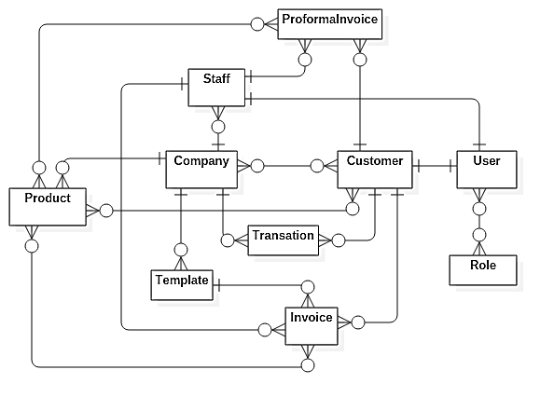

Figure 74. Conceptual diagram

# Software Design Description

## Design Overview

This section will provide you with the technical and user interface design aspect of the MIS development. It includes architectural design, detail design of common functions, business functions and design of database model.

Document overview:

Section 3.2: Overall description of system architecture design.

Section 3.3: Component diagrams that describe the connection and integration of the system.

Section 3.4: Detail design description including class diagram, class explanation, and sequence diagram to application function details.

Section 3.5: Screen designs.

Section 3.6: Attributed ERD.

## Sysmte Architectual Design

 Figure 75. System architectural design

In Web Application, the system is developed under MVC architecture style. This project follows MVC architecture with following components:

* Controller handles user interaction. Typically, controller reads data from a request, calls appropriate business method, selects and renders view for user.
* View is a user interface. It is responsible for rendering the model data and generating HTML output that client's browser can interpret.
* Model is responsible for managing data of the application. It responds to requests from view and also to instructions from controller to update itself. Model objects store and retrieve model state in a database.

Component Diagram

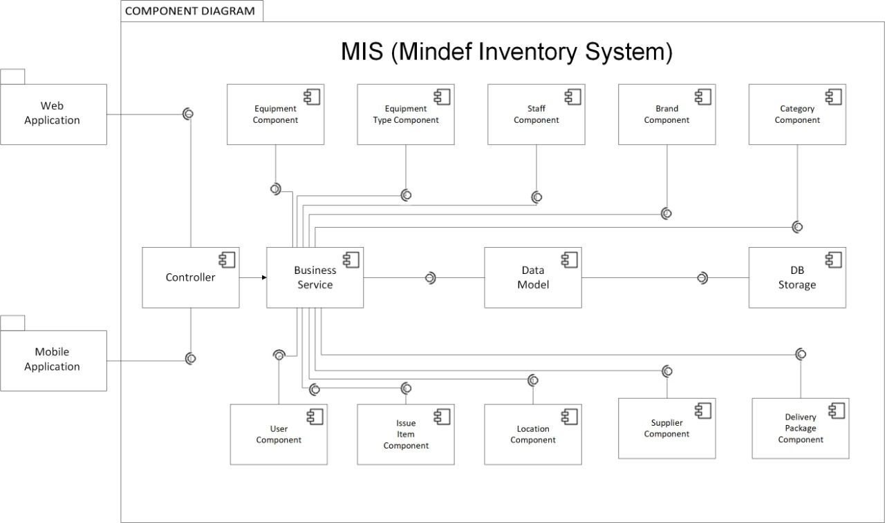

Figure 76. Component diagram

|  |  |
| --- | --- |
| COMPONENT DICTIONARY: DESCRIBES COMPONENTS | |
| MIS Development | Mindef Inventory System |
| Web Application | Web application package contains operation of MIS on web |
| Mobile Application | Moblie application package contains operations to display information and scan QR code |
| Controller | Handle requests and responses; accept input and convert it to commands for model and view. |
| Business Service | Handle system’s business operations |
| Data Model | Present the interaction between the system and database. |
| DB Storage | Store data of system. |
| Equipment Component | Handle Asset Tracking activities in the system |
| Supplier Component | Handle supplier detail in the system |
| Brand Component | Handle brand activities in the system |
| User Component | Handle account activities in the system |
| Personnel Issue to Component | Handle Personnel Issue to activities in the system |
| Location Component | Handle Location activities in the system |
| Equipment Type Component | Handle Equipment Type activities in the system |
| Staff Component | Handle Staff activities in the system |
| Category Component | Handle Category activities in the system |
| Issued Item Component | Handle Issued Item activities in the system |

Table 70. Component diagram dictionary

## Detail Description

## Class diagram





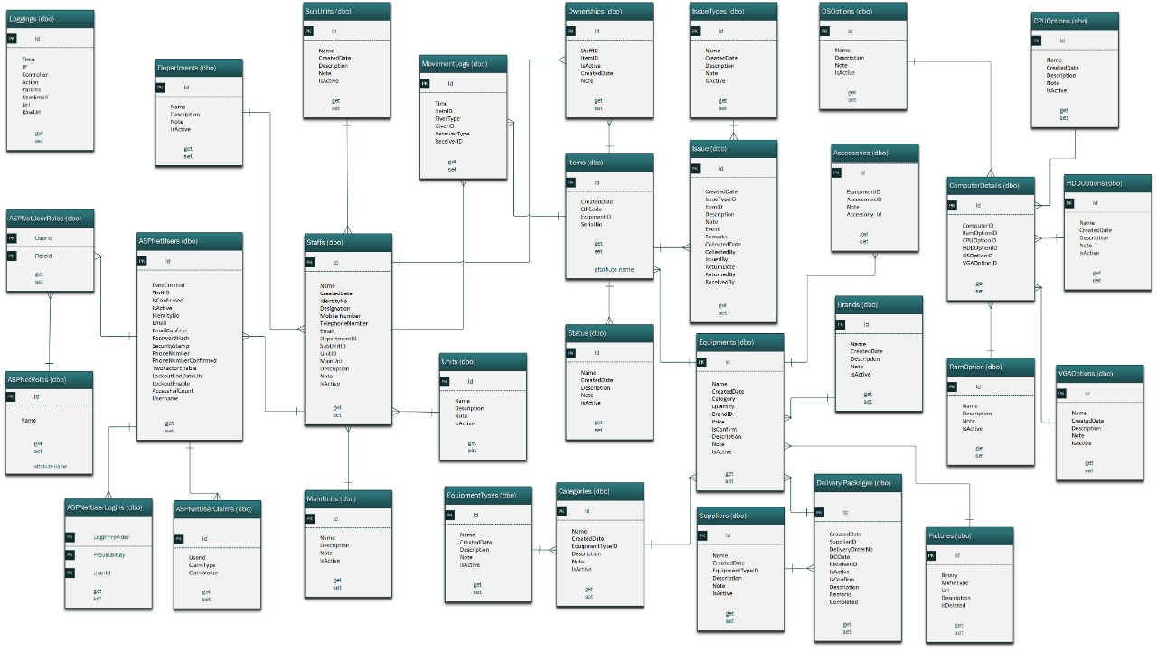

*Figure 77. Class diagram*

|  |  |  |
| --- | --- | --- |
| **CLASS DICTIONARY: DESCRIBE CLASS** | | |
| **Class Name** | **Mapping column with Conceptual diagram** | **Description** |
| **AppNetUsers** | **AppNetUsers** | Contain account information |
| **AppNetUsersRoles** | **AppNetUsersRoles** | Contain account Role information |
| **AppNetRoles** | **AppNetRoles** | Contain Role information |
| **AppNetUserClaims** | **AppNetUserClaims** | Contain user claim information |
| **AppNetUserLogins** | **AppNetUserLogins** | Contain user Login information |
| **Staff** | **Staff** | Contain system Staff information |
| **MainUnits** | **MainUnits** | Contain information regarding main units |
| **SubUnits** | **SubUnits** | Contain information regarding sub units |
| **Units** | **Units** | Contain information regarding units |
| **Department** | **Department** | Contain information regarding department |
| **OwnerShip** | **OwnerShip** | Contain information regarding Ownership |
| **Equipments** | **Equipments** | Contain information regarding Equipments |
| **Equipment Type** | **Equipment Type** | Contain information regarding Equipment type |
| **ComputerDetail** | **ComputerDetail** | Contain information regarding computer detail |
| **OsOptions** | **OsOptions** | Contain information regarding Os |
| **CPUOptions** | **CPUOptions** | Contain information regarding CPU |
| **HDDOptions** | **HDDOptions** | Contain information regarding HDD |
| **VGAOptions** | **VGAOptions** | Contain information regarding VGA |
| **RamOptions** | **RamOptions** | Contain information regarding RAM |
| **Brands** | **Brands** | Contain information regarding Brands |
| **Picture** | **Picture** | Contain information regarding Picture |
| **Items** | **Items** | Contain information regarding Items |
| **Supplier** | **Supplier** | Contain information regarding supplier |
| **Issues** | **Issues** | Contain Equipment Issue to Personnel information |
| **IssueTypes** | **IssueTypes** | Contain information regarding issue type |
| **Accessories** | **Accessories** | Contain information regarding accessories |
| **MovementLogs** | **MovementLogs** | Contain information regarding movement log |
| **Category** | **Category** | Contain Different Category of Equipment |
| **Location** | **Location** | Contain information regarding the location of Equipment |
| **Register** | **Register** | Not exist in conceptual diagram but we need this table to contain information of individual Staff credential |
| **Delivery Package** | **Delivery Package** | Contain new Equipment package receive from supplier information |
| **Status** | **Status** | Contain information regarding status |

Table 71. Class Diagram Dictionary



## Class Diagram Explanation

### AspNetUsers

|  |  |  |  |
| --- | --- | --- | --- |
| **Attribute** | **Type** | **Visibility** | **Description** |
| Id | int | Private | Unique identifier of a user |
| DateCreated | DateTime | Private | User’s Date Created |
| StaffId | String | Private | User’s Staff id |
| IsConfirmed | boolean | Private | User’s is confirmed |
| IsActive | boolean | Private | User is active or deactive |
| IdentityNo | String | Private | User’s Identity No |
| Email | String | Private | User’s email |
| EmailConfirmed | Boolean | Private | User’s Email Confirm |
| PasswordHash | String | Private | User’s password |
| SecurityStamp | String | Private | User’s security stamp |
| PhoneNumber | String | Private | User’s phone number |
| PhoneNumberConfirm | String | Private | User’s phone number confirm |
| TwoFactorEnable | boolean | Private | User’s two factor enable |
| LockoutEndDateUTC | String | Private | User’s Lock out end day |
| LookoutEnable | boolean | Private | User’s lock out enable |
| AccessFailCount | int | Private | User’s Fail count |
| Username | String | Private | User’s username |

Table 72. <Class Diagram Attributes> AspNetUsers

|  |  |  |  |
| --- | --- | --- | --- |
| **Method** | **Redirect Type** | **Visibility** | **Description** |
| Getter | Attribute Type | Public | Get attribute value |
| Setter | Void | Public | Set attribute value |

Table 73. <Class Diagram Methods> AspNetUsers



### AspnetUserRole

|  |  |  |  |
| --- | --- | --- | --- |
| **Attribute** | **Type** | **Visibility** | **Description** |
| UserId | Int | Private | User ID |
| RoleId | Int | Private | Role ID |

Table 74. <Class Diagram Attributes> AspnetUserRole

|  |  |  |  |
| --- | --- | --- | --- |
| **Method** | **Redirect Type** | **Visibility** | **Description** |
| Getter | Attribute Type | Public | Get attribute value |
| Setter | Void | Public | Set attribute value |

Table 75. <Class Diagram Methods> AspnetUserRole

### AspnetRoles

|  |  |  |  |
| --- | --- | --- | --- |
| **Attribute** | **Type** | **Visibility** | **Description** |
| Id | int | Private | Unique identifier of a role |
| Name | String | Private | Role name |

Table 76. <Class Diagram Attributes> AspnetRoles

|  |  |  |  |
| --- | --- | --- | --- |
| **Method** | **Redirect Type** | **Visibility** | **Description** |
| Getter | Attribute Type | Public | Get attribute value |
| Setter | Void | Public | Set attribute value |

Table 77. <Class Diagram Methods> AspnetRoles

### AspnetUserClaims

|  |  |  |  |
| --- | --- | --- | --- |
| **Attribute** | **Type** | **Visibility** | **Description** |
| Id | int | Private | Unique identifier of a role |
| UserId | String | Private | User ID |
| ClaimType | String | Private | Claim Type |
| ClaimValue | String | Private | Claim Value |

Table 78. <Class Diagram Attributes> AspnetUserClaims

|  |  |  |  |
| --- | --- | --- | --- |
| **Method** | **Redirect Type** | **Visibility** | **Description** |
| Getter | Attribute Type | Public | Get attribute value |
| Setter | Void | Public | Set attribute value |

Table 79. <Class Diagram Methods> AspnetUserClaims

### AspnetUserLogins

|  |  |  |  |
| --- | --- | --- | --- |
| **Attribute** | **Type** | **Visibility** | **Description** |
| LoginProvider | String | Private | Login Provider |
| ProviderKey | String | Private | Provider Key |
| UserId | int | Private | User id |

Table 80. <Class Diagram Attributes> AspnetUserLogins

|  |  |  |  |
| --- | --- | --- | --- |
| **Method** | **Redirect Type** | **Visibility** | **Description** |
| Getter | Attribute Type | Public | Get attribute value |
| Setter | Void | Public | Set attribute value |

Table 81. <Class Diagram Methods> AspnetUserLogins

### Staff

|  |  |  |  |
| --- | --- | --- | --- |
| **Attribute** | **Type** | **Visibility** | **Description** |
| Id | Int | Private | Unique identifier of a staff |
| Name | String | Private | Staff Name |
| CreatedDate | DateTime | Private | Staff created date |
| IndentityNo | String | Private | Staff Indentity number |
| Designation | String | Private | Staff Designation |
| MobileNumber | String | Private | Staff Mobile phone number |
| TelephoneNumber | String | Private | Staff Telephone number |
| Email | String | Private | Staff email |
| DepartmentId | Int | Private | Staff Department |
| SubUnitID | Int | Private | Staff Sub unit |
| UnitId | Int | Private | Staff Unit |
| MainUnitID | Int | Private | Staff Main Unit |
| Description | String | Private | Staff Description |
| Note | String | Private | Staff note |
| IsActive | Booolean | Private | Staff active state |

Table 82. <Class Diagram Attributes> Staff

|  |  |  |  |
| --- | --- | --- | --- |
| **Method** | **Redirect Type** | **Visibility** | **Description** |
| Getter | Attribute Type | Public | Get attribute value |
| Setter | Void | Public | Set attribute value |

Table 83. <Class Diagram Methods> Staff

### Department

|  |  |  |  |
| --- | --- | --- | --- |
| **Attribute** | **Type** | **Visibility** | **Description** |
| Id | Int | Private | Unique identifier of a department |
| Name | String | Private | Department Name |
| Description | String | Private | Department Description |
| Note | String | Private | Department note |
| IsActive | Booolean | Private | Department active state |

Table 84. <Class Diagram Attributes> Department

|  |  |  |  |
| --- | --- | --- | --- |
| **Method** | **Redirect Type** | **Visibility** | **Description** |
| Getter | Attribute Type | Public | Get attribute value |
| Setter | Void | Public | Set attribute value |

Table 85. <Class Diagram Methods> Department

### Main Unit

|  |  |  |  |
| --- | --- | --- | --- |
| **Attribute** | **Type** | **Visibility** | **Description** |
| Id | Int | Private | Unique identifier of a Main Unit |
| Name | String | Private | Main Unit Name |
| Description | String | Private | Main Unit Description |
| Note | String | Private | Main Unit note |
| IsActive | Booolean | Private | Main Unit active state |

Table 86. <Class Diagram Attributes> Main Unit

|  |  |  |  |
| --- | --- | --- | --- |
| **Method** | **Redirect Type** | **Visibility** | **Description** |
| Getter | Attribute Type | Public | Get attribute value |
| Setter | Void | Public | Set attribute value |

Table 87. <Class Diagram Methods> Main Unit

### Unit

|  |  |  |  |
| --- | --- | --- | --- |
| **Attribute** | **Type** | **Visibility** | **Description** |
| Id | Int | Private | Unique identifier of a Unit |
| Name | String | Private | Unit Name |
| Description | String | Private | Unit Description |
| Note | String | Private | Unit note |
| IsActive | Booolean | Private | Unit active state |

Table 88. <Class Diagram Attributes> Main Unit

|  |  |  |  |
| --- | --- | --- | --- |
| **Method** | **Redirect Type** | **Visibility** | **Description** |
| Getter | Attribute Type | Public | Get attribute value |
| Setter | Void | Public | Set attribute value |

Table 89. <Class Diagram Methods> Main Unit

### Sub-unit

|  |  |  |  |
| --- | --- | --- | --- |
| **Attribute** | **Type** | **Visibility** | **Description** |
| Id | Int | Private | Unique identifier of a Sub Unit |
| Name | String | Private | Sub Unit Name |
| Description | String | Private | Sub Unit Description |
| Note | String | Private | Sub Unit note |
| IsActive | Booolean | Private | Sub Unit active state |

Table 90. <Class Diagram Attributes> Main Unit

|  |  |  |  |
| --- | --- | --- | --- |
| **Method** | **Redirect Type** | **Visibility** | **Description** |
| Getter | Attribute Type | Public | Get attribute value |
| Setter | Void | Public | Set attribute value |

Table 91. <Class Diagram Methods> Main Unit

### Items

|  |  |  |  |
| --- | --- | --- | --- |
| **Attribute** | **Type** | **Visibility** | **Description** |
| Id | Int | Private | Unique identifier of a item |
| CreatedDate | DateTime | Private | Item created date |
| QrCode | String | Private | Item’s Qr Code |
| EquipmentID | Int | Private | Equipment ID |
| StatusID | Int | Private | Status ID |
| SerialNo | String | Private | Item Serial Number |

Table 92. <Class Diagram Attributes> Items

|  |  |  |  |
| --- | --- | --- | --- |
| **Method** | **Redirect Type** | **Visibility** | **Description** |
| Getter | Attribute Type | Public | Get attribute value |
| Setter | Void | Public | Set attribute value |

Table 93. <Class Diagram Methods> Items

### OwnerShip

|  |  |  |  |
| --- | --- | --- | --- |
| **Attribute** | **Type** | **Visibility** | **Description** |
| Id | Int | Private | Unique identifier of a Ownership |
| CreatedDate | DateTime | Private | Ownership created date |
| StaffID | Int | Private | Staff ID |
| ItemID | Int | Private | Item ID |
| IsActive | Boolean | Private | Ownership active state |
| Note | Strign | Private | Ownership note |

Table 94. <Class Diagram Attributes> Ownership

|  |  |  |  |
| --- | --- | --- | --- |
| **Method** | **Redirect Type** | **Visibility** | **Description** |
| Getter | Attribute Type | Public | Get attribute value |
| Setter | Void | Public | Set attribute value |

Table 95. <Class Diagram Methods> Ownership

### Movementlogs

|  |  |  |  |
| --- | --- | --- | --- |
| **Attribute** | **Type** | **Visibility** | **Description** |
| Id | Int | Private | Unique identifier of a Ownership |
| Time | DateTime | Private | Ownership created date |
| GiverID | Int | Private | Giver ID |
| ItemID | Int | Private | Item ID |
| GiverType | String | Private | Giver Type |
| ReceiverID | Int | Private | Receiver ID |
| ReceiverType | String | Private | Receiver Type |

Table 96. <Class Diagram Attributes> Movementlogs

|  |  |  |  |
| --- | --- | --- | --- |
| **Method** | **Redirect Type** | **Visibility** | **Description** |
| Getter | Attribute Type | Public | Get attribute value |
| Setter | Void | Public | Set attribute value |

Table 97. <Class Diagram Methods> Movementlogs

### Status

|  |  |  |  |
| --- | --- | --- | --- |
| **Attribute** | **Type** | **Visibility** | **Description** |
| Id | Int | Private | Unique identifier of a status |
| CreatedDate | DateTime | Private | status created date |
| Name | String | Private | Status Name |
| Description | String | Private | Status Description |
| Note | String | Private | Status Note |
| IsActive | Boolean | Private | Status Active state |

Table 98. <Class Diagram Attributes> Status

|  |  |  |  |
| --- | --- | --- | --- |
| **Method** | **Redirect Type** | **Visibility** | **Description** |
| Getter | Attribute Type | Public | Get attribute value |
| Setter | Void | Public | Set attribute value |

Table 99. <Class Diagram Methods> Status

### Issues

|  |  |  |  |
| --- | --- | --- | --- |
| **Attribute** | **Type** | **Visibility** | **Description** |
| Id | Int | Private | Unique identifier of a Issue |
| CreatedDate | DateTime | Private | Issue created date |
| IssueTypeID | Int | Private | Issuetype ID |
| ItemID | Int | Private | Item ID |
| Description | String | Private | Issue Description |
| Note | String | Private | Issue Note |
| Event | String | Private | Issue Event |
| Remark | String | Private | Issue remark |
| CollectedDate | DateTime | Private | Issue collected date |
| CollectedBy | String | Private | Issue collect by |
| issuedBy | String | Private | Issue issued by |
| ReturnDate | DateTime | Private | Issue return date |
| ReturnBy | String | Private | Issue return by |
| ReceivedBy | Int | Private | Issue receive by |

Table 100. <Class Diagram Attributes> Issues

|  |  |  |  |
| --- | --- | --- | --- |
| **Method** | **Redirect Type** | **Visibility** | **Description** |
| Getter | Attribute Type | Public | Get attribute value |
| Setter | Void | Public | Set attribute value |

Table 101. <Class Diagram Methods> Issues

### IssueTypes

|  |  |  |  |
| --- | --- | --- | --- |
| **Attribute** | **Type** | **Visibility** | **Description** |
| Id | Int | Private | Unique identifier of a issue type |
| CreatedDate | DateTime | Private | Issue type created date |
| Name | String | Private | Issue type Name |
| Description | String | Private | Issue type Description |
| Note | String | Private | Issue type Note |
| IsActive | Boolean | Private | Issue type Active state |

Table 102. <Class Diagram Attributes> Issue Type

|  |  |  |  |
| --- | --- | --- | --- |
| **Method** | **Redirect Type** | **Visibility** | **Description** |
| Getter | Attribute Type | Public | Get attribute value |
| Setter | Void | Public | Set attribute value |

Table 103. <Class Diagram Methods> Issue Type

### Accessories

|  |  |  |  |
| --- | --- | --- | --- |
| **Attribute** | **Type** | **Visibility** | **Description** |
| Id | Int | Private | Unique identifier of an Accessories |
| EquipmentId | DateTime | Private | Equipment Id |
| Accessoryid | String | Private | Accessory Id |
| Note | String | Private | Accessory Note |

Table 104. <Class Diagram Attributes> Issue Type

|  |  |  |  |
| --- | --- | --- | --- |
| **Method** | **Redirect Type** | **Visibility** | **Description** |
| Getter | Attribute Type | Public | Get attribute value |
| Setter | Void | Public | Set attribute value |

Table 105. <Class Diagram Methods> Issue Type

### Equipments

|  |  |  |  |
| --- | --- | --- | --- |
| **Attribute** | **Type** | **Visibility** | **Description** |
| Id | Int | Private | Unique identifier of an Equipment |
| Name | String | Private | Equipment Name |
| CreatedDate | DateTime | Private | Equipment Created Date |
| CategoryId | Int | Private | Equipment ‘s Category |
| Quantity | Int | Private | Equipment quantity |
| BrandId | Int | Private | Equipment brand |
| DeliveryPackageId | Int | Private | Equipment Delivery package |
| PictureID | Int | Private | Equipment Picture |
| Price | Float | Private | Equipment price |
| IsConfirmed | Boolean | Private | Equipment confirm state |
| Description | String | Private | Equipment Description |
| Note | String | Private | Equipment Note |
| IsActive | Boolean | Private | Equipment active state |

Table 106. <Class Diagram Attributes> Equipment

|  |  |  |  |
| --- | --- | --- | --- |
| **Method** | **Redirect Type** | **Visibility** | **Description** |
| Getter | Attribute Type | Public | Get attribute value |
| Setter | Void | Public | Set attribute value |

Table 107. <Class Diagram Methods> Equipment

### Categories

|  |  |  |  |
| --- | --- | --- | --- |
| **Attribute** | **Type** | **Visibility** | **Description** |
| Id | Int | Private | Unique identifier of a categories |
| Name | String | Private | Categories Name |
| CreatedDate | DateTime | Private | Categories Created Date |
| EquipmenTypeId | Int | Private | Categories ‘s Equipment Type |
| Description | String | Private | Categories Description |
| Note | String | Private | Categories Note |
| IsActive | Boolean | Private | Categories active state |

Table 108. <Class Diagram Attributes> Category

|  |  |  |  |
| --- | --- | --- | --- |
| **Method** | **Redirect Type** | **Visibility** | **Description** |
| Getter | Attribute Type | Public | Get attribute value |
| Setter | Void | Public | Set attribute value |

Table 109. <Class Diagram Methods> Category

### Equipment Type

|  |  |  |  |
| --- | --- | --- | --- |
| **Attribute** | **Type** | **Visibility** | **Description** |
| Id | Int | Private | Unique identifier of a Equipment type |
| Name | String | Private | Equipment type Name |
| CreatedDate | DateTime | Private | Equipment type Created Date |
| Description | String | Private | Equipment type Description |
| Note | String | Private | Equipment type Note |
| IsActive | Boolean | Private | Equipment type active state |

Table 110. <Class Diagram Attributes> Equipment Type

|  |  |  |  |
| --- | --- | --- | --- |
| **Method** | **Redirect Type** | **Visibility** | **Description** |
| Getter | Attribute Type | Public | Get attribute value |
| Setter | Void | Public | Set attribute value |

Table 111. <Class Diagram Methods> Equipment Type

### ComputerDetails

|  |  |  |  |
| --- | --- | --- | --- |
| **Attribute** | **Type** | **Visibility** | **Description** |
| Id | Int | Private | Unique identifier of a Computer Detail |
| ComputerId | Int | Private | Computer ‘s ID |
| RamOptionID | Int | Private | Computer Detail ‘s Ram |
| CPUOptionId | Int | Private | Computer Detail’s CPU |
| HDDOptionId | Int | Private | Computer Detail’s HDD |
| OSOptionId | Int | Private | Computer Detail’s OS |
| VGAOptionId | Int | Private | Computer Detail’s VGA |

Table 112. <Class Diagram Attributes> Equipment Type

|  |  |  |  |
| --- | --- | --- | --- |
| **Method** | **Redirect Type** | **Visibility** | **Description** |
| Getter | Attribute Type | Public | Get attribute value |
| Setter | Void | Public | Set attribute value |

Table 113. <Class Diagram Methods> Equipment Type

### OsOptions

|  |  |  |  |
| --- | --- | --- | --- |
| **Attribute** | **Type** | **Visibility** | **Description** |
| Id | Int | Private | Unique identifier of an Os |
| Name | String | Private | Os Name |
| Description | String | Private | Os Description |
| Note | String | Private | Os Note |
| IsActive | Boolean | Private | Os active state |

Table 114. <Class Diagram Attributes> OS Options

|  |  |  |  |
| --- | --- | --- | --- |
| **Method** | **Redirect Type** | **Visibility** | **Description** |
| Getter | Attribute Type | Public | Get attribute value |
| Setter | Void | Public | Set attribute value |

Table 115. <Class Diagram Methods> OS Options

### CPUOptions

|  |  |  |  |
| --- | --- | --- | --- |
| **Attribute** | **Type** | **Visibility** | **Description** |
| Id | Int | Private | Unique identifier of an CPU |
| Name | String | Private | CPU Name |
| Description | String | Private | CPU Description |
| Note | String | Private | CPU Note |
| IsActive | Boolean | Private | CPU active state |

Table 116. <Class Diagram Attributes> CPU Options

|  |  |  |  |
| --- | --- | --- | --- |
| **Method** | **Redirect Type** | **Visibility** | **Description** |
| Getter | Attribute Type | Public | Get attribute value |
| Setter | Void | Public | Set attribute value |

Table 117. <Class Diagram Methods> CPU Options

### HDDOptions

|  |  |  |  |
| --- | --- | --- | --- |
| **Attribute** | **Type** | **Visibility** | **Description** |
| Id | Int | Private | Unique identifier of an HDD |
| Name | String | Private | HDD Name |
| Description | String | Private | HDD Description |
| Note | String | Private | HDD Note |
| IsActive | Boolean | Private | HDD active state |

Table 118. <Class Diagram Attributes> HDD Options

|  |  |  |  |
| --- | --- | --- | --- |
| **Method** | **Redirect Type** | **Visibility** | **Description** |
| Getter | Attribute Type | Public | Get attribute value |
| Setter | Void | Public | Set attribute value |

Table 119. <Class Diagram Methods> HDD Options

### VGAOptions

|  |  |  |  |
| --- | --- | --- | --- |
| **Attribute** | **Type** | **Visibility** | **Description** |
| Id | Int | Private | Unique identifier of an VGA |
| Name | String | Private | VGA Name |
| Description | String | Private | VGA Description |
| Note | String | Private | VGA Note |
| IsActive | Boolean | Private | VGA active state |

Table 120. <Class Diagram Attributes> VGA Options

|  |  |  |  |
| --- | --- | --- | --- |
| **Method** | **Redirect Type** | **Visibility** | **Description** |
| Getter | Attribute Type | Public | Get attribute value |
| Setter | Void | Public | Set attribute value |

Table 121. <Class Diagram Methods> VGA Options

### RamOptions

|  |  |  |  |
| --- | --- | --- | --- |
| **Attribute** | **Type** | **Visibility** | **Description** |
| Id | Int | Private | Unique identifier of an RAM |
| Name | String | Private | RAM Name |
| Description | String | Private | RAM Description |
| Note | String | Private | RAM Note |
| IsActive | Boolean | Private | RAM active state |

Table 122. <Class Diagram Attributes> RAM Options

|  |  |  |  |
| --- | --- | --- | --- |
| **Method** | **Redirect Type** | **Visibility** | **Description** |
| Getter | Attribute Type | Public | Get attribute value |
| Setter | Void | Public | Set attribute value |

Table 123. <Class Diagram Methods> RAM Options

### Brands

|  |  |  |  |
| --- | --- | --- | --- |
| **Attribute** | **Type** | **Visibility** | **Description** |
| Id | Int | Private | Unique identifier of a Brand |
| Name | String | Private | Brand Name |
| CreatedDate | DateTime | Private | Brand’s Created date |
| Description | String | Private | Brand Description |
| Note | String | Private | Brand Note |
| IsActive | Boolean | Private | Brand active state |

Table 124. <Class Diagram Attributes> Brands

|  |  |  |  |
| --- | --- | --- | --- |
| **Method** | **Redirect Type** | **Visibility** | **Description** |
| Getter | Attribute Type | Public | Get attribute value |
| Setter | Void | Public | Set attribute value |

Table 125. <Class Diagram Methods> Brands

### Pictures

|  |  |  |  |
| --- | --- | --- | --- |
| **Attribute** | **Type** | **Visibility** | **Description** |
| Id | Int | Private | Unique identifier of a Picture |
| Binary | String | Private | Picture’s Binary |
| Mimetype | String | Private | Picture’s Mime Type |
| Url | String | Private | Picture’s Url |
| Description | String | Private | Picture’s Description |
| IsActive | Boolean | Private | Picture’s active state |

Table 126. <Class Diagram Attributes> Pictures

|  |  |  |  |
| --- | --- | --- | --- |
| **Method** | **Redirect Type** | **Visibility** | **Description** |
| Getter | Attribute Type | Public | Get attribute value |
| Setter | Void | Public | Set attribute value |

Table 127. <Class Diagram Methods> Pictures

### DeliveryPackages

|  |  |  |  |
| --- | --- | --- | --- |
| **Attribute** | **Type** | **Visibility** | **Description** |
| Id | Int | Private | Unique identifier of a Delivery package |
| CreatedDate | DateTime | Private | Delivery package’s Created date |
| SupplierId | Int | Private | Delivery package’s supplier |
| DeliveryOrderNo | String | Private | Delivery package’s Order number |
| DODate | DateTime | Private | Delivery package’s Delivery order date |
| ReceiverId | Int | Private | Delivery package’s Receiver |
| IsActive | Boolean | Private | Delivery package’s active state |
| Isconfirmed | Boolean | Private | Delivery package’s confirm state |
| Description | String | Private | Delivery package’s Description |
| Remarks | String | Private | Delivery package’s Remark |
| Completed | Boolean | Private | Delivery package’s complete state |

Table 128. <Class Diagram Attributes> Delivery package

|  |  |  |  |
| --- | --- | --- | --- |
| **Method** | **Redirect Type** | **Visibility** | **Description** |
| Getter | Attribute Type | Public | Get attribute value |
| Setter | Void | Public | Set attribute value |

Table 129. <Class Diagram Methods> Delivery package

### Suppliers

|  |  |  |  |
| --- | --- | --- | --- |
| **Attribute** | **Type** | **Visibility** | **Description** |
| Id | Int | Private | Unique identifier of a Supplier |
| Name | String | Private | Supplier’s Name |
| CreatedDate | DateTime | Private | Supplier’s Created date |
| ContactPerson | String | Private | Supplier’s Contact Person |
| MobileNumber | String | Private | Supplier’s Mobile Number |
| Telephonenumer | String | Private | Supplier’s telephone nubmer |
| Fax | String | Private | Supplier’s Fax |
| IsActive | Boolean | Private | Supplier’s active state |
| Email | String | Private | Supplier’s Email |
| Description | String | Private | Supplier’s Description |
| Note | String | Private | Supplier’s Note |
| Address | String | Private | Supplier’s Address |

Table 130. <Class Diagram Attributes> Suppliers

|  |  |  |  |
| --- | --- | --- | --- |
| **Method** | **Redirect Type** | **Visibility** | **Description** |
| Getter | Attribute Type | Public | Get attribute value |
| Setter | Void | Public | Set attribute value |

Table 131. <Class Diagram Methods> Suppliers

### Loggings

|  |  |  |  |
| --- | --- | --- | --- |
| **Attribute** | **Type** | **Visibility** | **Description** |
| Id | Int | Private | Unique identifier of a log |
| Time | Datetime | Private | Log’s created date |
| IP | String | Private | Log’s IP |
| Controller | String | Private | Log’s Controller |
| Action | String | Private | Log’s Action |
| Params | String | Private | Log’s parameter |
| UserEmail | String | Private | Log’s User Email |
| Url | Boolean | Private | Log’s Url |
| RawURl | String | Private | Log’s Raw Url |

Table 132. <Class Diagram Attributes> Loggings

|  |  |  |  |
| --- | --- | --- | --- |
| **Method** | **Redirect Type** | **Visibility** | **Description** |
| Getter | Attribute Type | Public | Get attribute value |
| Setter | Void | Public | Set attribute value |

Table 133. <Class Diagram Methods> Loggings

### 



## Interaction Diagram

* + 1. <Inventory User> Mobile Login



Figure 78. <Sequence Diagram><Inventory User> Mobile Login

1. * 1. <Inventory User > Mobile Logout



Figure 79. <Sequence Diagram><Inventory User> Mobile LogOut

1. * 1. <Inventory User> Mobile Search by User



Figure 80. <Sequence Diagram><Inventory User> Mobile Search by User

1. * 1. <Inventory User> Mobile Search by Location



Figure 81. <Sequence Diagram>><Inventory User> Mobile Search by Location

1. * 1. <Inventory User> Mobile Search by QR



Figure 82. <Sequence Diagram><Inventory User> Mobile Search by QR

1. * 1. <Invnetory User> Mobile Add Item



Figure 83. <Sequence Diagram><Inventory User>Mobile Add Item



## Web Sequence Diagram



Figure 84. <Sequence Diagram><Admin>Login



Figure 85. <Sequence Diagram><Admin>Log out

 Figure 86. <Sequence Diagram><Admin> Add brand

 Figure 87. <Sequence Diagram><Admin> Add staff

 Figure 88. <Sequence Diagram><Admin> Add Supplier

 Figure 89. <Sequence Diagram><Admin> Add Location

 Figure 90. <Sequence Diagram><Admin> Add Issue Item

 Figure 91. <Sequence Diagram><Admin> Add Equipment Type

 Figure 92. <Sequence Diagram><Admin>Add Category

 Figure 93. <Sequence Diagram><Admin> Add Equipment

 Figure 94. <Sequence Diagram><Admin> Add Delivery Package

 Figure 95. <Sequence Diagram><Admin> Edit Brand

 Figure 96. <Sequence Diagram><Admin> Edit Supplier

 Figure 97. <Sequence Diagram><Admin> Edit Location

 Figure 98. <Sequence Diagram><Admin> Edit Issue Item Figure 99. <Sequence Diagram><Admin> Edit Equipent type

 Figure 100. <Sequence Diagram><Admin> Edit Category

 Figure 101. <Sequence Diagram><Admin> Edit Equipment

 Figure 102. <Sequence Diagram><Admin> Edit Delivery Package

Delete

 Figure 103. <Sequence Diagram><Admin> Delete Brand

 Figure 104. <Sequence Diagram><Admin>Delete Staff

 Figure 105. <Sequence Diagram><Admin>Delete Supplier

 Figure 106. <Sequence Diagram><Admin>Delete Location

 Figure 107. <Sequence Diagram><Admin>Delte Issue Ite

 Figure 108. <Sequence Diagram><Admin> Delete Equipment Type

 Figure 109. <Sequence Diagram><Admin>Delete Category

 Figure 110. <Sequence Diagram><Admin> Delete Equipment

 Figure 111. <Sequence Diagram><Admin> Delete Delivery Package

View

 Figure 112. <Sequence Diagram><Admin> View Brand

 Figure 113. <Sequence Diagram><Admin> View Staff

 Figure 114. <Sequence Diagram><Admin> View Supplier

 Figure 115. <Sequence Diagram><Admin> View Location

 Figure 116. <Sequence Diagram><Admin> View Issued Item

 Figure 117. <Sequence Diagram><Admin> View Equipment type Figure 118. <Sequence Diagram><Admin> View Category

 Figure 119. <Sequence Diagram><Admin> View Equipment

 Figure 120. <Sequence Diagram><Admin> View Delivery Package

Search

 Figure 121. <Sequence Diagram><Admin> Search Brand

 Figure 122. <Sequence Diagram><Admin> Search Staff

 Figure 123. <Sequence Diagram><Admin> Search Supplier

 Figure 124. <Sequence Diagram><Admin> Search Location

 Figure 125. <Sequence Diagram><Admin> Search Issued Item

 Figure 126. <Sequence Diagram><Admin>Search Equipment Type

 Figure 127. <Sequence Diagram><Admin> Search Category

 Figure 128. <Sequence Diagram><Admin> Search Equipment

 Figure 129. <Sequence Diagram><Admin> Search Delivery Package



### Login

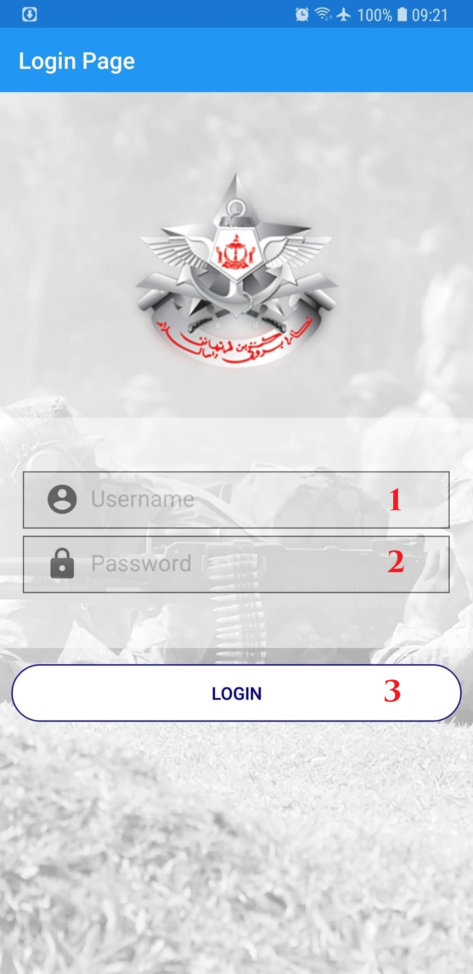

Figure 130. Login

**Fields**

|  |  |  |  |  |  |  |
| --- | --- | --- | --- | --- | --- | --- |
| **No** | **Field Name** | **Description** | **Read only** | **Mandatory** | **Control Type** | **Data Type** |
| 1 | Username | Fill username | No | Yes | TextBox | String |
| 2 | Password | Fill password | No | Yes | TextBox | String |

Table 133. <Fields> Login page

**Buttons/Hyperlinks:**

|  |  |  |  |  |
| --- | --- | --- | --- | --- |
| **No** | **Function** | **Description** | **Validation** | **Outcome** |
| 1 | Login | Login page | Required | Navigate to MainMenu |

Table 134. <Buttons/Hyperlinks> Home page



### Main Menu

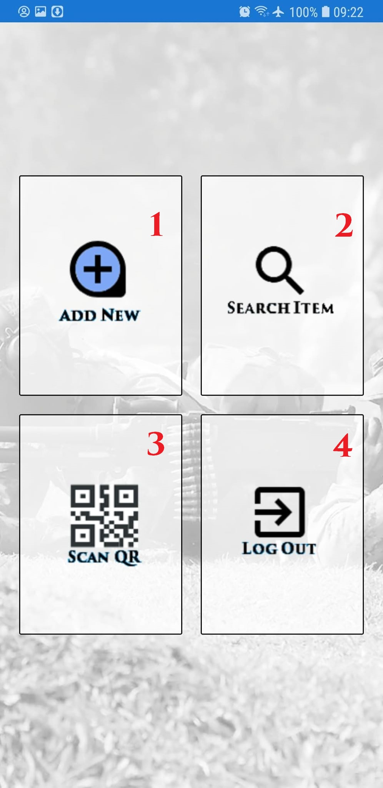

Figure 131. MainMenu

**Fields:N/A**

**Buttons/Hyperlinks:**

|  |  |  |  |  |
| --- | --- | --- | --- | --- |
| **No** | **Function** | **Description** | **Validation** | **Outcome** |
| 1 | Add | Login page | N/A | Navigate to Add page |
| 2 | Search | Invoice tab | N/A | Navigate to Search Menu page |
| 3 | Scan QR | Proforma Invoice Tab | N/A | Navigate to Scan Qr page |
| 4 | Log Out | Search by lookup code | N/A | Navigate to login page |

Table 135. <Buttons/Hyperlinks> MainMenu Page



### Add New Item

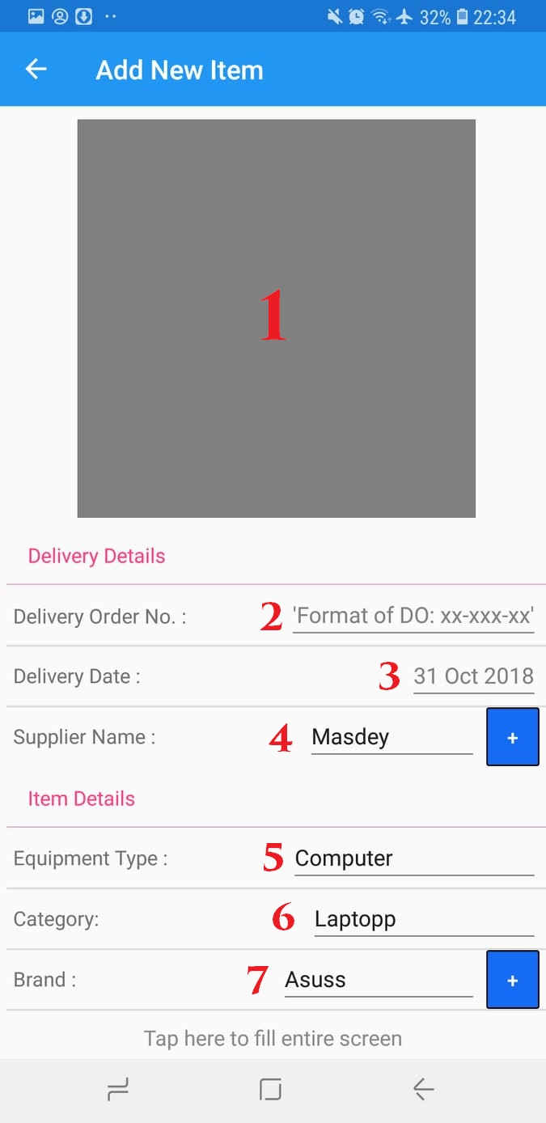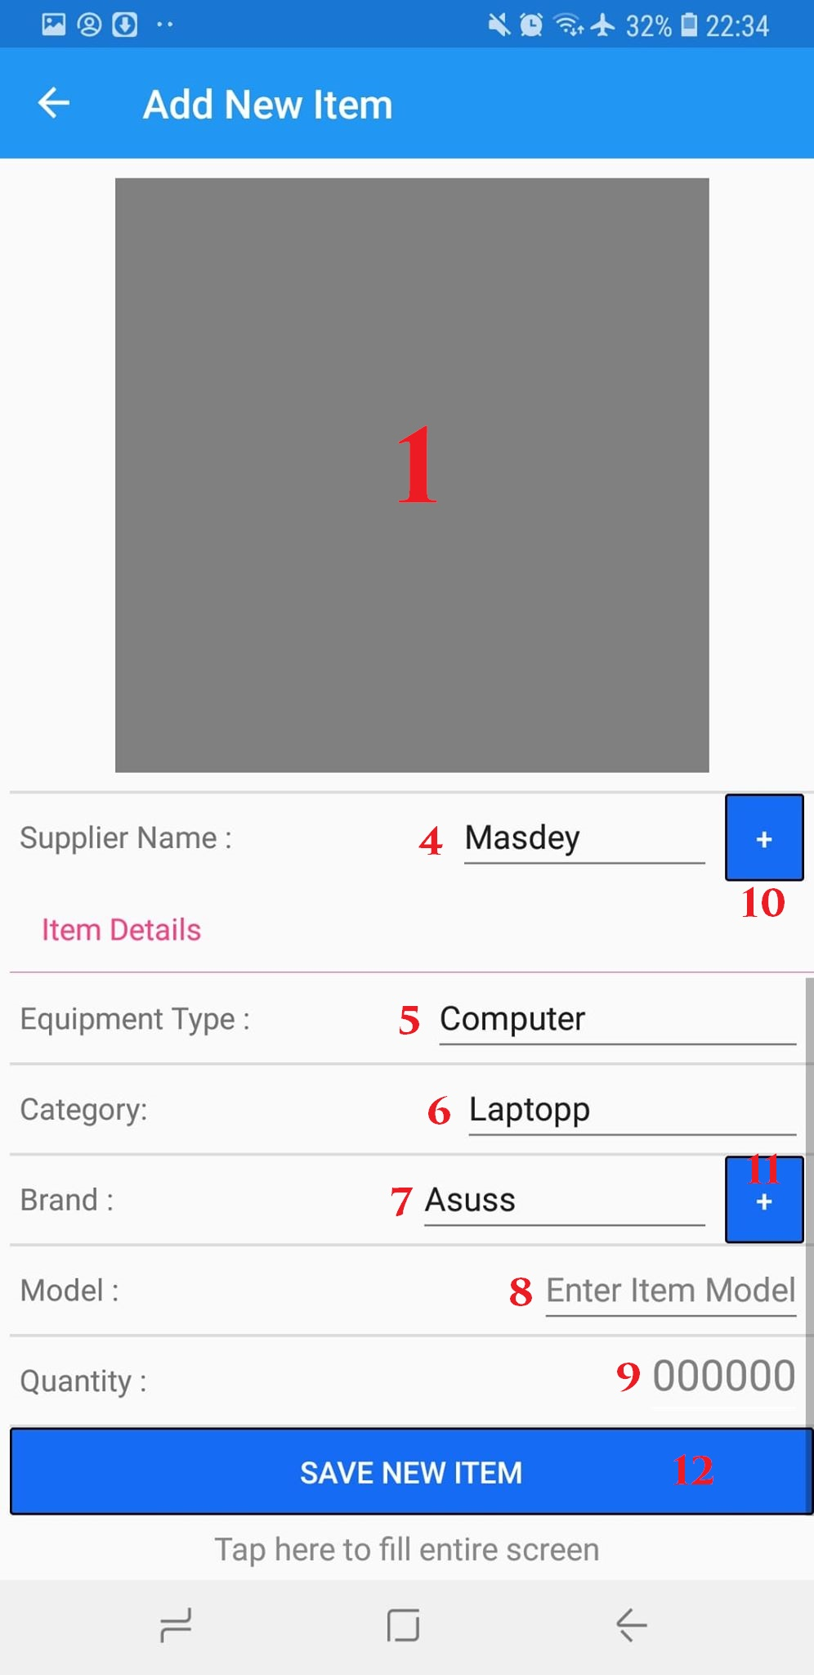

Figure 132. Add New Item

**Fields**

|  |  |  |  |  |  |  |
| --- | --- | --- | --- | --- | --- | --- |
| **No** | **Field Name** | **Description** | **Read only** | **Mandatory** | **Control Type** | **Data Type** |
| 2 | Delivery Order Number | Fill Delivery order number | No | Yes | TextBox | String |
| 3 | Delovery Date | Select Date | No | Yes | Date Picker | Date Time |
| 4 | Supplier Name | Select Supplier Name | No | Yes | Drop down list | String |
| 5 | Equipment Type | Selecy equipment type | No | Yes | Drop down list | String |
| 6 | Category | Select Category | No | Yes | Drop down list | String |
| 7 | Brand | Select Brand | No | Yes | Drop down list | String |
| 8 | Model | Fill Model | No | Yes | TextBox | String |
| 9 | Quantity | Fill Quantity | No | Yes | TextBox | int |

Table 136. <Fields> Home page

**Buttons/Hyperlinks:**

|  |  |  |  |  |
| --- | --- | --- | --- | --- |
| **No** | **Function** | **Description** | **Validation** | **Outcome** |
| 1 | Picture | Take item picture | Required | Open Camera and take picture |
| 10 | Add new Supplier | Add new  Supplier | N/A | Show pop up add Supplier |
| 11 | Add new Brand | Add new Brand | N/A | Show pop up add Brand |
| 12 | Add new Item | Add new Item | Validate required fields | Add new item assest |

Table 137. <Buttons/Hyperlinks> Add page



### Add Supplier

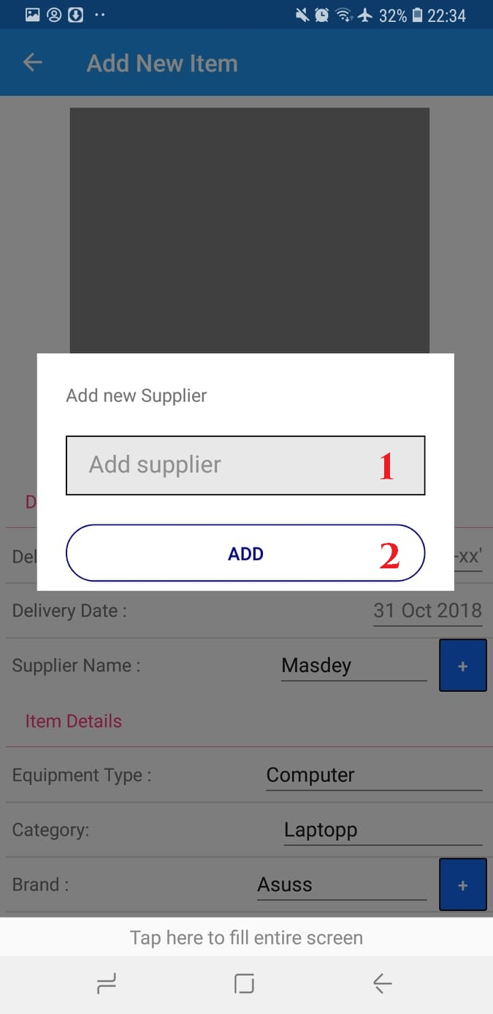

Figure 133. Add Supplier

**Fields**

|  |  |  |  |  |  |  |
| --- | --- | --- | --- | --- | --- | --- |
| **No** | **Field Name** | **Description** | **Read only** | **Mandatory** | **Control Type** | **Data Type** |
| 1 | Add supplier name | Fill supplier name | No | Yes | TextBox | String |

Table 138. <Fields> Home page

**Buttons/Hyperlinks:**

|  |  |  |  |  |
| --- | --- | --- | --- | --- |
| **No** | **Function** | **Description** | **Validation** | **Outcome** |
| 1 | Add supplier | Add new supplier | Validate required fields | Pop out to Add page |

Table 139. <Buttons/Hyperlinks> Add Supplier pop up

### Add Brand

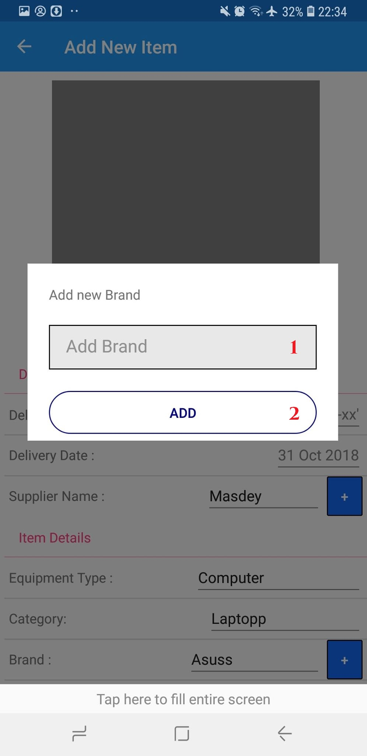

Figure 134. Add Brand

**Fields**

|  |  |  |  |  |  |  |
| --- | --- | --- | --- | --- | --- | --- |
| **No** | **Field Name** | **Description** | **Read only** | **Mandatory** | **Control Type** | **Data Type** |
| 1 | Add Brand name | Fill Brand name | No | Yes | TextBox | String |

Table 140. <Fields> Home page

**Buttons/Hyperlinks:**

|  |  |  |  |  |
| --- | --- | --- | --- | --- |
| **No** | **Function** | **Description** | **Validation** | **Outcome** |
| 1 | Add Brand | Add new Brand | Validate required fields | Pop out to Add page |

Table 141. <Buttons/Hyperlinks> Add Brand pop up

### Scan QR Code

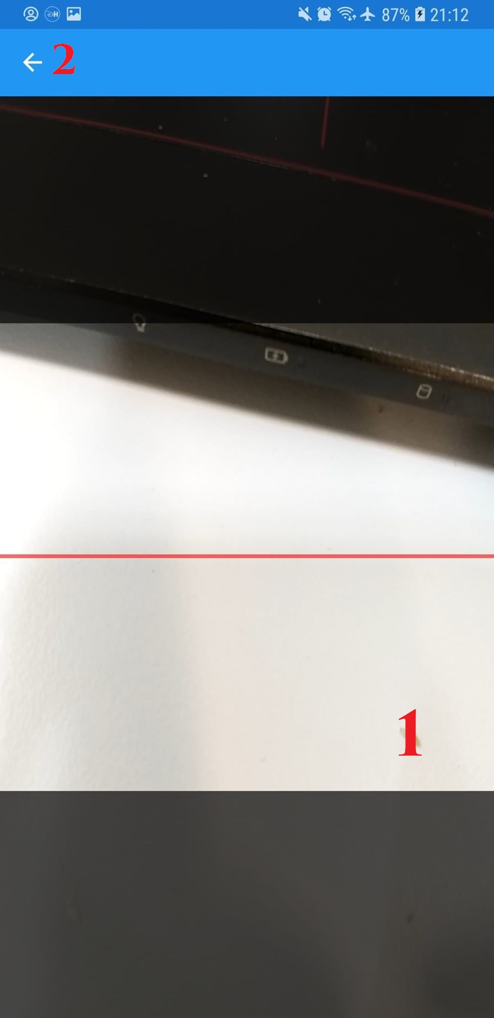

Figure 135. Scan QR Code

**Fields:N/A**

**Buttons/Hyperlinks:**

|  |  |  |  |  |
| --- | --- | --- | --- | --- |
| **No** | **Function** | **Description** | **Validation** | **Outcome** |
| 1 | Camera Scan | Scan for Qr code | N/A | Navigate to Item Detail Page |
| 2 | Go Back | Exit Camera | N/A | Navigate to MainMenu |

Table 142. <Buttons/Hyperlinks> Qr scan

### Search by Location Criteria

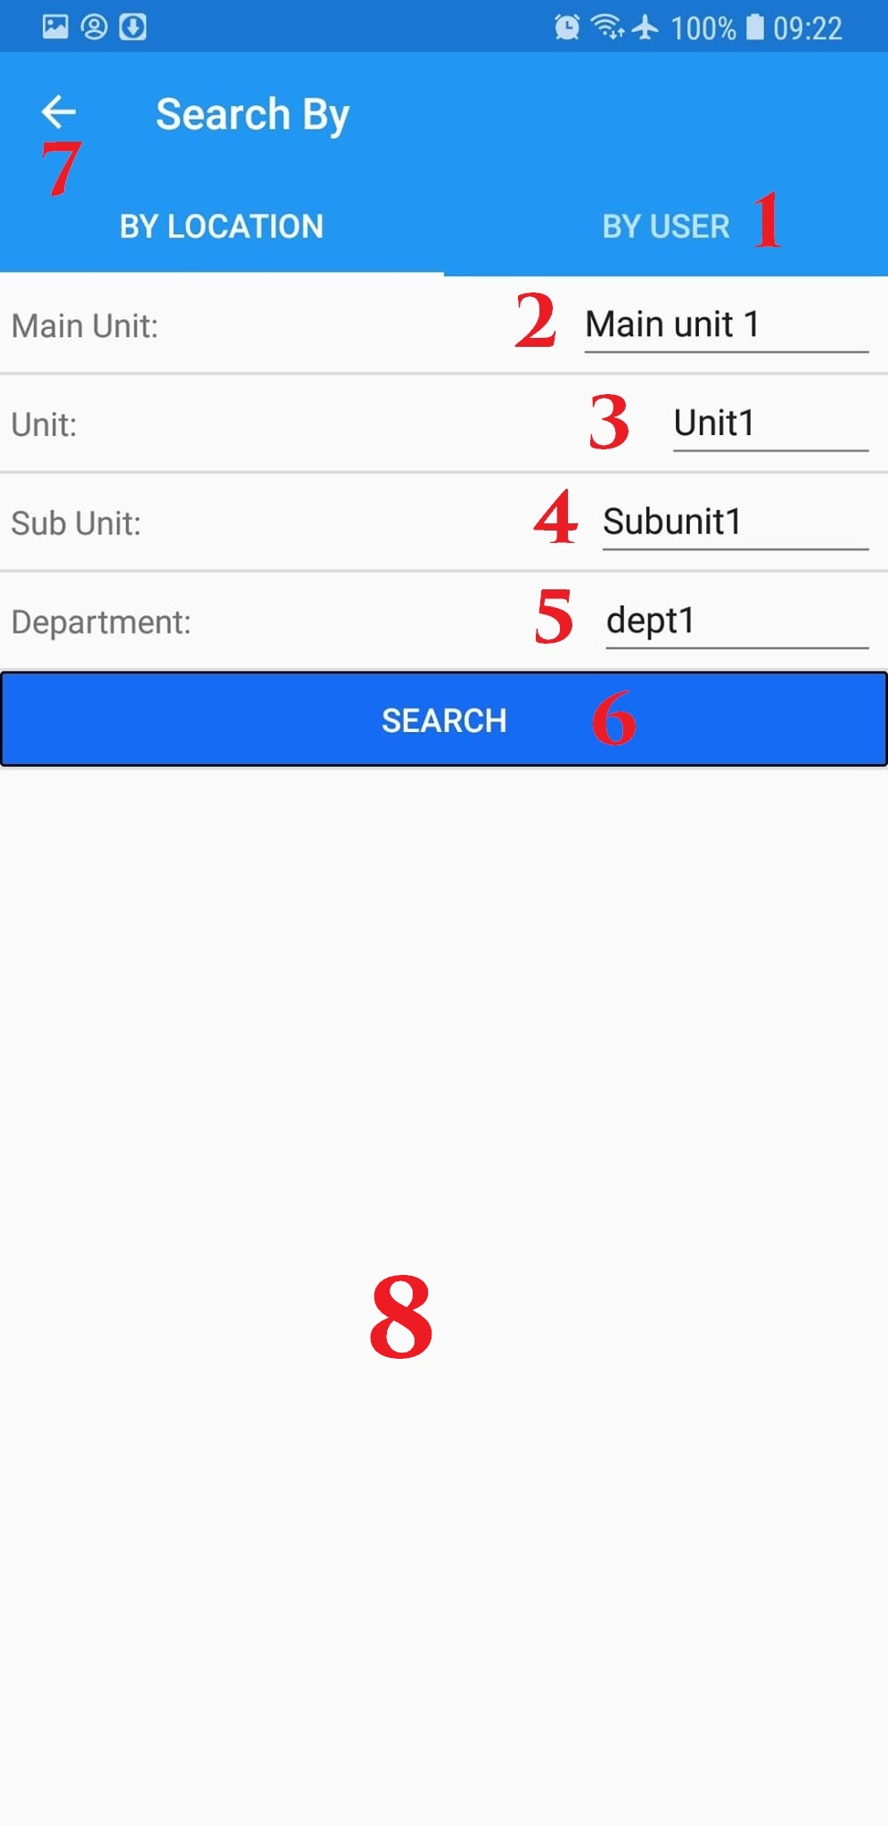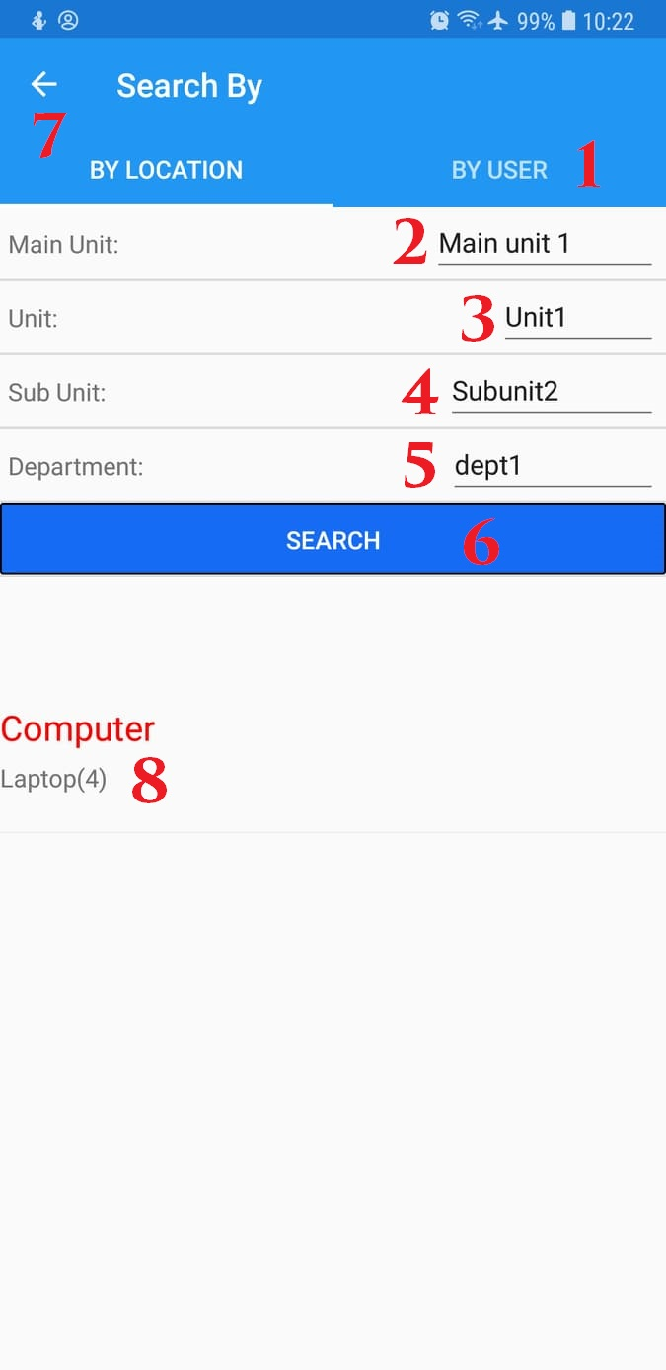

Figure 136. Search by Location Criteria

**Fields**

|  |  |  |  |  |  |  |
| --- | --- | --- | --- | --- | --- | --- |
| **No** | **Field Name** | **Description** | **Read only** | **Mandatory** | **Control Type** | **Data Type** |
| 2 | Main Unit Select | Select Main Unit for search | No | Yes | Drop down list | String |
| 3 | Unit Select | Select Unit for search | No | Yes | Drop down list | String |
| 4 | Sub Unit Select | Select Sub Unit for search | No | Yes | Drop down list | String |
| 5 | Department select | Select Department for search | No | Yes | Drop down list | String |

Table 143. <Fields> Search by location

**Buttons/Hyperlinks:**

|  |  |  |  |  |
| --- | --- | --- | --- | --- |
| **No** | **Function** | **Description** | **Validation** | **Outcome** |
| 1 | Search by user | Search by user | N/A | Navigate to Search by user tab |
| 6 | Search | Search base on location | N/A | Show out item list |
| 7 | Go back | Go back | N/A | Go to Main menu page |
| 8 | Item List | List of Search item | N/A | Show pop up contain list of item |

Table 144. <Buttons/Hyperlinks> Search by location

### Item List pop up

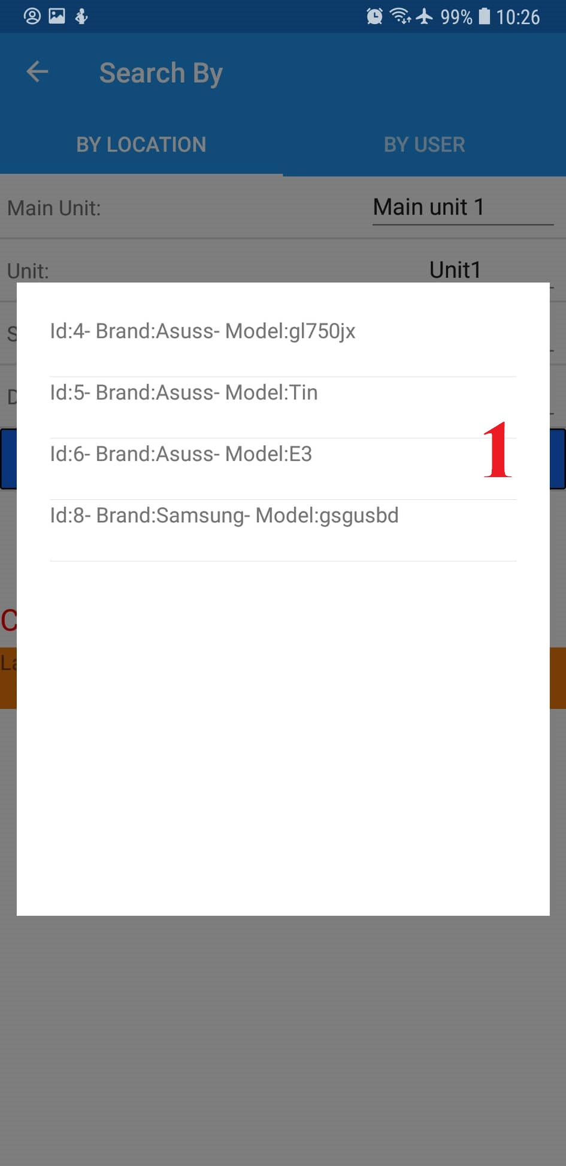

Figure 137. Location Search Item List pop up

**Fields:N/A**

**Buttons/Hyperlinks:**

|  |  |  |  |  |
| --- | --- | --- | --- | --- |
| **No** | **Function** | **Description** | **Validation** | **Outcome** |
| 1 | List of Item | List of search Item | N/A | Navigate to Detail page of selected item |

Table 145. <Buttons/Hyperlinks> Item List pop up

### Search by User Criteria

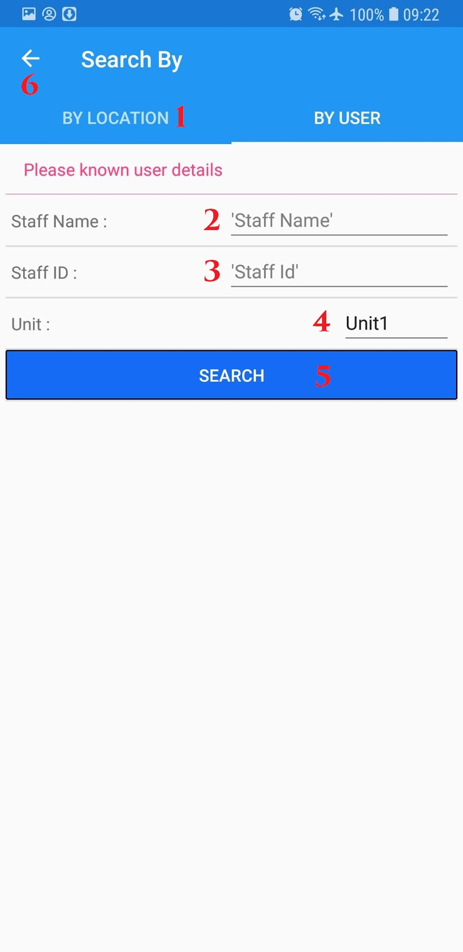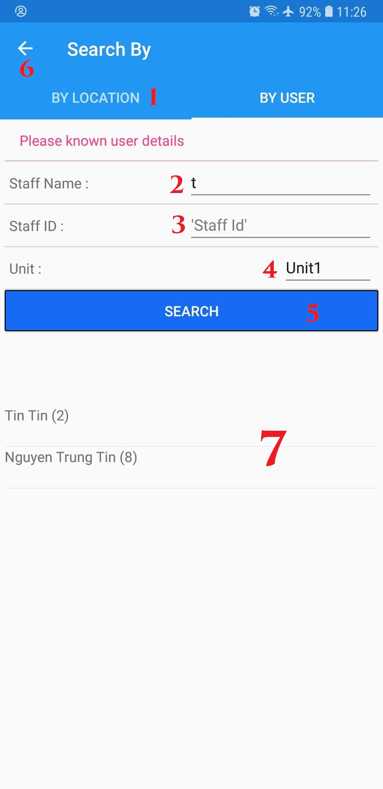

Figure 138. Search by User Criteria

**Fields**

|  |  |  |  |  |  |  |
| --- | --- | --- | --- | --- | --- | --- |
| **No** | **Field Name** | **Description** | **Read only** | **Mandatory** | **Control Type** | **Data Type** |
| 2 | Staff Name | Fill staff Name | No | Yes | TextBox | String |
| 3 | Staff Id | Fill staff id | No | Yes | TextBox | String |
| 4 | Unit | Select staff unit | No | Yes | Drop down list | String |

Table 146. <Fields> Home page

**Buttons/Hyperlinks:**

|  |  |  |  |  |
| --- | --- | --- | --- | --- |
| **No** | **Function** | **Description** | **Validation** | **Outcome** |
| 1 | Search by location | Search by location | N/A | Navigate to Search by location tab |
| 5 | Search | Search issued item with staff input | Validate required fields | Show list of staff that have issued item |
| 6 | Go back | Go back | N/A | Navigate to Main menu page |
| 7 | Item List | List of Search item | N/A | Show pop up contain list of item |

Table 147. <Buttons/Hyperlinks> Home page

### View Equipment Detail page

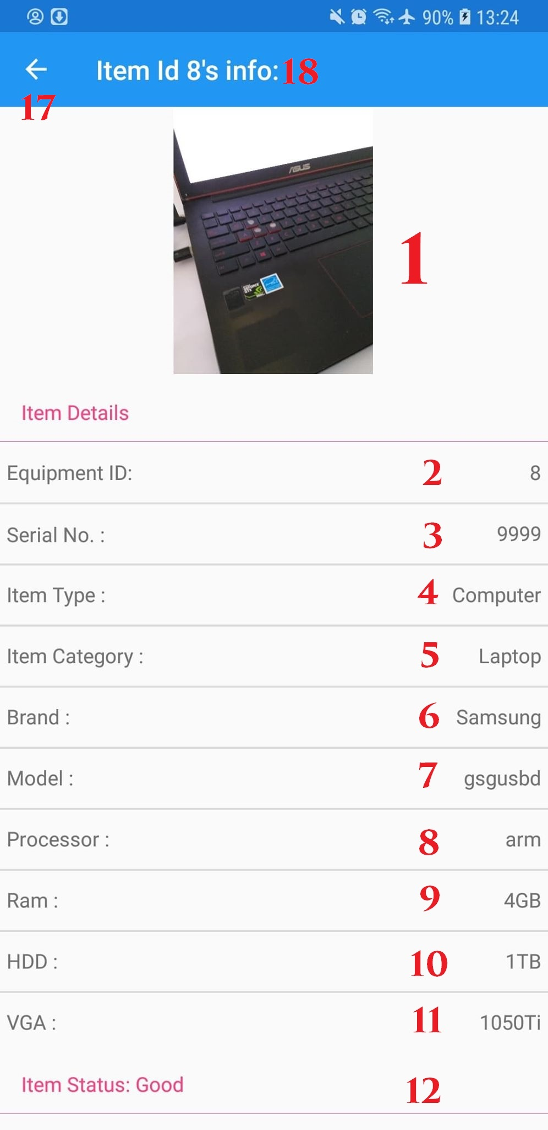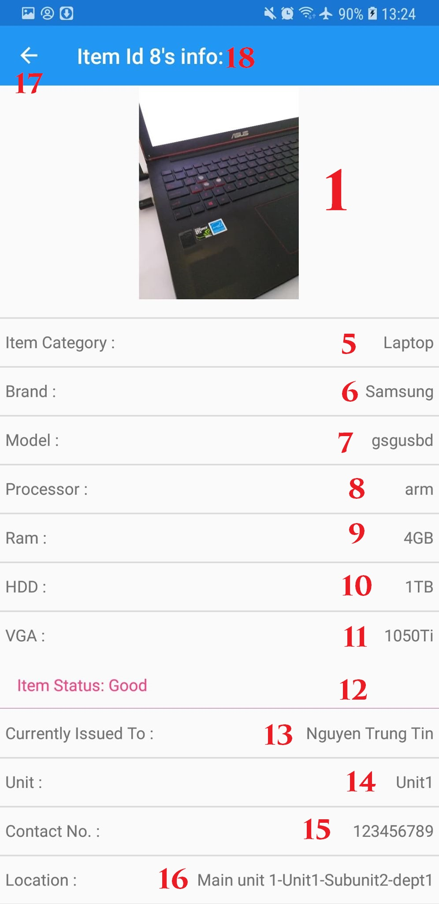

Figure 139. View Equipment

**Fields**

|  |  |  |  |  |  |  |
| --- | --- | --- | --- | --- | --- | --- |
| **No** | **Field Name** | **Description** | **Read only** | **Mandatory** | **Control Type** | **Data Type** |
| 2 | Equipment Id | Info about equipment id | Yes | Yes | Label | String |
| 3 | Serial Number | Info about Serial number | Yes | Yes | Label | String |
| 4 | Item type | Info about item type | Yes | Yes | Label | String |
| 5 | Item Category | Info about item category | Yes | Yes | Label | String |
| 6 | Item Brand | Info about item brand | Yes | Yes | Label | String |
| 7 | Item model | Info about item model | Yes | Yes | Label | String |
| 8 | Item processor | Info about item processor | Yes | Yes | Label | String |
| 9 | Item Ram | Info about item Ram | Yes | Yes | Label | String |
| 10 | Item HDD | Info about Item HDD | Yes | Yes | Label | String |
| 11 | Item VGA | Info about Item VGA | Yes | Yes | Label | String |
| 12 | Item Status | Info about item status | Yes | Yes | Label | String |
| 13 | Issued to | Name of employee item issued to | Yes | Yes | Label | String |
| 14 | Unit | Unit that employee belong | Yes | Yes | Label | String |
| 15 | Contact Number | Contact number of that employee | Yes | Yes | Label | String |
| 16 | Location | Item location info | Yes | Yes | Label | String |
| 18 | Title | Title of page | Yes | Yes | Label | String |

Table 148. <Fields> View Equipment detail page

**Buttons/Hyperlinks:**

|  |  |  |  |  |
| --- | --- | --- | --- | --- |
| **No** | **Function** | **Description** | **Validation** | **Outcome** |
| 17 | Go back | Go back to main menu | N/A | Navigate to Main menu |

Table 149. <Buttons/Hyperlinks> View Equipment detail page

## Web Interface

### Login Page

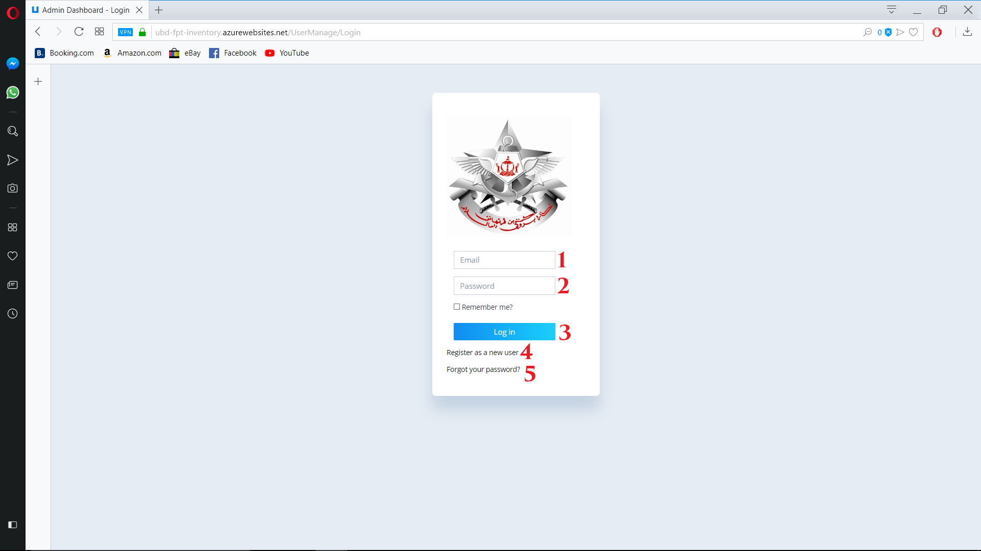

Figure 140. Login page

**Fields**

|  |  |  |  |  |  |  |
| --- | --- | --- | --- | --- | --- | --- |
| **No** | **Field Name** | **Description** | **Read only** | **Mandatory** | **Control Type** | **Data Type** |
| 1 | Username | Username to login | No | Yes | TextBox | String |
| 2 | Password | Password to login | No | Yes | TextBox | String |

Table 150. <Fields> Login page

**Buttons/Hyperlinks:**

|  |  |  |  |  |
| --- | --- | --- | --- | --- |
| **No** | **Function** | **Description** | **Validation** | **Outcome** |
| 3 | Login | Login to system | Validate account | Navigate to Main menu |
| 4 | Create new account | Help inventory user to create new account | N/A | Navigate to create new account page |
| 5 | Forgot password | Help inventory user to reset password | N/A | Navigate to reset password page |

Table 151. <Buttons/Hyperlinks> Login page

* + 1. Register Page

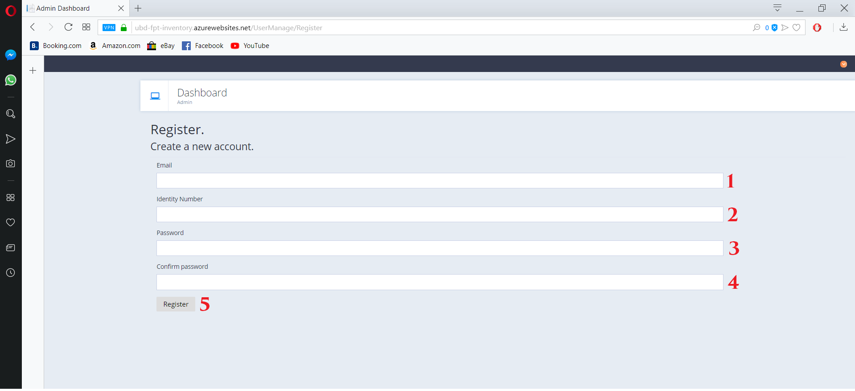

Figure 141. Register Page

**Fields**

|  |  |  |  |  |  |  |
| --- | --- | --- | --- | --- | --- | --- |
| **No** | **Field Name** | **Description** | **Read only** | **Mandatory** | **Control Type** | **Data Type** |
| 1 | Email | Enter staff’s email | No | Yes | Text | String |
| 2 | Identity number | Enter staff’s Identity number | No | Yes | Text | String |
| 3 | Password | Enter password | No | Yes | Text | String |
| 4 | Confirm Password | Re-enter password | No | Yes | Text | String |

Table 152. <Fields> Register Page

**Buttons/Hyperlinks:**

|  |  |  |  |  |
| --- | --- | --- | --- | --- |
| **No** | **Function** | **Description** | **Validation** | **Outcome** |
| 5 | Register | Register account | Check all input and valid indentity number | Create new account and wait for Confirm from admin |

Table 153. <Buttons/Hyperlinks> Register Page

* + 1. Forgot password page.

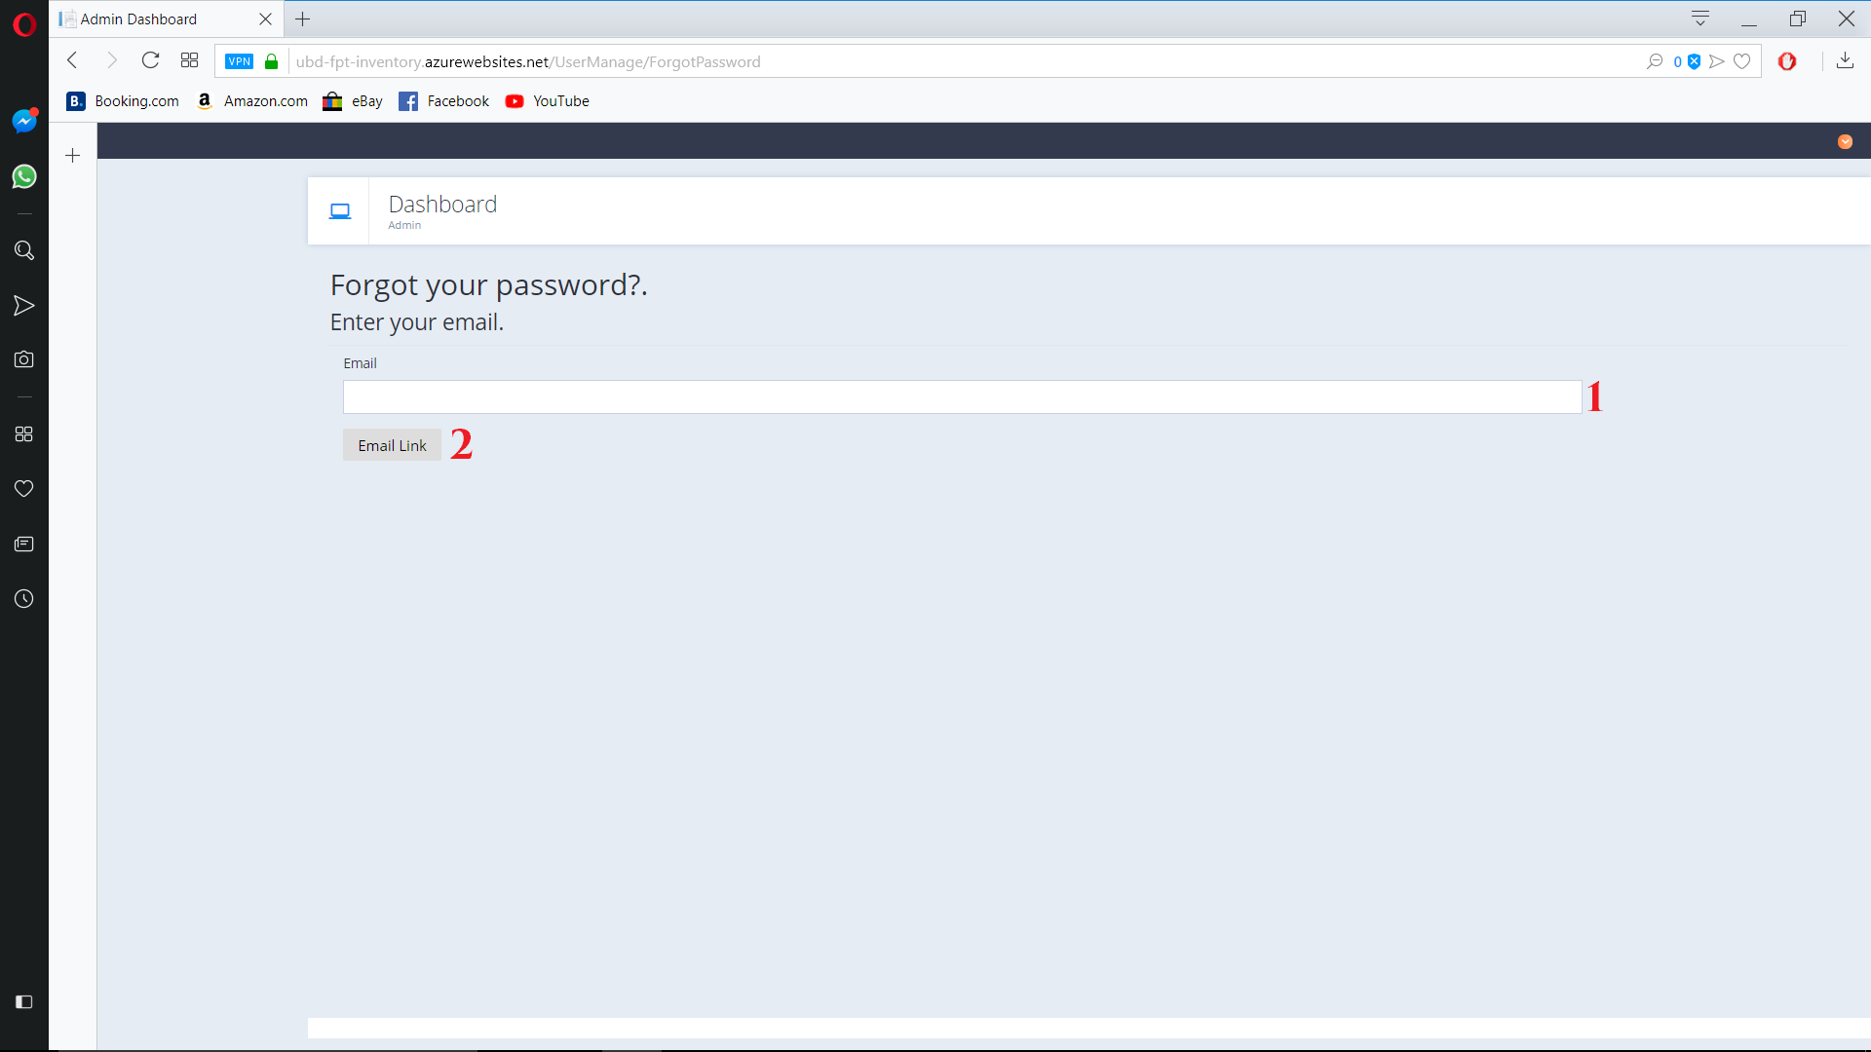

Figure 142. Forgot password page

**Fields**

|  |  |  |  |  |  |  |
| --- | --- | --- | --- | --- | --- | --- |
| **No** | **Field Name** | **Description** | **Read only** | **Mandatory** | **Control Type** | **Data Type** |
| 1 | Email | Inventory user’s Email | No | Yes | TextBox | String |

Table 154. <Fields> Forgot password page

**Buttons/Hyperlinks:**

|  |  |  |  |  |
| --- | --- | --- | --- | --- |
| **No** | **Function** | **Description** | **Validation** | **Outcome** |
| 2 | Email Link | Get email link for reset password | Validate required fields | Send reset password email to inventory’s user email |

Table 155. <Buttons/Hyperlinks> Forgot password page

* + 1. Main Menu

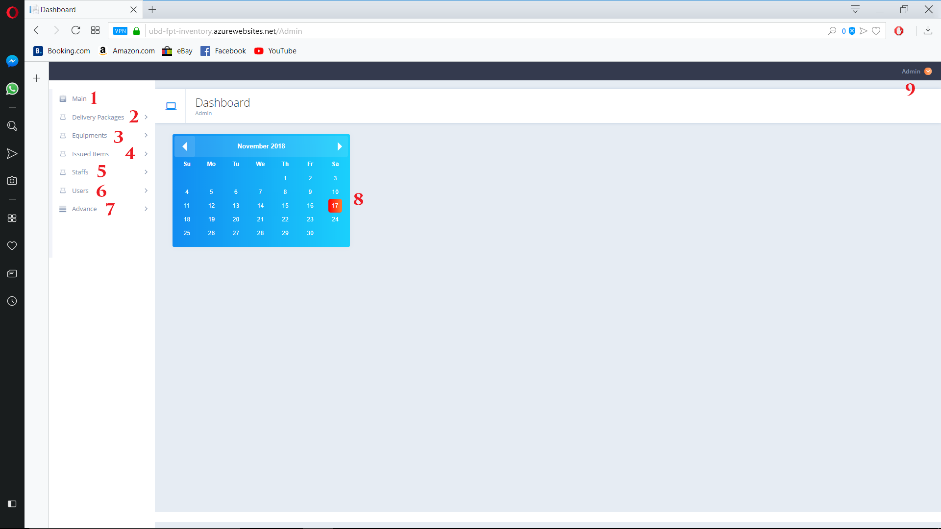

Figure 143. Main Menu

**Calendar**

|  |  |  |  |  |  |  |
| --- | --- | --- | --- | --- | --- | --- |
| **No** | **Field Name** | **Description** | **Read only** | **Mandatory** | **Control Type** | **Data Type** |
| 8 | Calender | Show Calendar | Yes | Yes | Calendar | Datetime |

Table 156. <Calendar> Main Menu

**Buttons/Hyperlinks:**

|  |  |  |  |  |
| --- | --- | --- | --- | --- |
| **No** | **Function** | **Description** | **Validation** | **Outcome** |
| 1 | Main | Go to Home page | Validate all required fields | Redirect to Home Page |
| 2 | Delivery Package | Show option for Devilery pakage | N/A | Show submenu of all option belong to Delivery Package mangament |
| 3 | Equipment | Show option for Equipment | N/A | Show submenu of all option belong to Equipment mangament |
| 4 | Issued item | Show option for Issued item | N/A | Show submenu of all option belong to Issued item mangament |
| 5 | Staff | Show option for Staff | N/A | Show submenu of all option belong to Staff mangament |
| 6 | Users | Show option for Users | N/A | Show submenu of all option belong to Users mangament |
| 7 | Advance | Show option for Advance | N/A | Show submenu of all option belong to Advance mangament |
| 9 | Admin | Show log out button | N/A | Show log out option |

Table 157. <Buttons/Hyperlinks> Main Menu

* + 1. Delivery Package Sub-Menu

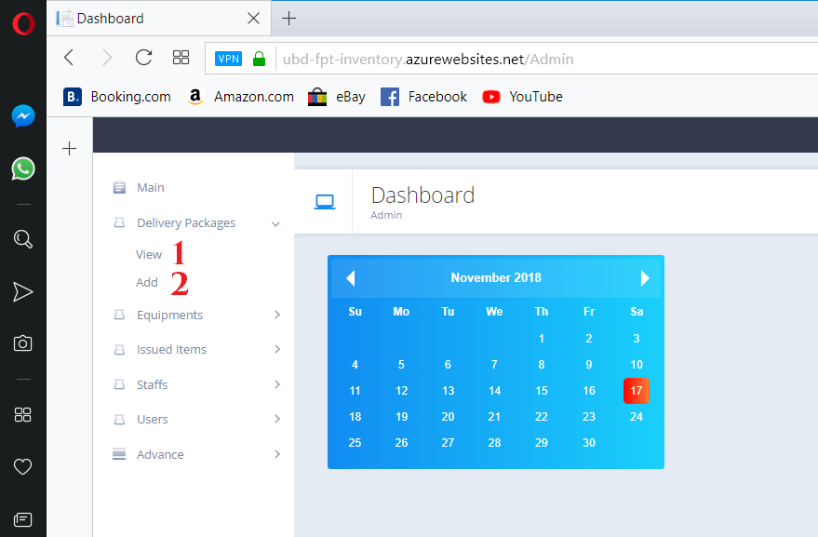

Figure 144. Delivery package sub menu

**Buttons/Hyperlinks:**

|  |  |  |  |  |
| --- | --- | --- | --- | --- |
| **No** | **Function** | **Description** | **Validation** | **Outcome** |
| 1 | View | Go to view package page | N/A | Redirect to view package page |
| 2 | Add | Go to add new package page | N/A | Redirect to add new package page |

Table 158. <Buttons/Hyperlinks>Delivery Package Sub-Menu

* + 1. View package page

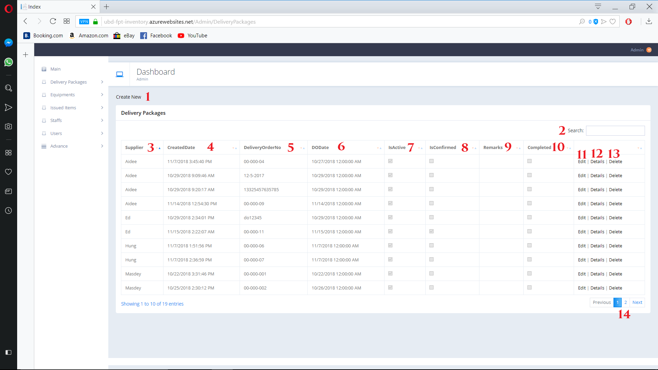

Figure 145. Delivery package sub menu

**Fields**

|  |  |  |  |  |  |  |
| --- | --- | --- | --- | --- | --- | --- |
| **No** | **Field Name** | **Description** | **Read only** | **Mandatory** | **Control Type** | **Data Type** |
| 2 | Search | Search by user input | No | No | TextBox | String |
| 3 | Supplier | Delivery Package’s suplier | Yes | Yes | Text | String |
| 4 | CreatedDate | Delivery Package’s created day | Yes | Yes | Text | String |
| 5 | DeliveryOrderNo | Delivery Package’s order number | Yes | Yes | Text | String |
| 6 | DeliveryOrderDate | Delivery Package’s order date | Yes | Yes | Text | String |
| 7 | IsActive | Delivery Package iss active for using | Yes | Yes | CheckBox | Boolean |
| 8 | Isconfirm | Delivery Package is confirm for using | Yes | Yes | CheckBox | Boolean |
| 9 | Remark | Delivery Package’s remark | Yes | Yes | Text | String |
| 10 | Completed | Delivery Package is used up | Yes | Yes | CheckBox | Boolean |

Table 159. <Fields>View delivery package

**Buttons/Hyperlinks:**

|  |  |  |  |  |
| --- | --- | --- | --- | --- |
| **No** | **Function** | **Description** | **Validation** | **Outcome** |
| 1 | Create new | Go to add new delivery package page | N/A | Navigate to add new delivery package page |
| 11 | Edit | Go to Edit delivery package page | N/A | Navigate to edit delivery package page |
| 12 | Detail | Go to deital delivery package page | N/A | Navigate to detail delivery package page |
| 13 | Delete | Go to delete delivery package page | N/A | Navigate to delete comfirm delivery package page |
| 14 | Navigation | Navigation through pages of list | N/A | Show selected page of delivery package list |

Table 160. <Buttons/Hyperlinks>View delivery package

* + 1. Create new delivery package page

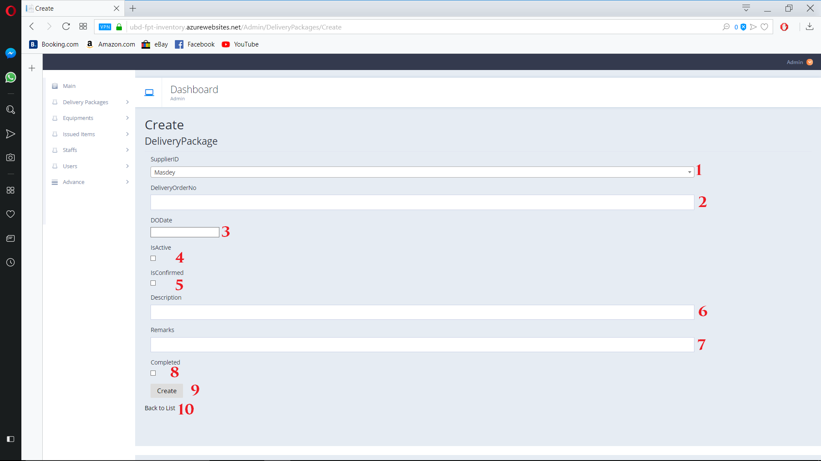

Figure 161. Create new Delivery Package page

**Fields**

|  |  |  |  |  |  |  |
| --- | --- | --- | --- | --- | --- | --- |
| **No** | **Field Name** | **Description** | **Read only** | **Mandatory** | **Control Type** | **Data Type** |
| 1 | SupplierId | Delivery package’s Supplier | No | Yes | Dropdown list | String |
| 2 | DeliveryOrderNo | Delivery package’s Order Number | No | Yes | TextBox | String |
| 3 | Delivery of Order date | Delivery Package’s Delivery day | No | Yes | Date Picker | Datetime |
| 4 | IsActive | Delivery Package is active | No | No | CheckBox | Boolean |
| 5 | IsConfirm | Delivery Package is confirm | No | No | CheckBox | Boolean |
| 6 | Decription | Delivery Package’s Decription | No | No | Textbox | String |
| 7 | Remark | Delivery Package’s remark | No | No | TextBox | String |
| 8 | Completed | Delivery Package is complete | No | No | CheckBox | Boolean |

Table 162. <Buttons/Hyperlinks> Create new delivery package

**Buttons/Hyperlinks:**

|  |  |  |  |  |
| --- | --- | --- | --- | --- |
| **No** | **Function** | **Description** | **Validation** | **Outcome** |
| 9 | Create | Create new delivery package | All required input fields | Add new delivery package |
| 10 | Back to list | Go back to view delivery package page | N/A | Navigate to view delivery package page |

Table 163. <Buttons/Hyperlinks> Create new delivery package

* + 1. Edit delivery package page

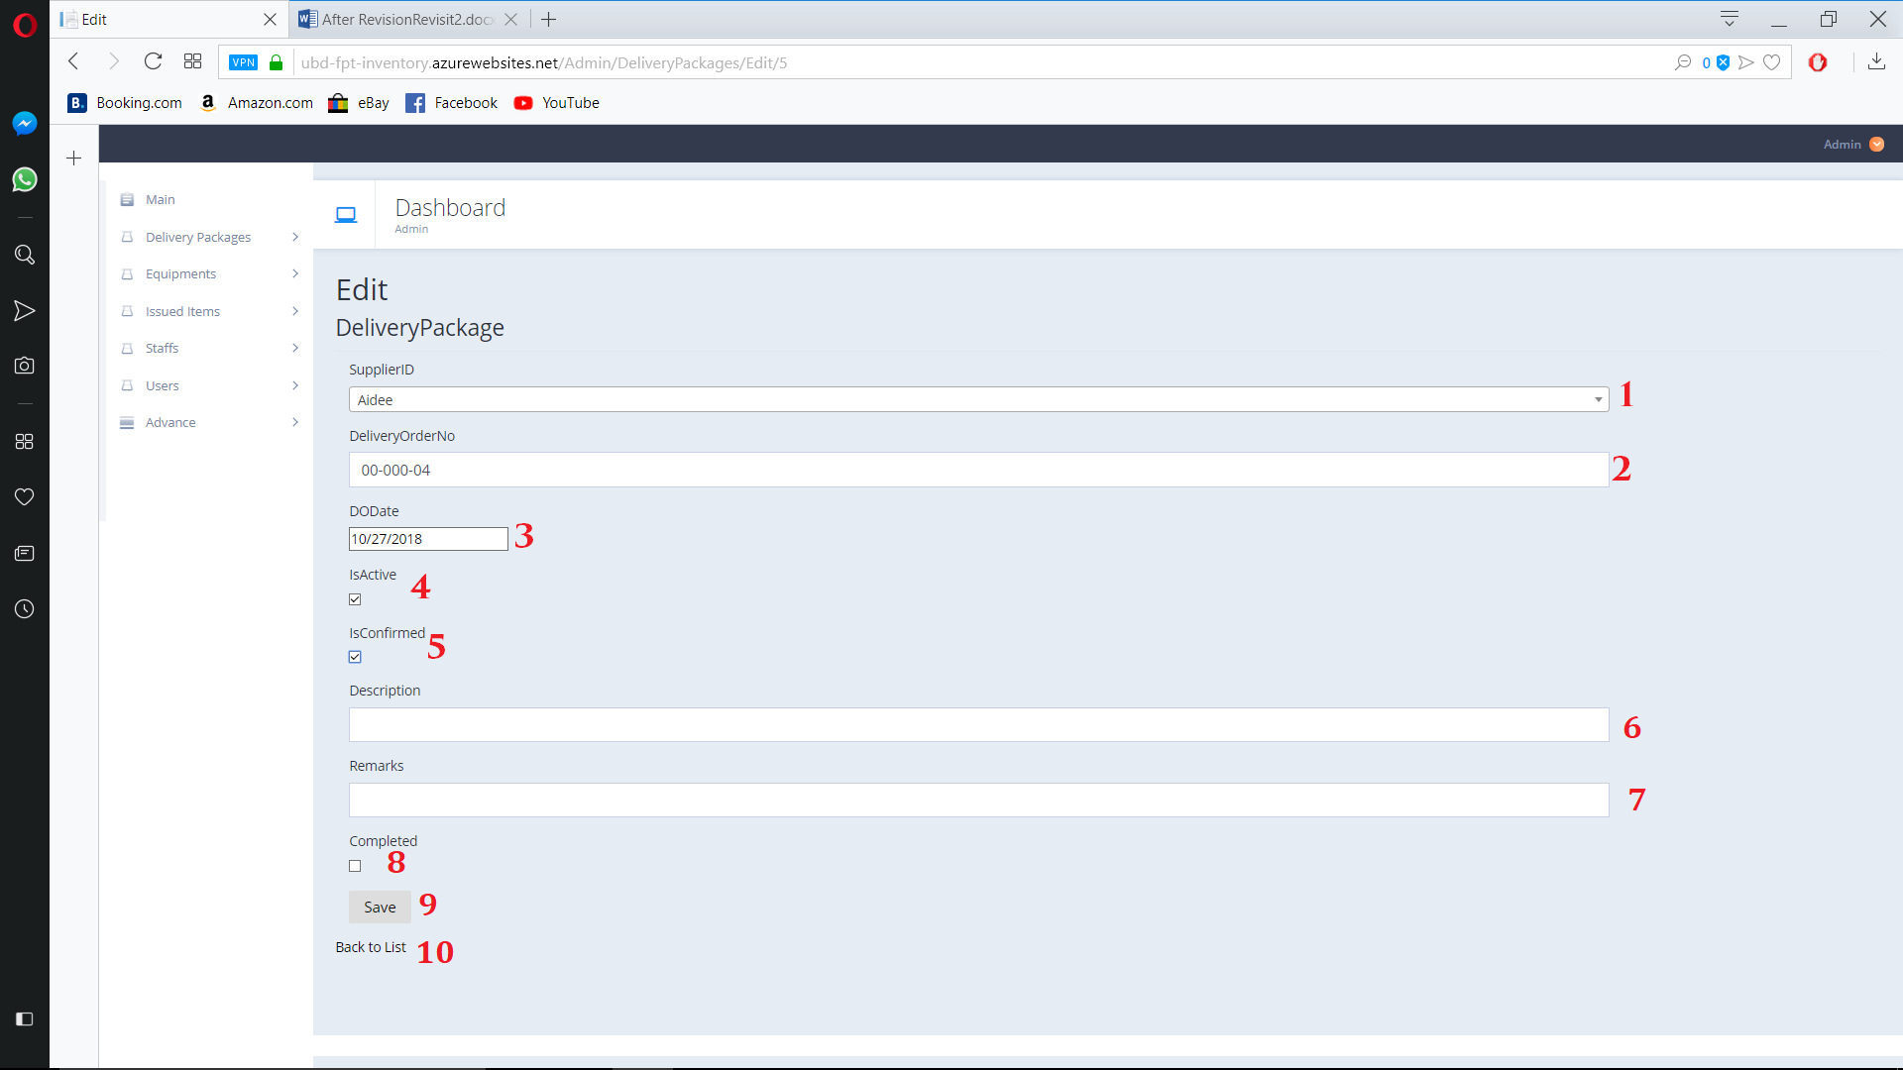

Figure 147. Edit delivery package page

**Fields**

|  |  |  |  |  |  |  |
| --- | --- | --- | --- | --- | --- | --- |
| **No** | **Field Name** | **Description** | **Read only** | **Mandatory** | **Control Type** | **Data Type** |
| 1 | SupplierId | Delivery package’s Supplier | No | Yes | Dropdown list | String |
| 2 | DeliveryOrderNo | Delivery package’s Order Number | No | Yes | TextBox | String |
| 3 | Delivery of Order date | Delivery Package’s Delivery day | No | Yes | Date Picker | Datetime |
| 4 | IsActive | Delivery Package is active | No | No | CheckBox | Boolean |
| 5 | IsConfirm | Delivery Package is confirm | No | No | CheckBox | Boolean |
| 6 | Decription | Delivery Package’s Decription | No | No | Textbox | String |
| 7 | Remark | Delivery Package’s remark | No | No | TextBox | String |
| 8 | Completed | Delivery Package is complete | No | No | CheckBox | Boolean |

Table 164. <Buttons/Hyperlinks> Edit delivery package

**Buttons/Hyperlinks:**

|  |  |  |  |  |
| --- | --- | --- | --- | --- |
| **No** | **Function** | **Description** | **Validation** | **Outcome** |
| 9 | Save | Create new delivery package | All required input fields | Add new delivery package |
| 10 | Back to list | Go back to view delivery package page | N/A | Navigate to view delivery package page |

Table 165. <Buttons/Hyperlinks> Edit delivery package

* + 1. Delivery package detail page

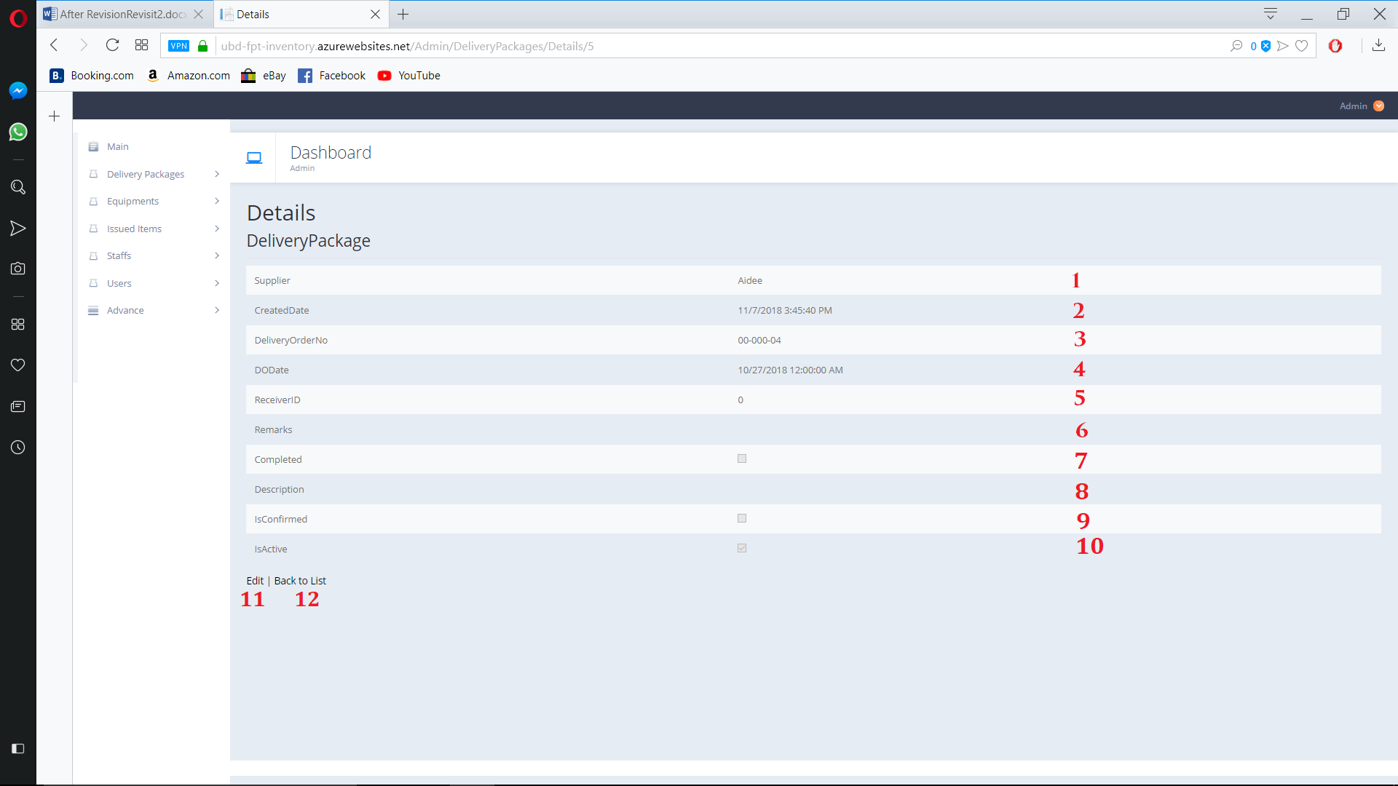

Figure 148. Delivery package detail page

**Fields**

|  |  |  |  |  |  |  |
| --- | --- | --- | --- | --- | --- | --- |
| **No** | **Field Name** | **Description** | **Read only** | **Mandatory** | **Control Type** | **Data Type** |
| 1 | Supplier | Delivery package’s Supplier | Yes | Yes | Text | String |
| 2 | CreatedDay | Delivery package’s Created Day | Yes | Yes | Text | String |
| 3 | DeliveryOrderNo | Delivery package’s Order Number | Yes | Yes | Text | String |
| 4 | Delivery of Order date | Delivery Package’s Delivery day | Yes | Yes | Text | Datetime |
| 5 | ReceiverId | Delivery Package’s Receiver id | Yes | Yes | Text | String |
| 6 | Remark | Delivery Package’s remark | Yes | No | Text | String |
| 7 | Completed | Delivery Package is complete | Yes | No | CheckBox | Boolean |
| 8 | Description | Delivery Package’s Description | Yes | No | Text | String |
| 9 | IsComfirmed | Delivery Package’s  Comfirmed state | Yes | No | CheckBox | Boolean |
| 10 | IsActive | Delivery Package’s  Active state | Yes | No | CheckBox | Boolean |

Table 166. <Buttons/Hyperlinks> Detail delivery package

**Buttons/Hyperlinks:**

|  |  |  |  |  |
| --- | --- | --- | --- | --- |
| **No** | **Function** | **Description** | **Validation** | **Outcome** |
| 11 | Edit | Go to Edit Page | N/A | Navigate to edit Delivery Package page |
| 12 | Back to list | Go back to view delivery package page | N/A | Navigate to view delivery package page |

Table 167. <Buttons/Hyperlinks> Detail delivery package

* + 1. Delivery package delete page

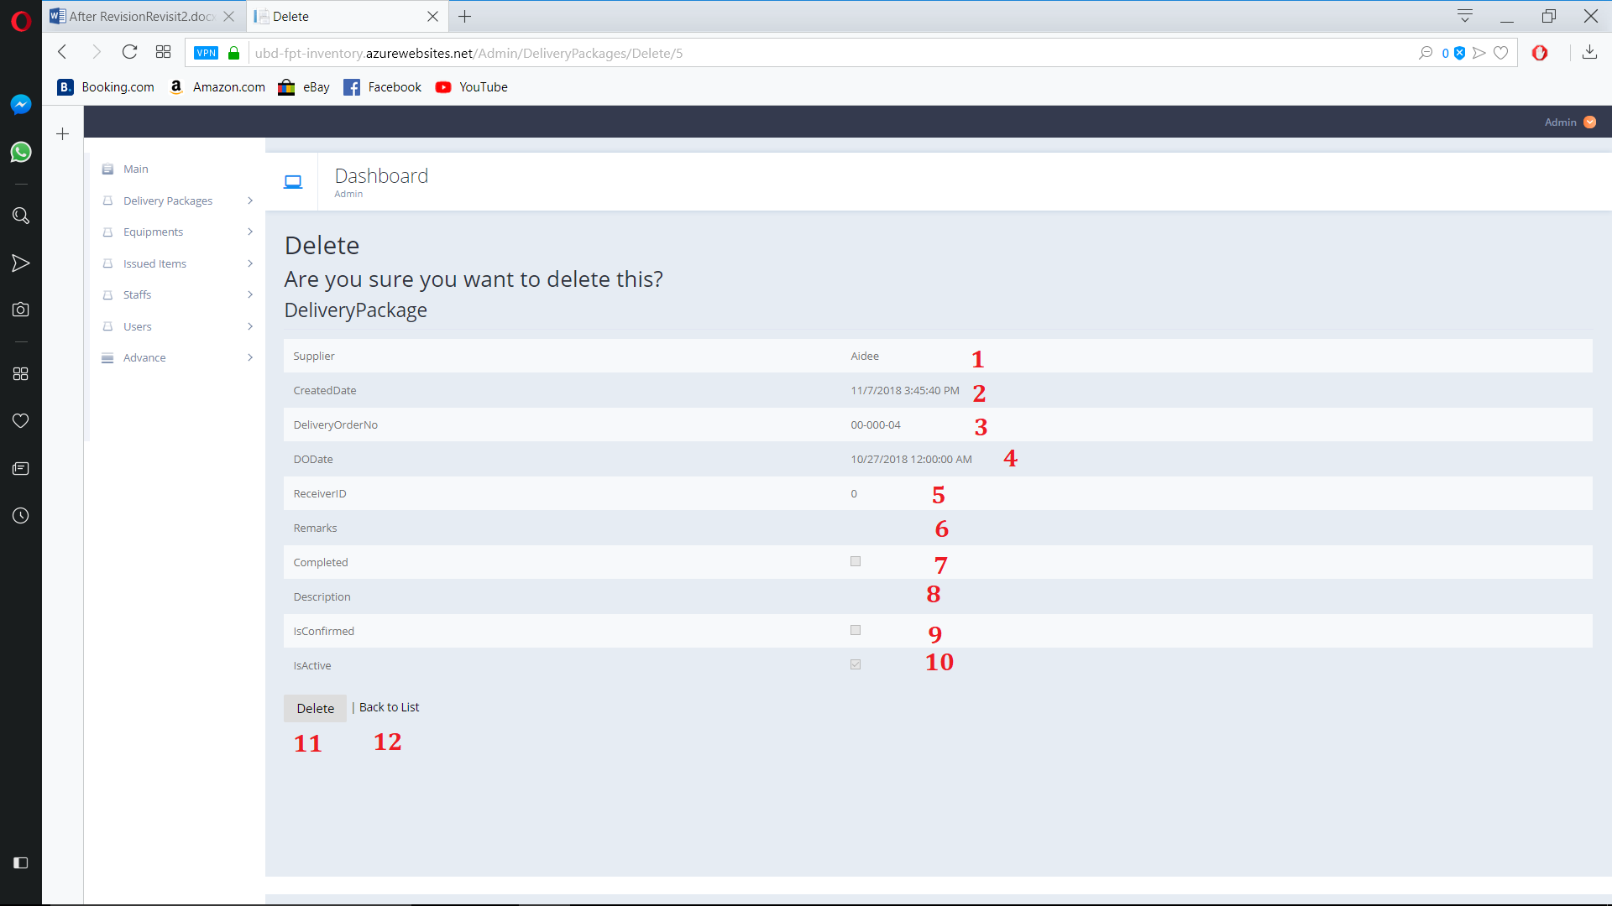

Figure 149. Delivery package delete page

**Fields**

|  |  |  |  |  |  |  |
| --- | --- | --- | --- | --- | --- | --- |
| **No** | **Field Name** | **Description** | **Read only** | **Mandatory** | **Control Type** | **Data Type** |
| 1 | Supplier | Delivery package’s Supplier | Yes | Yes | Text | String |
| 2 | CreatedDay | Delivery package’s Created Day | Yes | Yes | Text | String |
| 3 | DeliveryOrderNo | Delivery package’s Order Number | Yes | Yes | Text | String |
| 4 | Delivery of Order date | Delivery Package’s Delivery day | Yes | Yes | Text | Datetime |
| 5 | ReceiverId | Delivery Package’s Receiver id | Yes | Yes | Text | String |
| 6 | Remark | Delivery Package’s remark | Yes | No | Text | String |
| 7 | Completed | Delivery Package is complete | Yes | No | CheckBox | Boolean |
| 8 | Description | Delivery Package’s Description | Yes | No | Text | String |
| 9 | IsComfirmed | Delivery Package’s  Comfirmed state | Yes | No | CheckBox | Boolean |
| 10 | IsActive | Delivery Package’s  Active state | Yes | No | CheckBox | Boolean |

Table 168. <Buttons/Hyperlinks> Detail delivery package

**Buttons/Hyperlinks:**

|  |  |  |  |  |
| --- | --- | --- | --- | --- |
| **No** | **Function** | **Description** | **Validation** | **Outcome** |
| 11 | Delete | Delete current package | N/A | Delete current package |
| 12 | Back to list | Go back to view delivery package page | N/A | Navigate to view delivery package page |

Table 169. <Buttons/Hyperlinks> Detail delivery package

* + 1. Equipment view page

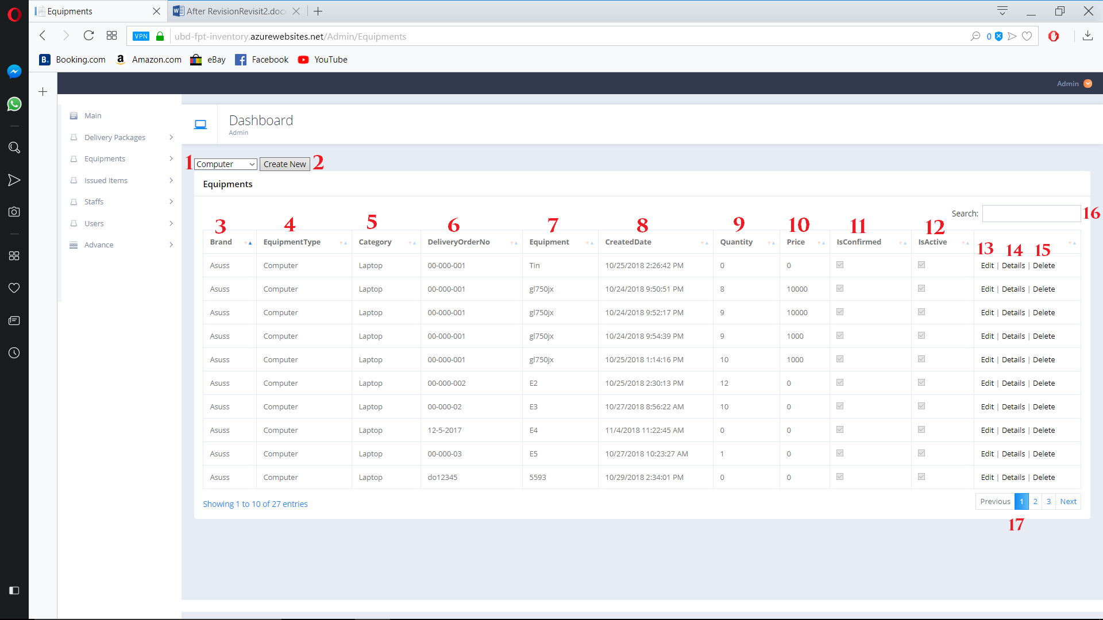

Figure 150. Equipment view Page

**Fields**

|  |  |  |  |  |  |  |
| --- | --- | --- | --- | --- | --- | --- |
| **No** | **Field Name** | **Description** | **Read only** | **Mandatory** | **Control Type** | **Data Type** |
| 1 | Equipment type dropdown list | Select Equipment type to create new | No | Yes | Dropdown list | String |
| 3 | Brand | Equipment’s brand | Yes | Yes | Text | String |
| 4 | EquipmentType | Equipment’s type | Yes | Yes | Text | String |
| 5 | Category | Equipment’s category | Yes | Yes | Text | String |
| 6 | DeliveryOrderNo | Equipment’s delivery order number | Yes | Yes | Text | String |
| 7 | Equipment | Equipment’s model | Yes | Yes | Text | String |
| 8 | CreatedDate | Equipment’s Created date | Yes | Yes | Text | String |
| 9 | Quantity | Equipment’s Quantity | Yes | Yes | Text | String |
| 10 | Price | Equipment’s price | Yes | Yes | Text | String |
| 11 | IsConfirmed | Equipment confirm state | Yes | Yes | CheckBox | Boolean |
| 12 | IsActive | Equipment active state | Yes | Yes | CheckBox | Boolean |
| 16 | Search | Search by user input | No | No | TextBox | String |

Table 170. <Buttons/Hyperlinks> Edit delivery package

**Buttons/Hyperlinks:**

|  |  |  |  |  |
| --- | --- | --- | --- | --- |
| **No** | **Function** | **Description** | **Validation** | **Outcome** |
| 2 | Create new | Create new Equipment | N/A | Navigate to create new Equipment page by on selected type |
| 13 | Edit | Go to Edit Equipment page | N/A | Navigate to edit Equipment page |
| 14 | Detail | Go to deital Equipment page | N/A | Navigate to detail Equipment page |
| 15 | Delete | Go to delete Equipment page | N/A | Navigate to delete Equipment package page |
| 17 | Navigation | Navigation through pages of list | N/A | Show selected page of Equipment list |

Table 171. <Buttons/Hyperlinks> Edit delivery package

* + 1. Add new Equipment ( Computer type)

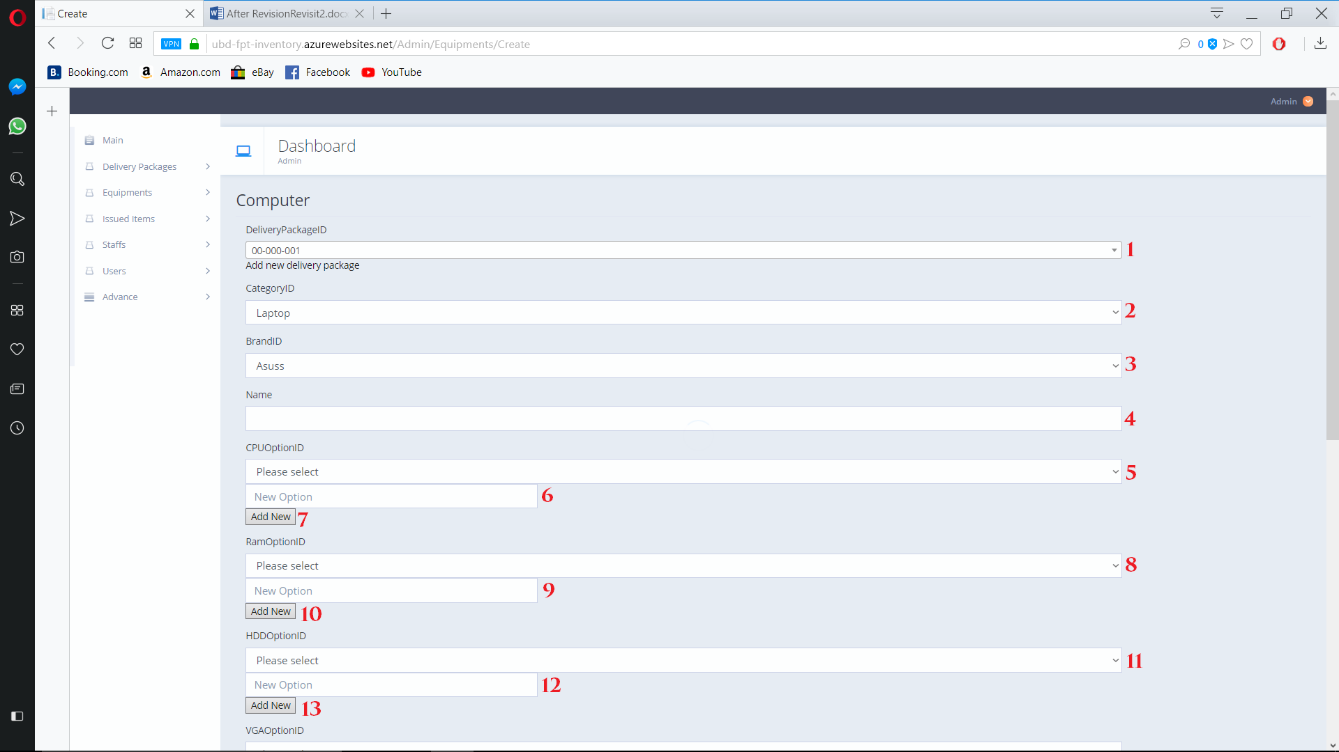

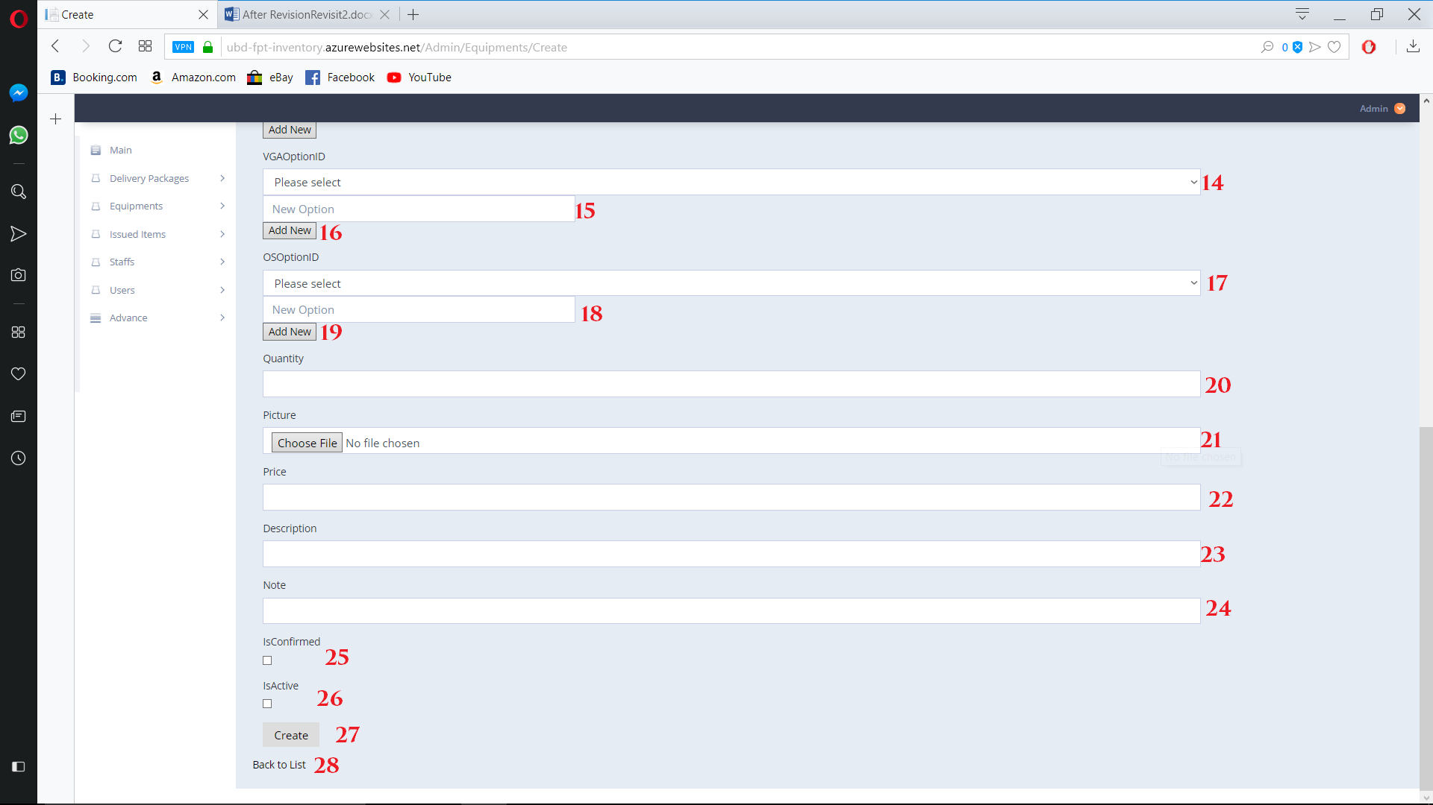

Figure 151. Add new Equipment Page

**Fields**

|  |  |  |  |  |  |  |
| --- | --- | --- | --- | --- | --- | --- |
| **No** | **Field Name** | **Description** | **Read only** | **Mandatory** | **Control Type** | **Data Type** |
| 1 | DeliveryPackageID | Equipment’s delivery package id | No | Yes | Drop  Down  List | String |
| 2 | CategoryID | Equipment’s category | No | Yes | Drop down  List | String |
| 3 | BrandId | Equipment’s brand | No | Yes | Drop down List | String |
| 4 | Name | Equipment’s Name | No | Yes | Textbox | String |
| 5 | CPUOptionID | Equipment’s CPU | No | No | Drop Down List | String |
| 6 | New CPU Option | Add new CPU option | No | No | Textbox | String |
| 8 | RamOptionID | Equipment’s Ram | No | No | Drop Down List | String |
| 9 | New Ram Option | Add new ram option | No | No | Textbox | String |
| 11 | HddOptionID | Equipment’s HDD | No | No | Drop down List | String |
| 12 | New Hdd Option | Add new Hdd Option | No | No | Textbox | String |
| 14 | VGAOptionID | Equipment’s VGA | No | No | Drop  Down List | String |
| 15 | New Vga Option | Add new Vga Option | No | No | TextBox | String |
| 17 | OsOptionID | Equipment’s Os | No | No | Drop Down  List | String |
| 18 | New OS Option | Add new OS Option | No | No | TextBox | String |
| 20 | Quantity | Equipment’s Quantity | No | Yes | TextBox | String |
| 22 | Price | Equipment’s Price | No | Yes | TextBox | String |
| 23 | Description | Equipment’s Description | No | No | TextBox | String |
| 24 | Note | Equipment’s Note | No | No | TextBox | String |
| 25 | IsConfirmed | Equipment’s confirm state | No | No | Check  Box | Boolean |
| 26 | IsActive | Equipment’s active state | No | No | Check  Box | Boolean |

Table 172. <Fields> Add new Equipment ( Computer type)

**Buttons/Hyperlinks:**

|  |  |  |  |  |
| --- | --- | --- | --- | --- |
| **No** | **Function** | **Description** | **Validation** | **Outcome** |
| 7 | Add new cpu option | Add new Cpu option | Validate required fields | Add new CPU Option to Cpu List |
| 10 | Add new Ram option | Add new Ram option | Validate required fields | Add new Ram Option to Ram List |
| 13 | Add new Hdd option | Add new Hdd option | Validate required fields | Add new Hdd Option to Hdd List |
| 16 | Add new VGA option | Add new VGA option | Validate required fields | Add new VGA Option to VGA List |
| 19 | Add new Os option | Add new Os option | Validate required fields | Add new Os Option to Os List |
| 21 | Choose picture | Choose Equipment’s picture | Required | Choose Picture for Equipment |
| 27 | Create | Create new Equipment | Validate required fields | New Equipment add to list |
| 28 | Back to list | Go back to Equipment view list | N/A | Navigate back to view equipment |

Table 172. <Buttons/Hyperlinks> Add new Equipment ( Computer type)

* + 1. Add new Equipment ( Other type)

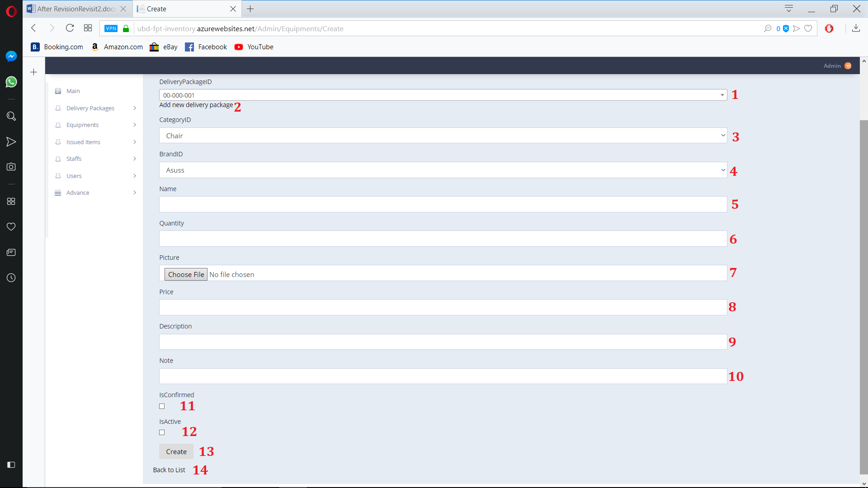

Figure 152. Delivery package sub menu

**Fields**

|  |  |  |  |  |  |  |
| --- | --- | --- | --- | --- | --- | --- |
| **No** | **Field Name** | **Description** | **Read only** | **Mandatory** | **Control Type** | **Data Type** |
| 1 | DeliveryPackageID | Equipment’s delivery package id | No | Yes | Drop  Down  List | String |
| 3 | CategoryID | Equipment’s category | No | Yes | Drop down  List | String |
| 4 | BrandId | Equipment’s brand | No | Yes | Drop down List | String |
| 5 | Name | Equipment’s Name | No | Yes | Textbox | String |
| 6 | Quantity | Equipment’s Quantity | No | Yes | TextBox | String |
| 8 | Price | Equipment’s Price | No | Yes | TextBox | String |
| 9 | Description | Equipment’s Description | No | No | TextBox | String |
| 10 | Note | Equipment’s Note | No | No | TextBox | String |
| 11 | IsConfirmed | Equipment’s confirm state | No | No | Check  Box | Boolean |
| 12 | IsActive | Equipment’s active state | No | No | Check  Box | Boolean |

Table 173. <Fields> Add new Equipment ( Other type)

**Buttons/Hyperlinks:**

|  |  |  |  |  |
| --- | --- | --- | --- | --- |
| **No** | **Function** | **Description** | **Validation** | **Outcome** |
| 2 | Add new delivery package | Add new delivery package | N/A | Add new delivery package |
| 7 | Choose picture | Choose Equipment’s picture | Required | Choose Picture for Equipment |
| 13 | Create | Create new Equipment | Validate required fields | New Equipment add to list |
| 14 | Back to list | Go back to Equipment view list | N/A | Navigate back to view equipment |

Table 174. <Buttons/Hyperlinks> Add new Equipment ( Other type)

* + 1. Edit Equipment ( Computer type)

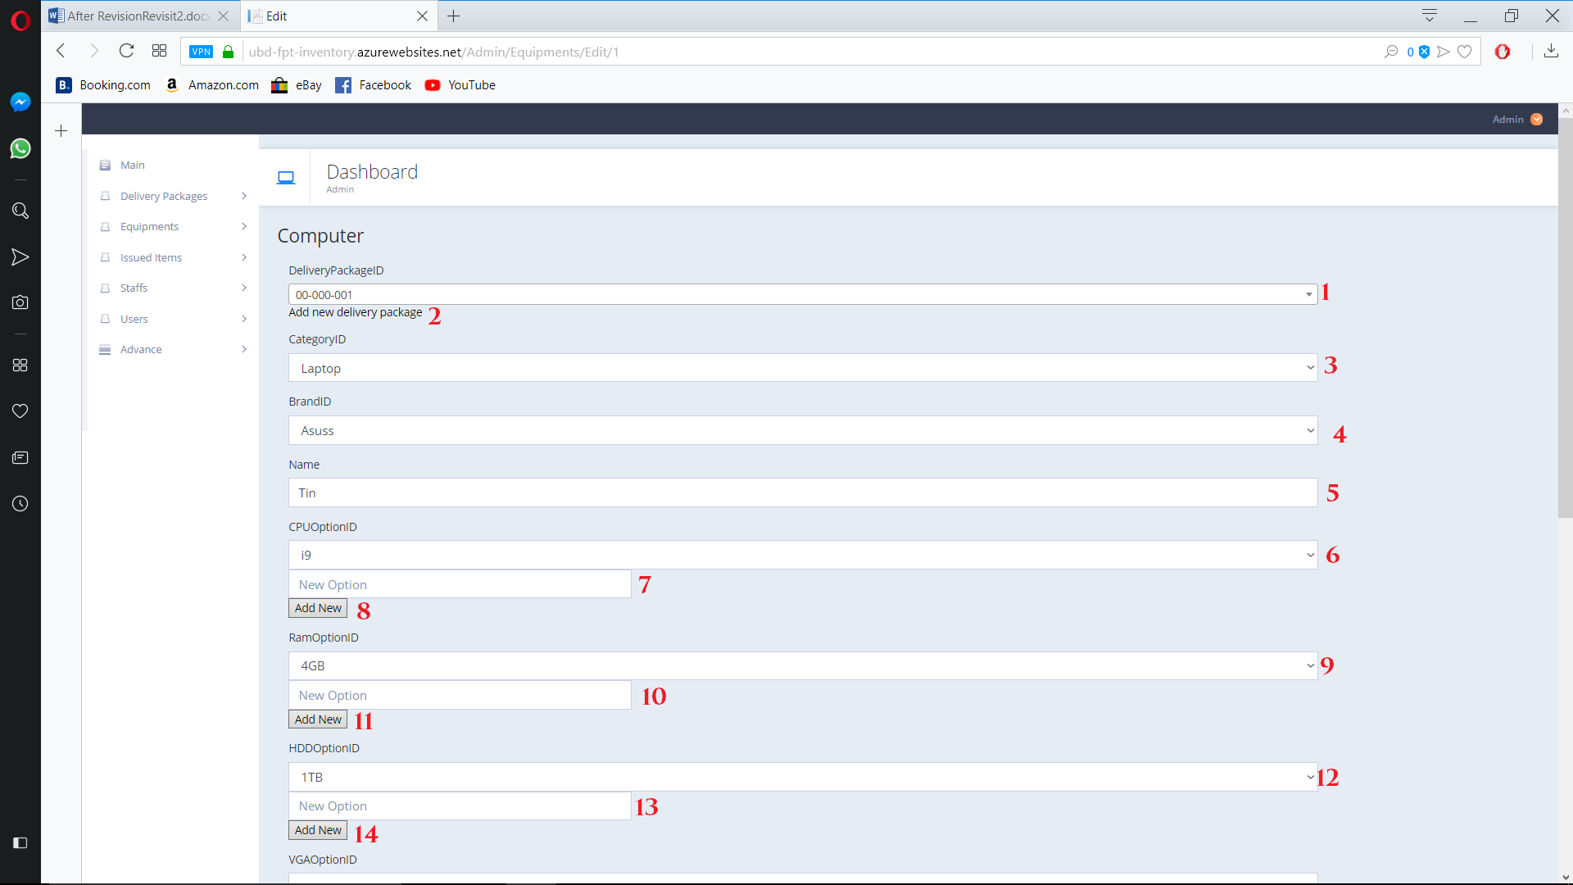

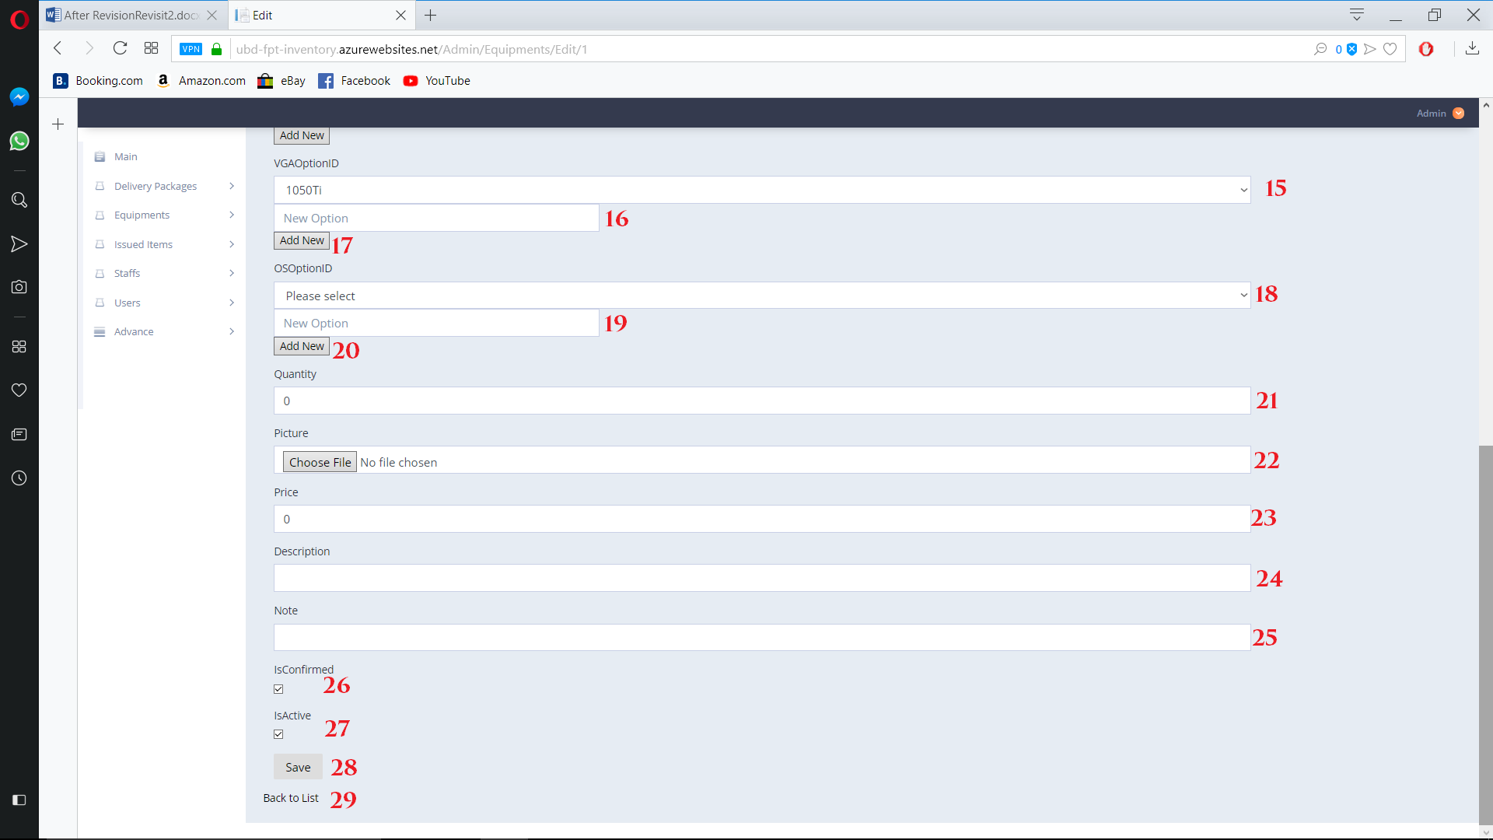

Figure 153. Edit Equipment page

**Fields**

|  |  |  |  |  |  |  |
| --- | --- | --- | --- | --- | --- | --- |
| **No** | **Field Name** | **Description** | **Read only** | **Mandatory** | **Control Type** | **Data Type** |
| 1 | DeliveryPackageID | Equipment’s delivery package id | No | Yes | Drop  Down  List | String |
| 3 | CategoryID | Equipment’s category | No | Yes | Drop down  List | String |
| 4 | BrandId | Equipment’s brand | No | Yes | Drop down List | String |
| 5 | Name | Equipment’s Name | No | Yes | Textbox | String |
| 6 | CPUOptionID | Equipment’s CPU | No | No | Drop Down List | String |
| 7 | New CPU Option | Add new CPU option | No | No | Textbox | String |
| 9 | RamOptionID | Equipment’s Ram | No | No | Drop Down List | String |
| 10 | New Ram Option | Add new ram option | No | No | Textbox | String |
| 12 | HddOptionID | Equipment’s HDD | No | No | Drop down List | String |
| 13 | New Hdd Option | Add new Hdd Option | No | No | Textbox | String |
| 15 | VGAOptionID | Equipment’s VGA | No | No | Drop  Down List | String |
| 16 | New Vga Option | Add new Vga Option | No | No | TextBox | String |
| 18 | OsOptionID | Equipment’s Os | No | No | Drop Down  List | String |
| 19 | New OS Option | Add new OS Option | No | No | TextBox | String |
| 21 | Quantity | Equipment’s Quantity | No | Yes | TextBox | String |
| 23 | Price | Equipment’s Price | No | Yes | TextBox | String |
| 24 | Description | Equipment’s Description | No | No | TextBox | String |
| 25 | Note | Equipment’s Note | No | No | TextBox | String |
| 26 | IsConfirmed | Equipment’s confirm state | No | No | Check  Box | Boolean |
| 27 | IsActive | Equipment’s active state | No | No | Check  Box | Boolean |

Table 175. <Fields> Add new Equipment ( Computer type)

**Buttons/Hyperlinks:**

|  |  |  |  |  |
| --- | --- | --- | --- | --- |
| **No** | **Function** | **Description** | **Validation** | **Outcome** |
| 2 | Add new delivery package | Add new delivery package | N/A | Add new delivery package |
| 8 | Add new cpu option | Add new Cpu option | Validate required fields | Add new CPU Option to Cpu List |
| 11 | Add new Ram option | Add new Ram option | Validate required fields | Add new Ram Option to Ram List |
| 14 | Add new Hdd option | Add new Hdd option | Validate required fields | Add new Hdd Option to Hdd List |
| 16 | Add new VGA option | Add new VGA option | Validate required fields | Add new VGA Option to VGA List |
| 19 | Add new Os option | Add new Os option | Validate required fields | Add new Os Option to Os List |
| 21 | Choose picture | Choose Equipment’s picture | Required | Choose Picture for Equipment |
| 27 | Save | Save edit Equipment | Validate required fields | Edit Equipment save to list |
| 28 | Back to list | Go back to Equipment view list | N/A | Navigate back to view equipment |

Table 176. <Buttons/Hyperlinks> Add new Equipment ( Computer type)

* + 1. Edit Equipment ( Other type)

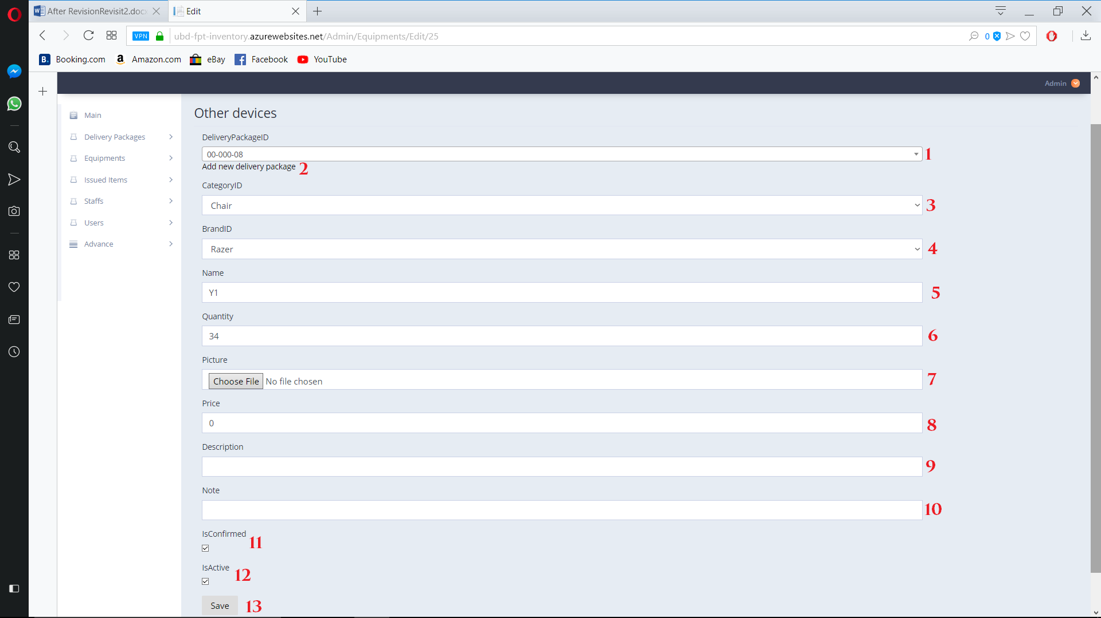

Figure 154. Edit Equipment

**Fields**

|  |  |  |  |  |  |  |
| --- | --- | --- | --- | --- | --- | --- |
| **No** | **Field Name** | **Description** | **Read only** | **Mandatory** | **Control Type** | **Data Type** |
| 1 | DeliveryPackageID | Equipment’s delivery package id | No | Yes | Drop  Down  List | String |
| 3 | CategoryID | Equipment’s category | No | Yes | Drop down  List | String |
| 4 | BrandId | Equipment’s brand | No | Yes | Drop down List | String |
| 5 | Name | Equipment’s Name | No | Yes | Textbox | String |
| 6 | Quantity | Equipment’s Quantity | No | Yes | TextBox | String |
| 8 | Price | Equipment’s Price | No | Yes | TextBox | String |
| 9 | Description | Equipment’s Description | No | No | TextBox | String |
| 10 | Note | Equipment’s Note | No | No | TextBox | String |
| 11 | IsConfirmed | Equipment’s confirm state | No | No | Check  Box | Boolean |
| 12 | IsActive | Equipment’s active state | No | No | Check  Box | Boolean |

Table 177. <Fields> Add new Equipment ( Other type)

**Buttons/Hyperlinks:**

|  |  |  |  |  |
| --- | --- | --- | --- | --- |
| **No** | **Function** | **Description** | **Validation** | **Outcome** |
| 2 | Add new delivery package | Add new delivery package | N/A | Add new delivery package |
| 7 | Choose picture | Choose Equipment’s picture | Required | Choose Picture for Equipment |
| 13 | Save | Save edit Equipment | Validate required fields | Edit Equipment save to list |
| 14 | Back to list | Go back to Equipment view list | N/A | Navigate back to view equipment |

Table 178. <Buttons/Hyperlinks> Add new Equipment ( Other type)

* + 1. Detail Equipment

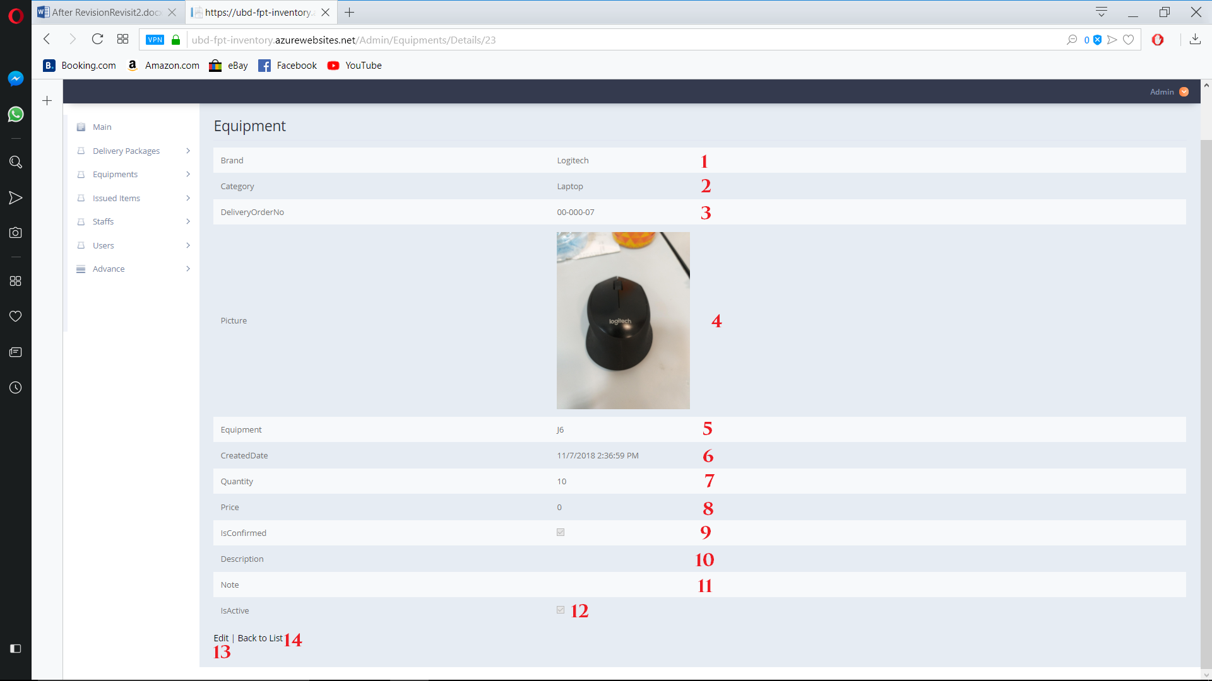

Figure 155. Detail Equipment Page

**Fields**

|  |  |  |  |  |  |  |
| --- | --- | --- | --- | --- | --- | --- |
| **No** | **Field Name** | **Description** | **Read only** | **Mandatory** | **Control Type** | **Data Type** |
| 1 | BrandId | Equipment’s brand | Yes | Yes | Text | String |
| 2 | Category | Equipment’s category | Yes | Yes | Text | String |
| 3 | DeliveryOrderNo | Equipment’s delivery package id | Yes | Yes | Text | String |
| 4 | Picture | Equipment’s Picture | Yes | Yes | Image | Image |
| 5 | Equipment | Equipment’s Model | Yes | Yes | Text | String |
| 6 | CreatedDate | Equipment’s Created day | Yes | Yes | Text | String |
| 7 | Quantity | Equipment’s Quantity | Yes | Yes | Text | String |
| 8 | IsConfirmed | Equipment’s confirm state | Yes | Yes | Check  Box | Boolean |
| 10 | Description | Equipment’s Description | Yes | Yes | Text | String |
| 11 | Note | Equipment’s Note | Yes | Yes | Text | String |
| 12 | IsActive | Equipment’s active state | Yes | Yes | Check  Box | Boolean |

Table 178. <Fields> Edit Equipment ( Other type)

**Buttons/Hyperlinks:**

|  |  |  |  |  |
| --- | --- | --- | --- | --- |
| **No** | **Function** | **Description** | **Validation** | **Outcome** |
| 13 | Edit | Go to Edit Page | N/A | Navigate to edit Equipment page |
| 14 | Back to list | Go back to view Equipment page | N/A | Navigate to view Equipment page |

Table 179. <Buttons/Hyperlinks> Edit Equipment ( Other type)

* + 1. Delete Equipment

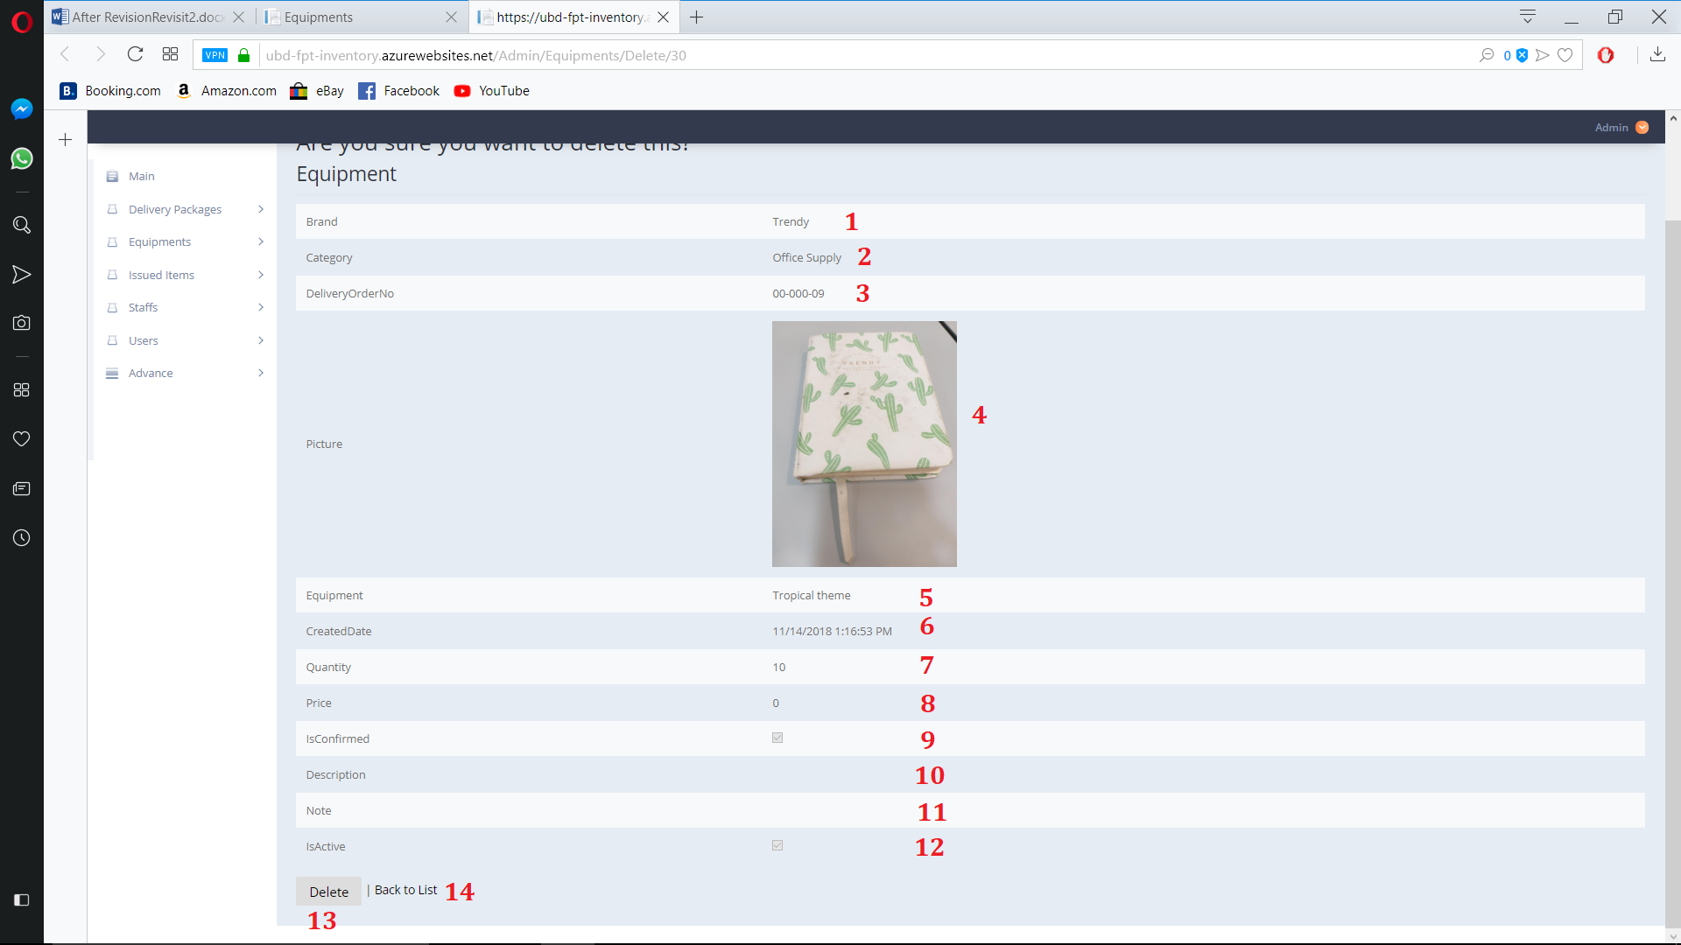

Figure 156. Delete Equipment Page

**Fields**

|  |  |  |  |  |  |  |
| --- | --- | --- | --- | --- | --- | --- |
| **No** | **Field Name** | **Description** | **Read only** | **Mandatory** | **Control Type** | **Data Type** |
| 1 | BrandId | Equipment’s brand | Yes | Yes | Text | String |
| 2 | Category | Equipment’s category | Yes | Yes | Text | String |
| 3 | DeliveryOrderNo | Equipment’s delivery package id | Yes | Yes | Text | String |
| 4 | Picture | Equipment’s Picture | Yes | Yes | Image | Image |
| 5 | Equipment | Equipment’s Model | Yes | Yes | Text | String |
| 6 | CreatedDate | Equipment’s Created day | Yes | Yes | Text | String |
| 7 | Quantity | Equipment’s Quantity | Yes | Yes | Text | String |
| 8 | IsConfirmed | Equipment’s confirm state | Yes | Yes | Check  Box | Boolean |
| 10 | Description | Equipment’s Description | Yes | Yes | Text | String |
| 11 | Note | Equipment’s Note | Yes | Yes | Text | String |
| 12 | IsActive | Equipment’s active state | Yes | Yes | Check  Box | Boolean |

Table 180. <Fields> Delete Equipment ( Other type)

**Buttons/Hyperlinks:**

|  |  |  |  |  |
| --- | --- | --- | --- | --- |
| **No** | **Function** | **Description** | **Validation** | **Outcome** |
| 13 | Delete | Delete selected Equipment | N/A | Delete selected Equipment |
| 14 | Back to list | Go back to view Equipment page | N/A | Navigate to view Equipment page |

Table 181. <Buttons/Hyperlinks> Delete Equipment ( Other type)

* + 1. View Issued Item

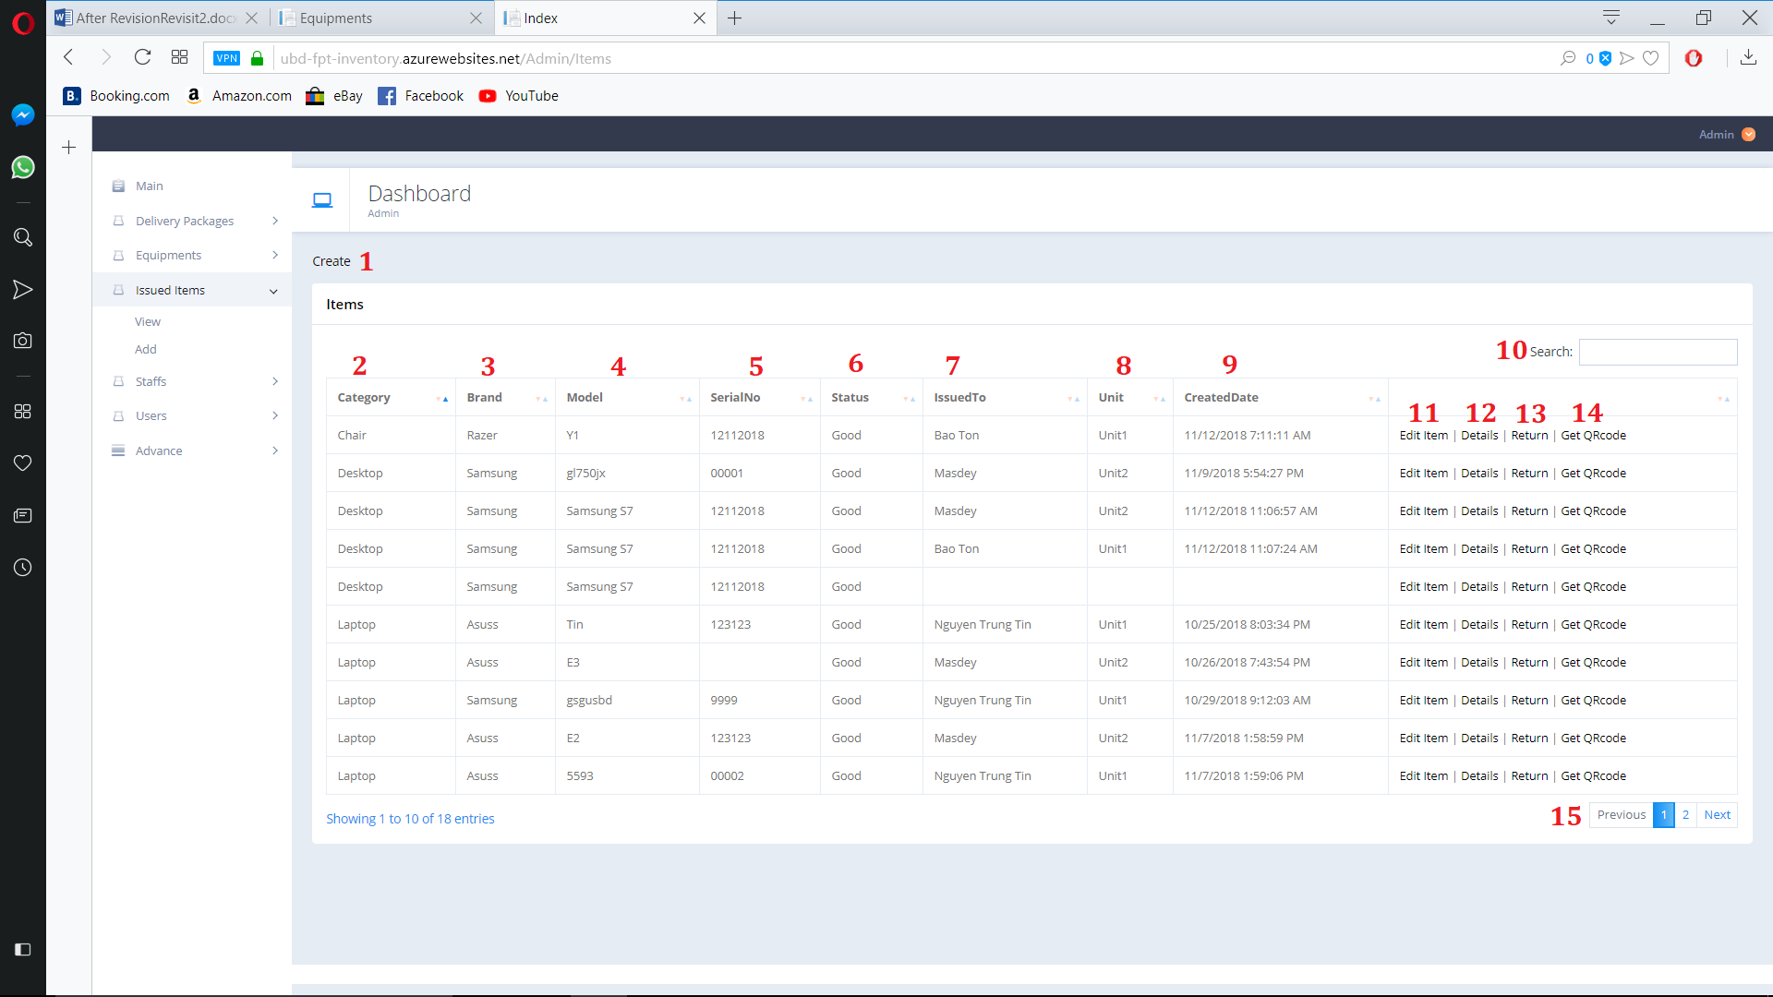

Figure 157. View Issued Item

**Fields**

|  |  |  |  |  |  |  |
| --- | --- | --- | --- | --- | --- | --- |
| **No** | **Field Name** | **Description** | **Read only** | **Mandatory** | **Control Type** | **Data Type** |
| 2 | Category | Issued Item’s category | Yes | Yes | Text | String |
| 3 | Brand | Issued Item’s brand | Yes | Yes | Text | String |
| 4 | Model | Issued Item’s Model | Yes | Yes | Image | Image |
| 5 | SerialNo | Issued Item’s Serial Number | Yes | Yes | Text | String |
| 6 | Status | Issued Item’s status | Yes | Yes | Text | String |
| 7 | IssuedTo | Issued Item’s staff that having the item | Yes | Yes | Text | String |
| 8 | Unit | Issued Item’s issued Unit | Yes | Yes | Check  Box | Boolean |
| 9 | CreatedDate | Issued Item’s created date | Yes | Yes | Text | String |
| 10 | Search | Search by user input | No | No | TextBox | String |

Table 182. <Fields> View Issued Item

**Buttons/Hyperlinks:**

|  |  |  |  |  |
| --- | --- | --- | --- | --- |
| **No** | **Function** | **Description** | **Validation** | **Outcome** |
| 1 | Create | Create new Issued Item | N/A | Navigate to create new Issued Item Page |
| 11 | Edit | Go to Edit delivery Issued Item | N/A | Navigate to edit Issued Item page |
| 12 | Detail | Go to detial Issued Item page | N/A | Navigate to detail Issued Item page |
| 13 | Return | Go to return Issued Item page | N/A | Navigate to return confirm Issued Item page |
| 14 | Get Qr Code | Show Qr code | N/A | Show Pop up windows contain Qr code |
| 15 | Navigation | Navigation through pages of list | N/A | Show selected page of Issued Item list |

Table 183. <Buttons/Hyperlinks> View Issued Item

* + 1. Create Issued Item

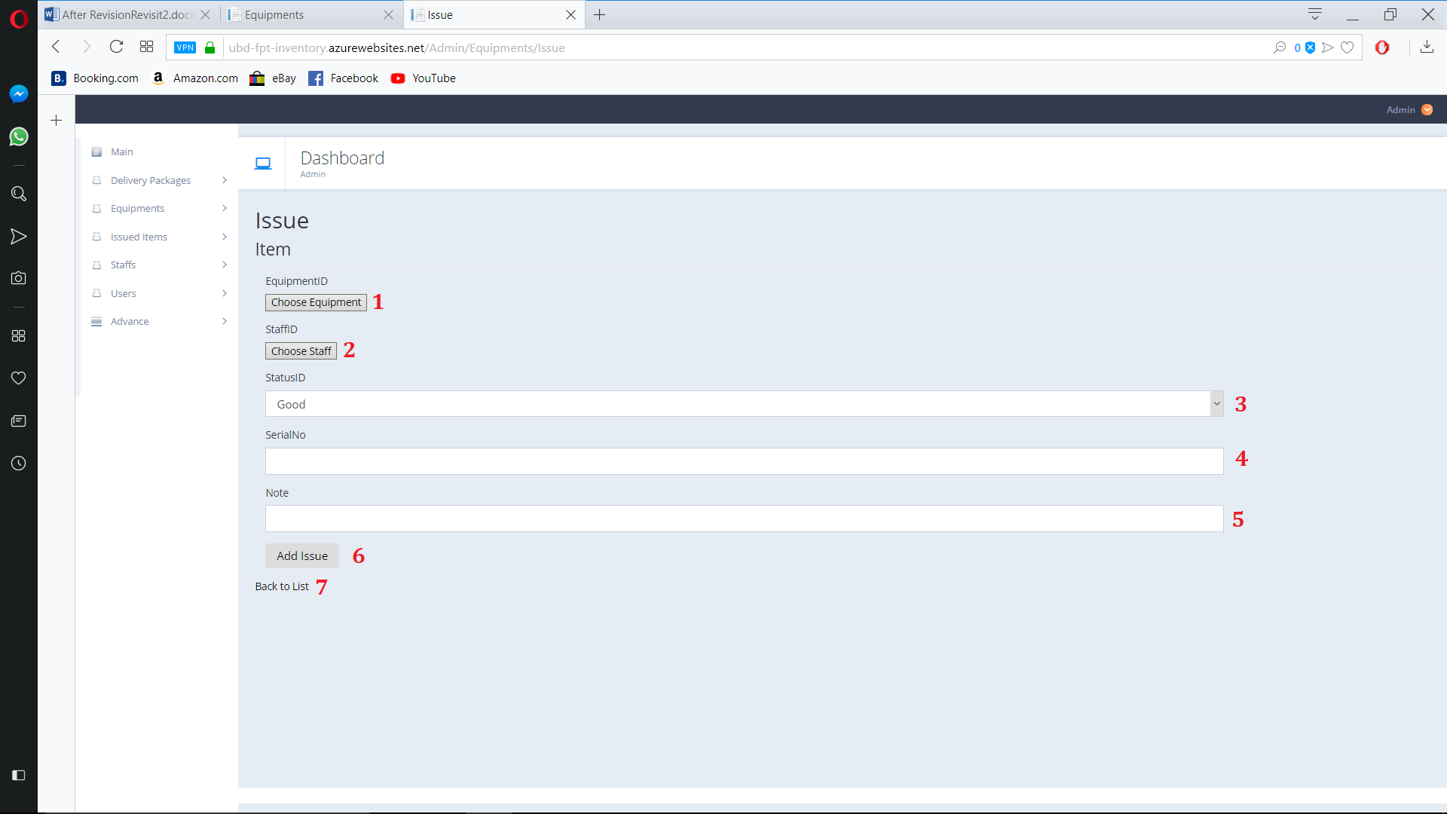

Figure 158. Create Issued Item

**Fields**

|  |  |  |  |  |  |  |
| --- | --- | --- | --- | --- | --- | --- |
| **No** | **Field Name** | **Description** | **Read only** | **Mandatory** | **Control Type** | **Data Type** |
| 3 | StatusId | Issued Item’s status | No | Yes | Drop down list | String |
| 4 | SerialNO | Issued Item’s Serial Number | No | Yes | Text | String |
| 5 | Note | Issued Item’s Note | No | No | Text | String |

Table 184. <Fields> View Issued Item

**Buttons/Hyperlinks:**

|  |  |  |  |  |
| --- | --- | --- | --- | --- |
| **No** | **Function** | **Description** | **Validation** | **Outcome** |
| 1 | EquipmentId | Choose Equipment | Required | Open pop up menu to choose equipment |
| 2 | StaffId | Choose Staff | Required | Open Pop up menu to choose staff |
| 6 | Add Issued | Add new Issue item | N/A | Add new issued item |
| 7 | Back to List | Go to Issued Item view page | N/A | Navigate to Issued Item view page |

Table 185. <Buttons/Hyperlinks> View Issued Item

* + 1. Edit Issued Item

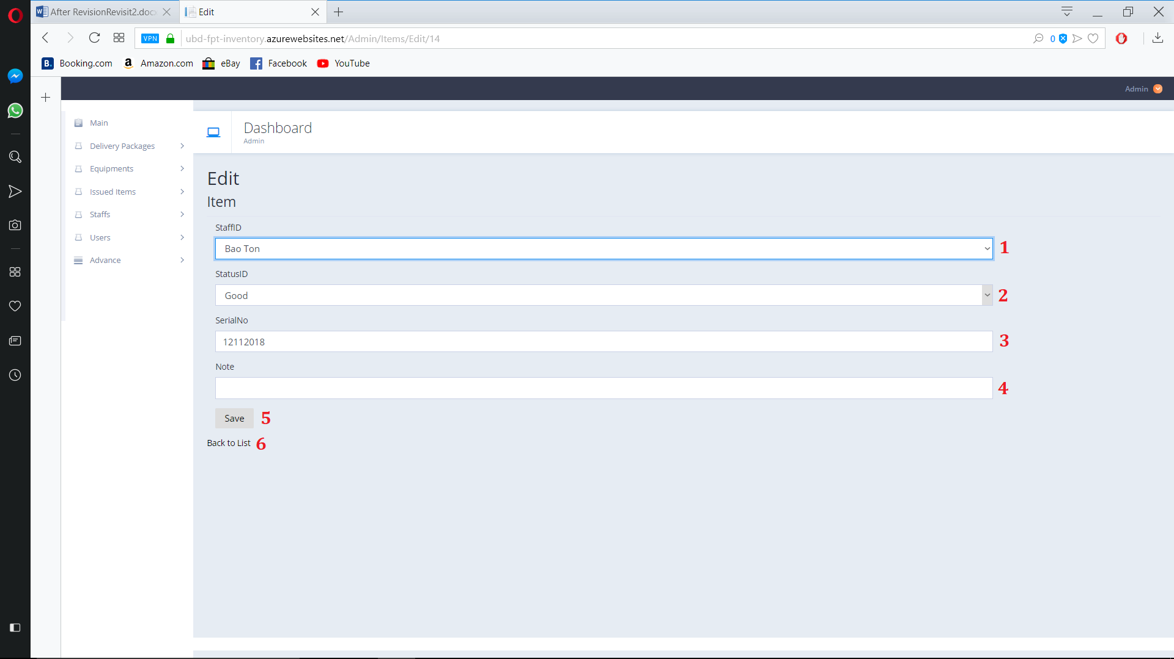

Figure 159. Edit Issued Item

**Fields**

|  |  |  |  |  |  |  |
| --- | --- | --- | --- | --- | --- | --- |
| **No** | **Field Name** | **Description** | **Read only** | **Mandatory** | **Control Type** | **Data Type** |
| 1 | StaffID | Issued Item’s staff that having the item | No | Yes | Drop down list | String |
| 2 | StatusId | Issued Item’s status | No | Yes | Drop down list | String |
| 3 | SerialNO | Issued Item’s Serial Number | No | Yes | Text | String |
| 4 | Note | Issued Item’s Note | No | No | Text | String |

Table 186. <Fields> View Issued Item

**Buttons/Hyperlinks:**

|  |  |  |  |  |
| --- | --- | --- | --- | --- |
| **No** | **Function** | **Description** | **Validation** | **Outcome** |
| 5 | Save | Save Item | N/A | Save Edit Issue item |
| 6 | Back to List | Go to Issued Item view page | N/A | Navigate to Issued Item view page |

Table 187. <Buttons/HyperLinks> View Issued Item

* + 1. Issued Item detail page

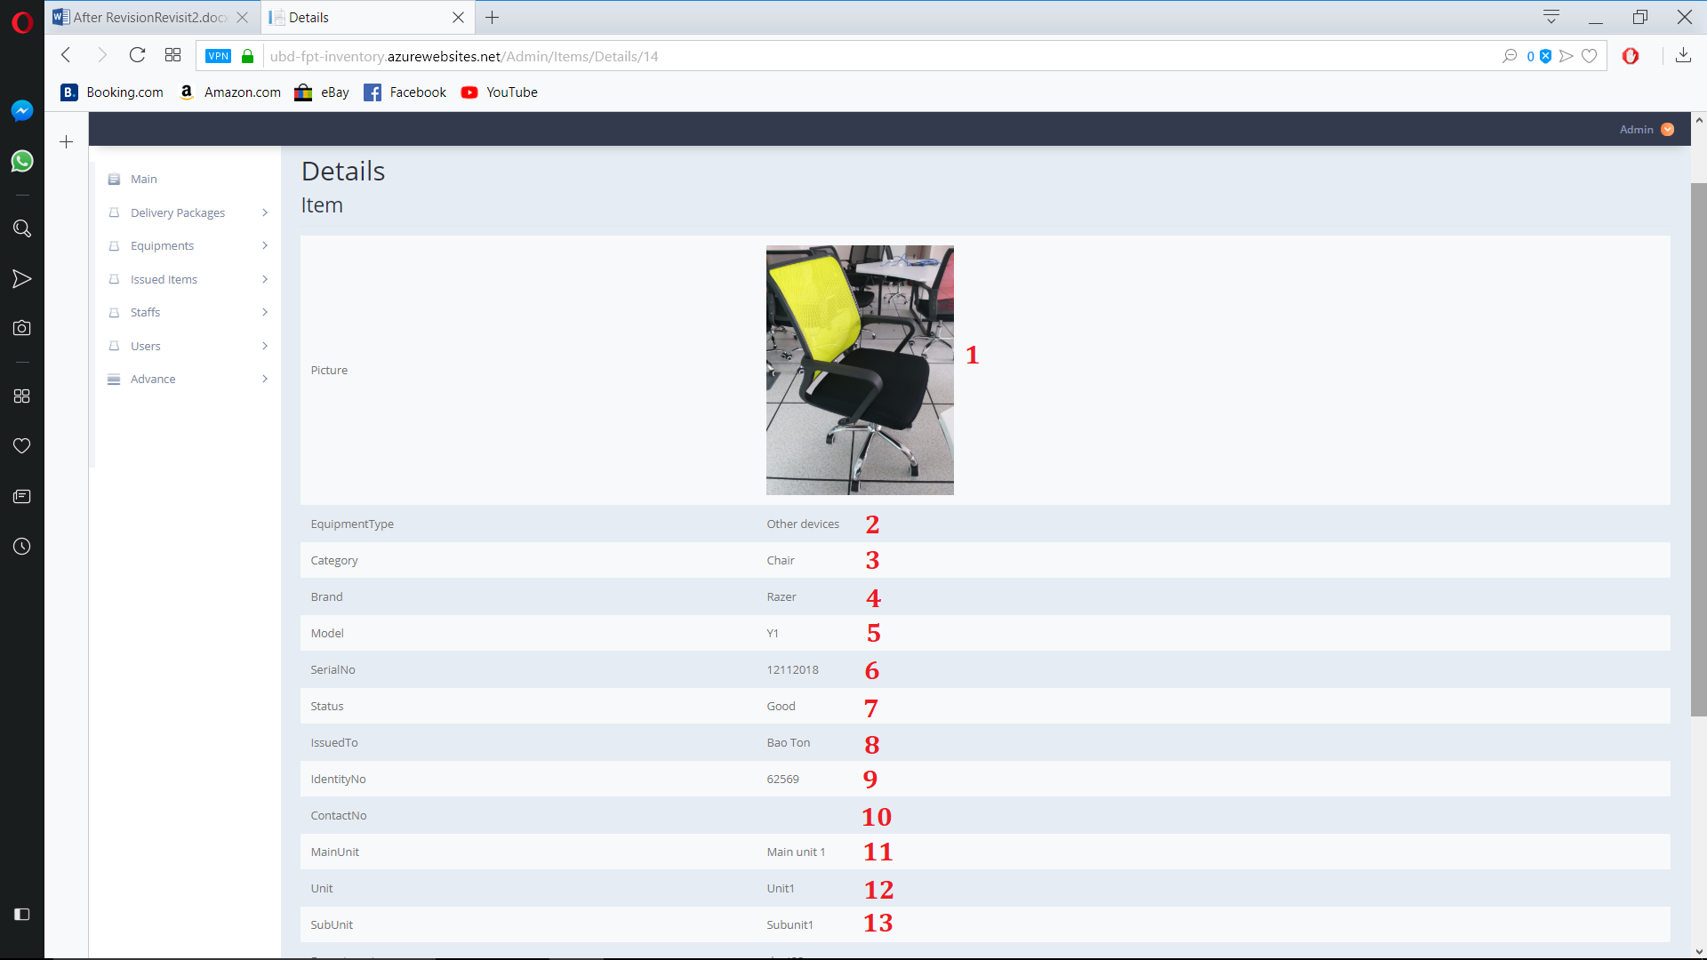 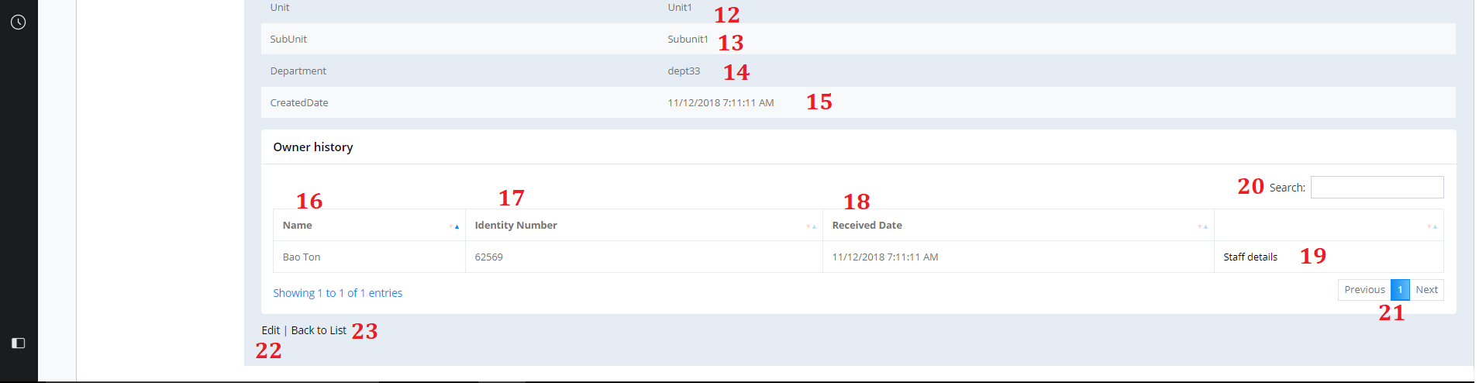

Figure 160. Issued Item Detail Page

**Fields**

|  |  |  |  |  |  |  |
| --- | --- | --- | --- | --- | --- | --- |
| **No** | **Field Name** | **Description** | **Read only** | **Mandatory** | **Control Type** | **Data Type** |
| 1 | Picture | Issued Item’s picture | Yes | Yes | Image | Image |
| 2 | EquipmentType | Issued Item’s Type | Yes | Yes | Text | String |
| 3 | Category | Issued Item’s category | Yes | Yes | Text | String |
| 4 | Brand | Issued Item’s Brand | Yes | Yes | Text | String |
| 5 | Model | Issued Item’s Model | Yes | Yes | Text | String |
| 6 | SerialNO | Issued Item’s Serial Number | Yes | Yes | Text | String |
| 7 | Status | Issued Item’s Status | Yes | Yes | Text | String |
| 8 | IssuedTo | Issued Item’s staff that having the item | Yes | Yes | Text | String |
| 9 | IdentityNo | Issued Item’s staff that having the item identity number | Yes | Yes | Text | String |
| 10 | ContactNo | Issued Item’s staff that having the item Contact number | Yes | Yes | Text | String |
| 11 | MainUnit | Issued Item’s staff that having the item Main Unit | Yes | Yes | Text | String |
| 12 | Unit | Issued Item’s staff that having the item Unit | Yes | Yes | Text | String |
| 13 | SubUnit | Issued Item’s staff that having the item Sub Unit | Yes | Yes | Text | String |
| 14 | Department | Issued Item’s staff that having the item Department | Yes | Yes | Text | String |
| 15 | CreatedDate | Issued Item’s Created Date | Yes | Yes | Text | String |
| 16 | Name | Staff Name | Yes | Yes | Text | String |
| 17 | IdentityNo | Staff Identity Number |  |  |  |  |
| 18 | Recerived Date | Date staff receive item |  |  |  |  |
| 20 | Search | Search by user input | No | No | TextBox | String |

Table 188. <Fields> View Issued Item

**Buttons/Hyperlinks:**

|  |  |  |  |  |
| --- | --- | --- | --- | --- |
| **No** | **Function** | **Description** | **Validation** | **Outcome** |
| 19 | Staff Detail | See staff detail | N/A | Go to staff detail page |
| 22 | Edit | Go to Edit Issued Item page | N/A | Navigate to Edit Issued Item page |
| 23 | Back To List | Go to Issued Item view page | N/A | Navigate to Issued Item view page |

Table 189. <Buttons/HyperLinks> View Issued Item

* + 1. Issued Item Return page

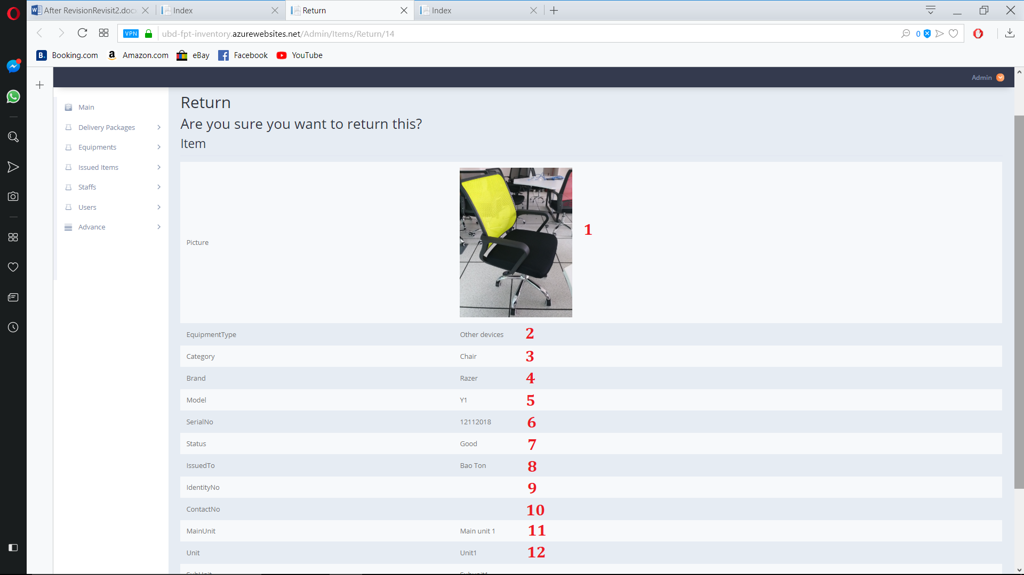

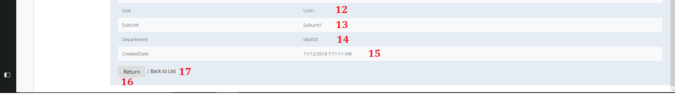

Figure 161. Issued Item Return Page

**Fields**

|  |  |  |  |  |  |  |
| --- | --- | --- | --- | --- | --- | --- |
| **No** | **Field Name** | **Description** | **Read only** | **Mandatory** | **Control Type** | **Data Type** |
| 1 | Picture | Issued Item’s picture | Yes | Yes | Image | Image |
| 2 | EquipmentType | Issued Item’s Type | Yes | Yes | Text | String |
| 3 | Category | Issued Item’s category | Yes | Yes | Text | String |
| 4 | Brand | Issued Item’s Brand | Yes | Yes | Text | String |
| 5 | Model | Issued Item’s Model | Yes | Yes | Text | String |
| 6 | SerialNO | Issued Item’s Serial Number | Yes | Yes | Text | String |
| 7 | Status | Issued Item’s Status | Yes | Yes | Text | String |
| 8 | IssuedTo | Issued Item’s staff that having the item | Yes | Yes | Text | String |
| 9 | IdentityNo | Issued Item’s staff that having the item identity number | Yes | Yes | Text | String |
| 10 | ContactNo | Issued Item’s staff that having the item Contact number | Yes | Yes | Text | String |
| 11 | MainUnit | Issued Item’s staff that having the item Main Unit | Yes | Yes | Text | String |
| 12 | Unit | Issued Item’s staff that having the item Unit | Yes | Yes | Text | String |
| 13 | SubUnit | Issued Item’s staff that having the item Sub Unit | Yes | Yes | Text | String |
| 14 | Department | Issued Item’s staff that having the item Department | Yes | Yes | Text | String |
| 15 | CreatedDate | Issued Item’s Created Date | Yes | Yes | Text | String |

Table 190. <Fields> View Issued Item

**Buttons/Hyperlinks:**

|  |  |  |  |  |
| --- | --- | --- | --- | --- |
| **No** | **Function** | **Description** | **Validation** | **Outcome** |
| 16 | Return | Return Item and clear current staff data | N/A | Return selected issued item |
| 17 | Back To List | Go to Issued Item view page | N/A | Navigate to Issued Item view page |

Table 191. <Buttons/Hyperlinks> View Issued Item

* + 1. Issued Item Get Qr Code

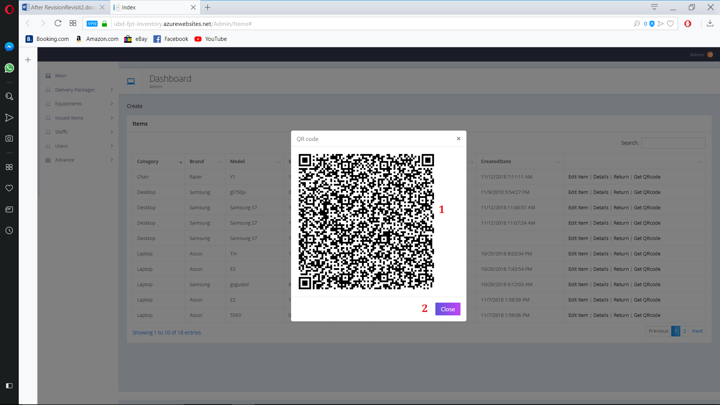

Figure 162. Issued Item get Qr code

**Fields**

|  |  |  |  |  |  |  |
| --- | --- | --- | --- | --- | --- | --- |
| **No** | **Field Name** | **Description** | **Read only** | **Mandatory** | **Control Type** | **Data Type** |
| 1 | Qr Picture | Qr’s picture | Yes | Yes | Image | Image |

Table 192. <Fields> Issued Item get Qr code

**Buttons/Hyperlinks:**

|  |  |  |  |  |
| --- | --- | --- | --- | --- |
| **No** | **Function** | **Description** | **Validation** | **Outcome** |
| 2 | Close | Close pop up qr page | N/A | Close pop up qr page |

Table 193. <Fields> Issued Item get Qr code

* + 1. View Staff

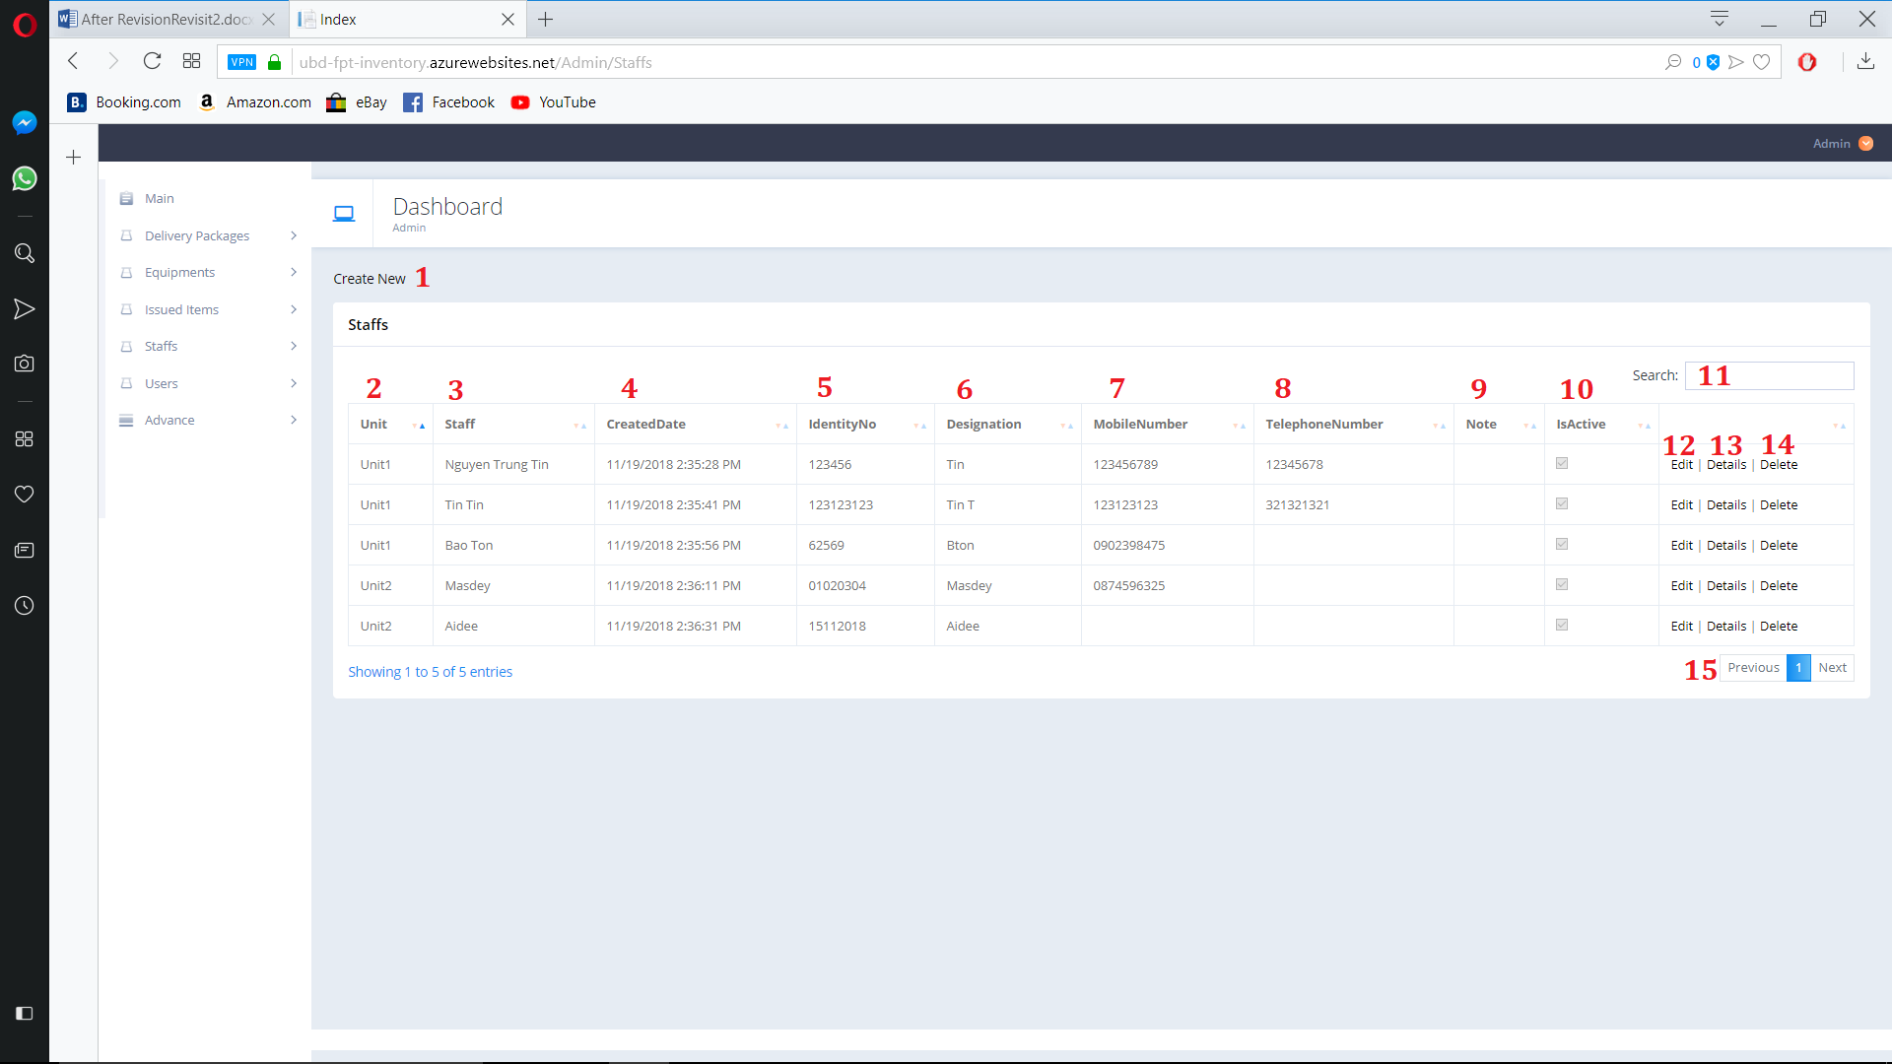

Figure 163. View Staff

**Fields**

|  |  |  |  |  |  |  |
| --- | --- | --- | --- | --- | --- | --- |
| **No** | **Field Name** | **Description** | **Read only** | **Mandatory** | **Control Type** | **Data Type** |
| 2 | Unit | Staff’s Unit | Yes | Yes | Text | String |
| 3 | Staff | Staff’s Name | Yes | Yes | Text | String |
| 4 | CreatedDate | Staff’s Created date | Yes | Yes | Text | String |
| 5 | Indentity Number | Staff’s Indentity Number | Yes | Yes | Text | String |
| 6 | Designation | Staff’s Designation | Yes | Yes | Text | String |
| 7 | MobileNumber | Staff’s Mobile Number | Yes | Yes | Text | String |
| 8 | TelephoneNumber | Staff’s Telephone Number | Yes | Yes | Text | String |
| 9 | Note | Staff’s Note | Yes | Yes | Text | String |
| 10 | IsActive | Staff’s active state | No | No | Check  Box | Boolean |
| 11 | Search | Search by user input | No | No | TextBox | String |

Table 194. <Fields> View Staff

**Buttons/Hyperlinks:**

|  |  |  |  |  |
| --- | --- | --- | --- | --- |
| **No** | **Function** | **Description** | **Validation** | **Outcome** |
| 1 | Create | Create new Staff | N/A | Navigate to create new Staff Page |
| 12 | Edit | Go to Edit Staff page | N/A | Navigate to edit Staff page |
| 13 | Detail | Go to Staff detail page | N/A | Navigate to Staff detail page |
| 14 | Delete | Go to delete Staff page | N/A | Navigate to delete staff page |
| 15 | Navigation | Navigation through pages of list | N/A | Show selected page of Staff list |

Table 195. <Buttons/Hyperlinks> View Staff

* + 1. Create staff

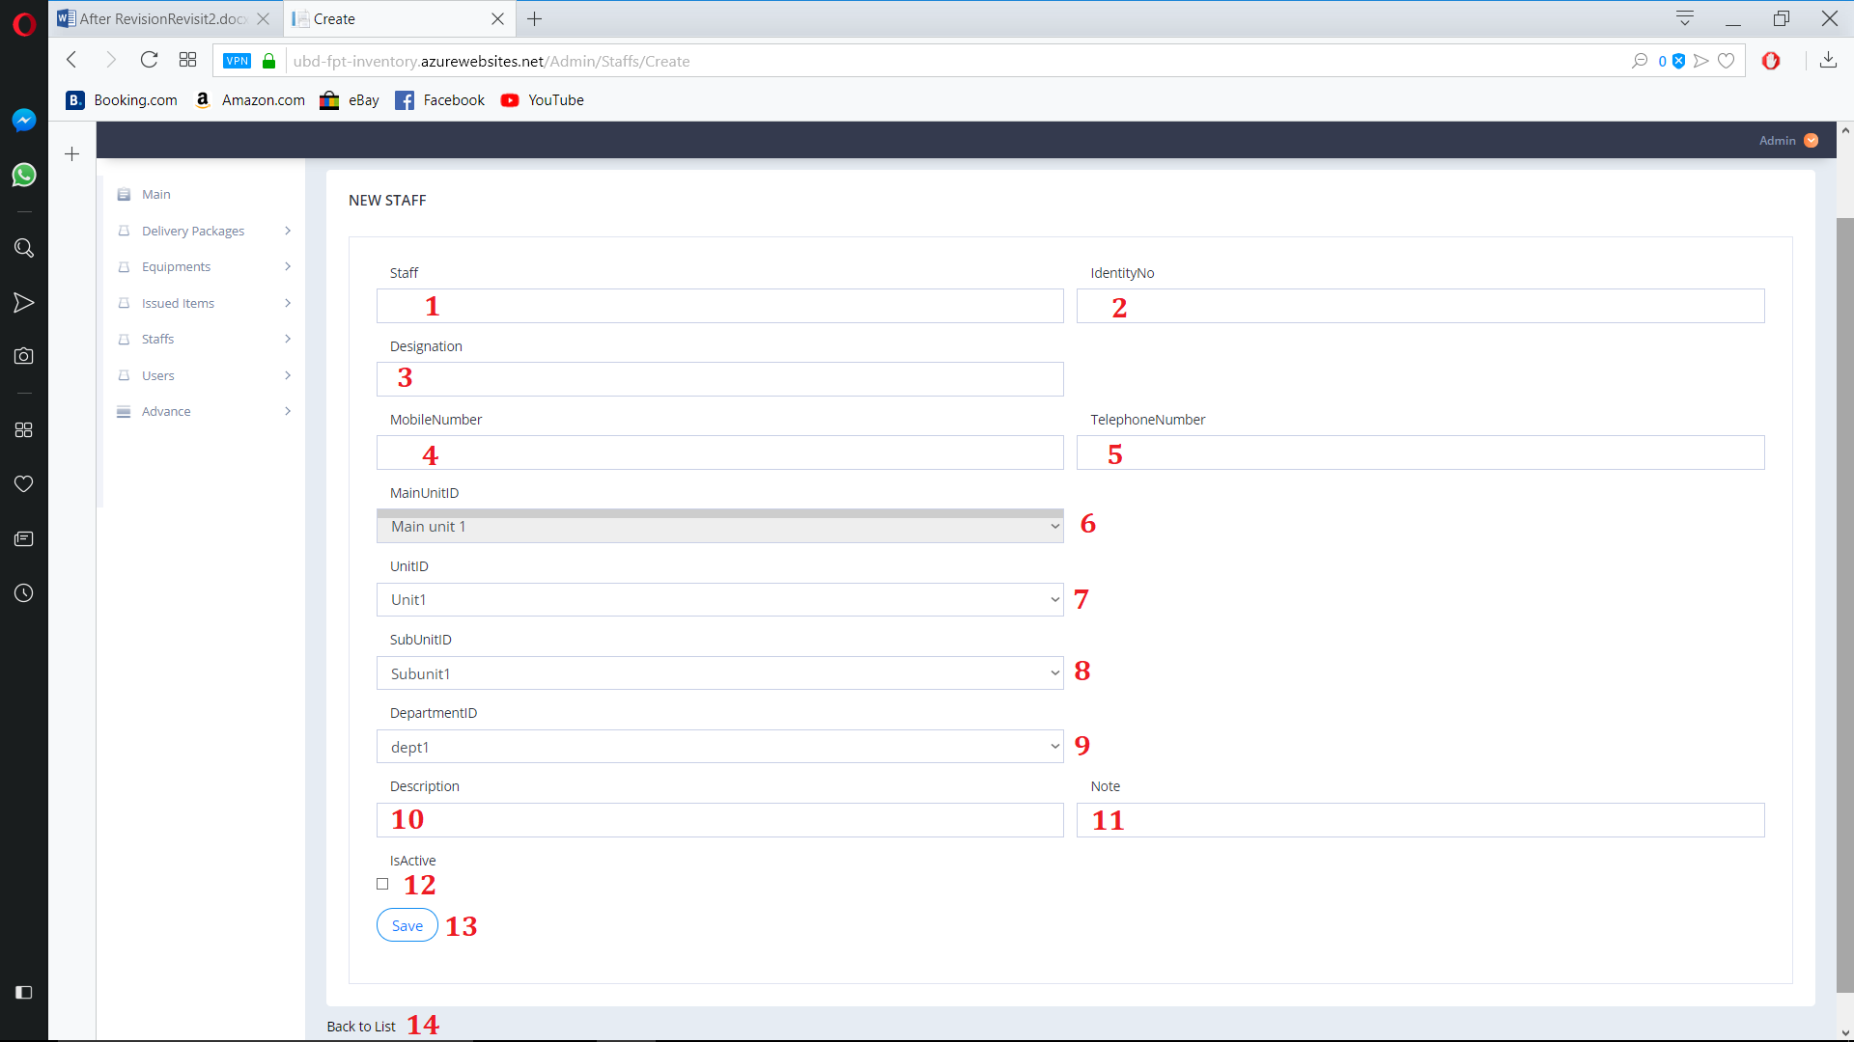 Figure 164. Create Staff

**Fields**

|  |  |  |  |  |  |  |
| --- | --- | --- | --- | --- | --- | --- |
| **No** | **Field Name** | **Description** | **Read only** | **Mandatory** | **Control Type** | **Data Type** |
| 1 | Staff | Staff’s Name | No | Yes | TextBox | String |
| 2 | IndentityNo | Staff’s Indentity Number | No | Yes | TextBox | String |
| 3 | Designation | Staff’s Designation | No | No | TextBox | String |
| 4 | MobileNumber | Staff’s Mobile Number | No | No | TextBox | String |
| 5 | TelephoneNumber | Staff’s Telephone Number | No | No | TextBox | String |
| 6 | MainUnitID | Staff’s Main Unit | No | Yes | Drop down list | String |
| 7 | UnitID | Staff’s Unit | No | Yes | Drop down list | String |
| 8 | SubUnitId | Staff’s Sub Unit | No | Yes | Drop down list | String |
| 9 | DepartmentID | Staff’s Department | No | Yes | Drop down list | String |
| 10 | Description | Staff’s Description | No | No | TextBox | String |
| 11 | Note | Staff’s Note | No | No | TextBox | String |
| 12 | IsActive | Staff’s active state | No | No | Check  Box | Boolean |

Table 196. <Fields> Create Staff

**Buttons/Hyperlinks:**

|  |  |  |  |  |
| --- | --- | --- | --- | --- |
| **No** | **Function** | **Description** | **Validation** | **Outcome** |
| 13 | Save | Save Staff | N/A | Save new Staff |
| 14 | Back to List | Go to Staff view page | N/A | Navigate to Staff view page |

Table 197. <Buttons/Hyperlinks> Create Staff

* + 1. Edit staff

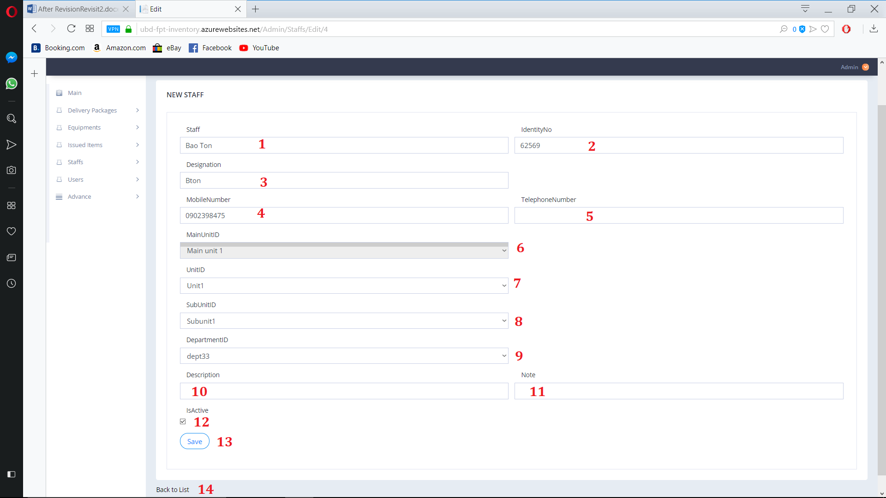

Figure 165. Edit Staff

**Fields**

|  |  |  |  |  |  |  |
| --- | --- | --- | --- | --- | --- | --- |
| **No** | **Field Name** | **Description** | **Read only** | **Mandatory** | **Control Type** | **Data Type** |
| 1 | Staff | Staff’s Name | No | Yes | TextBox | String |
| 2 | IndentityNo | Staff’s Indentity Number | No | Yes | TextBox | String |
| 3 | Designation | Staff’s Designation | No | No | TextBox | String |
| 4 | MobileNumber | Staff’s Mobile Number | No | No | TextBox | String |
| 5 | TelephoneNumber | Staff’s Telephone Number | No | No | TextBox | String |
| 6 | MainUnitID | Staff’s Main Unit | No | Yes | Drop down list | String |
| 7 | UnitID | Staff’s Unit | No | Yes | Drop down list | String |
| 8 | SubUnitId | Staff’s Sub Unit | No | Yes | Drop down list | String |
| 9 | DepartmentID | Staff’s Department | No | Yes | Drop down list | String |
| 10 | Description | Staff’s Description | No | No | TextBox | String |
| 11 | Note | Staff’s Note | No | No | TextBox | String |
| 12 | IsActive | Staff’s active state | No | No | Check  Box | Boolean |

Table 198. <Fields> Edit Staff

**Buttons/Hyperlinks:**

|  |  |  |  |  |
| --- | --- | --- | --- | --- |
| **No** | **Function** | **Description** | **Validation** | **Outcome** |
| 13 | Save | Save Staff | N/A | Save Edit Staff |
| 14 | Back to List | Go to Staff view page | N/A | Navigate to Staff view page |

Table 199. <Buttons/Hyperlinks> Edit Staff

* + 1. Detail staff

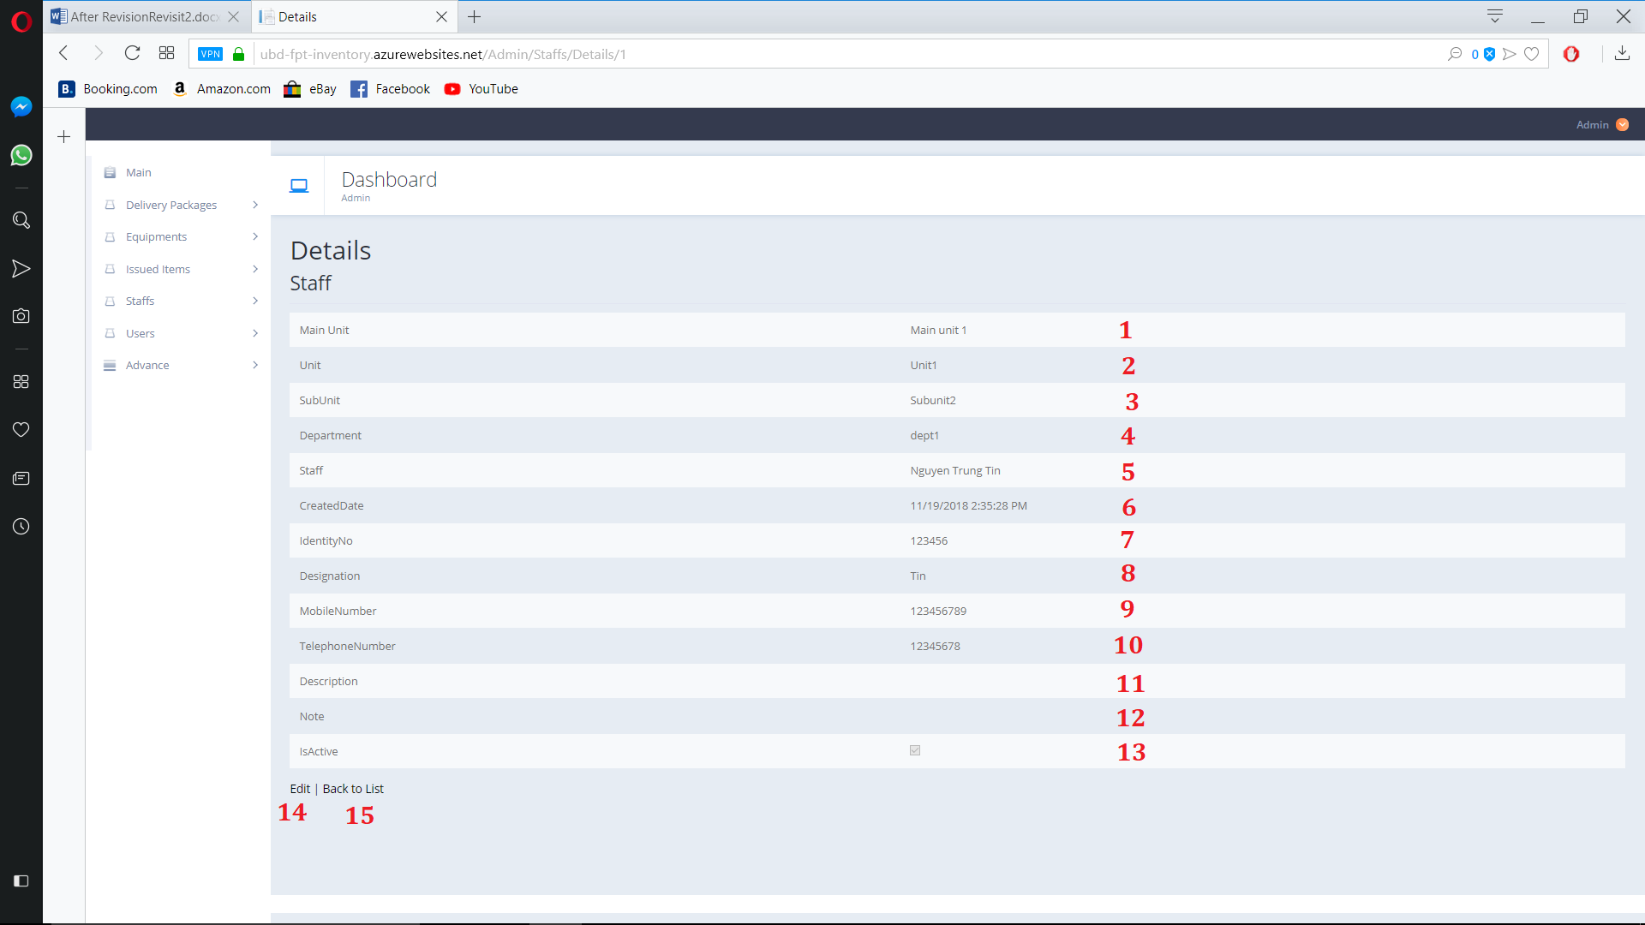

Figure 166. Detail Staff

**Fields**

|  |  |  |  |  |  |  |
| --- | --- | --- | --- | --- | --- | --- |
| **No** | **Field Name** | **Description** | **Read only** | **Mandatory** | **Control Type** | **Data Type** |
| 1 | MainUnit | Staff’s Main Unit | Yes | Yes | Text | String |
| 2 | Unit | Staff’s Unit | Yes | Yes | Text | String |
| 3 | SubUnit | Staff’s Sub Unit | Yes | Yes | Text | String |
| 4 | Department | Staff’s Department | Yes | Yes | Text | String |
| 5 | Staff | Staff’s Name | Yes | Yes | Text | String |
| 6 | CreatedDate | Staff’s Create Date | Yes | Yes | Text | String |
| 7 | IndentityNo | Staff’s Indentity Number | Yes | Yes | Text | String |
| 8 | Designation | Staff’s Designation | Yes | Yes | Text | String |
| 9 | MobileNumber | Staff’s Mobile Number | Yes | Yes | Text | String |
| 10 | TelephoneNumber | Staff’s Telephone Number | Yes | Yes | Text | String |
| 11 | Description | Staff’s Description | Yes | Yes | Text | String |
| 12 | Note | Staff’s Note | Yes | Yes | Text | String |
| 13 | IsActive | Staff’s active state | Yes | Yes | Check  Box | Boolean |

Table 200. <Fields> Detail Staff

**Buttons/Hyperlinks:**

|  |  |  |  |  |
| --- | --- | --- | --- | --- |
| **No** | **Function** | **Description** | **Validation** | **Outcome** |
| 14 | Edit | Go to Edit Page | N/A | Nagivate to Edit Staff Page |
| 15 | Back to List | Go to Staff view page | N/A | Navigate to Staff view page |

Table 201. <Buttons/Hyperlinks> Detail Staff

* + 1. Delete staff

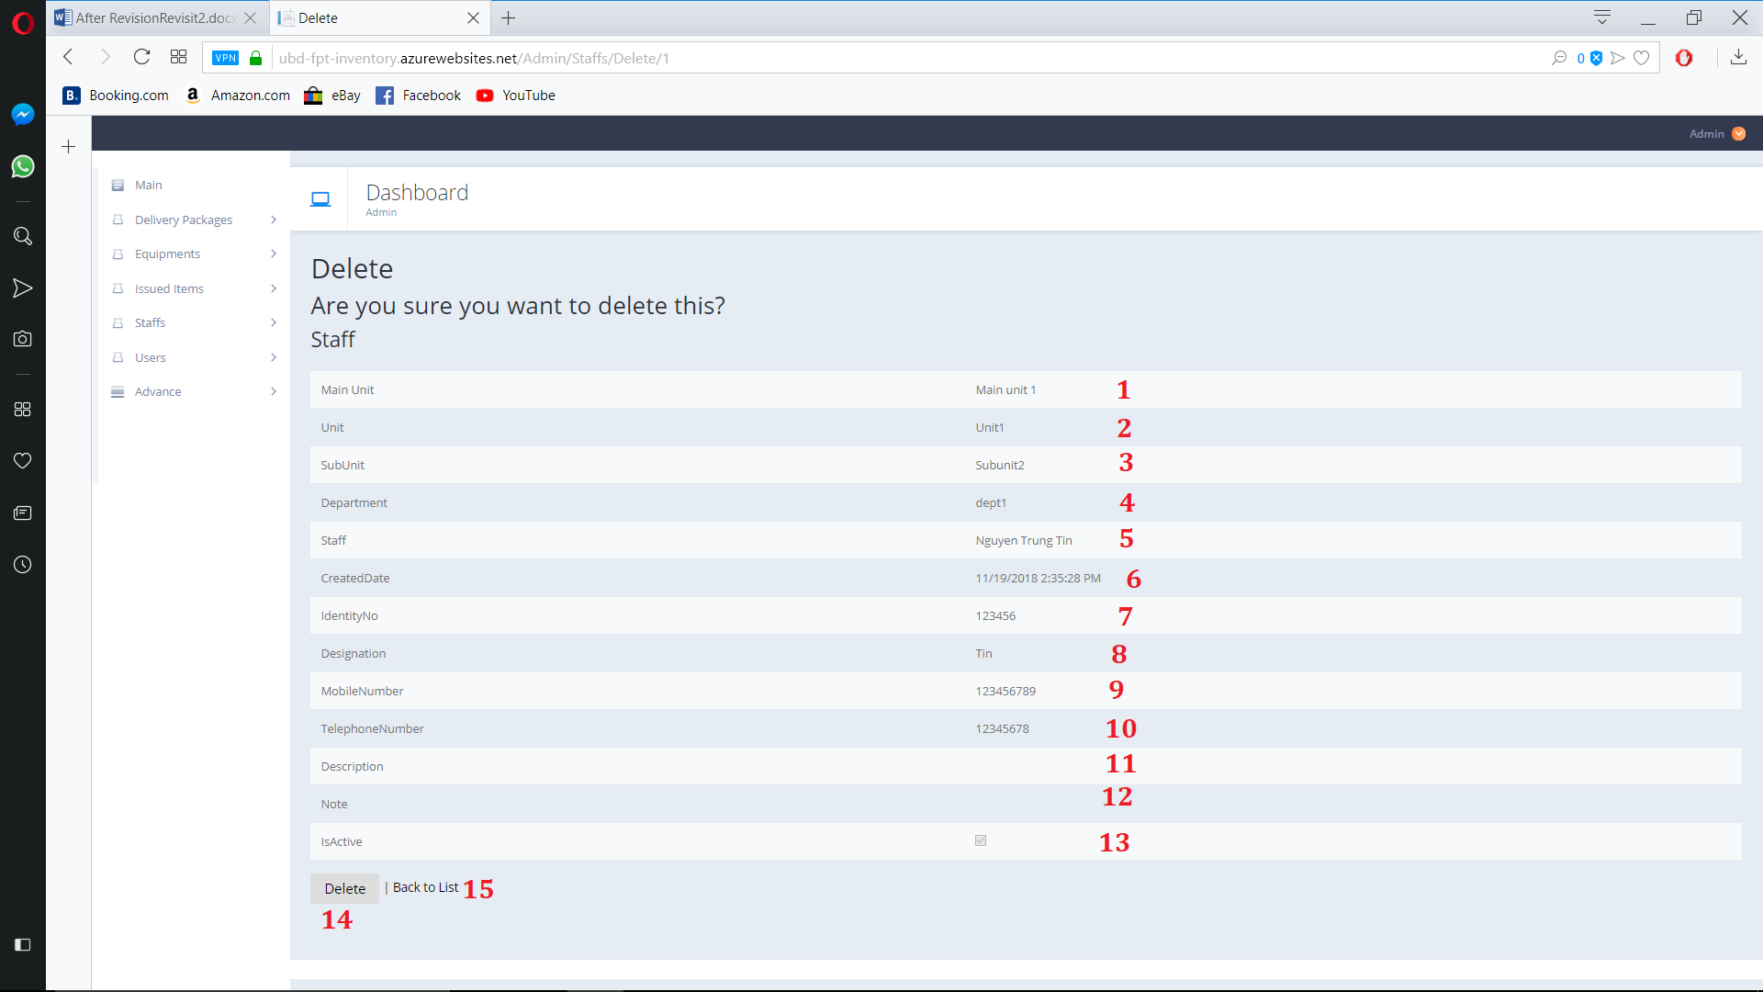

Figure 167. Delete Staff

**Fields**

|  |  |  |  |  |  |  |
| --- | --- | --- | --- | --- | --- | --- |
| **No** | **Field Name** | **Description** | **Read only** | **Mandatory** | **Control Type** | **Data Type** |
| 1 | MainUnit | Staff’s Main Unit | Yes | Yes | Text | String |
| 2 | Unit | Staff’s Unit | Yes | Yes | Text | String |
| 3 | SubUnit | Staff’s Sub Unit | Yes | Yes | Text | String |
| 4 | Department | Staff’s Department | Yes | Yes | Text | String |
| 5 | Staff | Staff’s Name | Yes | Yes | Text | String |
| 6 | CreatedDate | Staff’s Create Date | Yes | Yes | Text | String |
| 7 | IndentityNo | Staff’s Indentity Number | Yes | Yes | Text | String |
| 8 | Designation | Staff’s Designation | Yes | Yes | Text | String |
| 9 | MobileNumber | Staff’s Mobile Number | Yes | Yes | Text | String |
| 10 | TelephoneNumber | Staff’s Telephone Number | Yes | Yes | Text | String |
| 11 | Description | Staff’s Description | Yes | Yes | Text | String |
| 12 | Note | Staff’s Note | Yes | Yes | Text | String |
| 13 | IsActive | Staff’s active state | Yes | Yes | Check  Box | Boolean |

Table 202. <Fields> Delete Staff

**Buttons/Hyperlinks:**

|  |  |  |  |  |
| --- | --- | --- | --- | --- |
| **No** | **Function** | **Description** | **Validation** | **Outcome** |
| 14 | Delete | Delete staff | N/A | Delete selected staff |
| 15 | Back to List | Go to Staff view page | N/A | Navigate to Staff view page |

Table 203. <Buttons/Hyperlinks> Delete Staff

* + 1. View Users

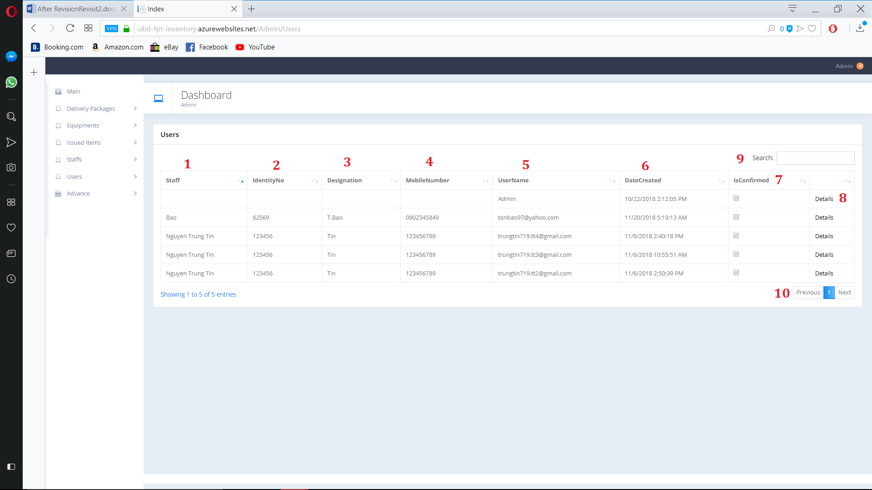

Figure 168. View Users

**Fields**

|  |  |  |  |  |  |  |
| --- | --- | --- | --- | --- | --- | --- |
| **No** | **Field Name** | **Description** | **Read only** | **Mandatory** | **Control Type** | **Data Type** |
| 1 | Staff | User account’s staff | Yes | Yes | Text | String |
| 2 | IndentityNo | User account’s Indentity No | Yes | Yes | Text | String |
| 3 | Designation | User account’s Designation | Yes | Yes | Text | String |
| 4 | MobileNumber | User account’s Mobile number | Yes | Yes | Text | String |
| 5 | Username | User account’s username | Yes | Yes | Text | String |
| 6 | DateCreated | User account’s create day | Yes | Yes | Text | String |
| 7 | IsConfirmed | User account’s Confirm State | Yes | Yes | Check  Box | Boolean |
| 9 | Search | Search by user input | No | No | TextBox | String |

Table 204. <Fields> View Users

**Buttons/Hyperlinks:**

|  |  |  |  |  |
| --- | --- | --- | --- | --- |
| **No** | **Function** | **Description** | **Validation** | **Outcome** |
| 8 | Detail | Go to user detail page | N/A | Navigate to User detail page |
| 10 | Navigation | Navigation through pages of list | N/A | Show selected page of User list |

Table 205. <Buttons/Hyperlinks> View Users

* + 1. User Detail

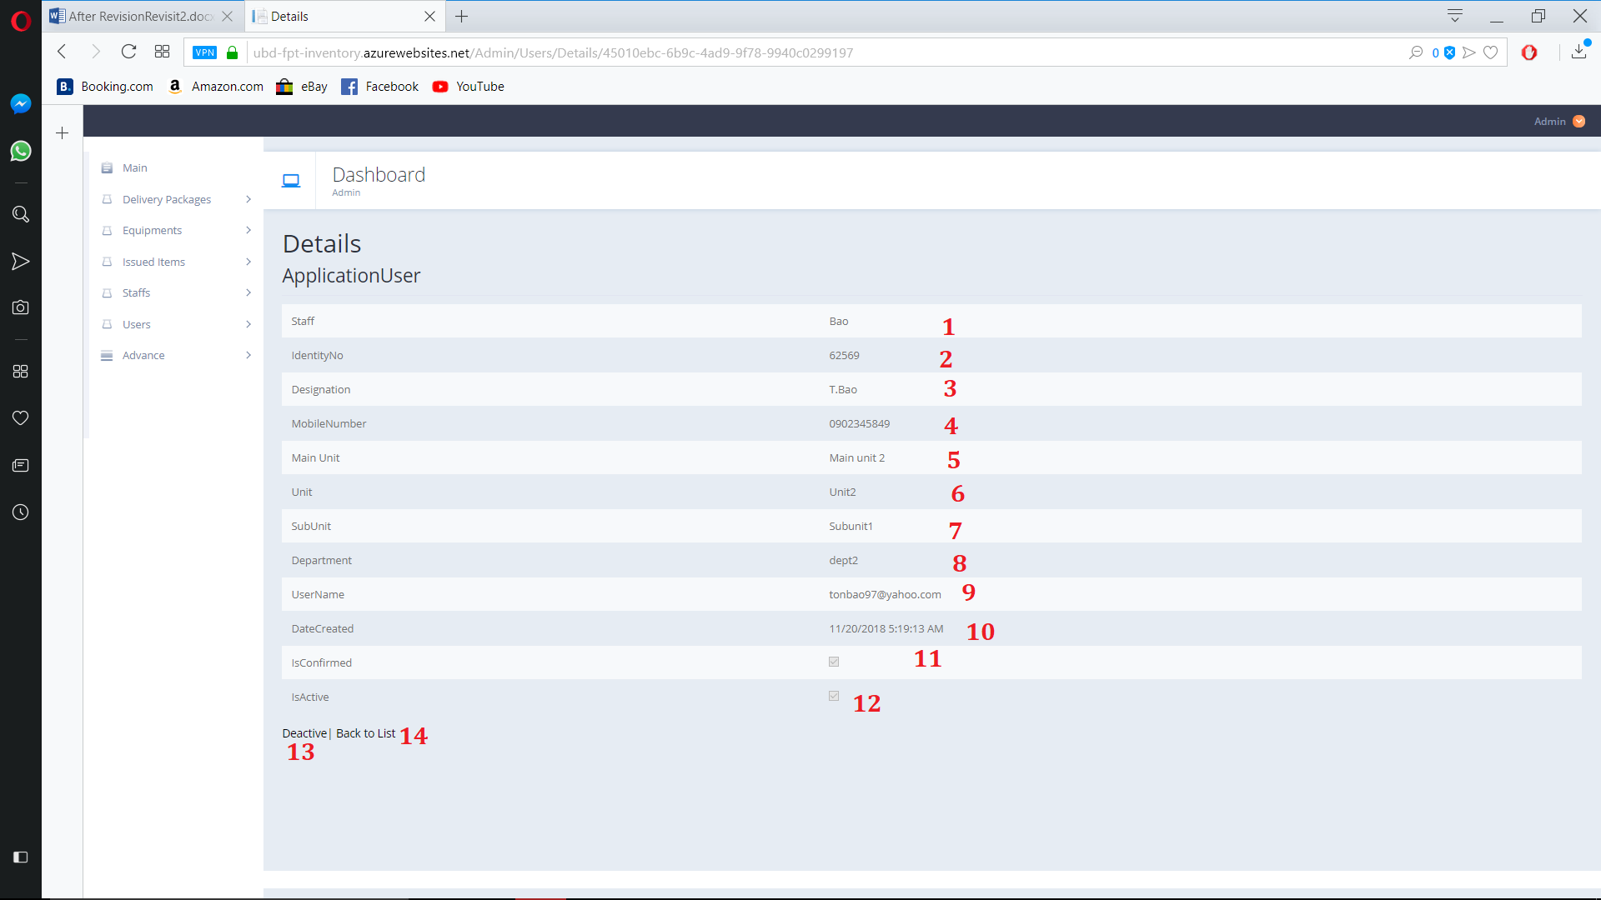

Figure 169. View User Detail

**Fields**

|  |  |  |  |  |  |  |
| --- | --- | --- | --- | --- | --- | --- |
| **No** | **Field Name** | **Description** | **Read only** | **Mandatory** | **Control Type** | **Data Type** |
| 1 | Staff | User account’s staff | Yes | Yes | Text | String |
| 2 | IndentityNo | User account’s Indentity No | Yes | Yes | Text | String |
| 3 | Designation | User account’s Designation | Yes | Yes | Text | String |
| 4 | MobileNumber | User account’s Mobile number | Yes | Yes | Text | String |
| 5 | Username | User account’s username | Yes | Yes | Text | String |
| 6 | Main Unit | User account’s staff Main Unit | Yes | Yes | Text | String |
| 7 | Unit | User account’s staff Unit | Yes | Yes | Text | String |
| 8 | Sub unit | User account’s staff Sub Unit | Yes | Yes | Text | String |
| 9 | Department | User account’s staff Department | Yes | Yes | Text | String |
| 10 | DateCreated | User account’s create day | Yes | Yes | Text | String |
| 11 | IsConfirmed | User account’s Confirm State | Yes | Yes | Check  Box | Boolean |
| 12 | IsActive | User account’s Active state | Yes | Yes | Check  Box | Boolean |

Table 206. <Fields> User Detail

**Buttons/Hyperlinks:**

|  |  |  |  |  |
| --- | --- | --- | --- | --- |
| **No** | **Function** | **Description** | **Validation** | **Outcome** |
| 13 | Deactive | Deactive account | N/A | Deactive account |
| 14 | Navigation | Navigation through pages of list | N/A | Show selected page of User list |

Table 207. <Buttons/Hyperlinks> User Detail

* + 1. Advanced Menu

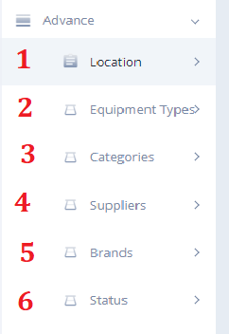

Figure 170. Advanced Menu

**Buttons/Hyperlinks:**

|  |  |  |  |  |
| --- | --- | --- | --- | --- |
| **No** | **Function** | **Description** | **Validation** | **Outcome** |
| 1 | Location | Open Location Sub Menu | N/A | Show all location option |
| 2 | Equipment Type | Open Equipment Type Sub Menu | N/A | Show all Equipment Type option |
| 3 | Categories | Open Categories Sub Menu | N/A | Show all Categories option |
| 4 | Suppliers | Open Suppliers Sub Menu | N/A | Show all Suppliers option |
| 5 | Brand | Open Brand Sub Menu | N/A | Show all Brand option |
| 6 | Status | Open Status Sub Menu | N/A | Show all Status option |

Table 208. <Buttons/Hyperlinks> Advanced Menu

* + 1. Location Sub Menu

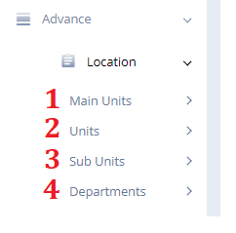

Figure 171. Location Sub menu

**Buttons/Hyperlinks:**

|  |  |  |  |  |
| --- | --- | --- | --- | --- |
| **No** | **Function** | **Description** | **Validation** | **Outcome** |
| 1 | Main Units | Open Main Units Sub Menu | N/A | Show all Main Units option |
| 2 | Units | Open Units Type Sub Menu | N/A | Show all Units option |
| 3 | Sub Units | Open Sub Units sub Menu | N/A | Show all Sub Units option |
| 4 | Departments | Open Departments sub Menu | N/A | Show all Departments option |

Table 209. <Buttons/Hyperlinks> Location Sub Menu

* + 1. Location View (Main Unit,Unit,Sub,…)

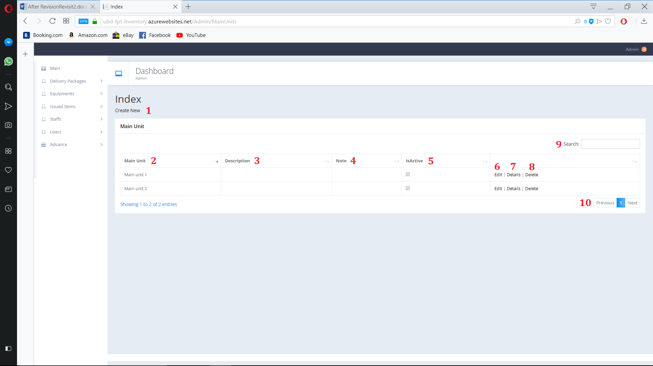

Figure 172. Location View

**Fields**

|  |  |  |  |  |  |  |
| --- | --- | --- | --- | --- | --- | --- |
| **No** | **Field Name** | **Description** | **Read only** | **Mandatory** | **Control Type** | **Data Type** |
| 2 | Location | Location’s Name | Yes | Yes | Text | String |
| 3 | Description | Location’s Description | Yes | Yes | Text | String |
| 4 | Note | Location’s Note | Yes | Yes | Text | String |
| 5 | IsActive | Location’s active state | Yes | Yes | Check  Box | Boolean |
| 9 | Search | Search By user input | No | No | TextBox | String |

Table 210. <Fields> Location View

**Buttons/Hyperlinks:**

|  |  |  |  |  |
| --- | --- | --- | --- | --- |
| **No** | **Function** | **Description** | **Validation** | **Outcome** |
| 1 | Create New | Create new Location | N/A | Navigate to create new page |
| 6 | Edit | Edit Select Location | N/A | Navigate to Edit page |
| 7 | Details | Open Location detail page | N/A | Navigate to Detail page |
| 8 | Delete | Delete Location | N/A | Navigate to Delete confirm page |
| 10 | Navigation | Navigation through pages of list | N/A | Show selected page of Location list |

Table 211. <Buttons/HyperLinks> Location View

Create Location

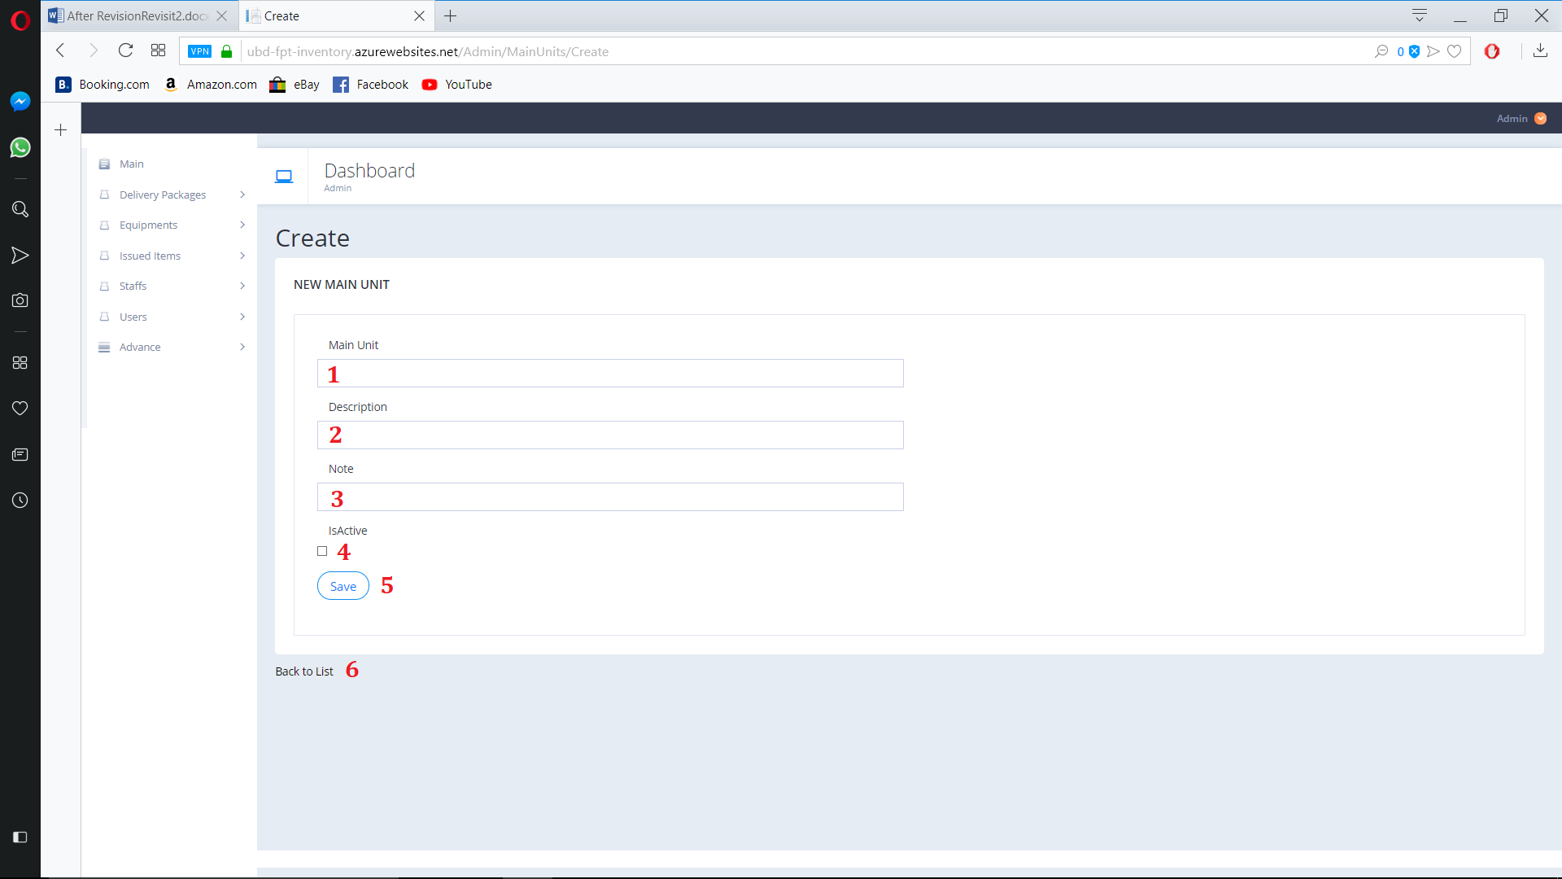

Figure 173. Create Location

**Fields**

|  |  |  |  |  |  |  |
| --- | --- | --- | --- | --- | --- | --- |
| **No** | **Field Name** | **Description** | **Read only** | **Mandatory** | **Control Type** | **Data Type** |
| 1 | Locations | Location’s Name | No | Yes | Text | String |
| 2 | Description | Location’s Description | No | No | Text | String |
| 3 | Note | Location’s Note | No | No | Text | String |
| 4 | IsActive | Location’s active state | No | No | Check  Box | Boolean |

Table 212. <Fields> Create Location

**Buttons/Hyperlinks:**

|  |  |  |  |  |
| --- | --- | --- | --- | --- |
| **No** | **Function** | **Description** | **Validation** | **Outcome** |
| 5 | Create New | Create new Location | N/A | Create new Location |
| 6 | Back to List | Go to Location view page | N/A | Navigate to Location view page |

Table 212. <Buttons/HyperLinks> Create Location

* + 1. Edit Location

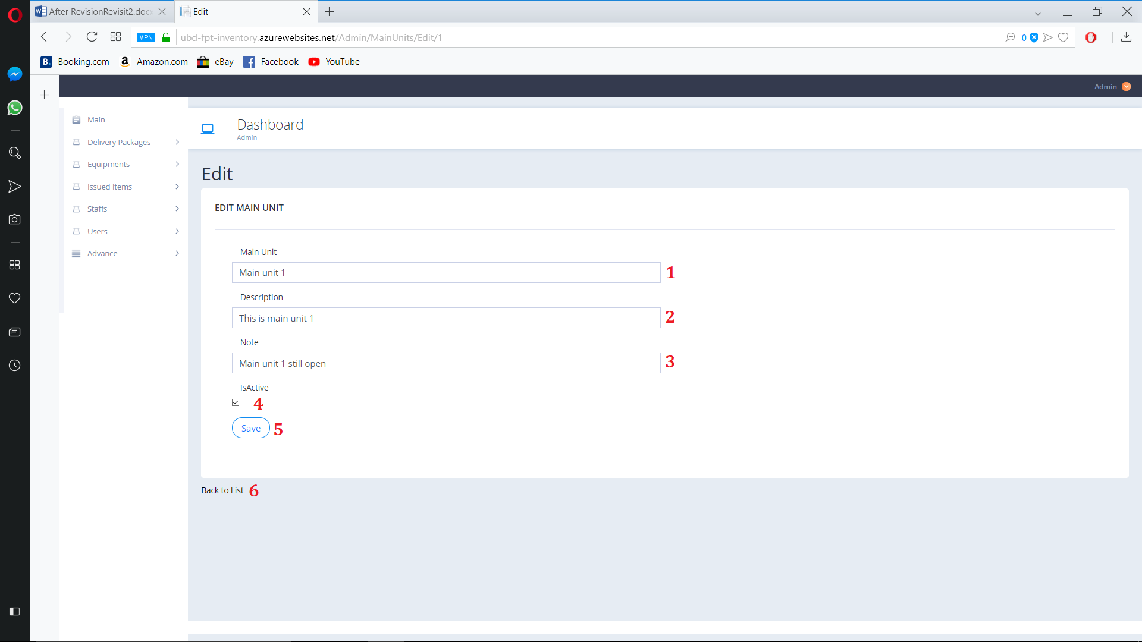

Figure 174. Edit Location

**Fields**

|  |  |  |  |  |  |  |
| --- | --- | --- | --- | --- | --- | --- |
| **No** | **Field Name** | **Description** | **Read only** | **Mandatory** | **Control Type** | **Data Type** |
| 1 | Locations | Location’s Name | No | Yes | Text | String |
| 2 | Description | Location’s Description | No | No | Text | String |
| 3 | Note | Location’s Note | No | No | Text | String |
| 4 | IsActive | Location’s active state | No | No | Check  Box | Boolean |

**Buttons/Hyperlinks:**

|  |  |  |  |  |
| --- | --- | --- | --- | --- |
| **No** | **Function** | **Description** | **Validation** | **Outcome** |
| 5 | Create New | Create new Location | N/A | Create new Location |
| 6 | Back to List | Go to Location view page | N/A | Navigate to Location view page |

* + 1. View Location

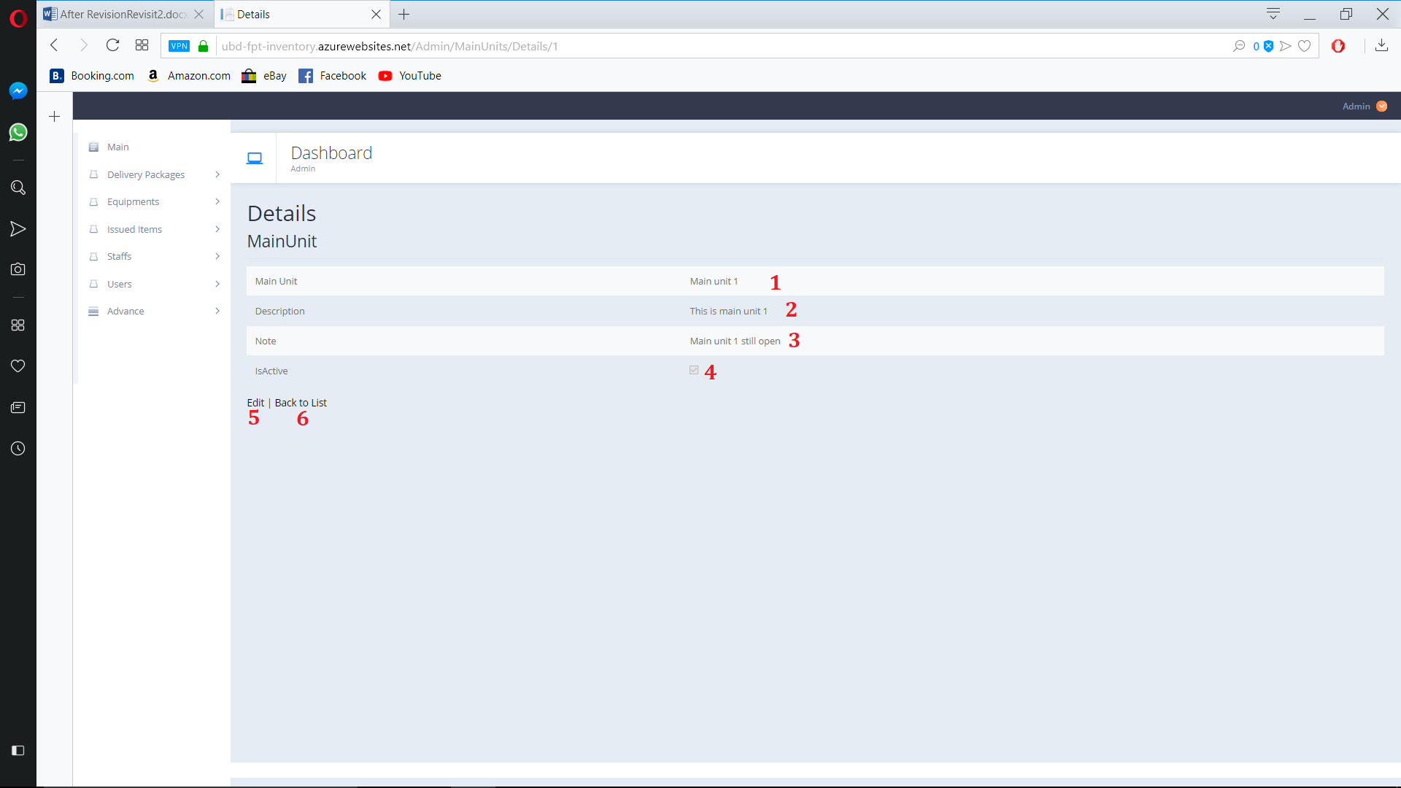

Figure 175. View Location

**Fields**

|  |  |  |  |  |  |  |
| --- | --- | --- | --- | --- | --- | --- |
| **No** | **Field Name** | **Description** | **Read only** | **Mandatory** | **Control Type** | **Data Type** |
| 1 | Locations | Location’s Name | Yes | Yes | Text | String |
| 2 | Description | Location’s Description | Yes | Yes | Text | String |
| 3 | Note | Location’s Note | Yes | Yes | Text | String |
| 4 | IsActive | Location’s active state | Yes | Yes | Check  Box | Boolean |

**Buttons/Hyperlinks:**

|  |  |  |  |  |
| --- | --- | --- | --- | --- |
| **No** | **Function** | **Description** | **Validation** | **Outcome** |
| 5 | Edit | Go to edit page | N/A | Nagvigate to edit page |
| 6 | Back to List | Go to Location view page | N/A | Navigate to Location view page |

* + 1. Delete Location

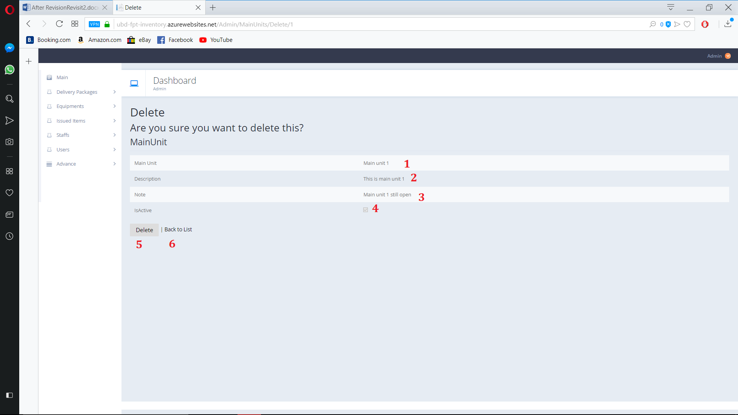

Figure 176. Delete Location

**Fields**

|  |  |  |  |  |  |  |
| --- | --- | --- | --- | --- | --- | --- |
| **No** | **Field Name** | **Description** | **Read only** | **Mandatory** | **Control Type** | **Data Type** |
| 1 | Locations | Location’s Name | Yes | Yes | Text | String |
| 2 | Description | Location’s Description | Yes | Yes | Text | String |
| 3 | Note | Location’s Note | Yes | Yes | Text | String |
| 4 | IsActive | Location’s active state | Yes | Yes | Check  Box | Boolean |

**Buttons/Hyperlinks:**

|  |  |  |  |  |
| --- | --- | --- | --- | --- |
| **No** | **Function** | **Description** | **Validation** | **Outcome** |
| 5 | Delete | Delete Location | N/A | Delete Location |
| 6 | Back to List | Go to Location view page | N/A | Navigate to Location view page |

* + 1. View Equipment Type

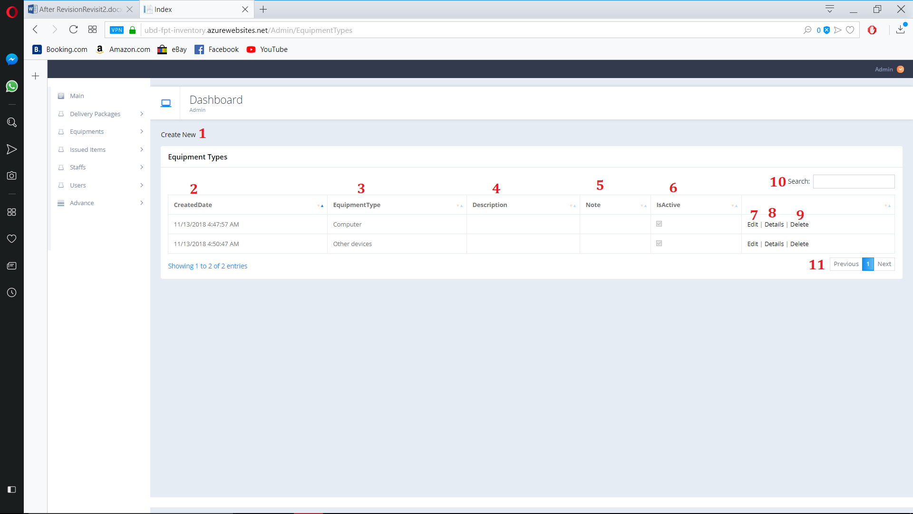

Figure 177. View Equipment Type

**Fields**

|  |  |  |  |  |  |  |
| --- | --- | --- | --- | --- | --- | --- |
| **No** | **Field Name** | **Description** | **Read only** | **Mandatory** | **Control Type** | **Data Type** |
| 2 | CreatedDate | Equipment Type’s Created Date | Yes | Yes | Text | String |
| 3 | EquipmentType | Equipment Type’s Name | Yes | Yes | Text | String |
| 4 | Description | Equipment Type’s Description | Yes | Yes | Text | String |
| 5 | Note | Equipment Type’s Note | Yes | Yes | Text | String |
| 6 | IsActive | Equipment Type’s active state | Yes | Yes | Check  Box | Boolean |
| 10 | Search | Search By user input | No | No | TextBox | String |

**Buttons/Hyperlinks:**

|  |  |  |  |  |
| --- | --- | --- | --- | --- |
| **No** | **Function** | **Description** | **Validation** | **Outcome** |
| 1 | Create New | Create new Equipment Type | N/A | Navigate to create new page |
| 6 | Edit | Edit Select Equipment Type | N/A | Navigate to Edit page |
| 7 | Details | Open Equipment Type detail page | N/A | Navigate to Detail page |
| 8 | Delete | Delete Equipment Type | N/A | Navigate to Delete confirm page |
| 10 | Navigation | Navigation through pages of list | N/A | Show selected page of Equipment Type list |

* + 1. Create Equipment Type

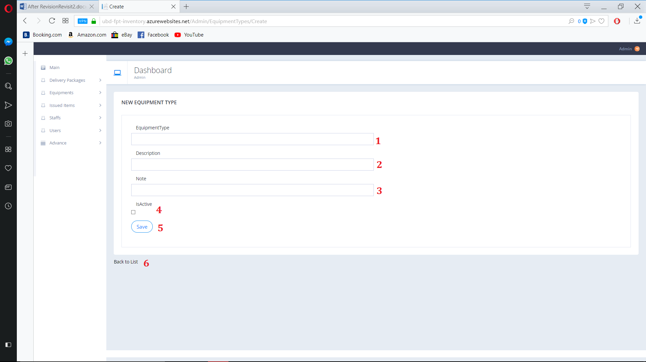

Figure 178. Create Equipment Type

**Fields**

|  |  |  |  |  |  |  |
| --- | --- | --- | --- | --- | --- | --- |
| **No** | **Field Name** | **Description** | **Read only** | **Mandatory** | **Control Type** | **Data Type** |
| 1 | Equipment Type | Equipment Type’s Name | No | Yes | Text | String |
| 2 | Description | Equipment Type’s Description | No | No | Text | String |
| 3 | Note | Equipment Type’s Note | No | No | Text | String |
| 4 | IsActive | Equipment Type’s active state | No | No | Check  Box | Boolean |

**Buttons/Hyperlinks:**

|  |  |  |  |  |
| --- | --- | --- | --- | --- |
| **No** | **Function** | **Description** | **Validation** | **Outcome** |
| 5 | Create New | Create new Equipment Type | N/A | Create new Equipment Type |
| 6 | Back to List | Go to Equipment Type view page | N/A | Navigate to Equipment Type view page |

* + 1. Edit Equipment Type

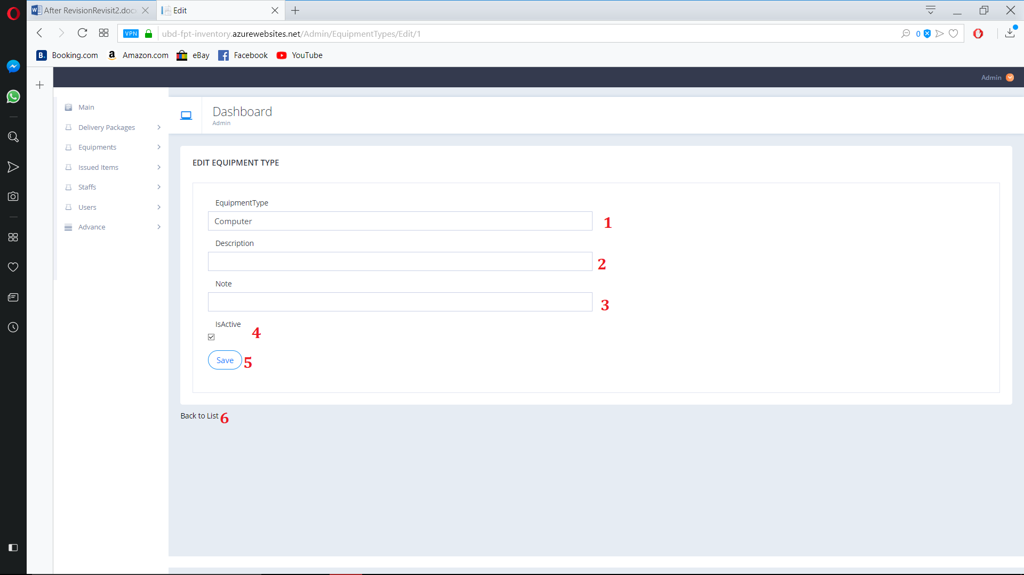

Figure 179. Edit Equipment Type

**Fields**

|  |  |  |  |  |  |  |
| --- | --- | --- | --- | --- | --- | --- |
| **No** | **Field Name** | **Description** | **Read only** | **Mandatory** | **Control Type** | **Data Type** |
| 1 | Equipment Type | Equipment Type’s Name | No | Yes | Text | String |
| 2 | Description | Equipment Type’s Description | No | No | Text | String |
| 3 | Note | Equipment Type’s Note | No | No | Text | String |
| 4 | IsActive | Equipment Type’s active state | No | No | Check  Box | Boolean |

**Buttons/Hyperlinks:**

|  |  |  |  |  |
| --- | --- | --- | --- | --- |
| **No** | **Function** | **Description** | **Validation** | **Outcome** |
| 5 | Create New | Create new Equipment Type | N/A | Create new Equipment Type |
| 6 | Back to List | Go to Equipment Type view page | N/A | Navigate to Equipment Type view page |

* + 1. Equipment Type Detail

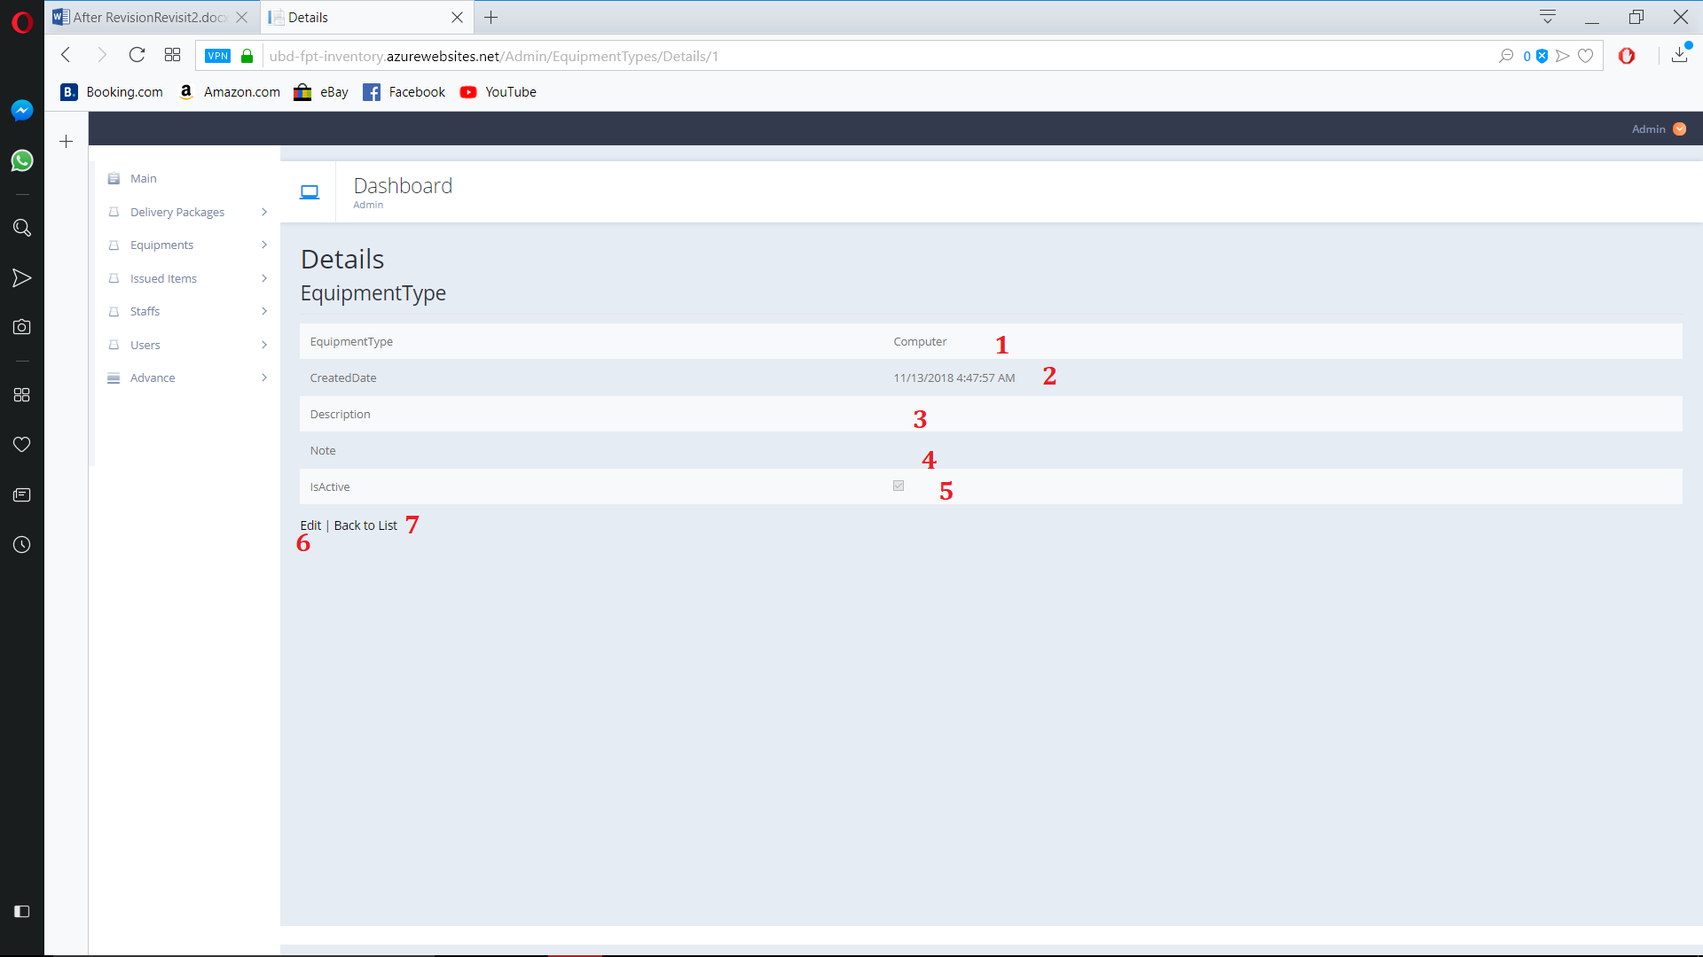

Figure 180. Equipment Type Detail

**Fields**

|  |  |  |  |  |  |  |
| --- | --- | --- | --- | --- | --- | --- |
| **No** | **Field Name** | **Description** | **Read only** | **Mandatory** | **Control Type** | **Data Type** |
| 1 | Equipment Type | Equipment Type’s Name | Yes | Yes | Text | String |
| 2 | Description | Equipment Type’s Description | Yes | No | Text | String |
| 3 | Note | Equipment Type’s Note | Yes | No | Text | String |
| 4 | IsActive | Equipment Type’s active state | Yes | No | Check  Box | Boolean |

**Buttons/Hyperlinks:**

|  |  |  |  |  |
| --- | --- | --- | --- | --- |
| **No** | **Function** | **Description** | **Validation** | **Outcome** |
| 5 | Edit | Go to edit page | N/A | Nagvigate to edit page |
| 6 | Back to List | Go to Equipment Type view page | N/A | Navigate to Equipment Type view page |

* + 1. Delete Equipment Type

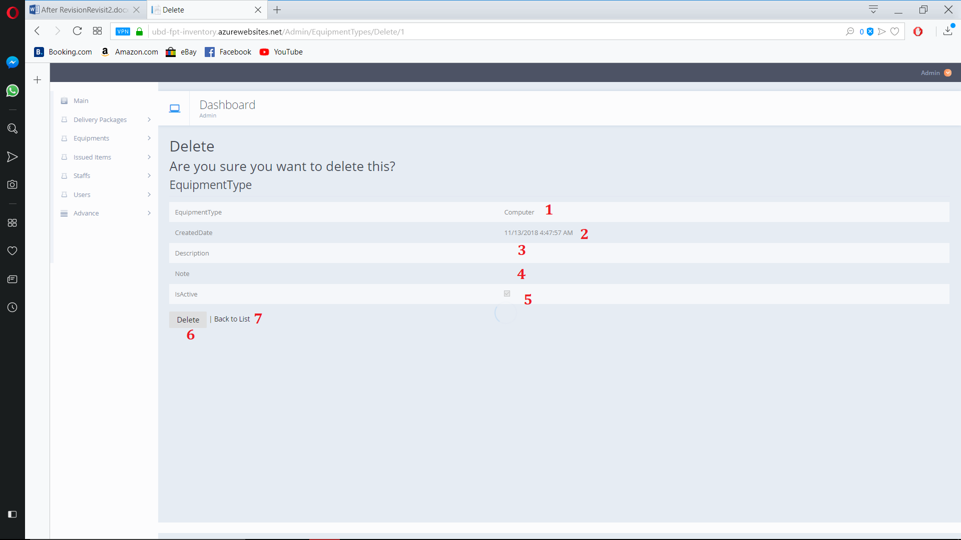

Figure 181. Delete Equipment type

**Fields**

|  |  |  |  |  |  |  |
| --- | --- | --- | --- | --- | --- | --- |
| **No** | **Field Name** | **Description** | **Read only** | **Mandatory** | **Control Type** | **Data Type** |
| 1 | Equipment Type | Equipment Type’s Name | Yes | Yes | Text | String |
| 2 | Description | Equipment Type’s Description | Yes | No | Text | String |
| 3 | Note | Equipment Type’s Note | Yes | No | Text | String |
| 4 | IsActive | Equipment Type’s active state | Yes | No | Check  Box | Boolean |

**Buttons/Hyperlinks:**

|  |  |  |  |  |
| --- | --- | --- | --- | --- |
| **No** | **Function** | **Description** | **Validation** | **Outcome** |
| 5 | Delete | Delete selected Equipment type | N/A | Delete selected Equipment type |
| 6 | Back to List | Go to Equipment Type view page | N/A | Navigate to Equipment Type view page |

* + 1. View Category

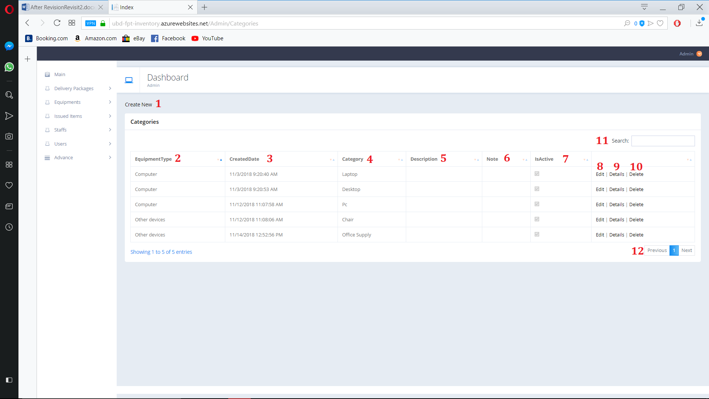

Figure 182. View Category

**Fields**

|  |  |  |  |  |  |  |
| --- | --- | --- | --- | --- | --- | --- |
| **No** | **Field Name** | **Description** | **Read only** | **Mandatory** | **Control Type** | **Data Type** |
| 2 | Equipment Type | Category belong to Type | Yes | Yes | Text | String |
| 3 | CreatedDate | Category’s Created Date | Yes | Yes | Text | String |
| 4 | Category | Category’s Name | Yes | Yes | Text | String |
| 5 | Description | Category’s Description | Yes | Yes | Text | String |
| 6 | Note | Category’s Note | Yes | Yes | Text | String |
| 7 | IsActive | Category’s active state | Yes | Yes | Check  Box | Boolean |
| 11 | Search | Search By user input | No | No | TextBox | String |

**Buttons/Hyperlinks:**

|  |  |  |  |  |
| --- | --- | --- | --- | --- |
| **No** | **Function** | **Description** | **Validation** | **Outcome** |
| 1 | Create New | Create new Category | N/A | Navigate to create new page |
| 8 | Edit | Edit Select Category | N/A | Navigate to Edit page |
| 9 | Details | Open Category detail page | N/A | Navigate to Detail page |
| 10 | Delete | Delete Category | N/A | Navigate to Delete confirm page |
| 12 | Navigation | Navigation through pages of list | N/A | Show selected page of Category list |

* + 1. Create Category

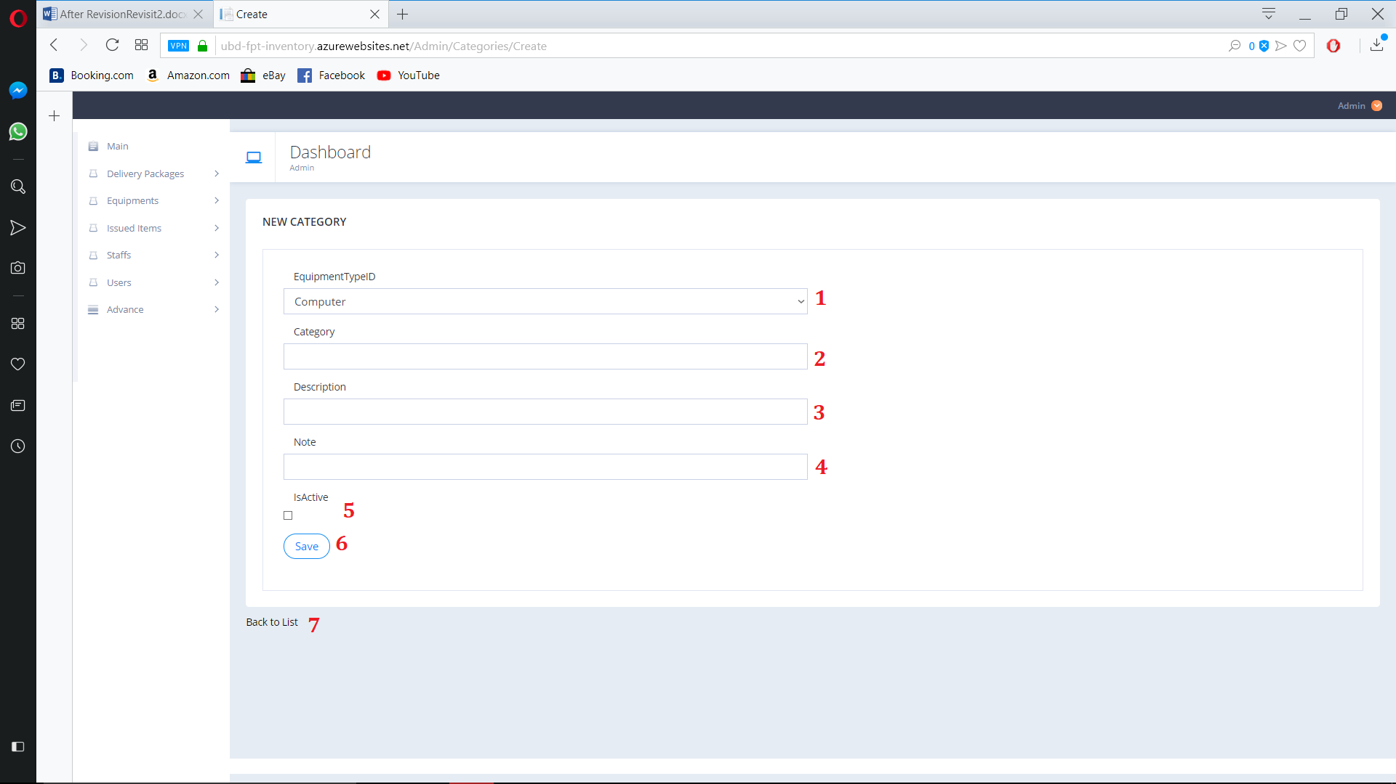

Figure 183. Create category

**Fields**

|  |  |  |  |  |  |  |
| --- | --- | --- | --- | --- | --- | --- |
| **No** | **Field Name** | **Description** | **Read only** | **Mandatory** | **Control Type** | **Data Type** |
| 1 | EquipmentTypeID | Category’s Type | No | Yes | Text | String |
| 2 | Category | Category’s Name | No | Yes | Text | String |
| 3 | Description | Category’s Description | No | No | Text | String |
| 4 | Note | Category’s Note | No | No | Text | String |
| 5 | IsActive | Category’s active state | No | No | Check  Box | Boolean |

**Buttons/Hyperlinks:**

|  |  |  |  |  |
| --- | --- | --- | --- | --- |
| **No** | **Function** | **Description** | **Validation** | **Outcome** |
| 6 | Save | Create new Category | N/A | Create new Category |
| 7 | Back to List | Go to Category view page | N/A | Navigate to Category view page |

* + 1. Edit Category

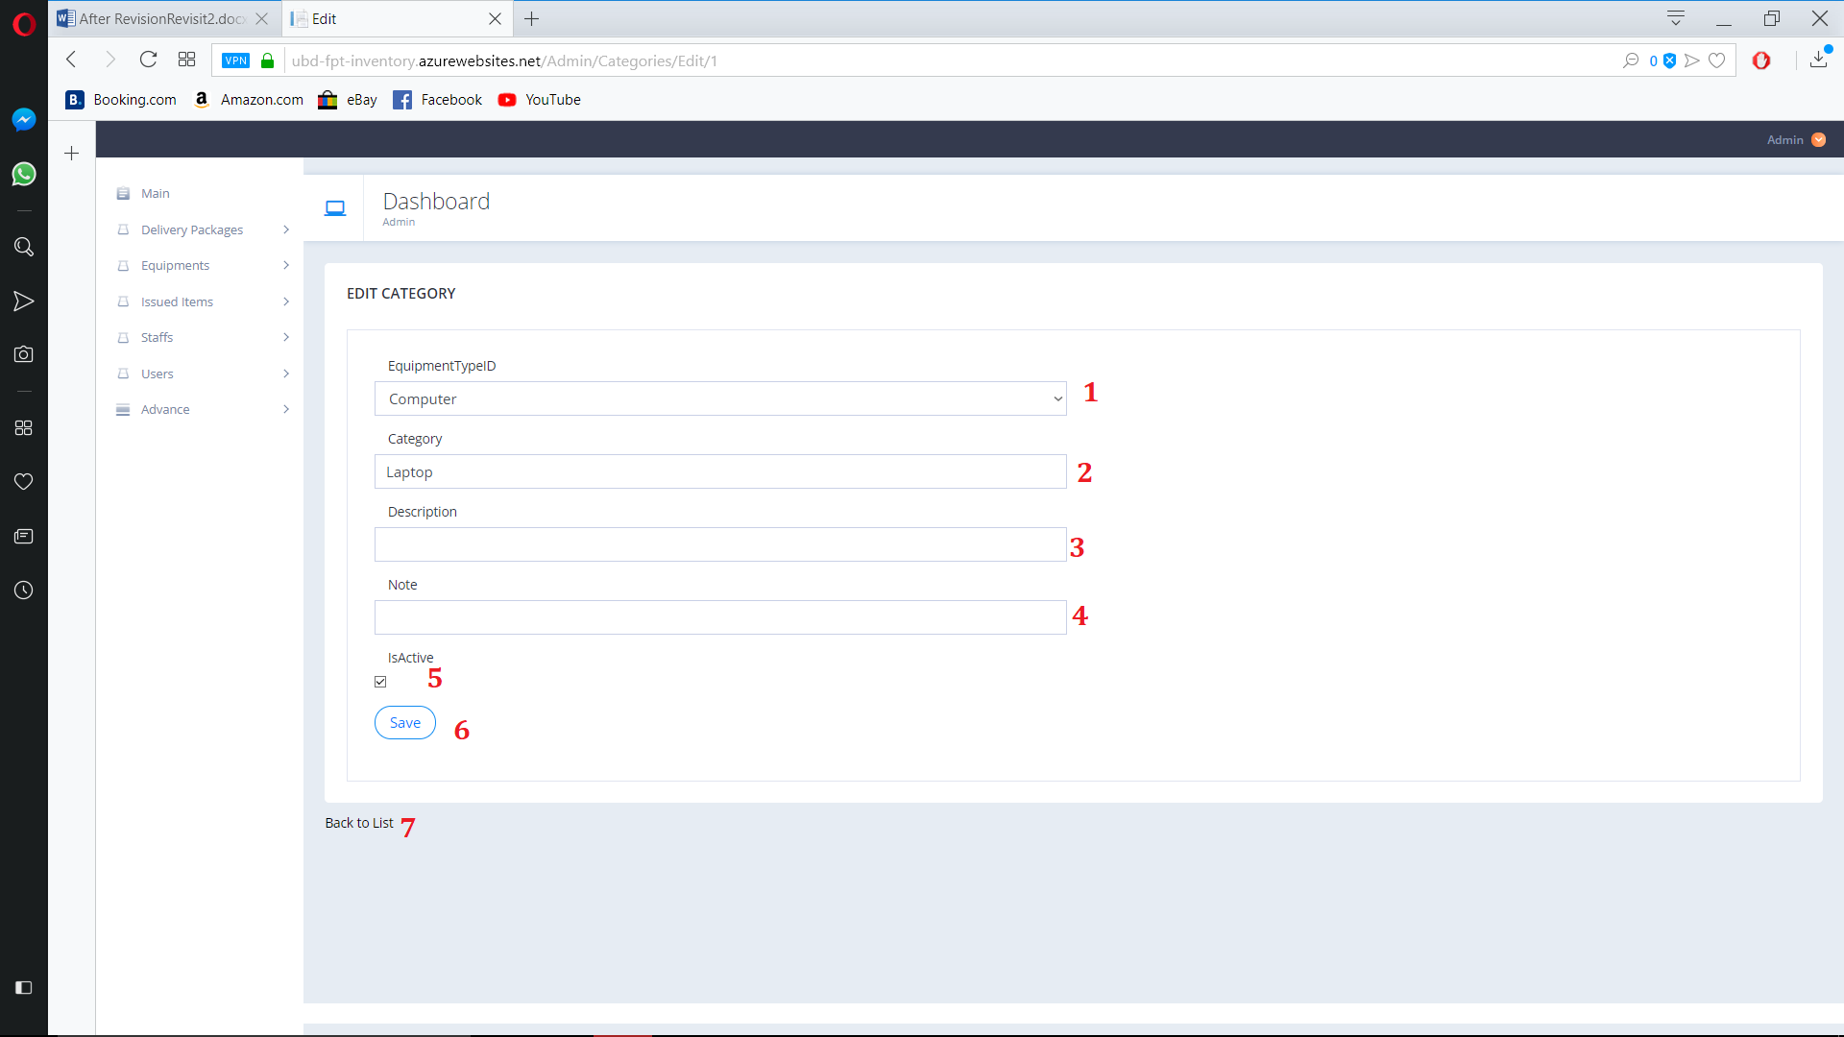

Figure 184. Edit Category

**Fields**

|  |  |  |  |  |  |  |
| --- | --- | --- | --- | --- | --- | --- |
| **No** | **Field Name** | **Description** | **Read only** | **Mandatory** | **Control Type** | **Data Type** |
| 1 | EquipmentTypeID | Category’s Type | No | Yes | Text | String |
| 2 | Category | Category’s Name | No | Yes | Text | String |
| 3 | Description | Category’s Description | No | No | Text | String |
| 4 | Note | Category’s Note | No | No | Text | String |
| 5 | IsActive | Category’s active state | No | No | Check  Box | Boolean |

**Buttons/Hyperlinks:**

|  |  |  |  |  |
| --- | --- | --- | --- | --- |
| **No** | **Function** | **Description** | **Validation** | **Outcome** |
| 6 | Save | Save edit Category | N/A | Save Edit Category |
| 7 | Back to List | Go to Category view page | N/A | Navigate to Category view page |

* + 1. Detail Category

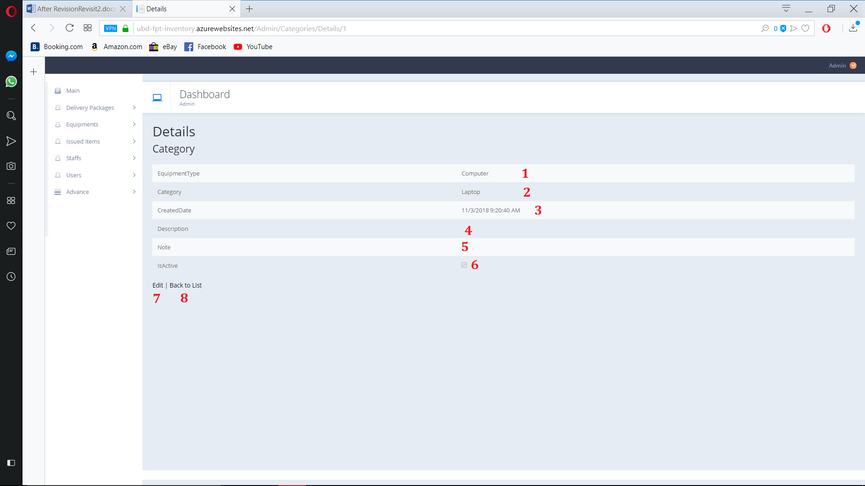

Figure 185. Detail Category

**Fields**

|  |  |  |  |  |  |  |
| --- | --- | --- | --- | --- | --- | --- |
| **No** | **Field Name** | **Description** | **Read only** | **Mandatory** | **Control Type** | **Data Type** |
| 1 | EquipmentType | Category’s Type | Yes | Yes | Text | String |
| 2 | Category | Category’s Name | Yes | Yes | Text | String |
| 3 | Description | Category’s Description | Yes | No | Text | String |
| 4 | Note | Category’s Note | Yes | No | Text | String |
| 5 | IsActive | Category’s active state | Yes | No | Check  Box | Boolean |

**Buttons/Hyperlinks:**

|  |  |  |  |  |
| --- | --- | --- | --- | --- |
| **No** | **Function** | **Description** | **Validation** | **Outcome** |
| 5 | Edit | Go to edit page | N/A | Nagvigate to edit page |
| 6 | Back to List | Go to Category view page | N/A | Navigate to Category view page |

* + 1. Delete Category

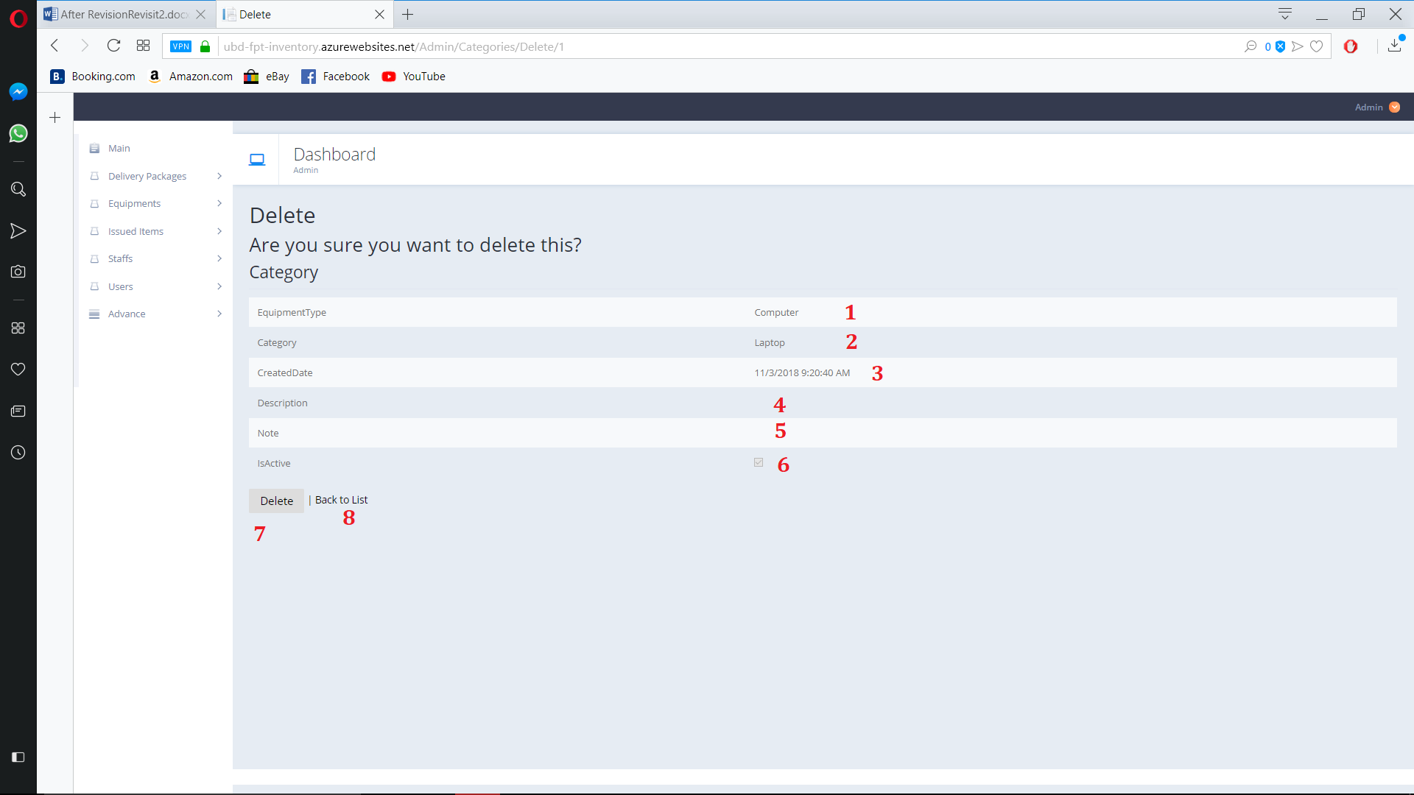

Figure 186. Delete Category

**Fields**

|  |  |  |  |  |  |  |
| --- | --- | --- | --- | --- | --- | --- |
| **No** | **Field Name** | **Description** | **Read only** | **Mandatory** | **Control Type** | **Data Type** |
| 1 | EquipmentType | Category’s Type | Yes | Yes | Text | String |
| 2 | Category | Category’s Name | Yes | Yes | Text | String |
| 3 | Description | Category’s Description | Yes | No | Text | String |
| 4 | Note | Category’s Note | Yes | No | Text | String |
| 5 | IsActive | Category’s active state | Yes | No | Check  Box | Boolean |

**Buttons/Hyperlinks:**

|  |  |  |  |  |
| --- | --- | --- | --- | --- |
| **No** | **Function** | **Description** | **Validation** | **Outcome** |
| 5 | Delete | Delete selected Category | N/A | Nagvigate to edit page |
| 6 | Back to List | Go to Category view page | N/A | Navigate to Category view page |

* + 1. View Supplier

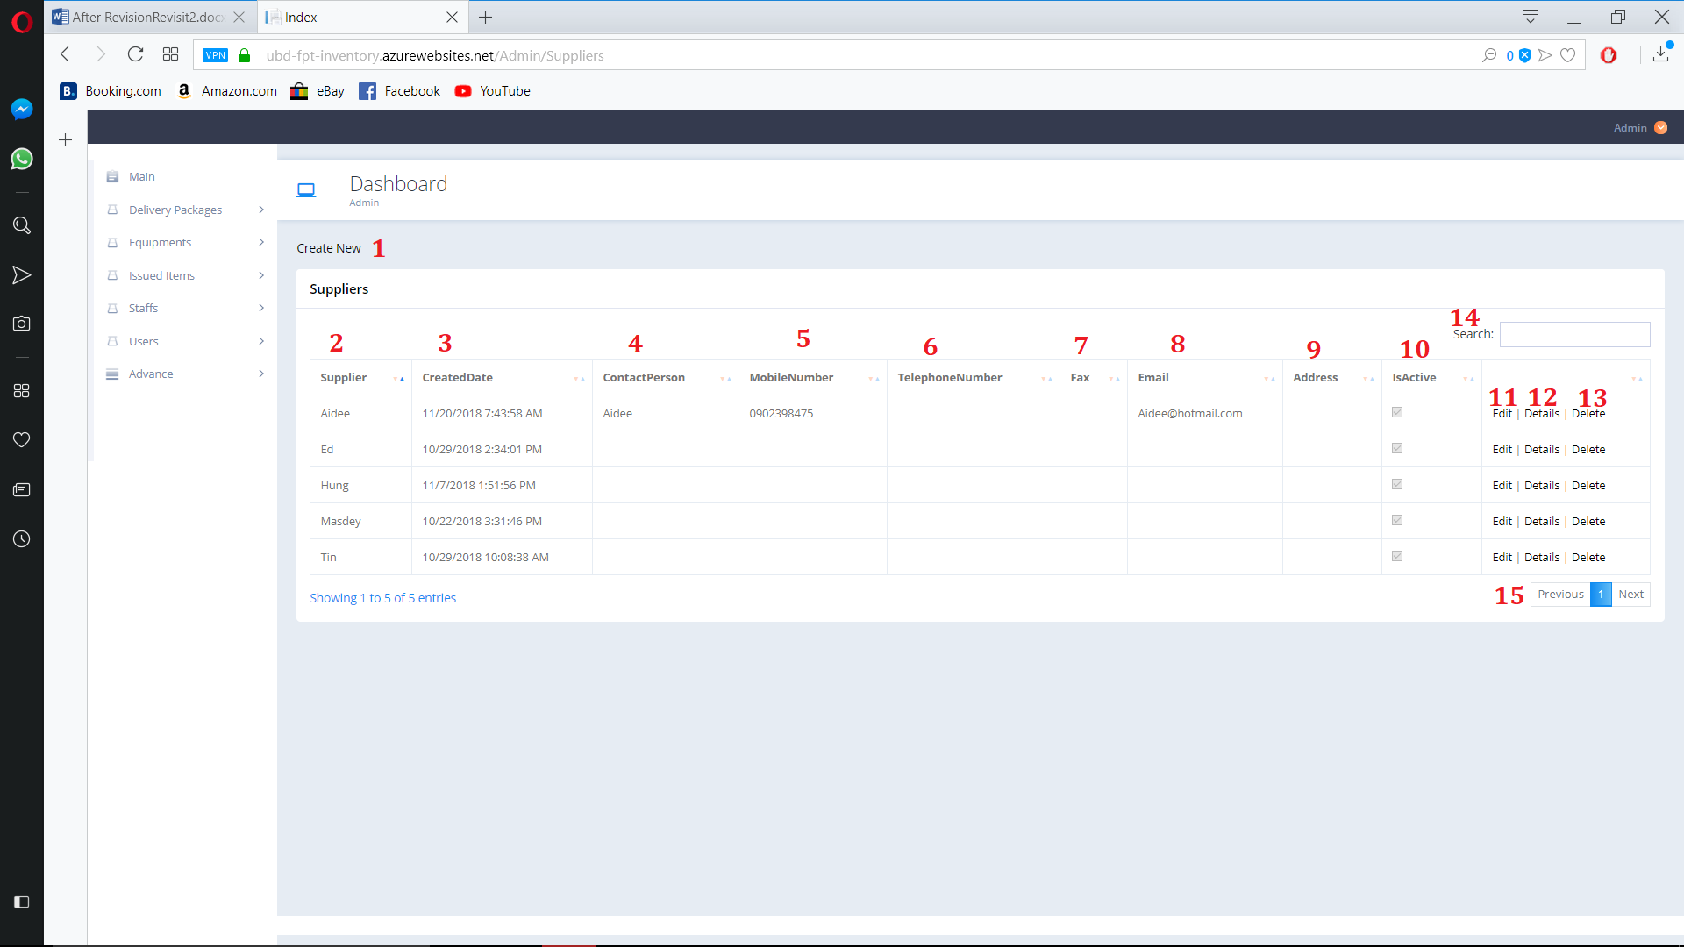

Figure 187. View Supplier

**Fields**

|  |  |  |  |  |  |  |
| --- | --- | --- | --- | --- | --- | --- |
| **No** | **Field Name** | **Description** | **Read only** | **Mandatory** | **Control Type** | **Data Type** |
| 2 | Supplier | Supplier’s Name | Yes | Yes | Text | String |
| 3 | CreatedDate | Supplier’s Created Date | Yes | Yes | Text | String |
| 4 | ContactPerson | Supplier’s ContactPerson | Yes | Yes | Text | String |
| 5 | MobileNumber | Supplier’s Phone number | Yes | Yes | Text | String |
| 6 | TelephoneNumber | Supplier’s Tele number | Yes | Yes | Text | String |
| 7 | Fax | Supplier’s Fax | Yes | Yes | Text | String |
| 8 | Email | Supplier’s Email | Yes | Yes | Text | String |
| 9 | Address | Supplier’s Address | Yes | Yes | Text | String |
| 10 | IsActive | Supplier’s Actice state | Yes | Yes | Check  Box | Boolean |
| 14 | Search | Search By user input | No | No | TextBox | String |

**Buttons/Hyperlinks:**

|  |  |  |  |  |
| --- | --- | --- | --- | --- |
| **No** | **Function** | **Description** | **Validation** | **Outcome** |
| 1 | Create New | Create new Supplier | N/A | Navigate to create new page |
| 6 | Edit | Edit Select Supplier | N/A | Navigate to Edit page |
| 7 | Details | Open Supplier detail page | N/A | Navigate to Detail page |
| 8 | Delete | Delete Supplier | N/A | Navigate to Delete confirm page |
| 10 | Navigation | Navigation through pages of list | N/A | Show selected page of Supplier list |

* + 1. Create Supplier

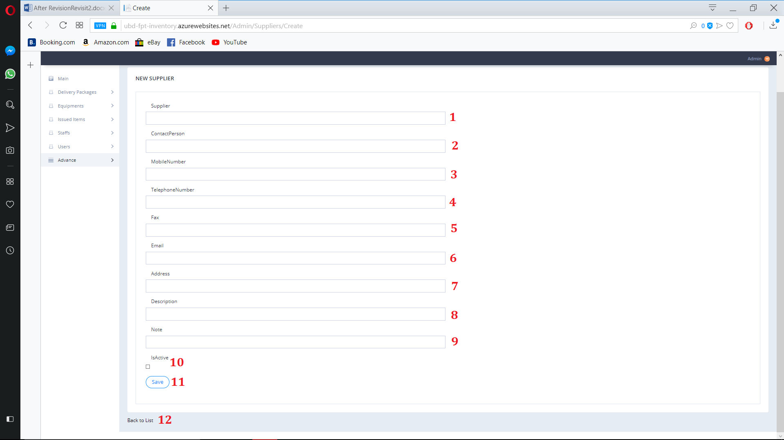

Figure 188. Create Supplier

**Fields**

|  |  |  |  |  |  |  |
| --- | --- | --- | --- | --- | --- | --- |
| **No** | **Field Name** | **Description** | **Read only** | **Mandatory** | **Control Type** | **Data Type** |
| 1 | Supplier | Supplier’s Name | No | Yes | Text | String |
| 2 | ContactPerson | Supplier’s ContactPerson | No | No | Text | String |
| 3 | MobileNumber | Supplier’s Phone number | No | No | Text | String |
| 4 | TelephoneNumber | Supplier’s Tele number | No | No | Text | String |
| 5 | Fax | Supplier’s Fax | No | No | Text | String |
| 6 | Email | Supplier’s Email | No | No | Text | String |
| 7 | Address | Supplier’s Address | No | No | Text | String |
| 8 | Description | Supplier’s Description | No | No | Text | String |
| 9 | Note | Supplier’s Note | No | No | Text | String |
| 10 | IsActive | Supplier’s Actice state | No | No | Check  Box | Boolean |

**Buttons/Hyperlinks:**

|  |  |  |  |  |
| --- | --- | --- | --- | --- |
| **No** | **Function** | **Description** | **Validation** | **Outcome** |
| 11 | Save | Create new Supplier | N/A | Create new Supplier |
| 12 | Back to List | Go to Supplier view page | N/A | Navigate to Supplier view page |

* + 1. Edit Supplier

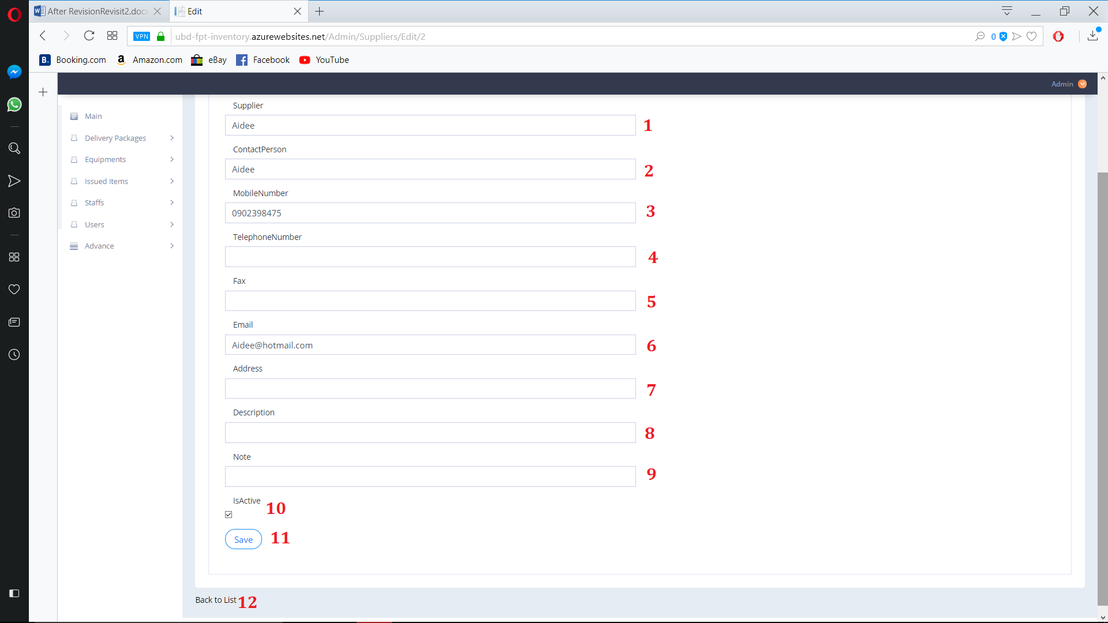

Figure 189. Edit Supplier

**Fields**

|  |  |  |  |  |  |  |
| --- | --- | --- | --- | --- | --- | --- |
| **No** | **Field Name** | **Description** | **Read only** | **Mandatory** | **Control Type** | **Data Type** |
| 1 | Supplier | Supplier’s Name | No | Yes | Text | String |
| 2 | ContactPerson | Supplier’s ContactPerson | No | No | Text | String |
| 3 | MobileNumber | Supplier’s Phone number | No | No | Text | String |
| 4 | TelephoneNumber | Supplier’s Tele number | No | No | Text | String |
| 5 | Fax | Supplier’s Fax | No | No | Text | String |
| 6 | Email | Supplier’s Email | No | No | Text | String |
| 7 | Address | Supplier’s Address | No | No | Text | String |
| 8 | Description | Supplier’s Description | No | No | Text | String |
| 9 | Note | Supplier’s Note | No | No | Text | String |
| 10 | IsActive | Supplier’s Actice state | No | No | Check  Box | Boolean |

**Buttons/Hyperlinks:**

|  |  |  |  |  |
| --- | --- | --- | --- | --- |
| **No** | **Function** | **Description** | **Validation** | **Outcome** |
| 11 | Save | Create new Supplier | N/A | Save Edit Supplier |
| 12 | Back to List | Go to Supplier view page | N/A | Navigate to Supplier view page |

* + 1. Supplier Detail

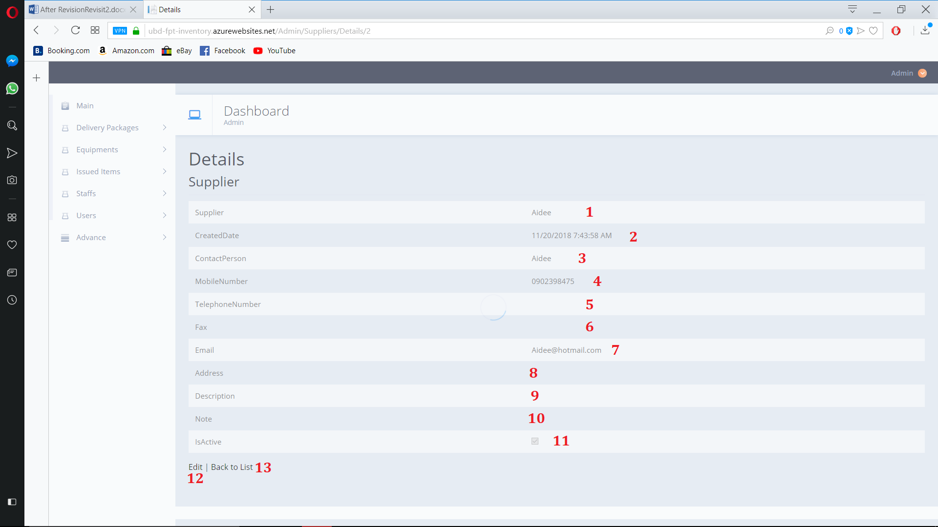

Figure 190. Supplier Detail

**Fields**

|  |  |  |  |  |  |  |
| --- | --- | --- | --- | --- | --- | --- |
| **No** | **Field Name** | **Description** | **Read only** | **Mandatory** | **Control Type** | **Data Type** |
| 1 | Supplier | Supplier’s Name | Yes | Yes | Text | String |
| 2 | CreatedDate | Supplier’s Created Date | Yes | Yes | Text | String |
| 3 | ContactPerson | Supplier’s ContactPerson | Yes | Yes | Text | String |
| 4 | MobileNumber | Supplier’s Phone number | Yes | Yes | Text | String |
| 5 | TelephoneNumber | Supplier’s Tele number | Yes | Yes | Text | String |
| 6 | Fax | Supplier’s Fax | Yes | Yes | Text | String |
| 7 | Email | Supplier’s Email | Yes | Yes | Text | String |
| 8 | Address | Supplier’s Address | Yes | Yes | Text | String |
| 9 | Description | Supplier’s Description | Yes | Yes | Text | String |
| 10 | Note | Supplier’s Note | Yes | Yes | Text | String |
| 11 | IsActive | Supplier’s Actice state | Yes | Yes | Check  Box | Boolean |

**Buttons/Hyperlinks:**

|  |  |  |  |  |
| --- | --- | --- | --- | --- |
| 12 | Edit | Go to Edit page | N/A | Navigate to Supplier edit page |
| 13 | Back to List | Go to Supplier view page | N/A | Navigate to Supplier view page |

* + 1. Supplier Delete

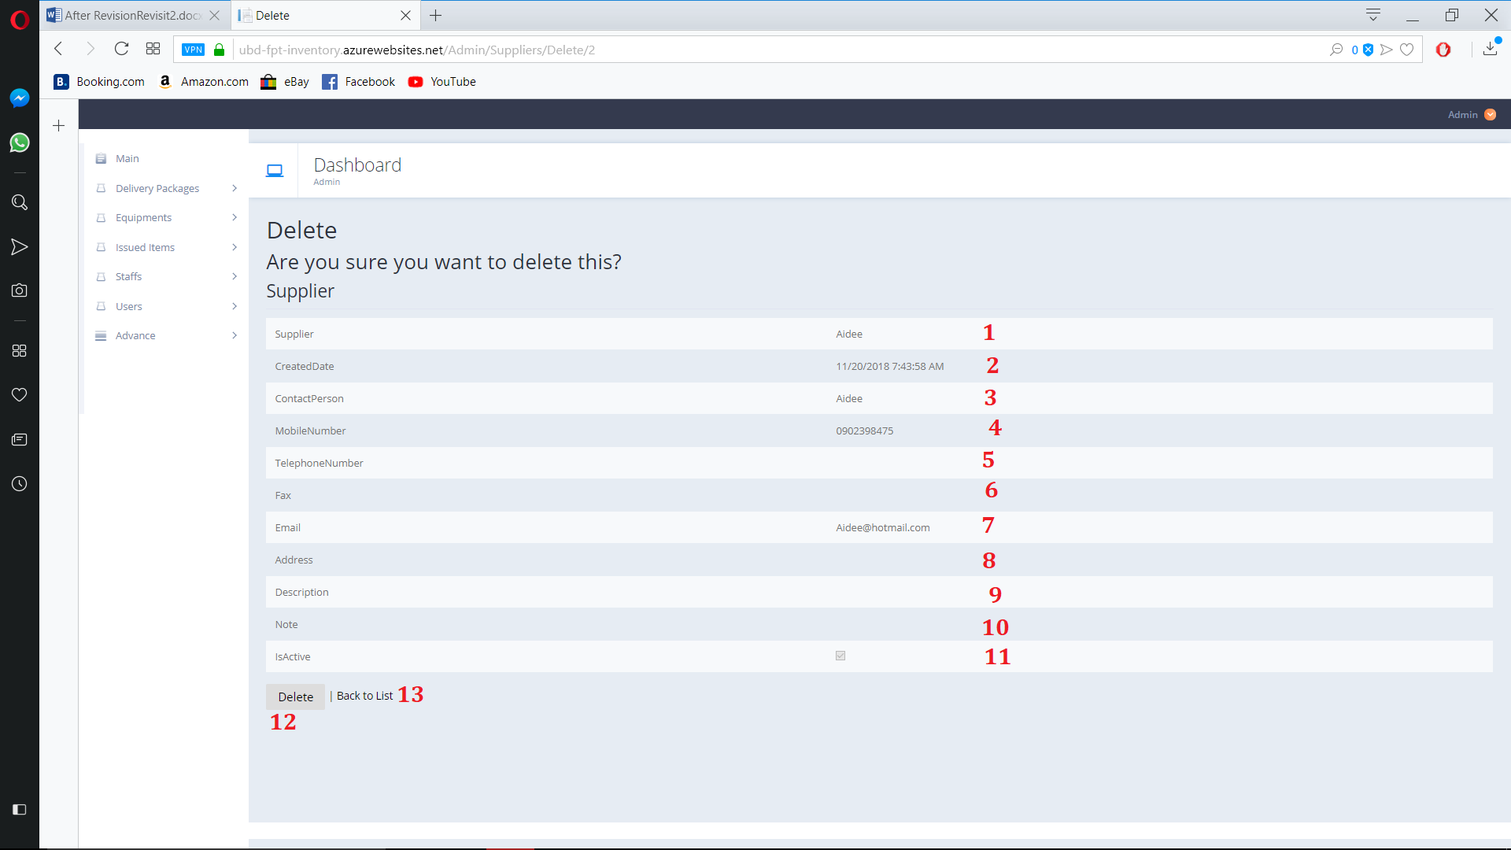

Figure 191. Supplier Delete

**Fields**

|  |  |  |  |  |  |  |
| --- | --- | --- | --- | --- | --- | --- |
| **No** | **Field Name** | **Description** | **Read only** | **Mandatory** | **Control Type** | **Data Type** |
| 1 | Supplier | Supplier’s Name | Yes | Yes | Text | String |
| 2 | CreatedDate | Supplier’s Created Date | Yes | Yes | Text | String |
| 3 | ContactPerson | Supplier’s ContactPerson | Yes | Yes | Text | String |
| 4 | MobileNumber | Supplier’s Phone number | Yes | Yes | Text | String |
| 5 | TelephoneNumber | Supplier’s Tele number | Yes | Yes | Text | String |
| 6 | Fax | Supplier’s Fax | Yes | Yes | Text | String |
| 7 | Email | Supplier’s Email | Yes | Yes | Text | String |
| 8 | Address | Supplier’s Address | Yes | Yes | Text | String |
| 9 | Description | Supplier’s Description | Yes | Yes | Text | String |
| 10 | Note | Supplier’s Note | Yes | Yes | Text | String |
| 11 | IsActive | Supplier’s Actice state | Yes | Yes | Check  Box | Boolean |

**Buttons/Hyperlinks:**

|  |  |  |  |  |
| --- | --- | --- | --- | --- |
| 12 | Detele | Delete supplier | N/A | Delete supplier |
| 13 | Back to List | Go to Supplier view page | N/A | Navigate to Supplier view page |

* + 1. Brand View

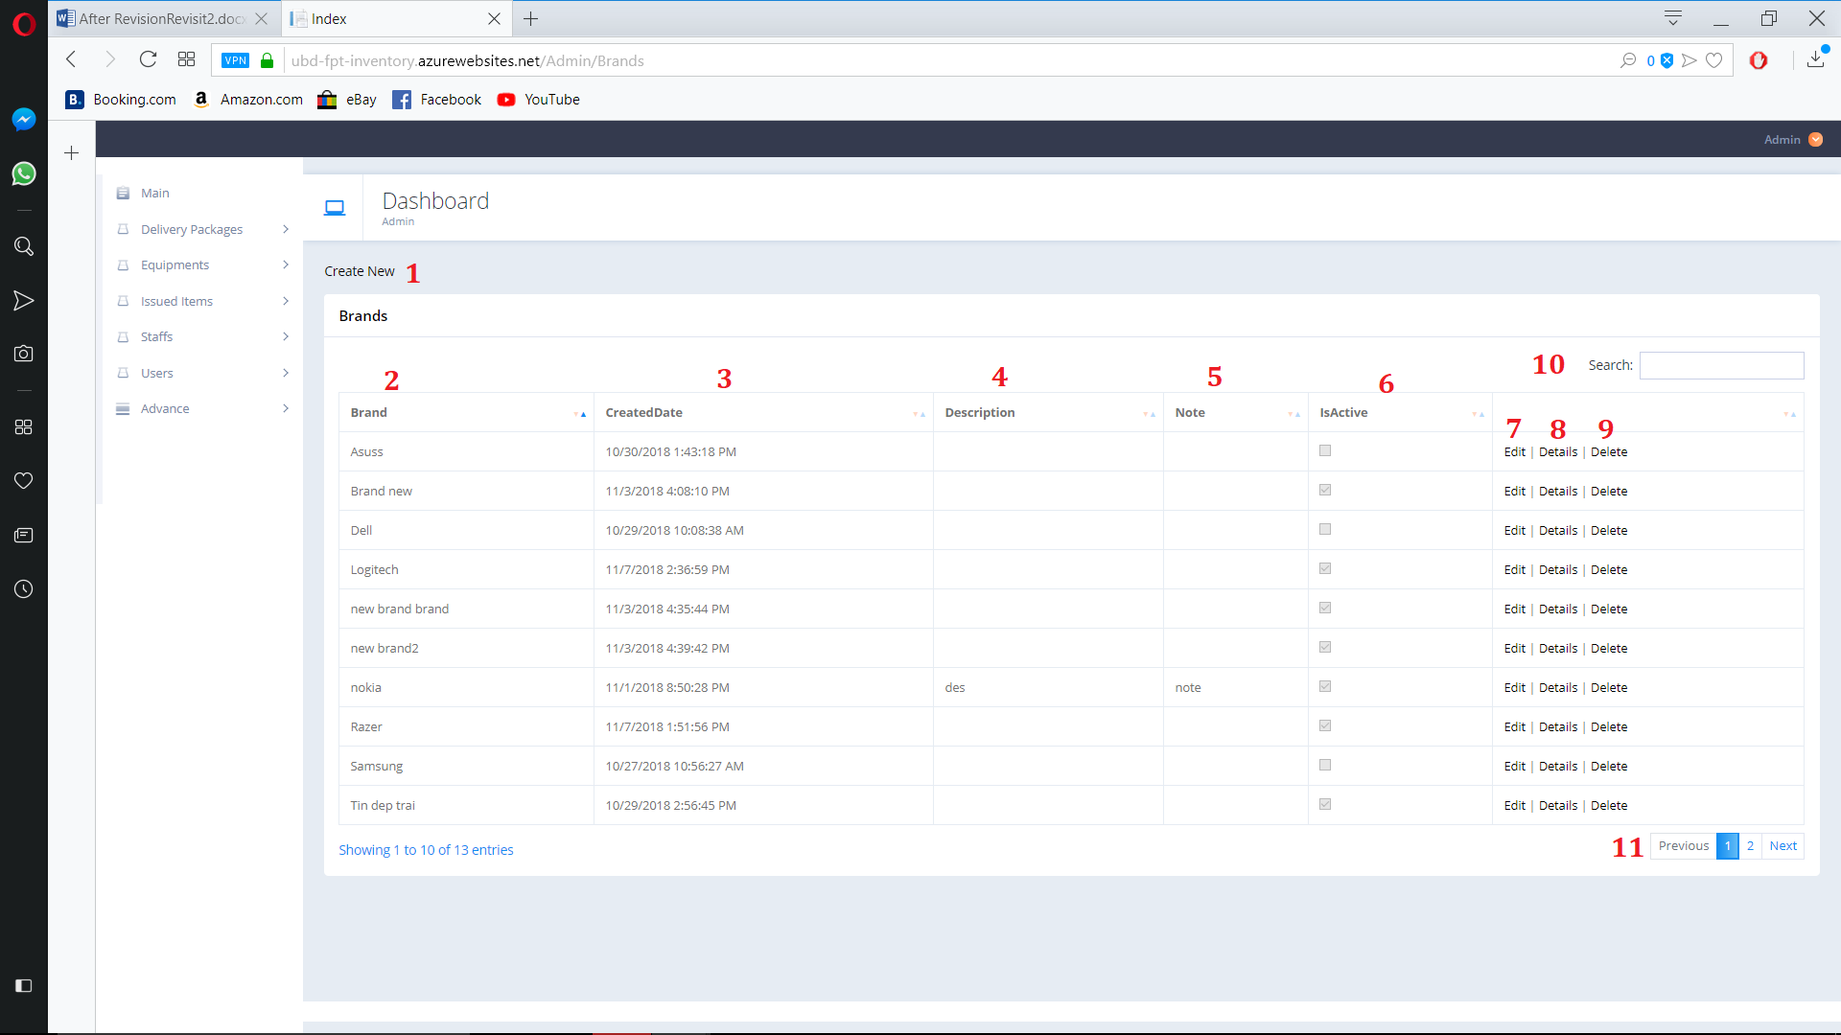

Figure 192. Brand View

**Fields**

|  |  |  |  |  |  |  |
| --- | --- | --- | --- | --- | --- | --- |
| **No** | **Field Name** | **Description** | **Read only** | **Mandatory** | **Control Type** | **Data Type** |
| 2 | Brand | Brand’s Name | Yes | Yes | Text | String |
| 3 | CreatedDate | Brand’s Created date | Yes | Yes | Text | String |
| 4 | Description | Brand’s Description | Yes | Yes | Text | String |
| 5 | Note | Brand’s Note | Yes | Yes | Text | String |
| 6 | IsActive | Brand’s active state | Yes | Yes | Check  Box | Boolean |
| 10 | Search | Search By user input | No | No | TextBox | String |

**Buttons/Hyperlinks:**

|  |  |  |  |  |
| --- | --- | --- | --- | --- |
| **No** | **Function** | **Description** | **Validation** | **Outcome** |
| 1 | Create New | Create new Brand | N/A | Navigate to create new page |
| 7 | Edit | Edit Select Brand | N/A | Navigate to Edit page |
| 8 | Details | Open Brand detail page | N/A | Navigate to Detail page |
| 9 | Delete | Delete Brand | N/A | Navigate to Delete confirm page |
| 11 | Navigation | Navigation through pages of list | N/A | Show selected page of Brand list |

* + 1. Create Brand

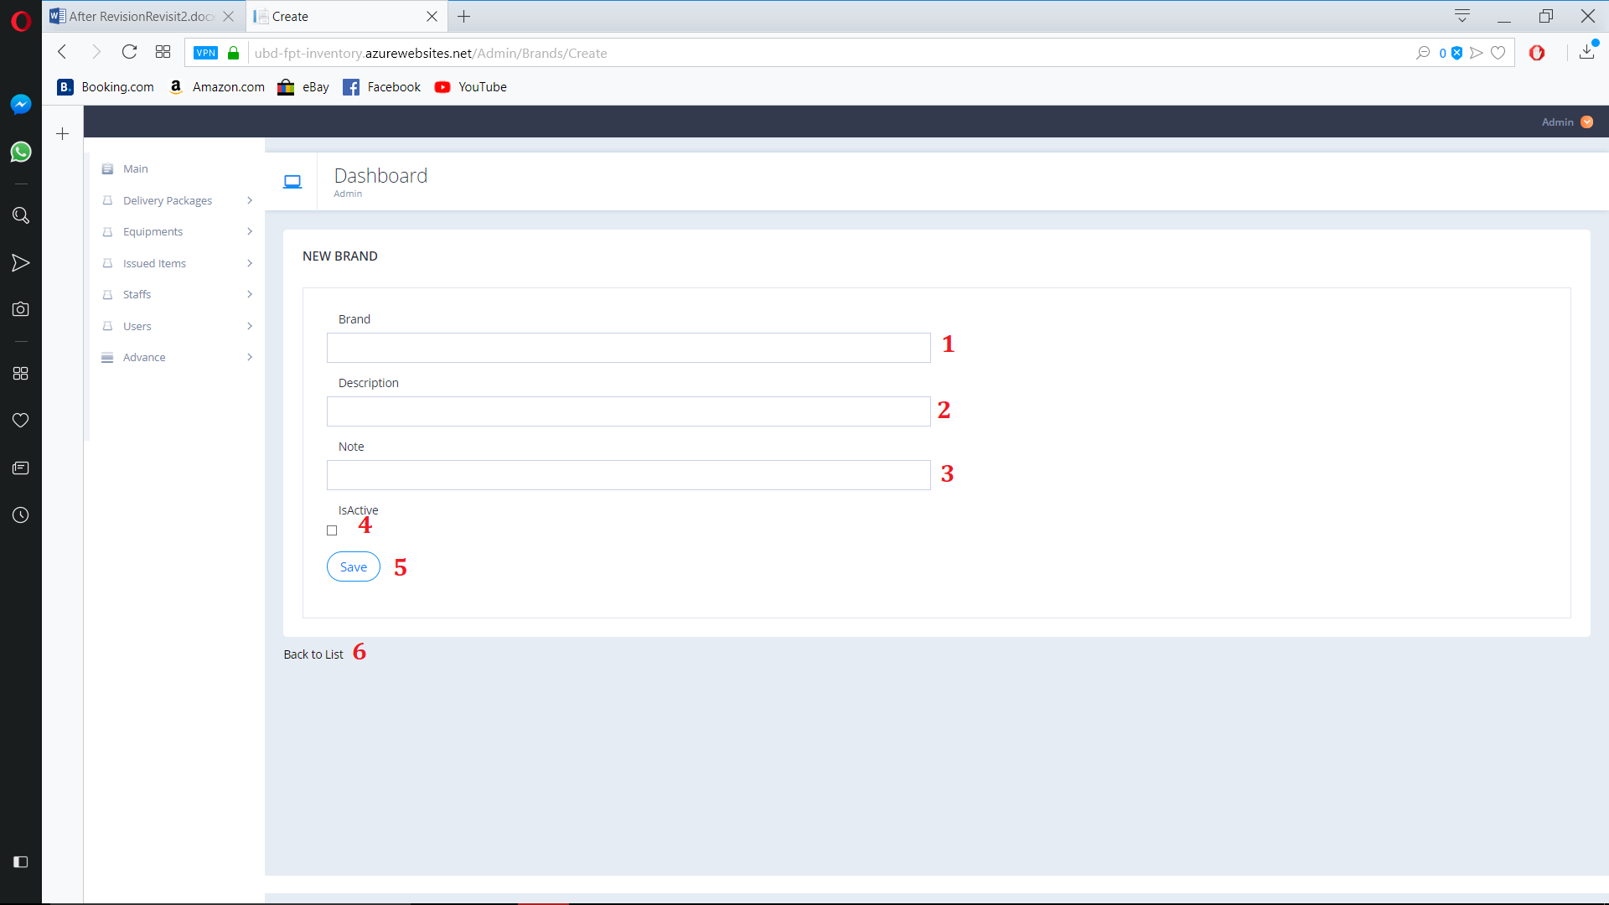

Figure 193. Create Brand

**Fields**

|  |  |  |  |  |  |  |
| --- | --- | --- | --- | --- | --- | --- |
| **No** | **Field Name** | **Description** | **Read only** | **Mandatory** | **Control Type** | **Data Type** |
| 1 | Brand | Brand’s Name | No | Yes | Text | String |
| 2 | Description | Brand’s Description | No | No | Text | String |
| 3 | Note | Brand’s Note | No | No | Text | String |
| 4 | IsActive | Brand’s active state | No | No | Check  Box | Boolean |

**Buttons/Hyperlinks:**

|  |  |  |  |  |
| --- | --- | --- | --- | --- |
| **No** | **Function** | **Description** | **Validation** | **Outcome** |
| 5 | Save | Create new Brand | N/A | Create new Brand |
| 6 | Back to List | Go to Brand view page | N/A | Navigate to Brand view page |

* + 1. Edit Brand

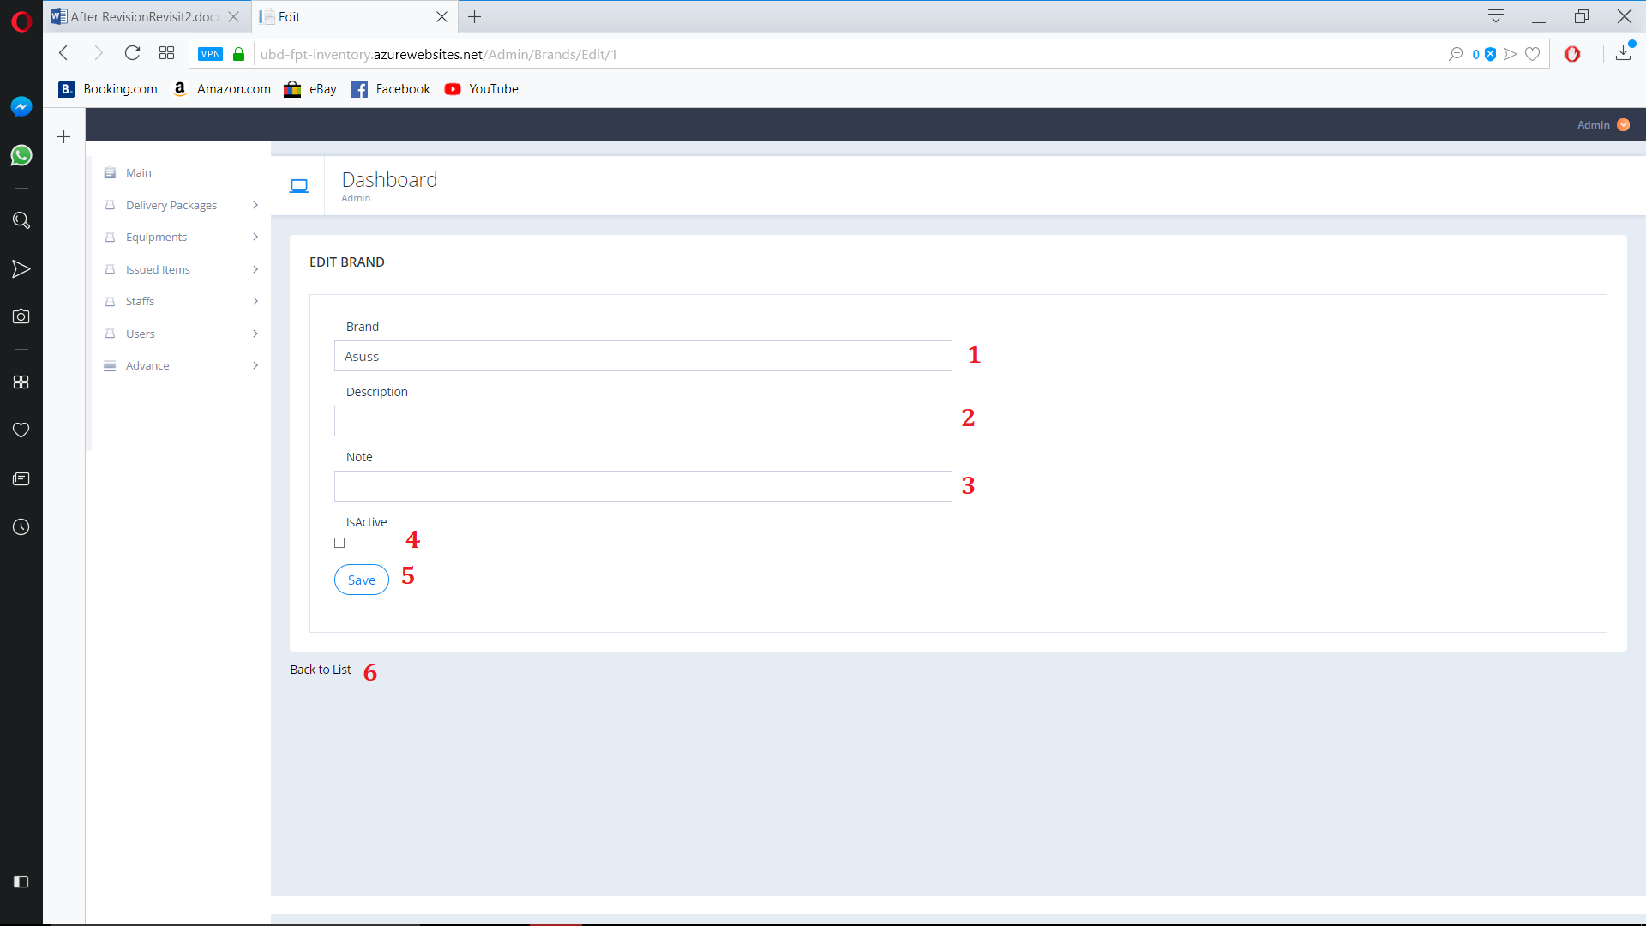

Figure 194. Edit Brand

**Fields**

|  |  |  |  |  |  |  |
| --- | --- | --- | --- | --- | --- | --- |
| **No** | **Field Name** | **Description** | **Read only** | **Mandatory** | **Control Type** | **Data Type** |
| 1 | Brand | Brand’s Name | No | Yes | Text | String |
| 2 | Description | Brand’s Description | No | No | Text | String |
| 3 | Note | Brand’s Note | No | No | Text | String |
| 4 | IsActive | Brand’s active state | No | No | Check  Box | Boolean |

**Buttons/Hyperlinks:**

|  |  |  |  |  |
| --- | --- | --- | --- | --- |
| **No** | **Function** | **Description** | **Validation** | **Outcome** |
| 5 | Save | Save Edit Brand | N/A | Save Edit Brand |
| 6 | Back to List | Go to Brand view page | N/A | Navigate to Brand view page |

* + 1. Brand Detail

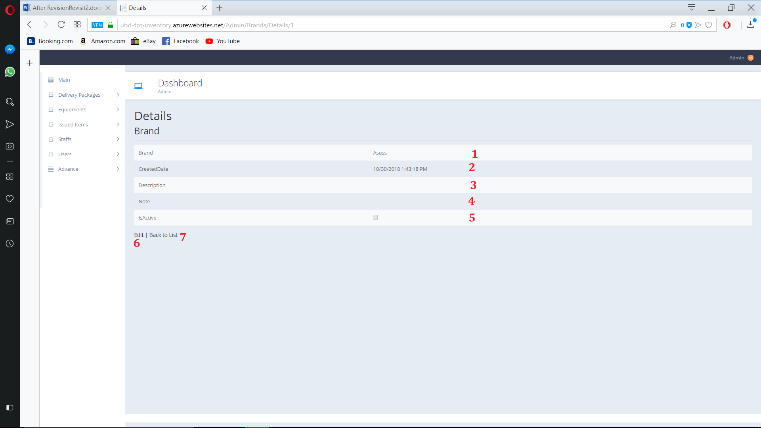

Figure 195. Brand Detail

**Fields**

|  |  |  |  |  |  |  |
| --- | --- | --- | --- | --- | --- | --- |
| **No** | **Field Name** | **Description** | **Read only** | **Mandatory** | **Control Type** | **Data Type** |
| 1 | Brand | Brand’s Name | Yes | Yes | Text | String |
| 2 | CreatedDate | Brand’s Create date | Yes | Yes | Text | String |
| 3 | Description | Brand’s Description | Yes | Yes | Text | String |
| 4 | Note | Brand’s Note | Yes | Yes | Text | String |
| 5 | IsActive | Brand’s active state | Yes | Yes | Check  Box | Boolean |

**Buttons/Hyperlinks:**

|  |  |  |  |  |
| --- | --- | --- | --- | --- |
| **No** | **Function** | **Description** | **Validation** | **Outcome** |
| 6 | Edit | Go to edit page | N/A | Nagvigate to edit page |
| 7 | Back to List | Go to Brand view page | N/A | Navigate to Brand view page |

* + 1. Delete Brand

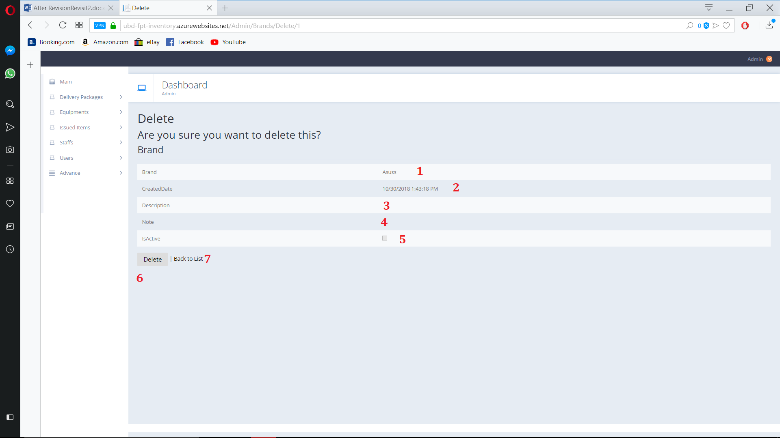

Figure 196. Delete Brand

**Fields**

|  |  |  |  |  |  |  |
| --- | --- | --- | --- | --- | --- | --- |
| **No** | **Field Name** | **Description** | **Read only** | **Mandatory** | **Control Type** | **Data Type** |
| 1 | Brand | Brand’s Name | Yes | Yes | Text | String |
| 2 | CreatedDate | Brand’s Create date | Yes | Yes | Text | String |
| 3 | Description | Brand’s Description | Yes | Yes | Text | String |
| 4 | Note | Brand’s Note | Yes | Yes | Text | String |
| 5 | IsActive | Brand’s active state | Yes | Yes | Check  Box | Boolean |

**Buttons/Hyperlinks:**

|  |  |  |  |  |
| --- | --- | --- | --- | --- |
| **No** | **Function** | **Description** | **Validation** | **Outcome** |
| 6 | Delete | Delete Brand | N/A | Delete Brand |
| 7 | Back to List | Go to Brand view page | N/A | Navigate to Brand view page |

* + 1. View Status

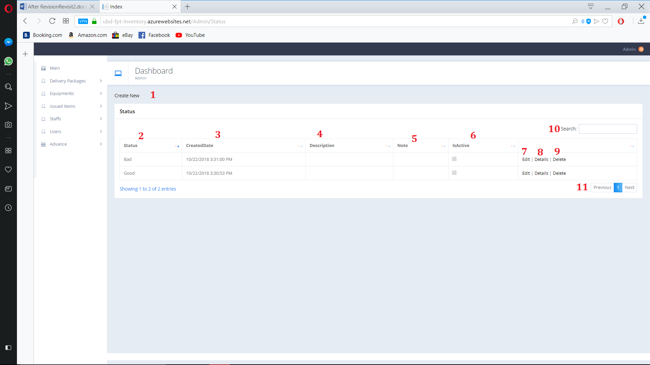

Figure 195. View Status

**Fields**

|  |  |  |  |  |  |  |
| --- | --- | --- | --- | --- | --- | --- |
| **No** | **Field Name** | **Description** | **Read only** | **Mandatory** | **Control Type** | **Data Type** |
| 2 | Status | Status | Yes | Yes | Text | String |
| 3 | CreatedDate | Status’s Created date | Yes | Yes | Text | String |
| 4 | Description | Status’s Description | Yes | Yes | Text | String |
| 5 | Note | Status’s Note | Yes | Yes | Text | String |
| 6 | IsActive | Status’s active state | Yes | Yes | Check  Box | Boolean |
| 10 | Search | Search By user input | No | No | TextBox | String |

**Buttons/Hyperlinks:**

|  |  |  |  |  |
| --- | --- | --- | --- | --- |
| **No** | **Function** | **Description** | **Validation** | **Outcome** |
| 1 | Create New | Create new Status | N/A | Navigate to create new page |
| 7 | Edit | Edit Select Status | N/A | Navigate to Edit page |
| 8 | Details | Open Status detail page | N/A | Navigate to Detail page |
| 9 | Delete | Delete Status | N/A | Navigate to Delete confirm page |
| 11 | Navigation | Navigation through pages of list | N/A | Show selected page of Status list |

* + 1. Create Status

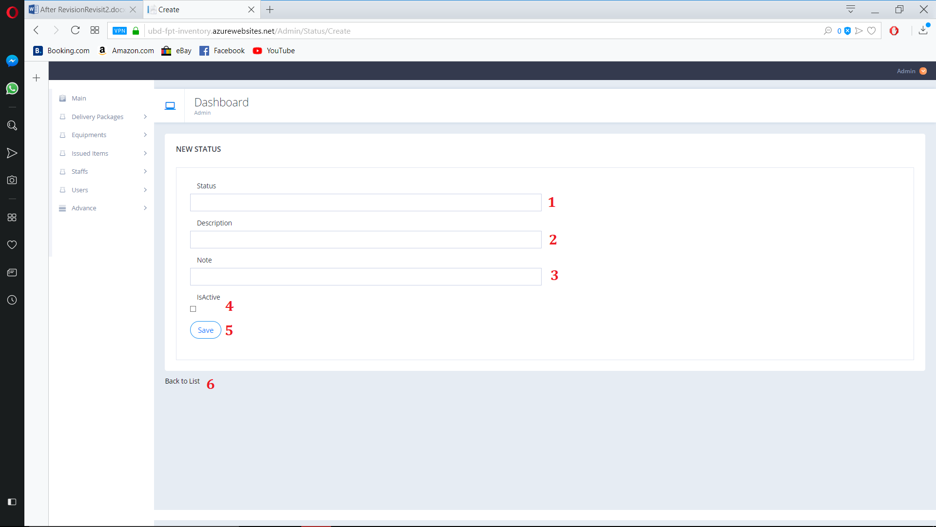

Figure 195. Create Status

**Fields**

|  |  |  |  |  |  |  |
| --- | --- | --- | --- | --- | --- | --- |
| **No** | **Field Name** | **Description** | **Read only** | **Mandatory** | **Control Type** | **Data Type** |
| 1 | Status | Status | No | Yes | Text | String |
| 2 | Description | Status’s Description | No | No | Text | String |
| 3 | Note | Status’s Note | No | No | Text | String |
| 4 | IsActive | Status’s active state | No | No | Check  Box | Boolean |

**Buttons/Hyperlinks:**

|  |  |  |  |  |
| --- | --- | --- | --- | --- |
| **No** | **Function** | **Description** | **Validation** | **Outcome** |
| 5 | Save | Create new Status | N/A | Create new Status |
| 6 | Back to List | Go to Status view page | N/A | Navigate to Status view page |

* + 1. Edit Status

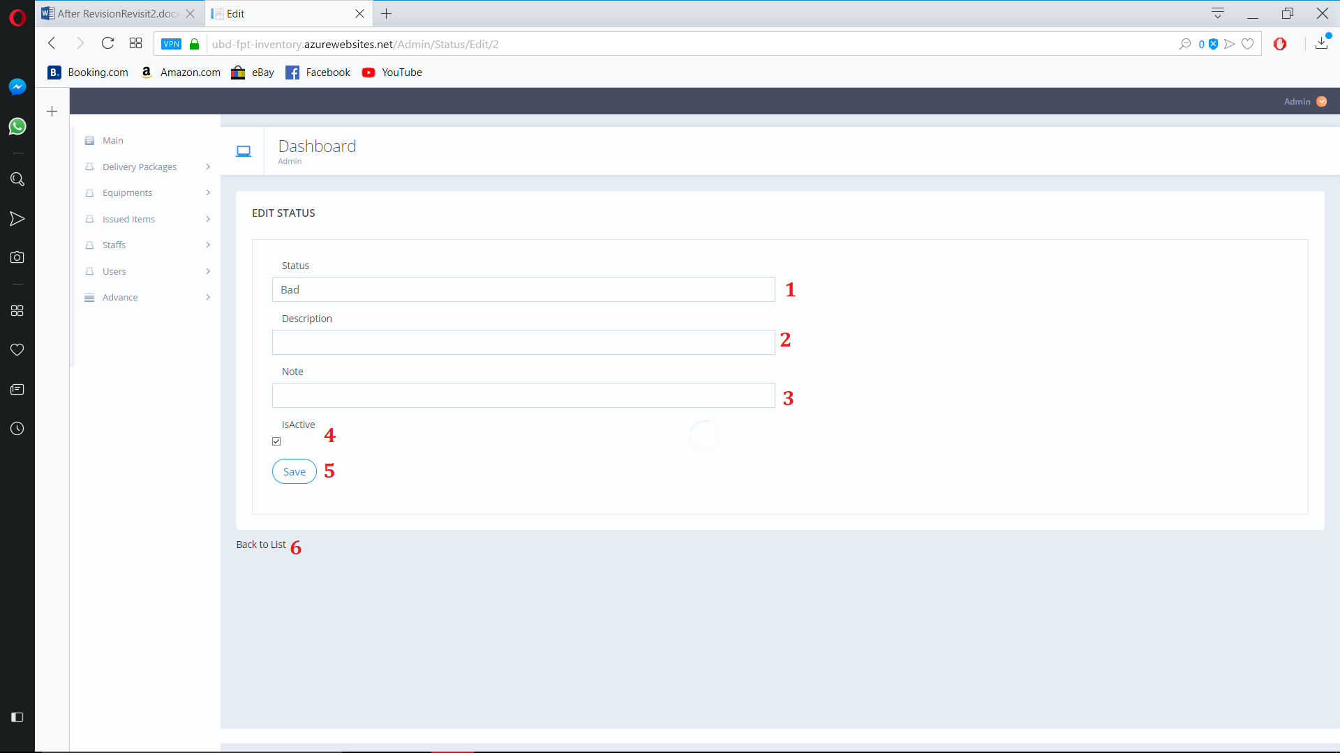

Figure 196. Edit Status

**Fields**

|  |  |  |  |  |  |  |
| --- | --- | --- | --- | --- | --- | --- |
| **No** | **Field Name** | **Description** | **Read only** | **Mandatory** | **Control Type** | **Data Type** |
| 1 | Status | Status | No | Yes | Text | String |
| 2 | Description | Status’s Description | No | No | Text | String |
| 3 | Note | Status’s Note | No | No | Text | String |
| 4 | IsActive | Status’s active state | No | No | Check  Box | Boolean |

**Buttons/Hyperlinks:**

|  |  |  |  |  |
| --- | --- | --- | --- | --- |
| **No** | **Function** | **Description** | **Validation** | **Outcome** |
| 5 | Save | Save Edit Status | N/A | Save Edit Status |
| 6 | Back to List | Go to Status view page | N/A | Navigate to Status view page |

* + 1. Status Detail

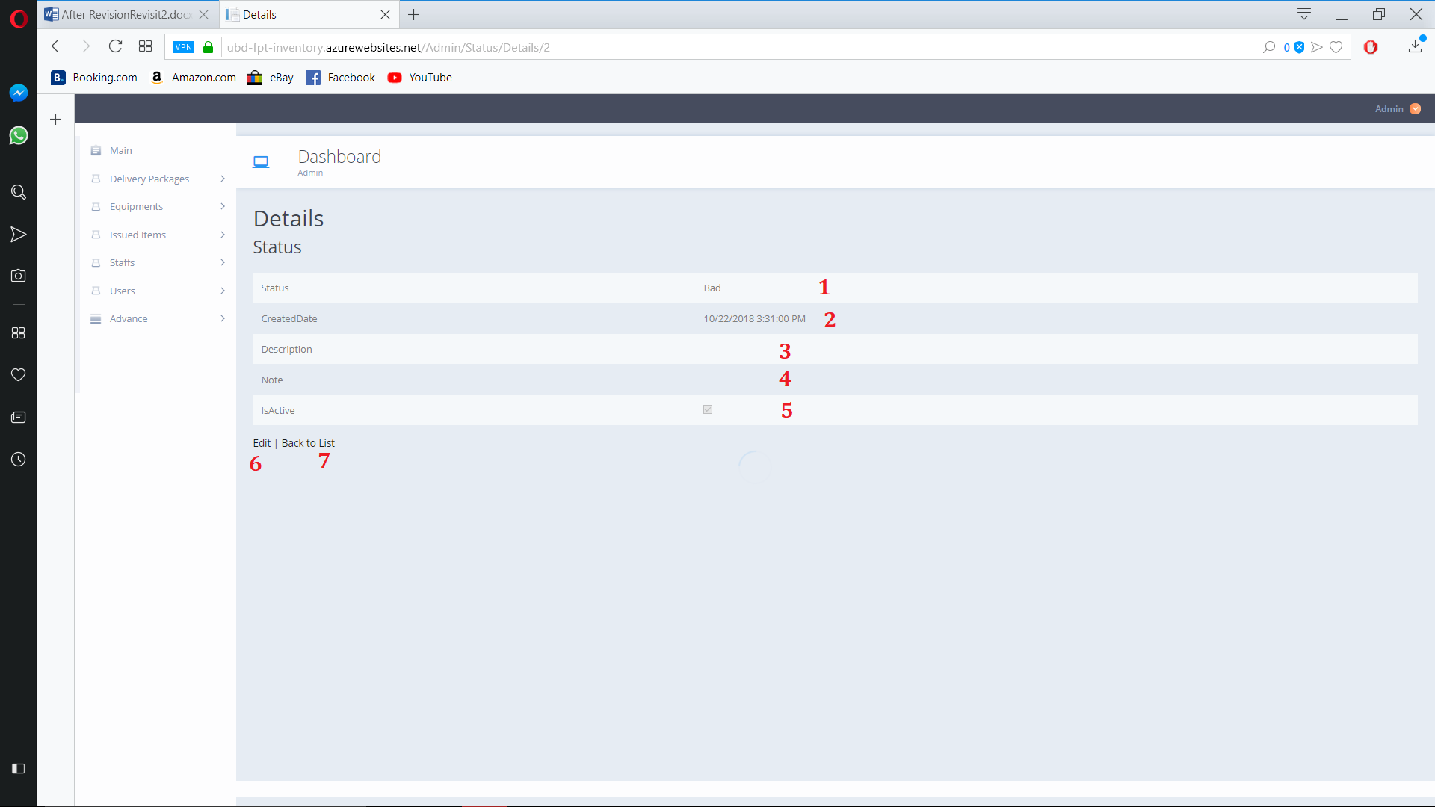

Figure 197. Status Detail

**Fields**

|  |  |  |  |  |  |  |
| --- | --- | --- | --- | --- | --- | --- |
| **No** | **Field Name** | **Description** | **Read only** | **Mandatory** | **Control Type** | **Data Type** |
| 1 | Status | Status | Yes | Yes | Text | String |
| 2 | CreatedDate | Status’s Crated Date | Yes | Yes | Text | String |
| 3 | Description | Status’s Description | Yes | Yes | Text | String |
| 4 | Note | Status’s Note | Yes | Yes | Text | String |
| 5 | IsActive | Status’s active state | Yes | Yes | Check  Box | Boolean |

**Buttons/Hyperlinks:**

|  |  |  |  |  |
| --- | --- | --- | --- | --- |
| **No** | **Function** | **Description** | **Validation** | **Outcome** |
| 6 | Edit | Go to edit page | N/A | Nagvigate to edit page |
| 7 | Back to List | Go to Status view page | N/A | Navigate to Status view page |

* + 1. Delete Status

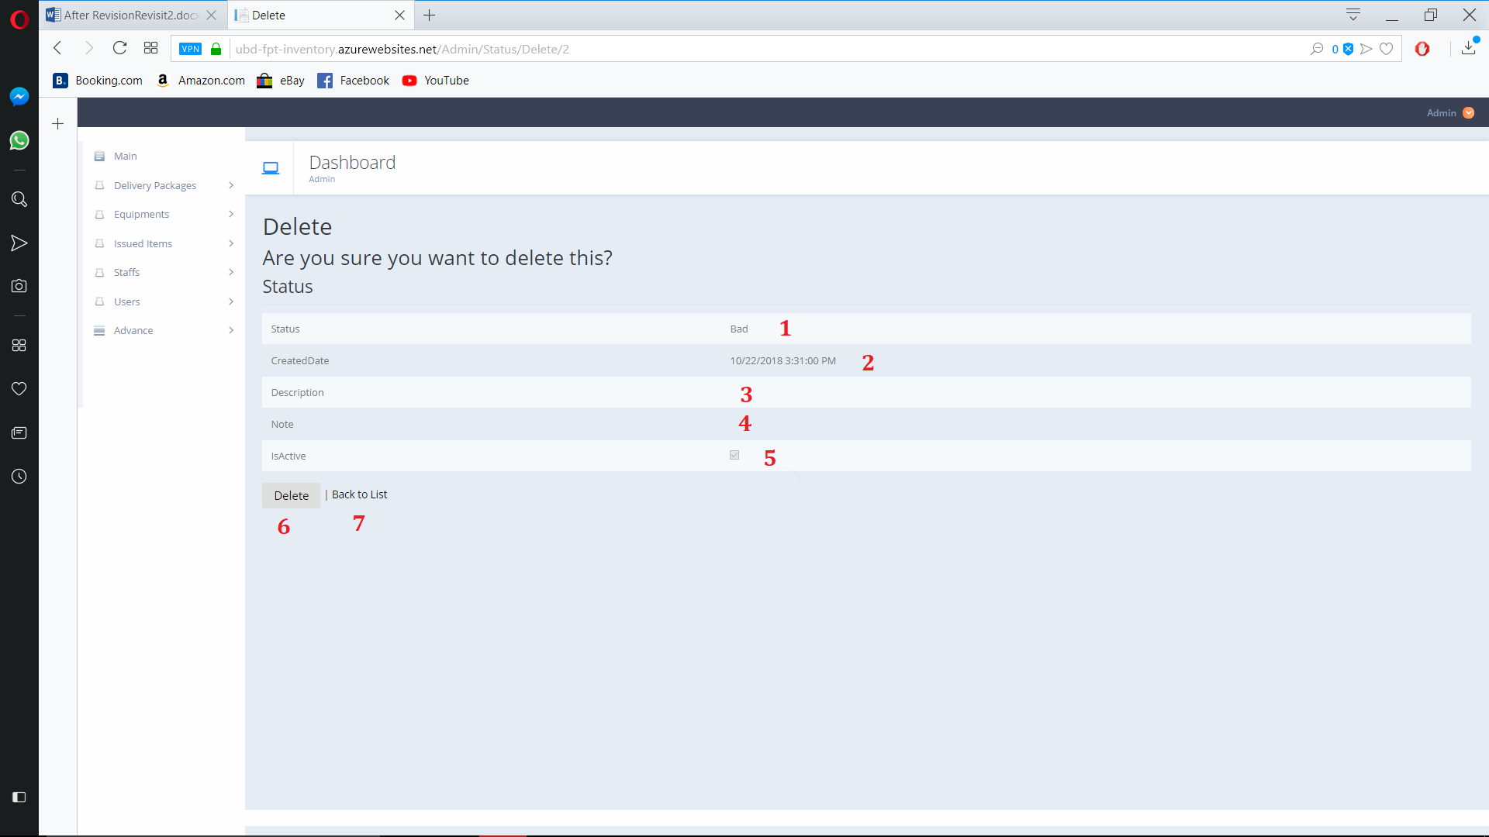

Figure 198. Delete Status

**Fields**

|  |  |  |  |  |  |  |
| --- | --- | --- | --- | --- | --- | --- |
| **No** | **Field Name** | **Description** | **Read only** | **Mandatory** | **Control Type** | **Data Type** |
| 1 | Status | Status | Yes | Yes | Text | String |
| 2 | CreatedDate | Status’s Crated Date | Yes | Yes | Text | String |
| 3 | Description | Status’s Description | Yes | Yes | Text | String |
| 4 | Note | Status’s Note | Yes | Yes | Text | String |
| 5 | IsActive | Status’s active state | Yes | Yes | Check  Box | Boolean |

**Buttons/Hyperlinks:**

|  |  |  |  |  |
| --- | --- | --- | --- | --- |
| **No** | **Function** | **Description** | **Validation** | **Outcome** |
| 6 | Delete | Delete Status | N/A | Delete Status |
| 7 | Back to List | Go to Status view page | N/A | Navigate to Status view page |

1. System Implementation & Test

## Introduction

### Overview

This section describes approach and methodologies used by our team to plan, organize and manage testing process of MIS

It provides all necessary information about implementation and testing procedure of the system including test plans, test cases, test results and pass/fail criteria as well as testing flow to cover all possible cases.

### Test Approach

* **Goal:** Test main features in the whole MIS based on core flow.
* **Method:** black-box testing.
* **Technique:** check list, pair testing.

The testing process for this project consists of Integration System test level.

System testing is focused on assessing the system’s reliability and the process of testing an integrated system to verify if it meets specified requirements.

Testing will cover functionalities through the use of test interface. This process is concerned with finding errors that result from unanticipated interactions between components and component interface problems.

## Database Relationship Diagram

### Physical Diagram

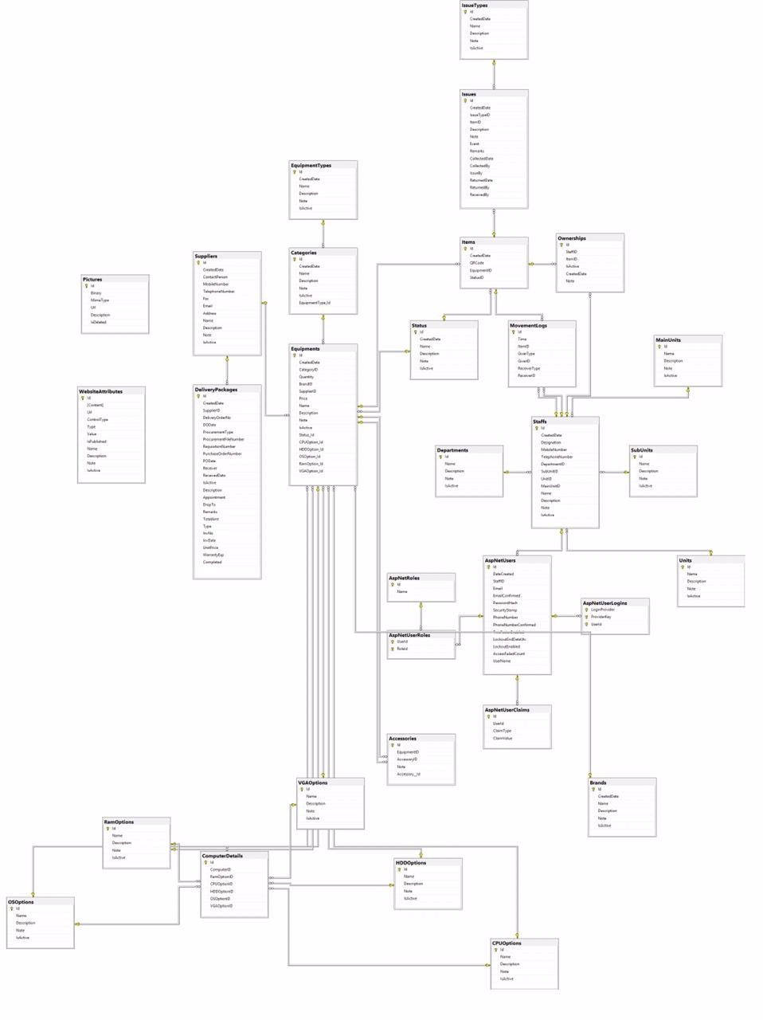

Figure 114. Physical database

* 1. Test Plan

The pupose to this section is to verify and ensure that MIS meets its entire technical, functional and business requirement. In other word the test plan can be consider the quality check for the system development. This will be sperated into two type namely White box testing and Black box testing.

**WHITE BOX TESTING**

also known as Clear **Box Testing**, Open **Box Testing**, Glass **Box Testing**, Transparent **Box Testing**, Code-Based **Testing** or Structural **Testing** is a software **testing** method in which the internal structure/design/implementation of the item being tested is known to the tester.

**BLACK BOX TESTING**,

also known as Behavioral**Testing**, is a software **testing** method in which the internal structure/design/implementation of the item being tested is not known to the tester. These **tests**can be functional or non-functional, though usually functional.

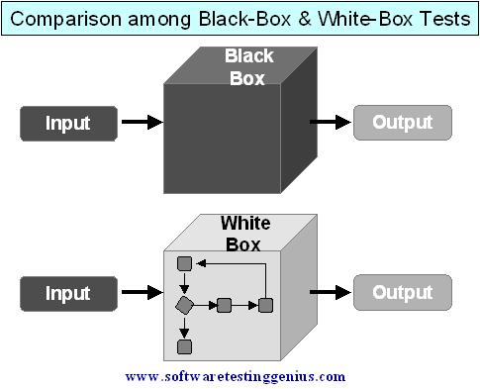

Both test are require in order to minimize system error and the statbility of the system as a whole.

The following parts describe which features will be tested and which will be not.

* + 1. Features To Be Tested Web Application

All the test must pass Adding , Editing, Deleteing , Viewing and Searching to each class listed below

* Issued to personnel, Asset (Equipment) ,Brand and Supplier

Features To Be Tested Mobile Application

All the test must pass Adding, Viewing, Searching and Scanning to each class listed below

* + 1. Features Not To Be Tested
* Log in, log out, update profile,…
* Admin: create company, create account,…
  1. System Testing Test Case
     1. Test Case
        + 1. Login Mobile

|  |  |  |  |  |  |  |
| --- | --- | --- | --- | --- | --- | --- |
| **ID** | **Test Case Description** | **Test case procedure** | **Expected output** | **Inter-test case dependence** | **Result** | **Test Date** |
| LM01 | Missing username or password login  (Mobile) | * Click on Login without enter Username or password | Show notice message “Please enter username and password” | N/A | Pass | 18/11/2018 |
| LM 02 | Wrong username or password login(Mobile) | * Click on Login with invalid username or password | Show notice message “Username or password is incorrect” | N/A | Pass | 18/11/2018 |
| LM 03 | No connection login(Mobile) | * Click on “Login” without connection to server | Show warning message “No connection to server” | N/A | Pass | 18/11/2018 |
| LM 04 | Account not confirm by admin | * Try To login in with account not yet confirm | Show warning message “Your account is not confirm by admin”. | N/A | Pass | 18/11/2018 |
| LM05 | Account not active | * Try To login in with account not active | Show warning message “Your account is not active”. | N/A | Pass | 18/11/2018 |
| LM06 | Login Succesfully | * Click on “Login” with suitable account | Redirect to main menu and save token | N/A | Pass | 18/11/2018 |

* + - * 1. Table 171. <Test case> Login Mobile
        2. Add Mobile

|  |  |  |  |  |  |  |
| --- | --- | --- | --- | --- | --- | --- |
| **ID** | **Test Case Description** | **Test case procedure** | **Expected output** | **Inter-test case dependence** | **Result** | **Test Date** |
| AM01 | Missing info | * Click on “Save new Iten” button Add new item page but not input everything | Show notice message “Please input all needed info” | N/A | Pass | 18/11/2018 |
| AM02 | Not taking picture | * Click on “Save new Iten” button without taking item picture | Show notice message “Please input all needed info” | N/A | Pass | 18/11/2018 |
| AM03 | No connection | * When user click on “Add New” On main menu but there is no connection | Show notice message “No connection to server” and return to main menu | N/A | Pass | 18/11/2018 |
| AM04 | Save Error | * Click on “Save new Iten” button but having error from server or lost connection | Show warning message “Saving item not successfully”. | N/A | Pass | 18/11/2018 |

Table 172. <Test case> Add Mobile

* + - * 1. Search Item Mobile

|  |  |  |  |  |  |  |
| --- | --- | --- | --- | --- | --- | --- |
| **ID** | **Test Case Description** | **Test case procedure** | **Expected output** | **Inter-test case dependence** | **Result** | **Test Date** |
| SM01 | No connection | * When user press on “Search Item” On main menu but there is no connection | Show notice message “No connection to server” and return to main menu | N/A | Pass | 18/11/2018 |
| SM02 | No Result | * After input(Or selected) all required information and press on button “Search” but no result found | Show notice message “No Result Found” | N/A | Pass | 18/11/2018 |
| SM03 | Not input required Info (Search by User) | * User press on Search Without input required info | Show notice message “Please input staff Name or Staff Id” | N/A | Pass | 18/11/2018 |

Table 173. <Test case> Search Item Mobile

* + - * 1. Scan Qr

|  |  |  |  |  |  |  |
| --- | --- | --- | --- | --- | --- | --- |
| **ID** | **Test Case Description** | **Test case procedure** | **Expected output** | **Inter-test case dependence** | **Result** | **Test Date** |
| QR01 | No connection | * When user press on “Scan Qr” on main menu but there is no connection | Show notice message “No connection to server” and return to main menu | N/A | Pass | 18/11/2018 |
| QR02 | No Result found | * After scan Qr code but no result found | Show notice message “No Result Found” and return to main menu | N/A | Pass | 18/11/2018 |

Table 174. <Test case> Scan Qr

* + - * 1. Forgot password

|  |  |  |  |  |  |  |
| --- | --- | --- | --- | --- | --- | --- |
| **ID** | **Test Case Description** | **Test case procedure** | **Expected output** | **Inter-test case dependence** | **Result** | **Test Date** |
| FP01 | Account Token | * Click on the link to reset password in email and input username to reset * Click on reset password but input wrong username | Show error | N/A | Pass | 18/11/2018 |

Table 175. <Test case> Forgot Password

* + - * 1. Create new Equipment

|  |  |  |  |  |  |  |
| --- | --- | --- | --- | --- | --- | --- |
| **ID** | **Test Case Description** | **Test case procedure** | **Expected output** | **Inter-test case dependence** | **Result** | **Test Date** |
| NE01 | Not enter Equipment Name (Model) | * Click On “ Create” Button without enter Equipment Name (Model) | Show error “ The name field is required” | N/A | Pass | 18/11/2018 |
| NE01 | Not enter Equipment Quantity | * Click On “ Create” Button without enter Equipment Quantity | Show error “ The Quantity field is required” | N/A | Pass | 18/11/2018 |
| NE01 | Not Choose Equipment Picture | * Click On “ Create” Button without Choose Equipment Picture | Show error “ The Picture field is required” | N/A | Pass | 18/11/2018 |
| NE01 | Not enter Equipment Price | * Click On “ Create” Button without enter Equipment Price | Show error “ The Price field is required” | N/A | Pass | 18/11/2018 |

Table 176. <Test case> Create new Equipment

**2. User Manual**

### 2.1. Mobile Application

1. **Login**



Figure 114. <User Manual> Login

|  |  |
| --- | --- |
| **Step** | **Description** |
| 1 | Enter username. |
| 2 | Enter password. |
| 3 | Press Login Button |

Table 181. <User Manual> Login

1. **Main Menu**



Figure 114. <User Manual> Main Menu

|  |  |
| --- | --- |
| **Step** | **Description** |
| 1 | Click add new to add new equipment |
| 2 | Click Search Item to search Issued Item |
| 3 | Click Scan Qr To scan qr code |
| 4 | Click Log out to log out |

Table 181. <User Manual> Login

1. **Add New**

 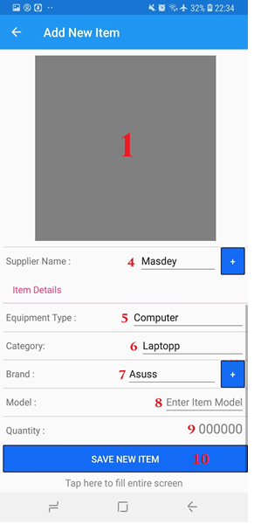

|  |  |
| --- | --- |
| **Step** | **Description** |
| 1 | Take Picture of equipment |
| 2 | Input Delivery Order Number |
| 3 | Select date of delivery |
| 4 | Choose Supplier |
| 5 | Choose Equipment Type |
| 6 | Choose Category |
| 7 | Choose Brand |
| 8 | Enter Model |
| 9 | Enter Quantiy |
| 10 | Save New Item |

Table 181. <User Manual> Add New

1. **Seach By Location**

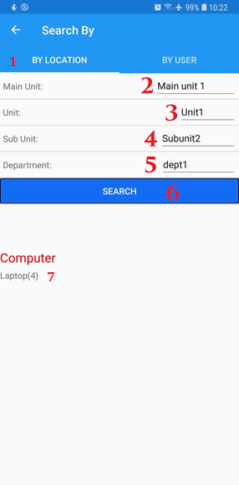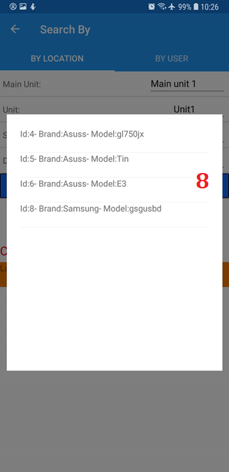

Figure 114. <User Manual> Search By Location

|  |  |
| --- | --- |
| **Step** | **Description** |
| 1 | Select Search by location |
| 2 | Choose Main Unit |
| 3 | Choose unit |
| 4 | Choose Sun Unit |
| 5 | Choose Department |
| 6 | Press Search Button |
| 7 | Select Type of Issued item |
| 8 | Select Item |

Table 181. <User Manual> Add New

1. **Seach By User**

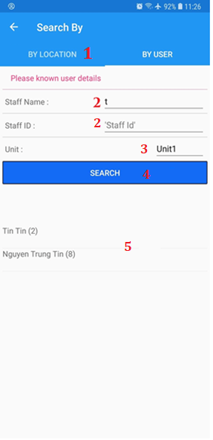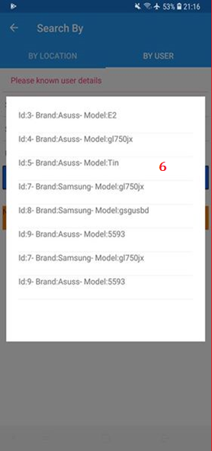

Figure 114. <User Manual> Search By User

|  |  |
| --- | --- |
| **Step** | **Description** |
| 1 | Select Search by User |
| 2 | Enter Staff name or Staff Id or Both |
| 3 | Select Unit |
| 4 | Press Search Button |
| 5 | Select Staff you want to see issued item |
| 6 | Select Item |

### Web Application

### Login

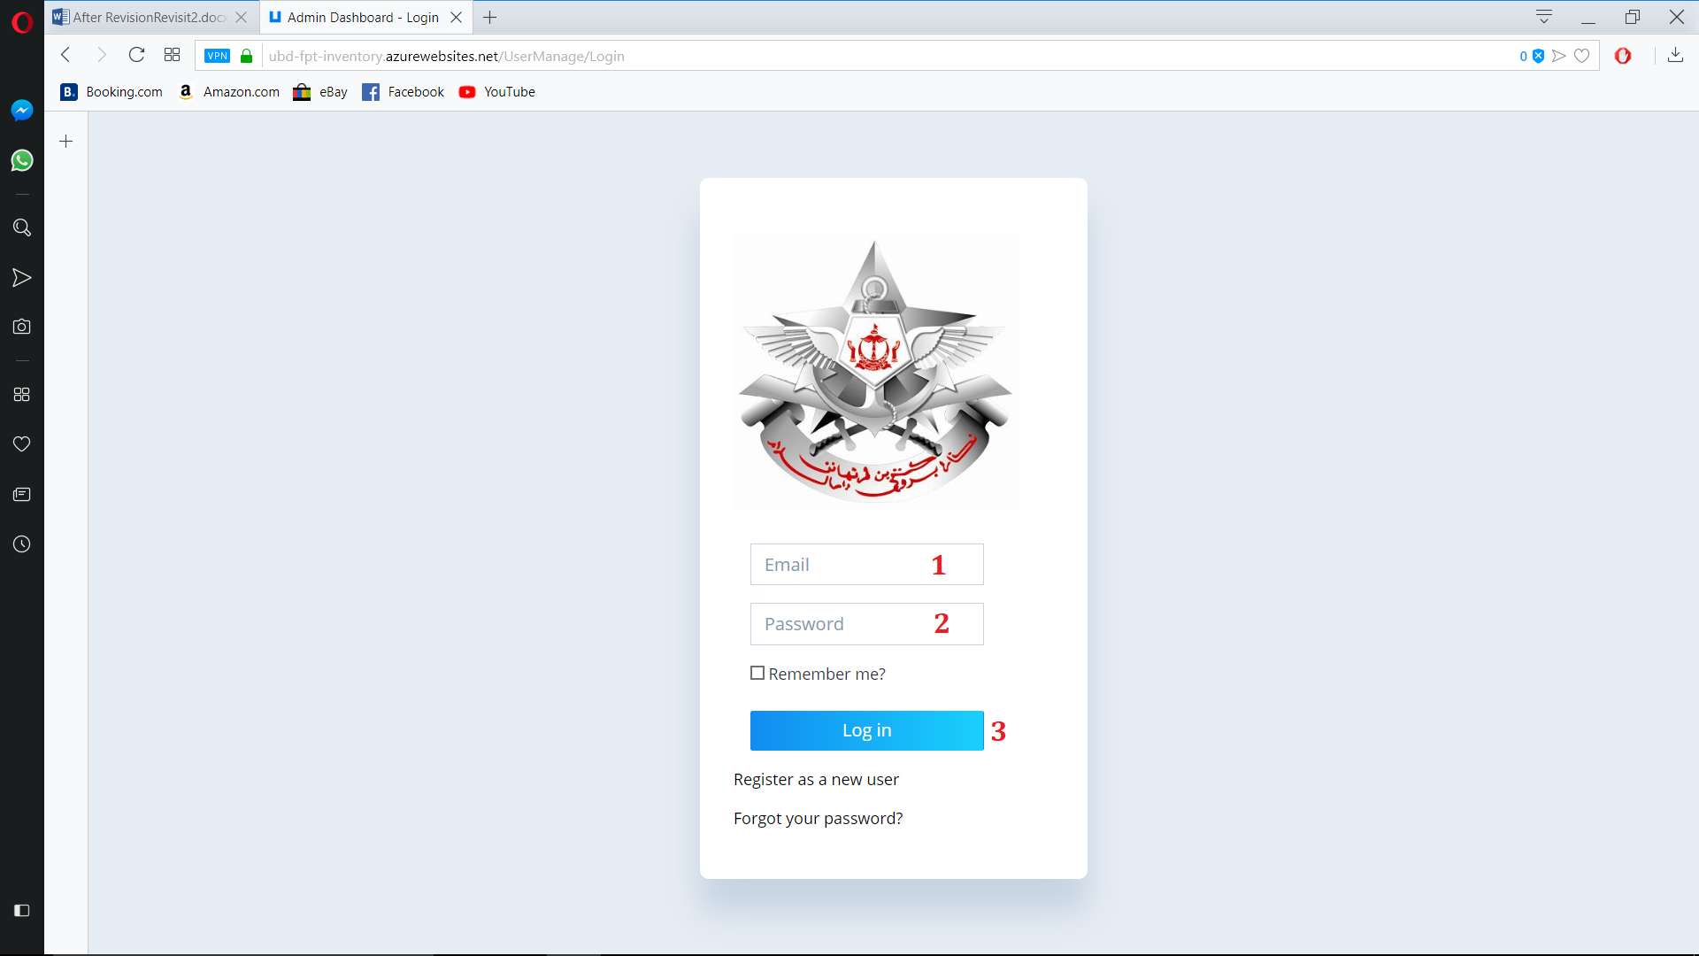

Figure 114. <User Manual> Login Web

|  |  |
| --- | --- |
| **Step** | **Description** |
| 1 | Enter username. |
| 2 | Enter password. |
| 3 | Click On Login Button |

### Register

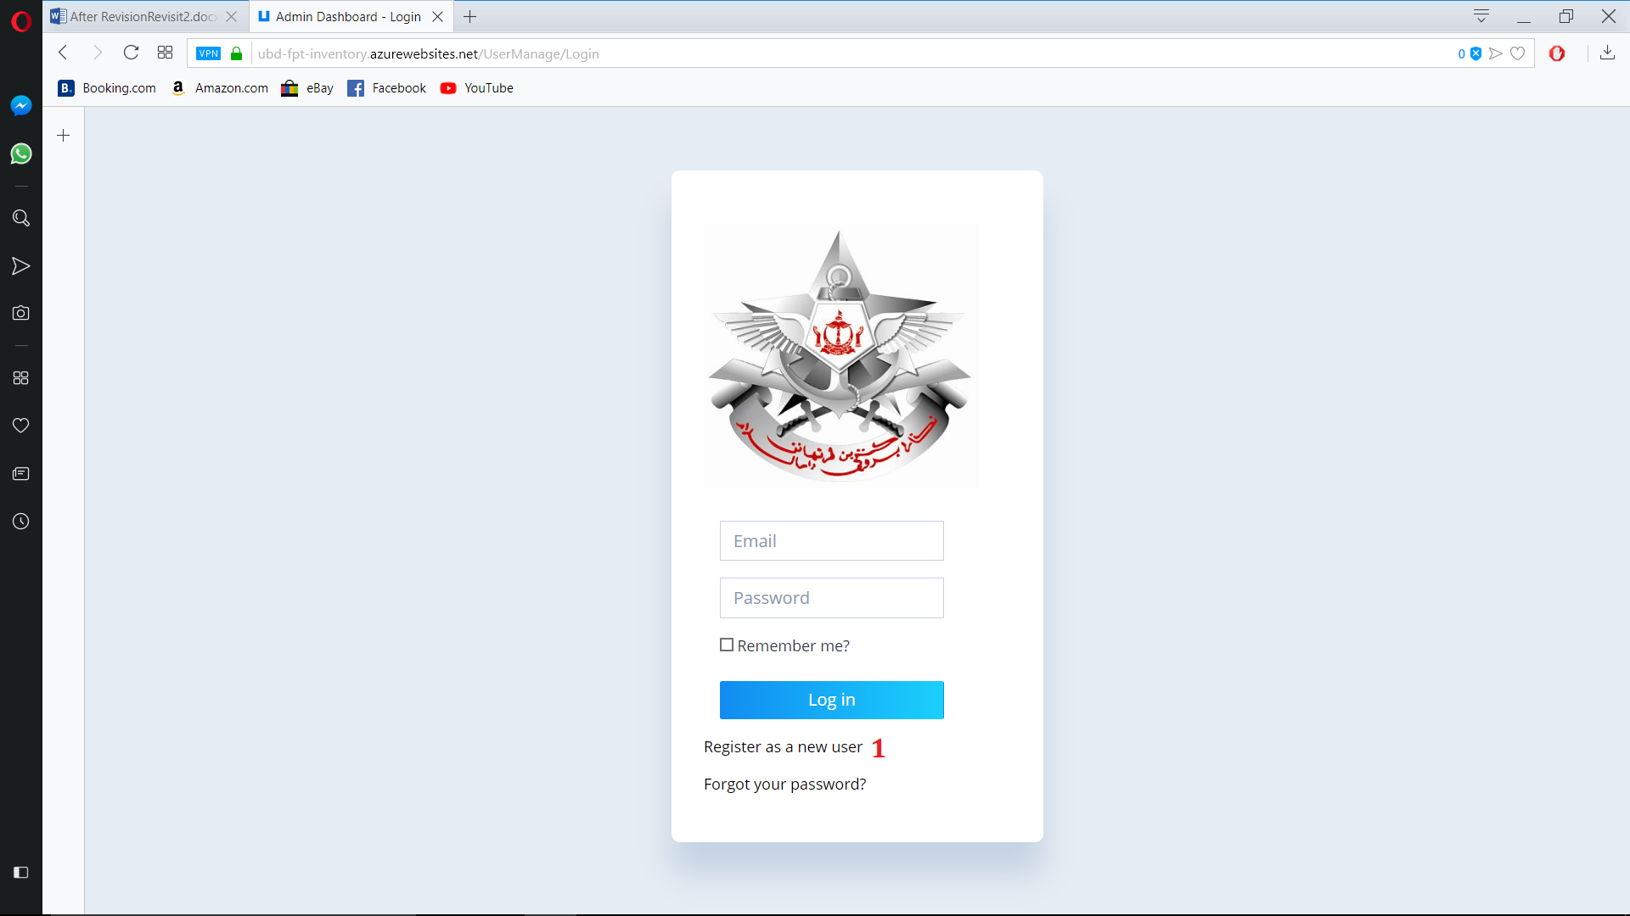

Figure 114. <User Manual> Login Web

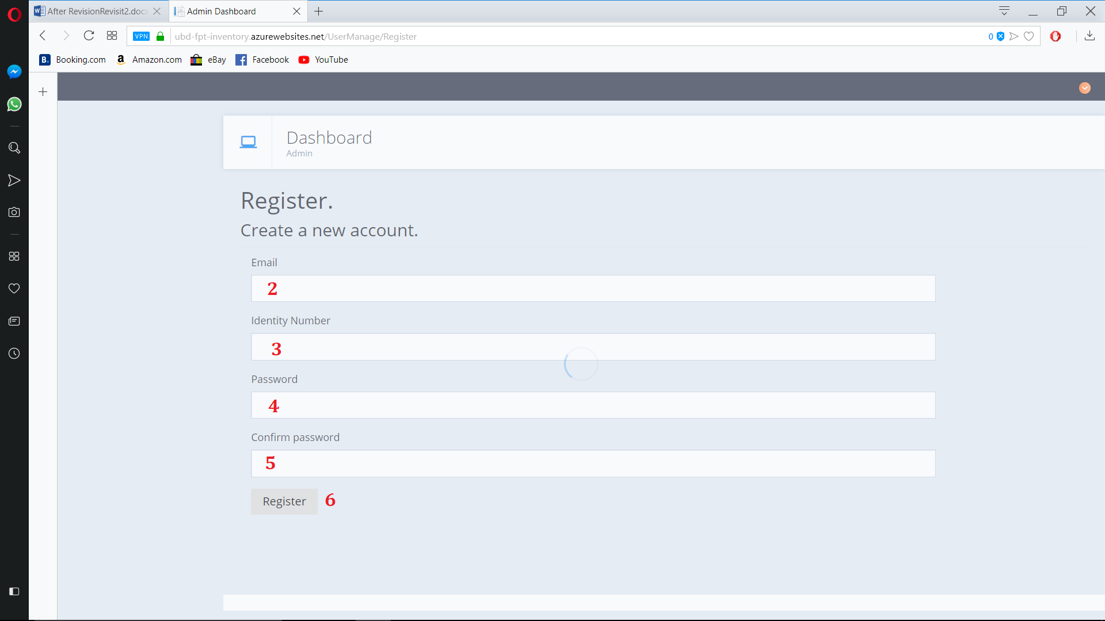

Figure 114. <User Manual> Login Web

|  |  |
| --- | --- |
| **Step** | **Description** |
| 1 | Click on Register as a new user |
| 2 | Enter Email |
| 3 | Email Staff’s Indentity Number |
| 4 | Enter Password |
| 5 | Re-enter Password |
| 6 | Press Register |

### Forgot Password

### 

### Figure 114. <User Manual> Forgot password

### 

### Figure 114. <User Manual> Forgot password

### 

### Figure 114. <User Manual> Forgot password

### 

### Figure 114. <User Manual> Forgot password

|  |  |
| --- | --- |
| **Step** | **Description** |
| 1 | Click on Forgot password |
| 2 | Enter Email |
| 3 | Press Email Link |
| 4 | Go to your email and click on the link sent by Inventory system |
| 5 | Enter Email |
| 6 | Enter Password |
| 7 | Re-enter Password |
| 8 | Press Reset |

### Create New Computer Equipment

### 

### Figure 114. <User Manual> Create New Computer Equipment

### 

### Figure 114. <User Manual> Create New Computer Equipment

### 

### Figure 114. <User Manual> Create New Computer Equipment

### 

### Figure 114. <User Manual> Create New Computer Equipment

|  |  |
| --- | --- |
| **Step** | **Description** |
| 1 | Click on View from Equipment Sub menu |
| 2 | Choose computer Equipment Type |
| 3 | Click on Create New |
| 4 | Choose Deliery Package |
| 5 | Choose Category |
| 6 | Choose Brand |
| 7 | Enter Equipment Name(Or Model) |
| 8 | Choose CPU |
| 9 | Choose Ram |
| 10 | Choose HDD |
| 11 | Choose VGA |
| 12 | Choose OS |
| 13 | Enter Quantity |
| 14 | Choose Equipment picture |
| 15 | Enter Price |
| 16 | Enter Description (If needed) |
| 17 | Enter Note (If needed) |
| 18 | Toggle confirm or not |
| 19 | Toggle active or not |
| 20 | Create new computer equipment |

### Create New other divices Equipment

### 

### Figure 114. <User Manual> Create New other device Equipment

### 

### Figure 114. <User Manual> Create New other device Equipment

|  |  |
| --- | --- |
| **Step** | **Description** |
| 1 | Click on View from Equipment Sub menu |
| 2 | Choose computer Equipment Type |
| 3 | Click on Create New |
| 4 | Choose Deliery Package |
| 5 | Choose Category |
| 6 | Choose Brand |
| 7 | Enter Equipment Name(Or Model) |
| 8 | Enter Quantity |
| 9 | Choose Equipment picture |
| 10 | Enter Price |
| 11 | Enter Description (If needed) |
| 12 | Enter Note (If needed) |
| 13 | Toggle confirm or not |
| 14 | Toggle active or not |
| 15 | Create new computer equipment |

### Create New Issued Item

### 

|  |  |
| --- | --- |
| **Step** | **Description** |
| 1 | Click on Choose Equipment Button |
| 2 | Select Equipment that needed to be issued |
| 3 | Click on Choose staff button |
| 4 | Select Staff that Item will be issued to |
| 5 | Select item status |
| 6 | Enter item serial number |
| 7 | Enter Note (If needed) |
| 8 | Click on add issued |

### Scan Qr Code

### 

### 

### 

### 

|  |  |
| --- | --- |
| **Step** | **Description** |
| 1 | Click on Get Qr code in issue item page |
| 2 | Get Qr Code |
| 3 | Click on Scan Qr Code on mobile version |
| 4 | Scan Qr code |
| 5 | Read Info on id info page |